Arrays
_____________________________________________________________________________________

Q. what is array?
_________________________________________________________________________
Array is a collection of similar type of data it is used for store multiple values in single variable
suppose consider we have example we want to calculate addition of 100 values so we required to declare 100 variable in program for storing 100 values but it is not feasible in real time so we want to declare single variable which should able to store 100 values in this case we can use array.

How to declare array in program
_______________________________________________________________________
If we want to declare array in program we have following syntax

Syntax: datatype variablename [size];

Example: int a[5];
If we think about above statement we have variable of type integer with 5 values means variable a is able to store 5 values as well as variable a maintain index for store 5 values shown in following diagram

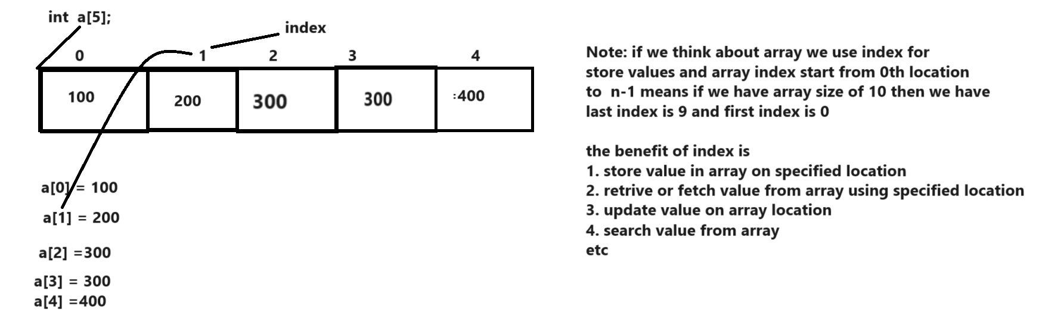

if we think about above diagram we try to insert the value on specified index manually and if we have larger array of size then it is not possible to store value on every index manually so better way you can use loop for maintain index and start index from 0th location
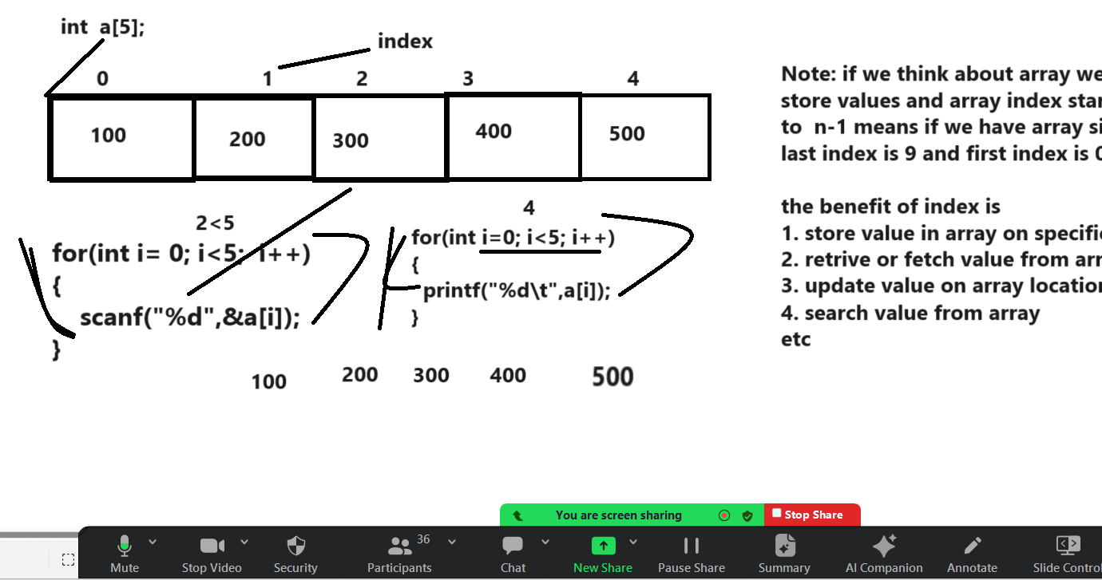

Example:
#include<stdio.h>

int main(){
int a[5],i;

printf("\nEnter values in array\n");
for(i=0;i<5;i++){
scanf("%d",&a[i]);
}
printf("\nDisplay array values\n");
for(i=0;i<5;i++){
printf("%d\t",a[i]);
}

return 0;
}
WAP to input five values in array and calculate its sum
10 20 30 40 50 = 150
#include<stdio.h>

int main(){
int a[5],i,sum=0;

printf("\nEnter values in array\n");
for(i=0;i<5;i++){
scanf("%d",&a[i]);
sum = sum + a[i];
}
printf("\nDisplay array values\n");
for(i=0;i<5;i++){
printf("%d\t",a[i]);
}
printf("\nSum of all element is %d\n",sum);

return 0;
}

Example: WAP to create array and store 5 values in it and input one extra value and search in array
if value found then show the message value present in array and if value not found show the message value not present in array.

10 20 30 40 50
Enter search value
40
Output: value found

If we want to perform searching operation on array we need to know the some data structure searching algorithm

There are two ways to perform searching operation
1. Linear search Algorithm
2. Binary Search algorithm

Q. what is data structure?
_______________________________________________________________________________
Data structure is technique where we can store and manage data internally in memory as well as maintain the relationship of data called as data structure

Q. what is benefit of data structure?
________________________________________________________________________
1. To Maintain standard storage technique
2. to Provide standard approaches for data searching, insertion, deletion, updation and sorting etc
3. To provide optimum solution for result means provide technique to use minimum resources
etc

Types of data structure
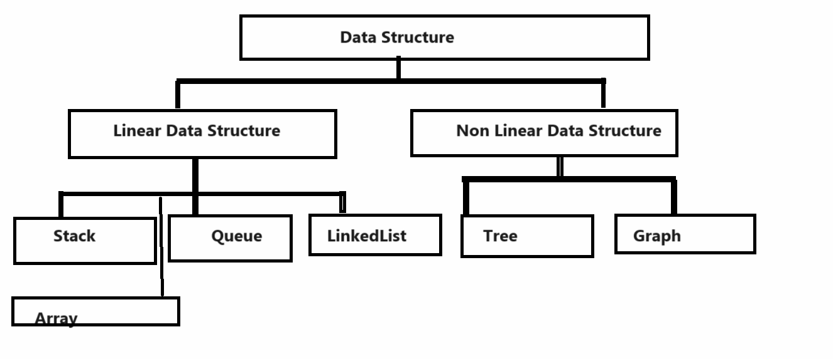

Now we want to perform searching operation on array

a) Linear Search
_____________________________________________________________________________
Linear search means we search key or search value with every element in array from 0 to n-1 index

Algorithm of Linear search
1. Declare array of size 5
2. Store value in array
3. Input Search key value
4. Set flag variable as 0 at initially
5. Compare search key in array with every element
6. if search key found in array set flag =1 and break the loop
7. after loop if flag is 1 then show message value found
otherwise show message value not found

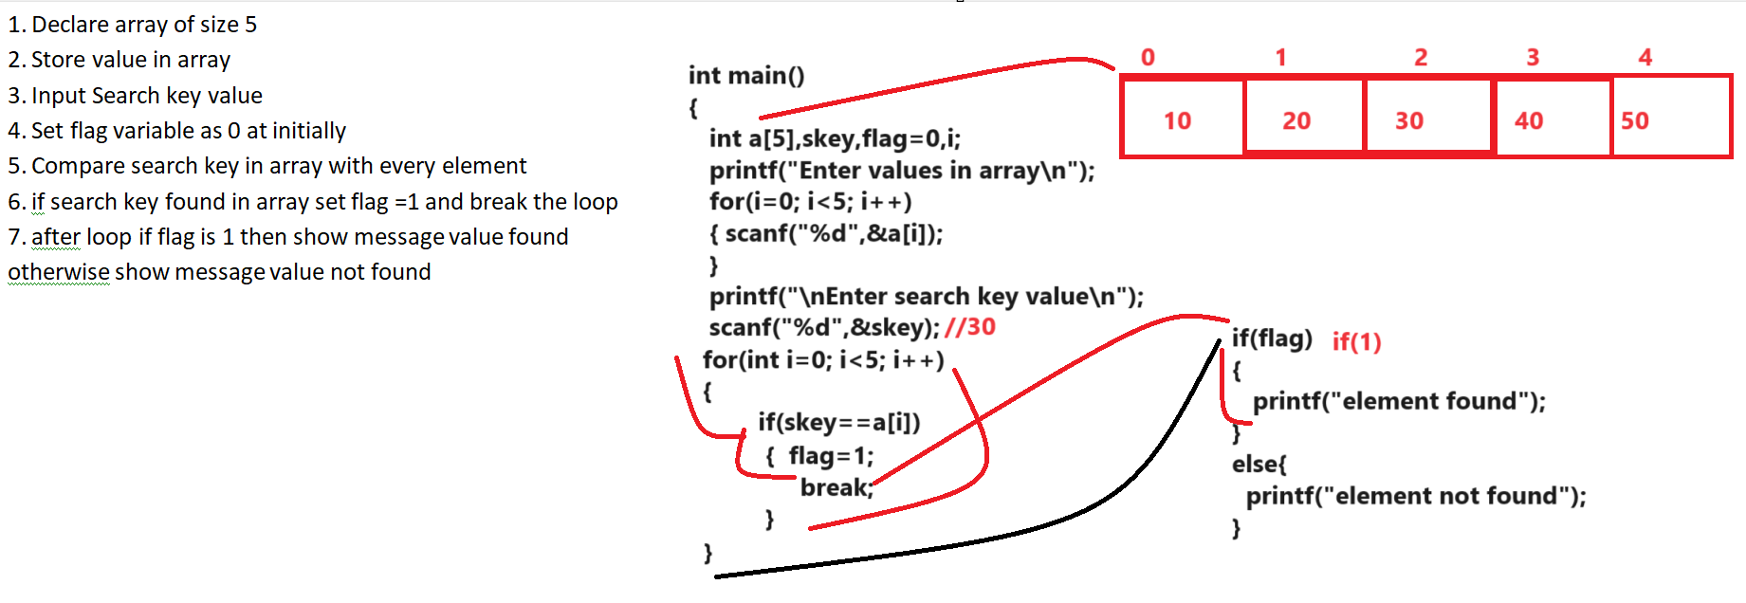

Source code
#include<stdio.h>
int main(){

int a[5],i,flag=0,skey;
printf("\nEnter five values in array\n");
for(i=0; i<5; i++){
scanf("%d",&a[i]);
}
printf("\nDisplay all values of array\n");
for(i=0;i<5;i++){
printf("%d\t",a[i]);
}
printf("\nenter search key value\n");
scanf("%d",&skey);
for(i=0; i<5;i++){
if(skey==a[i]){
flag=1;
break;
}
}

if(flag){
printf("\nelement found in array");
}
else{
printf("\n element not found in array");
}
return 0;
}
The major limitation of linear search is when we have large number of data in array and if search key found at last then we need to perform unwanted iteration for search or if search key is not found in array then we need to travel complete array unnecessary
so if we want to solve this problem we have to use binary search key algorithm
binary search key algorithm works on sorted array

Binary Search algorithm
__________________________________________________________________________
Steps.
1. DECLARE ARRAY
2. Store value in array (data should be in sorted format)
3. Input Search key
4. Divide array in two sections or portion and find mid of element array
5. Compare search with mid element
6. If Middle element equal with search key then declare element found and stop search
7. if search key value is less than middle element then search at left portion of array
8. if search key value is greater than middle element then search at right portion of array
9. repeat step 4 , 5 and 6 until element not found or up to complete array iterations
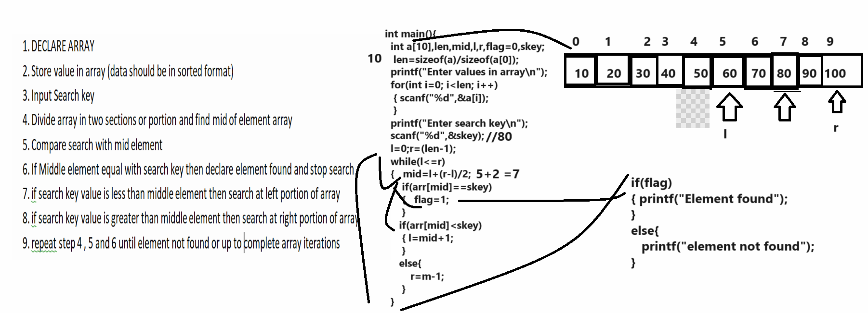
Source code with example
#include<stdio.h>
int main(){

int a[10],i,flag=0,skey,l,r,len,mid;
len=sizeof(a)/sizeof(a[0]);
printf("\nEnter five values in array\n");
for(i=0; i<len; i++){
scanf("%d",&a[i]);
}
printf("\nDisplay all values of array\n");
for(i=0;i<len;i++){
printf("%d\t",a[i]);
}
printf("\nenter search key value\n");
scanf("%d",&skey);
l=0;
r=(len-1);
while(l<r){
mid=l+(r-l)/2;
if(a[mid]==skey){
flag=1;
break;
}
if(a[mid]<skey){
l=mid+1;
}
else{
r=mid-1;
}
}
if(flag){
printf("\nelement found in array");
}
else{ printf("\n element not found in array");
}

return 0;
}
Sorting algorithm
______________________________________________________________________

WAP to input five values in array and arrange all elements in ascending order
__________________________________________________________________________________

Bubble Sort sorting algorithm
____________________________________________________________________________________
Steps to work with bubble sort algorithm

1. DECLARE array
2. Store Data in Array
3. Set two pointers one at previous index and one at next index if previous index value is greater than next index then perform swapping between two index values.
4. Compare single element with index+1 element
5. Repeat step 3 and 4 up to complete array sort.
6. STOP

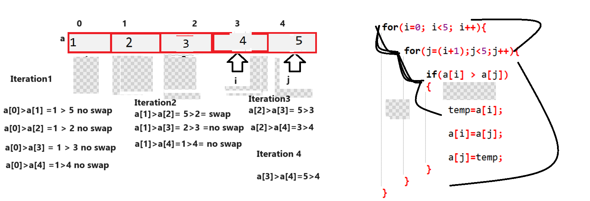

Source code
#include<stdio.h>
int main(){
int a[5],i,j,temp;
printf("\nenter five values in array\n");
for(i=0; i<5; i++){
scanf("%d",&a[i]);
}
printf("\nDisplay array before sorting\n");
for(i=0; i<5; i++){
printf("%d\t",a[i]);
}
//perform sorting on array elements
for(i=0; i<5; i++){

for(j=(i+1);j<5;j++){

if(a[i] > a[j])
{

temp=a[i];

a[i]=a[j];

a[j]=temp;
}
}
}
printf("\nDisplay array after sorting\n");
for(i=0; i<5; i++){
printf("%d\t",a[i]);
}

return 0;
}

WAP to create array of size 5 and input values in ascending order and find the missing values
Input: 1 5 9 12 14
Output: 2 3 4 6 7 8 10 11 13

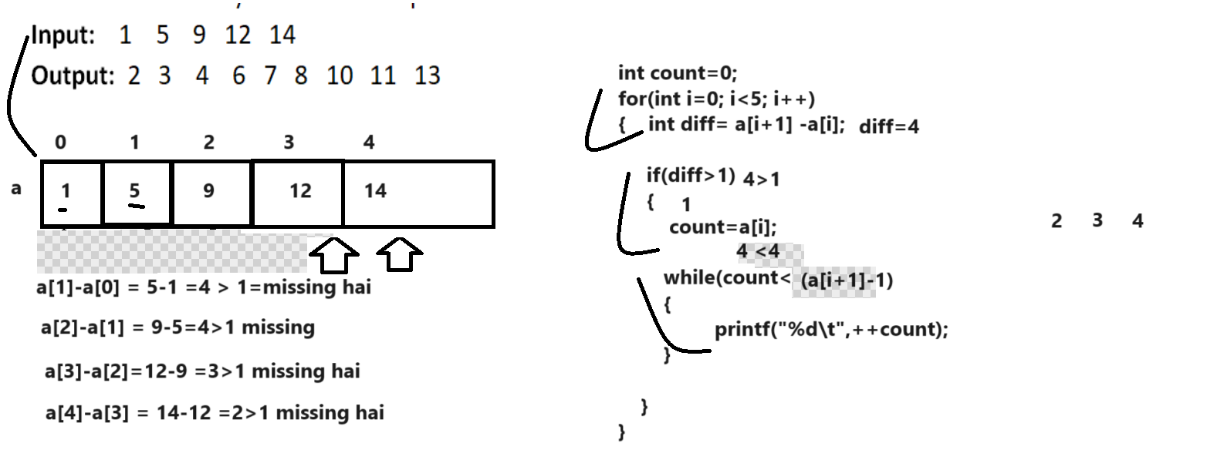

#include<stdio.h>
int main(){
int a[5],i,j,temp,diff,count;
printf("\nenter five values in array\n");
for(i=0; i<5; i++){
scanf("%d",&a[i]);
}

for(int i=0; i<5;i++){
int diff=a[i+1]-a[i];
if(diff>1){
count=a[i];
while(count<(a[i+1]-1))
{
printf("%d\t",++count);
}
}
}

return 0;
}

Example: WAP declare two array of size five name as a[5],b[5],c[10] and merge two array with each other
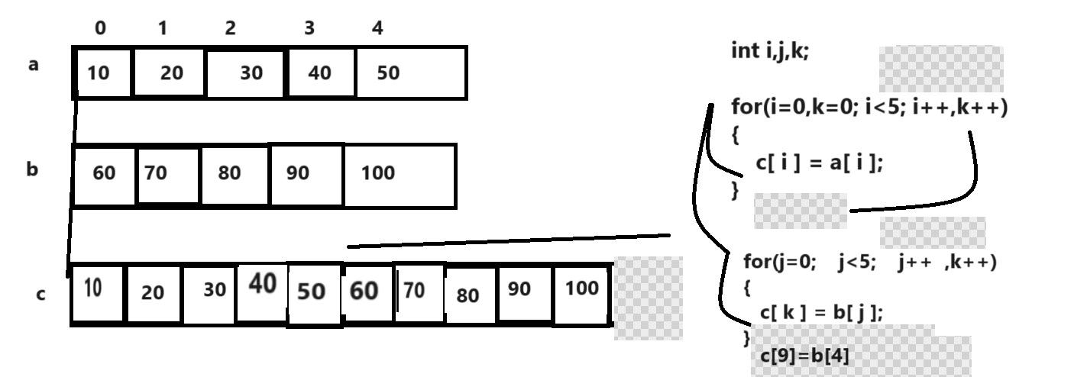

Source code
#include<stdio.h>
int main(){
int a[5],b[5],c[10],i,j,k;
printf("\nEnter five values in array\n");
for(i=0;i<5;i++){
scanf("%d",&a[i]);
}
printf("\nenter five value in second array\n");
for(i=0;i<5;i++){
scanf("%d",&b[i]);
}
//merging logic
for(i=0,k=0;i<5;i++,k++){
c[i]=a[i];
}
for(j=0;j<5;j++,k++){
c[k]=b[j];
}
printf("\nDisplay first array\n");
for(i=0;i<5;i++){
printf("%d\t",a[i]);
}
printf("\nDisplay second array\n");
for(i=0;i<5;i++){
printf("%d\t",b[i]);
}
printf("\ndisplay c array after merging\n");
for(i=0;i<10;i++){
printf("%d\t",c[i]);
}

return 0;
}

Example: WAP to create array of size 10 and find the occurrence of every element in array

10 20 30 10 20 30 10 20 30 40

10 -----3
20 ---- 3
30 --- 3
40 ----1

Stack Implementation by using Array
____________________________________________________________________________________

Q. what is stack?
____________________________________________________________________________
Stack is data structure which maintains the data in last in first out format means last inserted element remove first from stack. we can say stack is single ended data structure means using single side we can insert data in stack as well as remove data from stack and stack has pointer name as top and the initial value of top is -1 so when we insert data in stack then top increase by 1 and when we remove data from stack then top decrease by 1

There are two types of operation we can perform on Stack
__________________________________________________________________________________
PUSH: push operation means we can insert data in stack and when insert data in stack then stack top increase by 1 and in the case of push operation there is possibility called as stack is full or overflow.
Stack overflow means if we try to insert data in stack but there is no space for new element called as stack overflow.

Consider we have stack with size 5 and we want to insert element in it then your stack work as

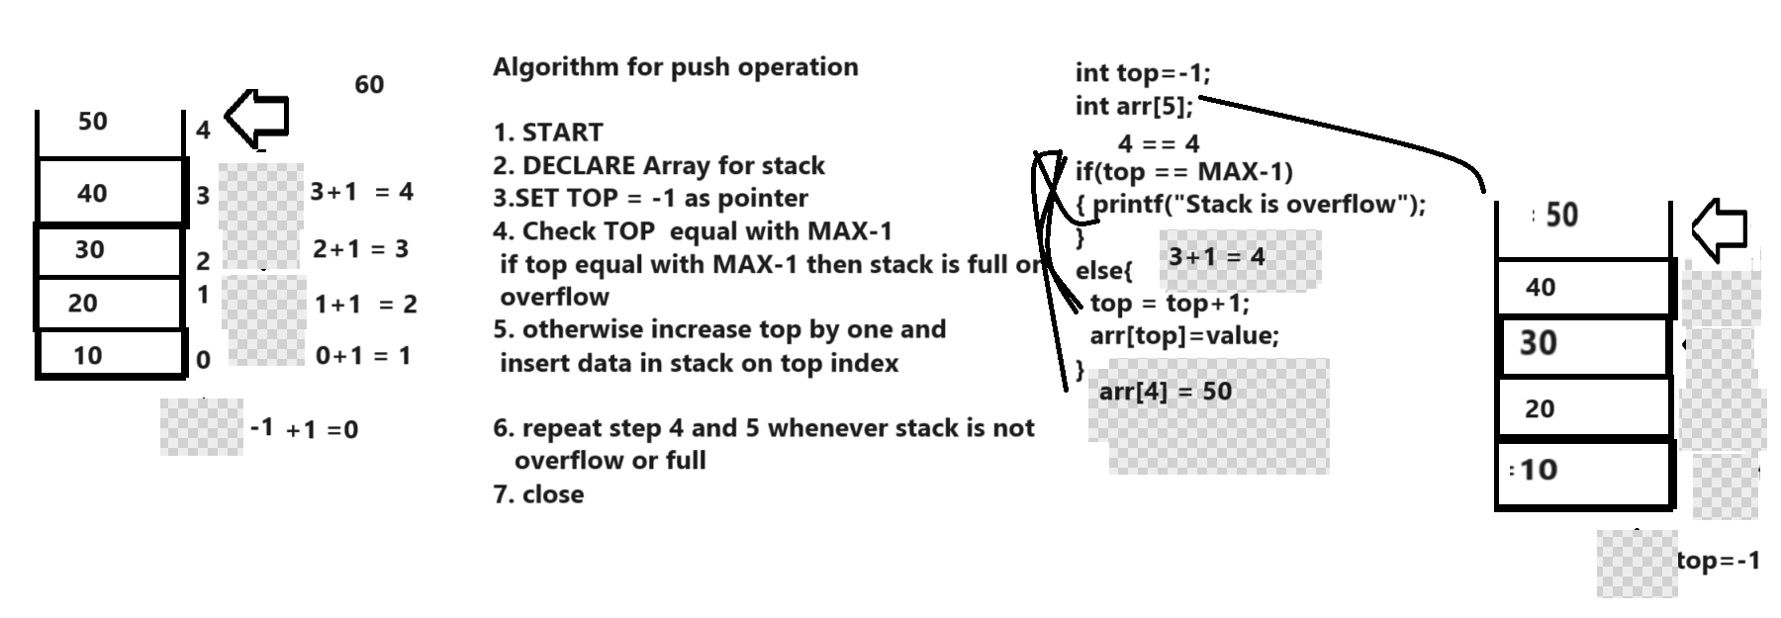
POP: POP operation means we want to remove top most data from stack called as POP operation when we remove the data from stack then top should be decrease by -1 but if we think about POP operation there is one possibility called as stack underflow means when remove the element from stack if there is no element present in stack then we can say it is underflow condition.
Stack underflow condition occur when your top is -1

Following diagram demonstrate POP operation
__________________________________________________________________________________
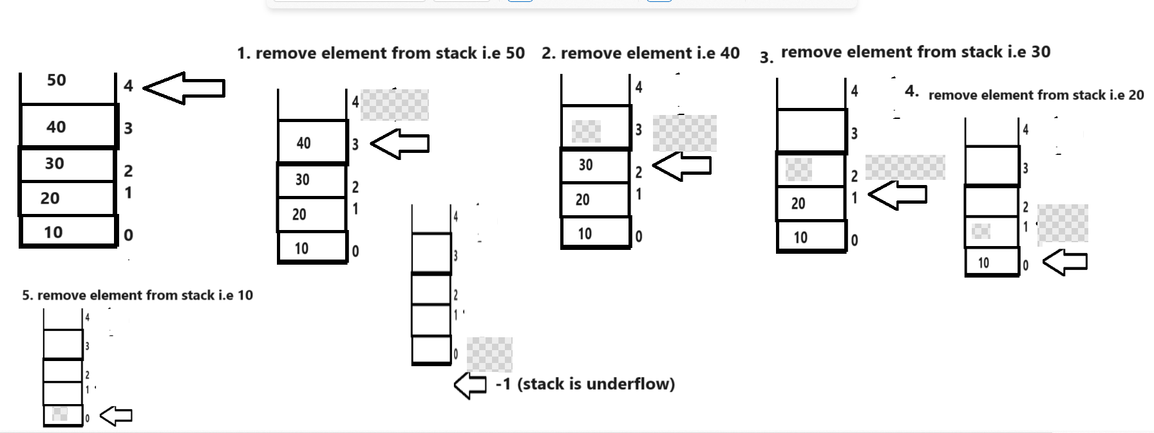

Algorithm of POP operation
____________________________________________________________________________
1. START
2. DECLARE ARRAY
3. SET top=-1
4. If TOP ==-1
Stack is underflow
5. Extract data from stack and decrease top by -1
6. Repeat step 4 and 5 until stack is empty
7. STOP
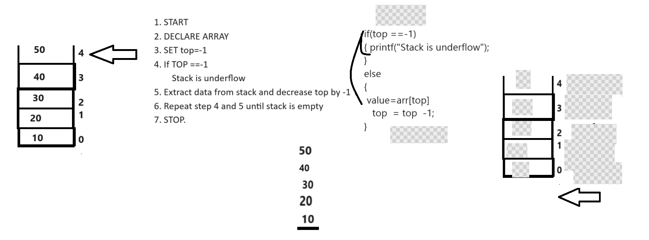

Source code
#include<stdio.h>
int main(){
int arr[5],top=-1,choice,value,MAX;
MAX=sizeof(arr)/sizeof(arr[0]);
do{
printf("1:PUSH");
printf("\n2:POP");
printf("\n3:DISPLAY");
printf("\nEnter your choice\n");
scanf("%d",&choice);
switch(choice){
case 1:
if(top==MAX-1){
printf("Stack is overflow\n");
}
else{
printf("\nEnter value in stack\n");
scanf("%d",&value);
top = top +1;
arr[top]=value;
}
break;
case 2:
if(top==-1){
printf("Stack is underflow");
}
else{
value=arr[top];
top=top-1;
printf("\nDeleted value is %d\n",value);
}
break;
case 3:
if(top==-1){
printf("Stack underflow");
}
else{
for(int i=top; i>=0;i--){
printf("%d\n",arr[i]);
}
}
break;
default:
printf("Wrong choice");
}
}while(choice!=4)

return 0;
}

Two dimensional arrays
___________________________________________________________________________________
Two dimensional array is used for create the matrix but it is not matrix internally it is way to create matrix.
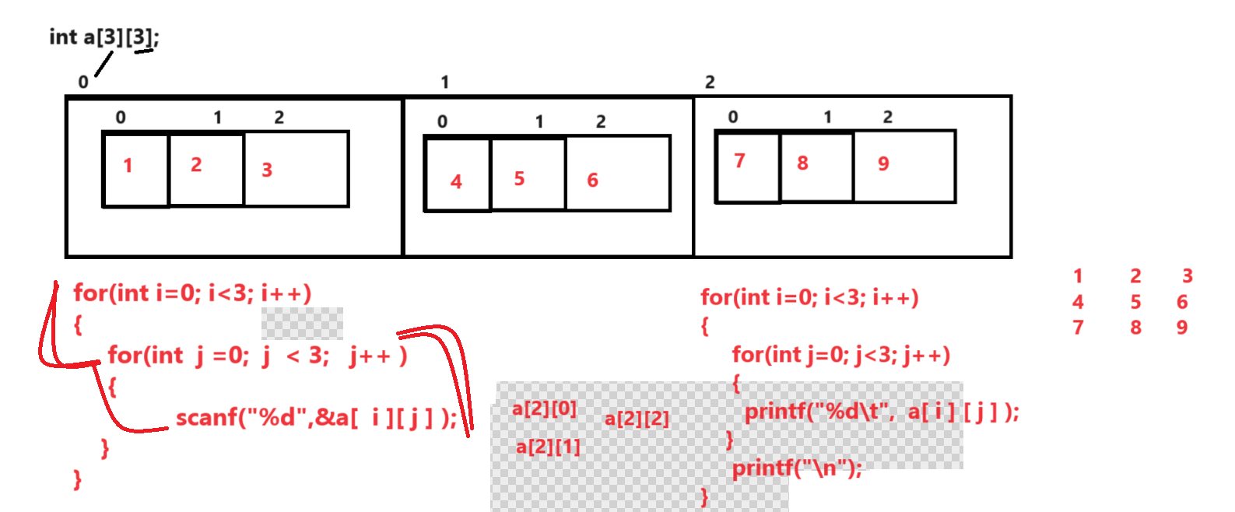
Example:
#include<stdio.h>
int main(){
int a[3][3],i,j;
printf("\nEnter values in matrix\n");
for(i=0;i<3; i++){
for(j=0;j<3;j++){
scanf("%d",&a[i][j]);
}
}
printf("\nDisplay matrix value\n");
for(i=0;i<3; i++){
for(j=0;j<3;j++){
printf("%d\t",a[i][j]);
}
printf("\n");
}
return 0;
}
Example: WAP to create 3 x 3 matrix and calculate the sum of every row.
#include<stdio.h>
int main(){
int a[3][3],i,j,sum;
printf("\nEnter values in matrix\n");
for(i=0;i<3; i++){
for(j=0;j<3;j++){
scanf("%d",&a[i][j]);
}
}
printf("\nDisplay matrix value\n");
for(i=0;i<3; i++){
sum=0;
for(j=0;j<3;j++){
printf("%d\t",a[i][j]);
sum = sum + a[i][j];
}
printf(" = %d \n",sum);
}

return 0;
}

Example:WAP to create 3 x 3 matrix and calculate the sum of left and right diagonal element of array
#include<stdio.h>
int main(){
int a[3][3],i,j,sum;
printf("\nEnter values in matrix\n");
for(i=0;i<3; i++){
for(j=0;j<3;j++){
scanf("%d",&a[i][j]);
}
}
printf("\nDisplay matrix value\n");
int lsum=0,rsum=0;
for(i=0;i<3; i++){
for(j=0;j<3;j++){
if(i==j){
lsum=lsum+a[i][j];
}
if(j==2-i){
rsum=rsum+a[i][j];
}
printf("%d\t",a[i][j]);
}
printf("\n");
}
printf("Sum of all left diagonal is %d\n",lsum);
printf("Sum of all right diagonal is %d\n",rsum);
return 0;
}
Example: WAP to Create 3 x 3 matrix and transpose means convert row to column and column to row
#include<stdio.h>
int main(){
int a[3][3],i,j;
printf("\nEnter values in matrix\n");
for(i=0; i<3; i++){
for(j=0; j<3; j++){
scanf("%d",&a[i][j]);
}
}
printf("\nDisplay matrix before transpose\n");
for(i=0; i<3; i++){
for(j=0; j<3; j++)
{ printf("%d\t",a[i][j]);
}
printf("\n");
}
printf("\nDisplay matrix after transpose\n");
for(i=0; i<3; i++){
for(j=0; j<3; j++)
{
printf("%d\t",a[j][i]);
}
printf("\n");
}
return 0;
}

WAP to Create two 3 x3 matrix and calculate its multiplication
#include<stdio.h>
int main(){
int a[3][3],b[3][3],c[3][3],i,j,k,sum=0;
printf("Enter values in first matrix\n");
for(i=0;i<3;i++){
for(j=0;j<3;j++){
scanf("%d",&a[i][j]);
}
}
printf("Enter values in second matrix\n");
for(i=0;i<3;i++){
for(j=0;j<3;j++){
scanf("%d",&b[i][j]);
}
}
printf("\nDisplay first matrix\n");
for(i=0;i<3;i++){
for(j=0;j<3;j++){
printf("%d\t",a[i][j]);
}
printf("\n");
}
printf("\nDisplay second matrix\n");
for(i=0;i<3;i++){
for(j=0;j<3;j++){
printf("%d\t",b[i][j]);
}
printf("\n");
}
//multiplication logic
for(i=0;i<3;i++){
for(j=0;j<3;j++){
sum=0;
for(k=0;k<3;k++){
sum=sum+a[i][k]*b[k][j];
}
c[i][j]=sum;
}
}
printf("\nDisplay Resultant matrix\n");
for(i=0;i<3;i++){
for(j=0;j<3;j++){
printf("%d\t",c[i][j]);
}
printf("\n");
}
return 0;
}
Example: WAP to calculate the power of corner elements
#include<stdio.h>
int main(){
int a[3][3],i,j,k,sum=0;
printf("Enter values in first matrix\n");
for(i=0;i<3;i++){
for(j=0;j<3;j++){
scanf("%d",&a[i][j]);
}
}
printf("\nDisplay first matrix\n");
for(i=0;i<3;i++){
for(j=0;j<3;j++){
printf("%d\t",a[i][j]);
}
printf("\n");
}
//Calculate power of corner element
printf("\nDisplay first matrix\n");
for(i=0;i<3;i++){
for(j=0;j<3;j++){
if((i==0 && j==0) ||(i==0 && j==2)||(i==2&&j==0)||(i==2&&j==2)){
int p=1;
for(k=1;k<=3;k++){
p=p*a[i][j];
}
printf("%d\t",p);
}
}
printf("\n");
}
return 0;
}
Example: WAP to create 3 x 3 matrix and convert in parse matrix
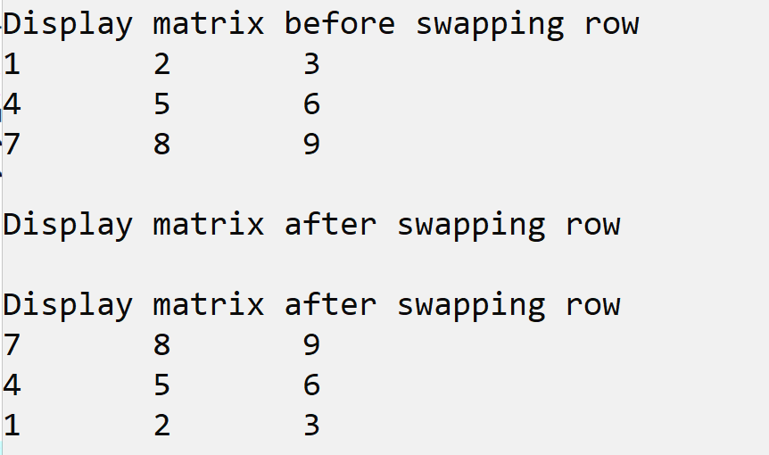

Source code
#include<stdio.h>
int main(){

int a[3][3],i,j,temp;
printf("\nEnter three values in matrix\n");
for(i=0;i<3;i++){
for(j=0;j<3;j++){
scanf("%d",&a[i][j]);
}
}
printf("\nDisplay matrix before swapping row\n");
for(i=0;i<3;i++){
for(j=0;j<3;j++){
printf("%d\t",a[i][j]);
}
printf("\n");
}
printf("\nDisplay matrix after swapping row\n");
int count=2;
for(i=0;i<3;i++){
for(j=0;j<3;j++){
if(i==0){
int temp=a[i][j];
a[i][j]=a[count][j];
a[count][j]=temp;

}
}
}
printf("\nDisplay matrix after swapping row\n");
for(i=0;i<3;i++){
for(j=0;j<3;j++){
printf("%d\t",a[i][j]);
}
printf("\n");
}
}

Example:

