Inheritance
________________________________________________________________________________
Q. what is inheritance?
_____________________________________________________________________
Inheritance means to transfer the properties of one class to another class called as inheritance.
So property provider class knows as parent class and property receiver class known as child class.
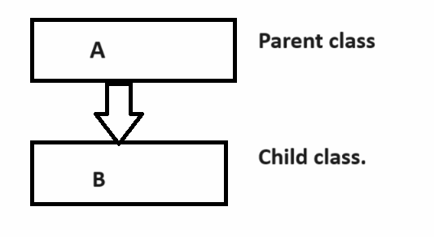
Q. why use inheritance or what are the benefits of inheritance?
________________________________________________________________________________
There are Major two benefits of inheritance
1. Reuse the code or Reusability: means we can reuse the parent class content by child class without creating its object means if we have some general logic and if we required that logics more than one time in different places so better way you can store logic in class known as parent and reuse that class by inherit in another classes called as child class.
Suppose consider we want to design a simple calculator means calculator can perform four different operations like as Add, Mul, Div, Sub but if we think every operation required two values so you can design application like as
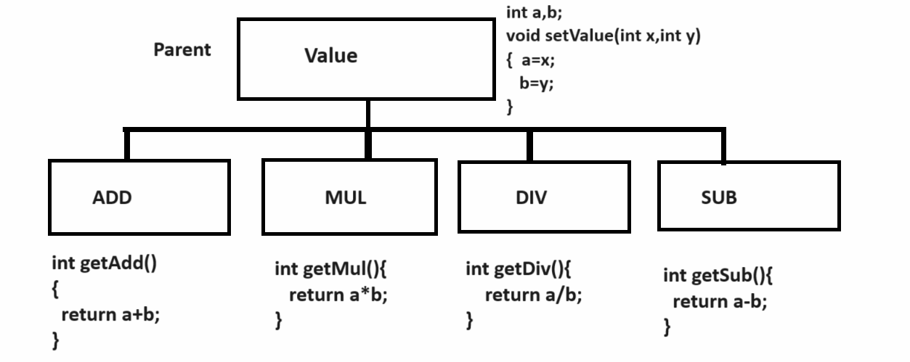
2. Extensibility: Extensibility means we can reuse content of parent class in child class as well as add own properties called as extensibility
Example: if we think about above diagram we have parent class name as Value which contain setValue() function and we have four child classes name as ADD, MUL, DIV,SUB so these four classes access the properties from Value class as well as every class has own property like as getAdd(), getMul(),getDiv(),getSub() etc called as extensibility

How to perform inheritance practically using C++
__________________________________________________________________________________
If we want to perform inheritance practically we have to use following syntax

Syntax:
class childclassname: access specifier parentclassname{

};
Example:
class Value{
protected:
int a,b;
public:
void setValue(int x,int y)
{ a=x;
b=y;
}
};
class Add:public Value{
public:
int getAdd(){
return a+b;
}
};
Here Value is our parent class and Add is our child class

If you want to work with inheritance using C++ we have Types of inheritance
________________________________________________________________________
1. Single level inheritance: Single parent class and single child class called as single level inheritance.
A
|
B
2. Multi level inheritance: Multi level inheritance means one class is parent of another class and child of another in multi level inheritance there is only one pure parent and one pure child class
A --- Pure parent
|
B
|
C
|
D --- Pure child
3. Multiple inheritances: Multiple inheritance means there is more than one parent and single child called as multiple inheritances.

A B C
_________________
|
D
4. Hierarchical inheritance: Hierarchical inheritance means single parent class and more than one child classes called as hierarchical inheritance.

A
|
_____________________________
B C D E F

5. Hybrid inheritance: Hybrid inheritance means it is combination of all kinds of inheritance
Note: the major limitation of hybrid inheritance is the main parent class content get replicated in last child class via intermediate classes and if we create object of last child and try to call main parent content then compiler get confused because there is ambiguity problem and if we want to solve this problem we have virtual keyword.
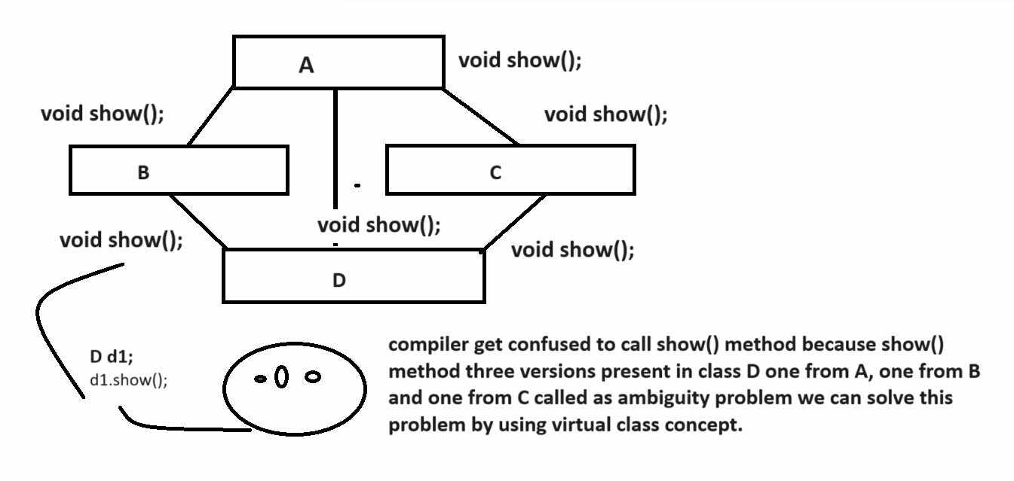

Example of Hierarchical inheritance
_____________________________________________________________________________
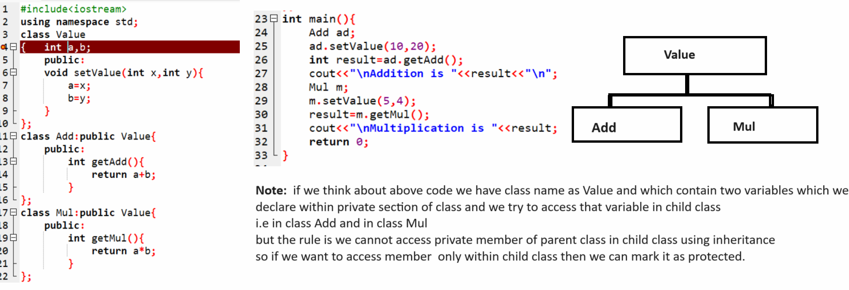
Source code
#include<iostream>
using namespace std;
class Value
{ protected:
int a,b;
public:
void setValue(int x,int y){
a=x;
b=y;
}
};
class Add:public Value{
public:
int getAdd(){
return a+b;
}
};
class Mul:public Value{
public:
int getMul(){
return a*b;
}
};
int main(){
Add ad;
ad.setValue(10,20);
int result=ad.getAdd();
cout<<"\nAddition is "<<result<<"\n";
Mul m;
m.setValue(5,4);
result=m.getMul();
cout<<"\nMultiplication is "<<result;
return 0;
}

Example using multiple inheritances
_____________________________________________________________________________
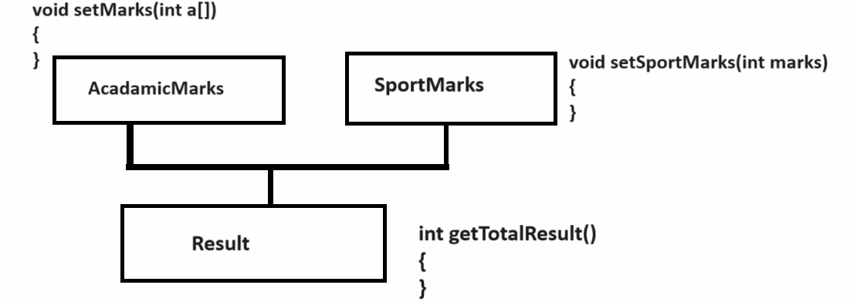

Source code
#include<iostream>
using namespace std;
class AcadamicMarks
{ protected:
int *ptr;
public:
void setMarks(int m[]){
ptr=m;
}
};
class SportMarks{
protected:
int smarks;
public:
void setSportMarks(int smarks){
this->smarks=smarks;
}

};
class Result:public AcadamicMarks,public SportMarks
{
public:
int getTotalMarks(){
int agg=0;
for(int i=0;i<6; i++){
agg=agg+ptr[i];
}
agg=agg+smarks;
return (agg/7);
}
};
int main(){

Result r;
int marks[6];
cout<<"\nEnter marks of six subject\n";
for(int i=0; i<6;i++){
cin>>marks[i];
}
r.setMarks(marks);
r.setSportMarks(70);
int total=r.getTotalMarks();
cout<<"\nTotal marks is "<<total<<"\n";
return 0;
}
Hybrid inheritance
____________________________________________________________
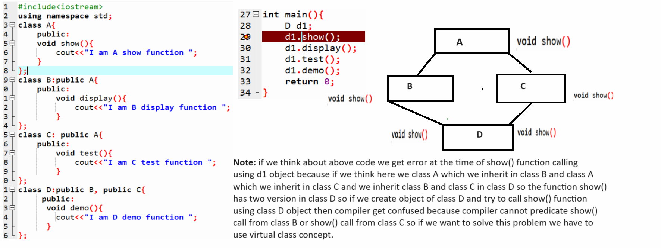

Shown in following code.
#include<iostream>
using namespace std;
class A{
public:
void show(){
cout<<"I am A show function\n ";
}
};
class B:virtual public A{
public:
void display(){
cout<<"I am B display function\n";
}
};
class C: virtual public A{
public:
void test(){
cout<<"I am C test function\n";
}
};
class D:public B, public C{
public:
void demo(){
cout<<"I am D demo function\n";
}
};
int main(){
D d1;
d1.show();
d1.display();
d1.test();
d1.demo();
return 0;
}
Constructor in inheritance
_______________________________________________________________________________
If we define default constructor within parent class and define constructor in child class and if we create object of child class then parent constructor get executed before child class constructor.
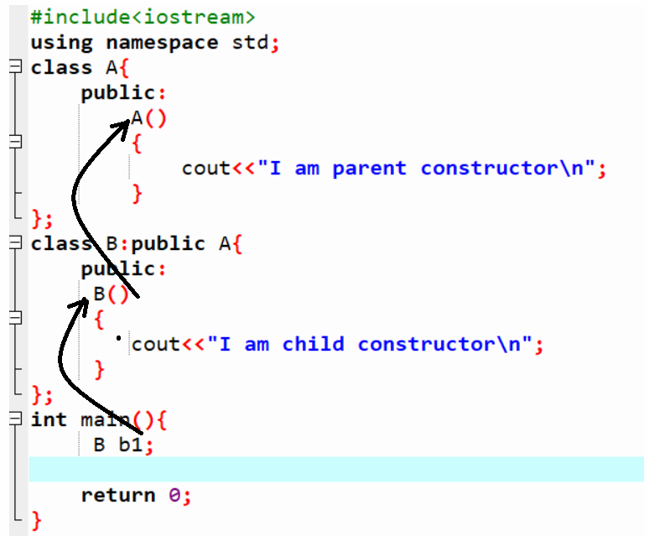

Note: if parent class contain parameterized constructor and if we create object of child class then parent constructor not executed before child class constructor then compiler will generate compile time error to us

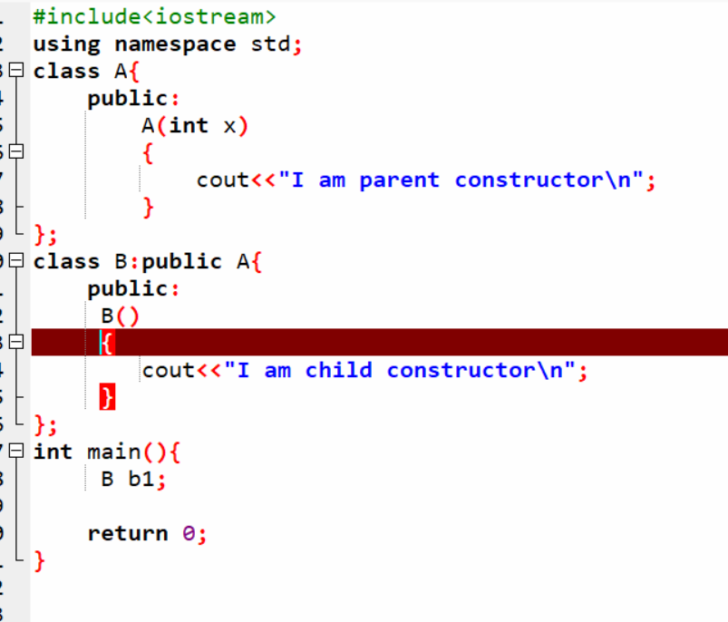
Note: if we think about above code we get compile time error because we have parameterized constructor in parent class and default constructor in child class so the responsibility of child constructor is pass parameter to parent constructor so for this purpose we can use base class constructor concept in C++. Base class constructor concept helps us to pass parameter from child class constructor to parent class.
Syntax of Base class Constructor concept
__________________________________________________________________________
class child classname : access specifier parentclassname{
public:
childclassname():parentclassname(variables){
write here your logics
}
};

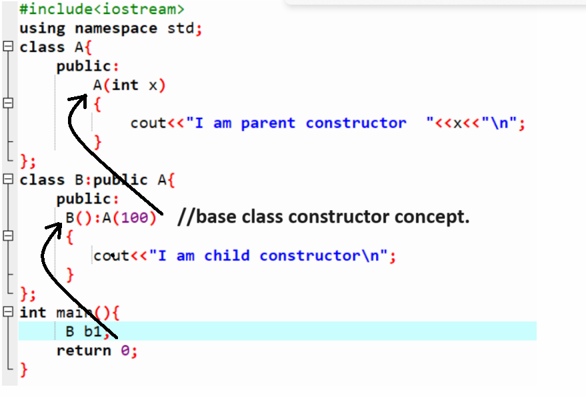

Method overriding concept
________________________________________________________________________
Q. what is method overriding?
____________________________________________________________________________
Method overriding means if we define method parent class and redefine same method within child class called as method overriding.

Example:
class A{
public:
void show()
{ cout<<”I am parent class method”;
}
}
class B:public A{
public:
void show()
{ cout<<”I am child class method”;
}
};
If we think about above code we have two classes one is class A and we have one child class name as B and we have void show() method present in class A and show() method present in class B means we define same method within parent class and redefine same method again in child class so it is called as method overriding.

Note: if we think about method overriding if we create object of child class and try to call overridden method then by default child logics get executed means child logics get override on parent logics

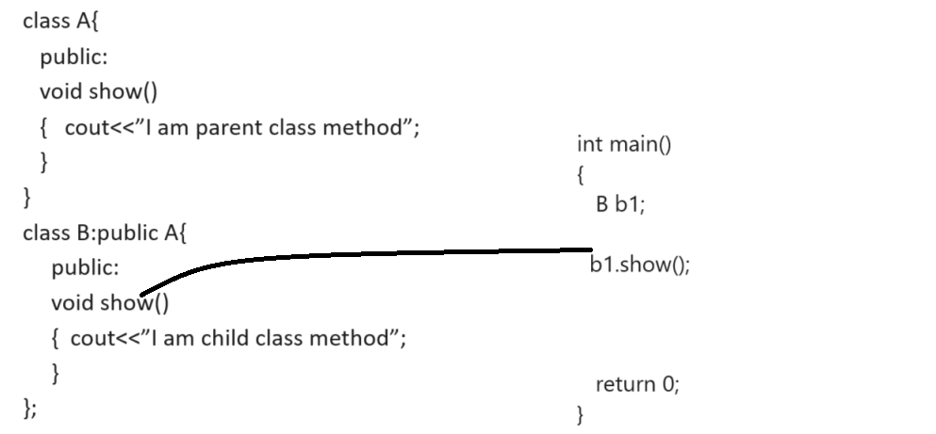

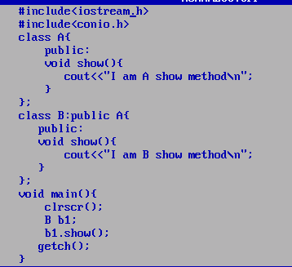
Output:


Q. why we need to use method overriding?
_________________________________________________________________________
There are two reasons of method overriding
1. Child class can customize logics of parent class as per his requirement
#include<iostream.h>
#include<conio.h>

class Per
{
protected:
int per;
public:
void calPer(int a[])
{ int agg=0;
for(int i=0; i<6; i++)
{ agg=agg+a[i];
}
per=agg/6;
}
};
class Eight:public Per
{
public:
int getEightPer(){
return per;
}
};
class Nine:public Per
{
public:
int getNinePer(){
return per;
}
};
class Ten:public Per
{
public:
int getTenPer(){
return per;
}
void calPer(int a[])
{
for(int i=0;i<6;i++)
{
for(int j=(i+1);j<6;j++)
{
if(a[i]<a[j])
{
int temp=a[i];
a[i]=a[j];
a[j]=temp;
}
}
}
int agg=0;
for( i=0;i<5;i++)
{
agg=agg+a[i];
}
per=agg/5;
}
};
void main(){
clrscr();
int marks[]={60,80,90,50,60,70};
Eight e;
e.calPer(marks);
int ep=e.getEightPer();
cout<<"\nEighth class percentage is "<<ep<<"\n";
Nine n;
n.calPer(marks);
int np=n.getNinePer();
cout<<"\nNine class percentage is "<<np<<"\n";
Ten t;
t.calPer(marks);
int tp=t.getTenPer();
cout<<"\nTen class percentage is "<<tp;
getch();
}
2. To Achieve dynamic polymorphism
(Note: will discuss this concept in abstract class and abstract methods)

Abstract class and abstract methods
____________________________________________________________________
Q. what is abstract class?
_____________________________________________________________________
Abstract class means class cannot create its object and abstract method means method cannot have logics so if we declare abstract method in C++ we have to use pure virtual function and if we declare pure virtual function in class then class known as abstract class.
Syntax:
class classname{
public:
virtual return type functionname(arguments)=0; //pure virtual function or it is abstract function
};
Example:
class Vehicle{
public:
virtual void engine()=0;
};
Here Vehicle is abstract class and engine() is abstract function so we cannot create object of Vehicle class and cannot define engine() function.

Q. Why use abstract class and abstract function?
______________________________________________________________________
There are two reasons to declare abstract class and abstract function

1. To achieve abstraction:
2. To achieve dynamic polymorphism.

Q. What is abstraction?
___________________________________________________________________
abstraction means hide the implementation detail from end user at design level called as abstraction means in the case of abstraction we not write logic of method just we write its template or proto type and we can write a logic of method as per the requirement of child class.
Means we can say in the case of abstraction we know what to do but don’t know how to do it is depend on child class requirement
Example: if we think about Vehicle then we can say every vehicle class has engine but we cannot predicate its design because design of engine () vary from Vehicle category to vehicle category
Means Bike is vehicles but it has different engine design, Car is Vehicle but it has different engine design.

If we want to work with abstract class and abstract method we need to know the some important points

1. Abstract class cannot create its object
Note: if we try to create object of abstract class we get compile time error.
2. Abstract method cannot have logics and if we want to write logic of abstract method we need to override it in child class and write its logic.
so the benefit we can write different of method of method in every child class as per requirement of child

#include<iostream.h>
#include<conio.h>
class Vehicle // this is your abstract class
{
public:
virtual void engine()=0;//abstract function or pure virtual function
};
class Bike:public Vehicle{
public:
void engine(){
cout<<"100 CC\n";
}
};
class Car:public Vehicle
{ public:
void engine(){
cout<<"1000 CC\n";
}
};
void main(){
clrscr();
Bike b;
b.engine();
Car c;
c.engine();
getch();
}
Note: if we think about above code we have abstract class name as Vehicle which contain one abstract
Method name as void engine () and it is abstract method and we override this method in Bike class and this method in Car class so we write engine() method logic differently in Bike and differently in Car class
this is the benefit of abstract methods we can change its logic as per the requirement of child.

Note: we cannot create object of abstract class but can create its reference or pointer and if we want to create reference or pointer of abstract class we have to create object of its child class.

Syntax: classname *variablename=new childclassname();
Example : Vehicle *v = new Car();
here v is pointer or reference and new Car() is actual object

Q. what is benefit of abstract class reference?
____________________________________________________________________________
The major goal of abstract class reference is achieve dynamic polymorphism.

Q. what is dynamic polymorphism?
____________________________________________________________
Dynamic polymorphism means functionality bounded with object at program run time called as dynamic polymorphism means we change object at run time using parent class reference and parent class reference call method from class whose object address stored in it called as dynamic polymorphism.
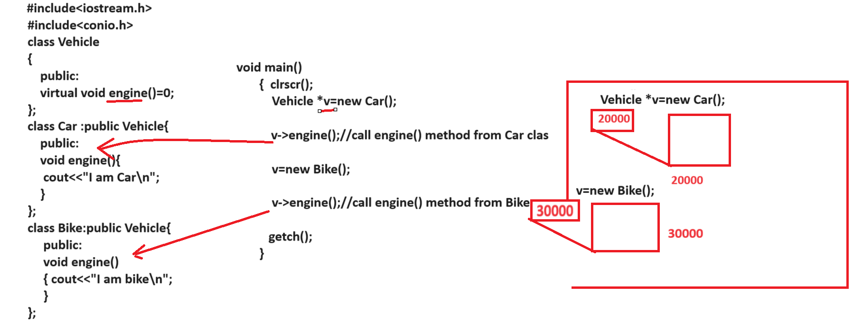

Example: WAP to create abstract class name as Value with one abstract method and one abstract method
void setValue(int x,int y): this is non abstract method which accept two parameter
virtual int getResult()=0: this is your abstract method
and we have two child classes name as Add and Mul and we have to inherit Value class in Add and in Mul and we want to create reference of Value class and when user press
case 1: perform addition using value class reference
case 2: perform multiplication using value class reference.

Example:
#include<iostream.h>
#include<conio.h>

class Value{
protected:
int a,b;
public:
void setValue(int x,int y)
{ a=x;
b=y;
}
virtual int getResult()=0;
};
class Add:public Value{
public:
int getResult(){
return a+b;
}
};
class Mul:public Value{
public:
int getResult(){
return a*b;
}
};
int main(){
clrscr();
int choice;
Value *v;
int a,b;
cout<<"\n1:Addition\n";
cout<<"\n2:Multiplication\n";
cout<<"\nEnter your choice\n";
cin>>choice;
cout<<"\nEnter two values\n";
cin>>a>>b;
switch(choice)
{
case 1:
v = new Add();
v->setValue(a,b);
int result=v->getResult();
cout<<"\nAddition is "<<result<<"\n";
break;
case 2:
v = new Mul();
v->setValue(a,b);
result=v->getResult();
cout<<"\nMultiplication is "<<result;
break;
default:
cout<<"\nWrong choice\n";
}
getch();
}

Q. what is benefit of dynamic polymorphism?
__________________________________________________________________________
The major benefit of dynamic polymorphism is to achieve loose coupling.

Q. what is coupling?
________________________________________________________________________
Coupling means if particular method is dependent on some another class object called as coupling.

There are two types of coupling
________________________________________________________________________
1. Tight coupling: Tight coupling means if method of particular class is 100% dependent on object of another class called as tight coupling.
2. Loose coupling: Loose coupling means if method of particular class is partially dependent on another class object called as loose coupling.

Example: Suppose consider we are working on Calculator and we have four classes one is
Value which is our abstract class , one is Add , one is Mul and last is Calculator and Calculator class contain method name as void performOperation(Add ad) shown in following code.
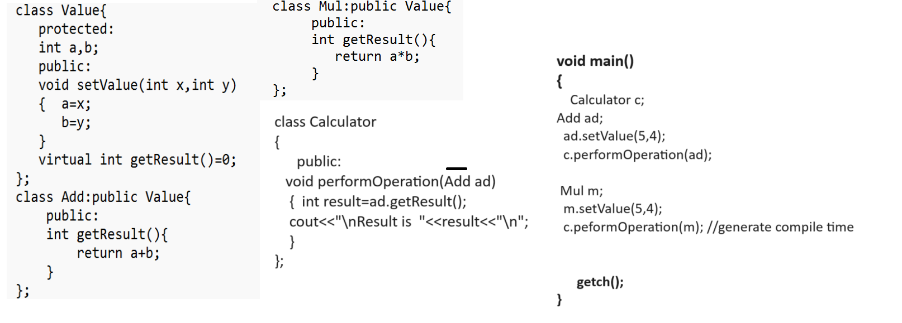
Note: if we think about above code it is implementation of tight coupling and generate compile time error if we think about performOperation(Add ad) method of Calculator class and if we think about main method we have statement Calculator c; here we have c is object of Calculator class and Add ad ; is object of Add class and we have c.performOperation(ad) means we pass Add object as parameter to performOperation() it is acceptable because type match from function calling and function definition but if we think about code Mul m; and c.performOperation(m) means we pass Mul class object as parameter to Calculator class but it is not possible because we have Add class object parameter so we cannot pass any other class object as parameter to performOperation() means performOperation() method is 100% dependent on Add class object as parameter so we can say it is called as tight coupling.

So if we want to solve this problem we have two ways
1. Using Compile time polymorphism with function overloading
as per our example if we want to pass Mul class object as parameter to performOperation() method then we can overload the performOperation() two times using Add class parameter and Using Mul class parameter so the benefit we can call any one method as per parameter type.
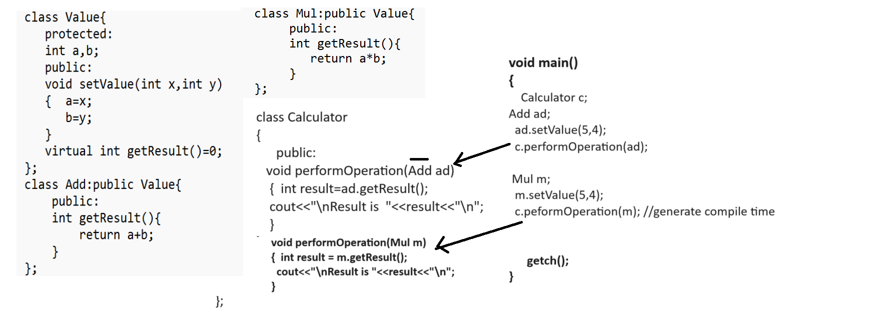
The major limitation suppose consider we have Calculator with 100 different operation and we design 100 classes for operations means separate class for every operation so we required to performOperation () 100 times in Calculator class so it is not possible in real time so design single method which should able to accept 100 different parameters then we can use dynamic polymorphism

2. Using Run time polymorphism with function overriding.

