LinkedList
___________________________________________________________

Q. what is LinkedList?
____________________________________________________________________
LinkedList is a collection of node
Q. what is node?
___________________________________________________________
Node is a block of memory which contains two sections 1. Data and 2. Address
Data section contains actual user data and address section contain address of next node shown in following diagram.

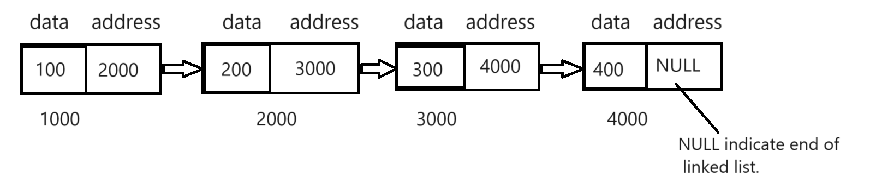

How to create Node practically using C Language
_____________________________________________________________________________
If we want to create node programmatically by using c language we can use structure.
Syntax:
struct structurename{
datatype variablename;
datatype variablename;
struct structurename *pointername;
};
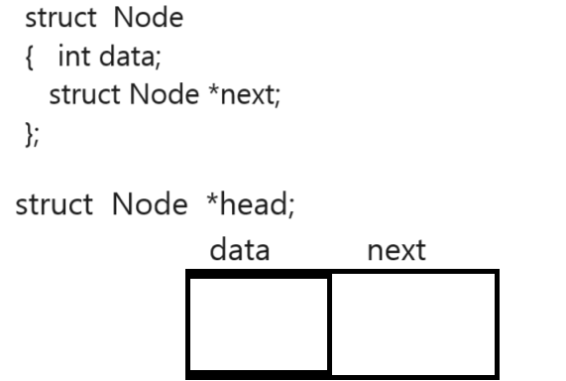

How to Create LinkedList
____________________________________________________________________________
If we want to create LinkedList we have following ways
1. Inserting Node at Beginning
2. Inserting node at ending
3. Inserting node at middle.

How to create LinkedList by inserting node at beginning
___________________________________________________________________________________
1. Declare Node structure
2. Create Head Pointer and mark it as NULL or starting pointer
3. If Head pointer is NULL then allocate memory for head pointer using malloc
4. Store Data in head pointer and mark its next pointer as NULL
5. If Head pointer is not NULL then allocate memory for temporary node.
6. Store data in temporary node
7. Store head pointer in temporary next section or next pointer
8. Shift head pointer on temporary node
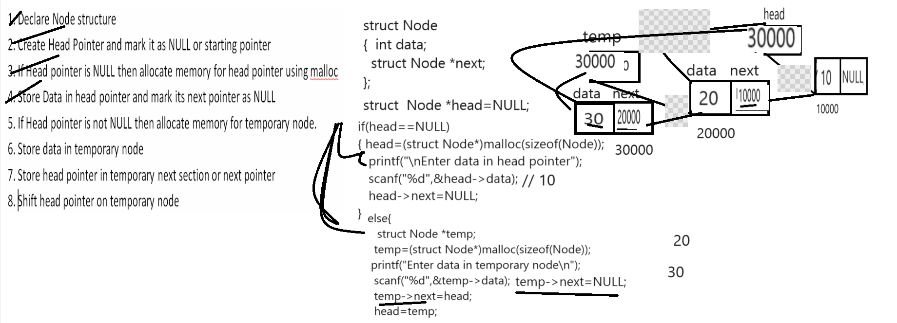

How to display linked list data
_______________________________________________________________________
If we want to display linked list data we have to use following code.

Algorithm
____________________________________________
1. Check head pointer is null or not
If head pointer is null then show message linked list empty
2. If head pointer is not null then create one new temporary pointer
3. Assign head pointer in temporary pointer
4. Travel temporary pointer up to null using loop
5. Fetch data using temporary pointer and display
6. Move temporary pointer on next node.
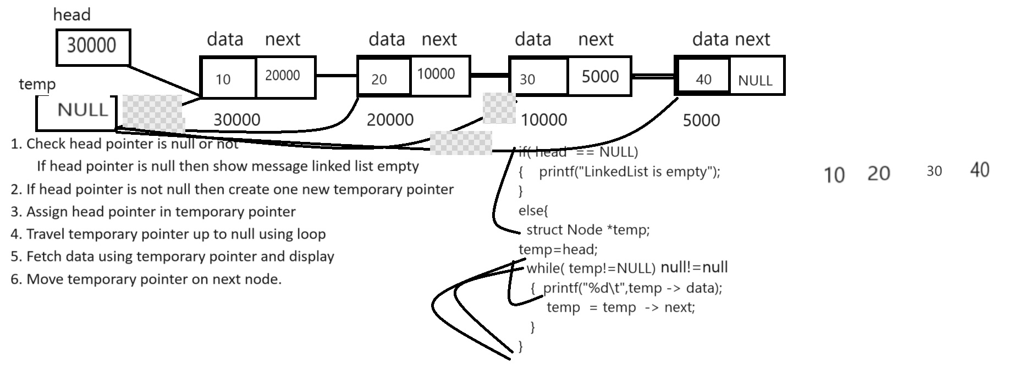
Source code
#include<stdio.h>
#include<stdlib.h>
struct Node
{
int data;
struct Node *next;
};
struct Node *head=NULL;
void insert(){
if(head==NULL){
head=(struct Node*)malloc(sizeof(Node));
printf("\nEnter data in node\n");
scanf("%d",&head->data);
head->next=NULL;
}
else{
struct Node *temp;
temp=(struct Node*)malloc(sizeof(Node));
printf("\nEnter data in new node\n");
scanf("%d",&temp->data);
temp->next=head;
head=temp;
}
}
void show(){
struct Node *temp;
temp=head;
while(temp!=NULL){
int data=temp->data;
printf("%d\t",data);
temp=temp->next;
}

}
int main(){
int choice;
do{
printf("1:INSERT\n");
printf("2:View\n");
printf("\nEnter your choice\n");
scanf("%d",&choice);
switch(choice){
case 1:
insert();
break;
case 2:
show();
break;
default:
printf("wrong choice");
}
}while(choice!=3);

return 0;
}

Insert Node at Ending in LinkedList
_______________________________________________________________________________
Algorithm and steps
1. Declare structure for Node
2. Create Head pointer and initialize NULL value in it
3. If Head pointer is NULL then allocate memory for Head pointer and store data in it
and marks its next pointer as NULL
4. If head pointer is not null then allocate memory temporary node and store data in it
and mark its next as null
5. Travel LinkedList up to last pointer and attach last node to temp node

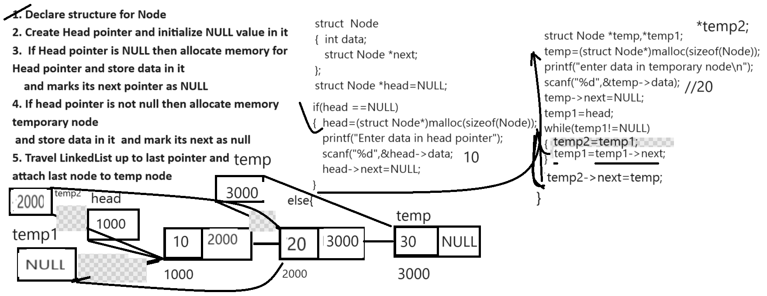

Source code for insert node in linked list at ending
#include<stdio.h>
#include<stdlib.h>
struct Node
{ int data;
struct Node *next;
};
struct Node *head=NULL;
void insertNodeAtEnd(){
if(head==NULL){
head=(struct Node*)malloc(sizeof(Node));
printf("\nEnter data in head node\n");
scanf("%d",&head->data);
head->next=NULL;
}
else{
struct Node *temp,*temp1,*temp2;
temp=(struct Node*)malloc(sizeof(Node));
printf("\nEnter data in temporary node\n");
scanf("%d",&temp->data);
temp->next=NULL;
temp1=head;
while(temp1!=NULL){
temp2=temp1;
temp1=temp1->next;
}
temp2->next=temp;
}
}
void show(){
if(head==NULL){
printf("Data not present in linked list");
}
else{
struct Node *temp=head;
while(temp!=NULL){
printf("%d\t",temp->data);
temp=temp->next;
}
}
}
int main(){
int choice,value;
do{ printf("1:INSERT");
printf("\n2:Display");
printf("\nEnter your choice\n");
scanf("%d",&choice);
switch(choice){
case 1:
insertNodeAtEnd();
break;
case 2:
show();
break;
default:
printf("Wrong chocie");
}
}while(choice!=3);
return 0;
}

How to Delete node at beginning of LinkedList
_____________________________________________________________________________
Steps
1. Create temporary node
2. Initialize head pointer in temporary node
3. Move head pointer on second node
4. Set temp next pointer as NULL
5. Extract data from temporary pointer
6. Delete temporary pointer.

#include<stdio.h>
#include<stdlib.h>
struct Node
{
int data;
struct Node *next;
};
struct Node *head=NULL;

void insertNodeAtEnd(){
if(head==NULL){
head=(struct Node*)malloc(sizeof(Node));
printf("\nEnter data in head node\n");
scanf("%d",&head->data);
head->next=NULL;
}
else{
struct Node *temp,*temp1,*temp2;
temp=(struct Node*)malloc(sizeof(Node));
printf("\nEnter data in temporary node\n");
scanf("%d",&temp->data);
temp->next=NULL;
temp1=head;
while(temp1!=NULL){
temp2=temp1;
temp1=temp1->next;
}
temp2->next=temp;
}
}
void show(){

if(head==NULL){
printf("Data not present in linked list");
}
else{
struct Node *temp=head;
while(temp!=NULL){
printf("%d\t",temp->data);
temp=temp->next;
}
}
}
void deleteAtBeg(){
struct Node *temp;
if(head==NULL){
printf("there is no data in linked list");
}
else{
temp=head;
head=head->next;
temp->next=NULL;
int data=temp->data;
printf("Deleted node data is %d\n",data);
free(temp);
temp=NULL;
}
}
int main(){
int choice,value;
do{
printf("1:INSERT");
printf("\n2:Display");
printf("\n3:Delete At begining\n");
printf("\nEnter your choice\n");
scanf("%d",&choice);
switch(choice){
case 1:
insertNodeAtEnd();
break;
case 2:
show();
break;
case 3:
deleteAtBeg();
break;
default:
printf("Wrong chocie");
}
}while(choice!=4);

return 0;
}

