Pointer
____________________________________________________________________________________

Q. what is pointer?
_____________________________________________________________________________
Pointer is derived data type which is used for allocate memory dynamically at program run time

Q. what is derived data type?
____________________________________________________________________________
Derived data type means those data type acquire property from another data type and add own properties or user defined properties called as derived data type.

Q. what is meaning of dynamic memory allocation?
___________________________________________________________________________________
Dynamic memory allocation means decide how much memory required at program run time called as dynamic memory allocation.
Suppose consider we have array of size 500 then we cannot store more than 500 values in array as well as if we store less than 500 values in array then memory utilize all space of array means if we store 10 values in array then 490 value memory get lost or unused.
But if we want to allocate memory at program run time as per your choice means if we required 500 values then system should provide space 500 value and if we required 5 value then system provide space for 5 values means not allocate extra space more than 5 called as dynamic allocation or run time memory allocation and we can achieve dynamic memory allocation by using pointer.

How to declare pointer in c Language?
____________________________________________________________________________________
Syntax: datatype *variablename;
Example: int *ptr;
Note: when we use * with any variable at the time of variable declaration called as pointer.

How pointers allocate dynamic memory at program run time?
_________________________________________________________________________________
Pointer can allocate memory at run time with the help of memory address means pointer can store address of another memory at program time for store values

What is memory address?
________________________________________________________________________________
Memory address is unique integer number or hex number provided by ram to variable or memory block called as memory address.

Can we see the memory address?
_________________________________________________________________________
Yes we can see the memory address and for that we have & operator
If we use & with variable in c program then we get the memory address of that variable provided by ram.
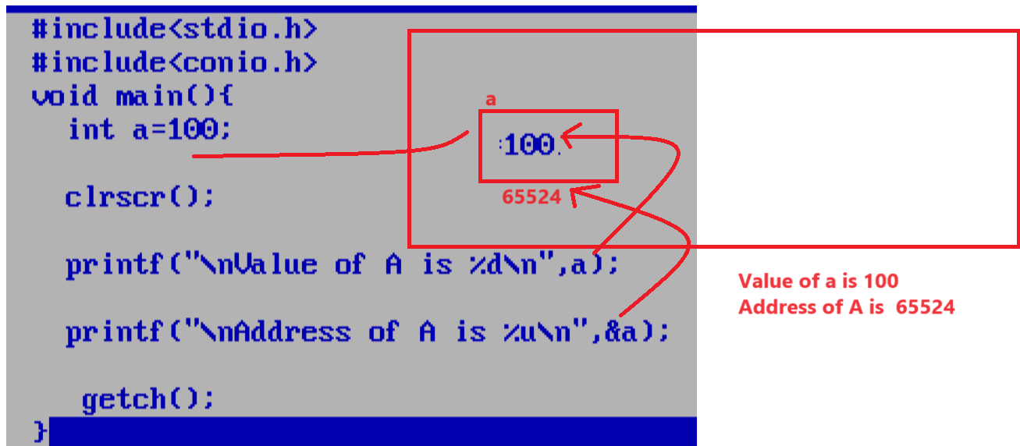

How to store address of another memory in pointer or
How to store address of another variable in pointer
___________________________________________________________________________________
If we want to store address of another variable in pointer we have to use following syntax

Syntax: data type *variablename;
variablename=&normalvariable;

Example: int *ptr, a=100;
ptr=&a;

Some important points of pointer
1) Pointer always use address of another variable or memory
2) Pointer has own different address.
3) If we want to use any value through the pointer we have to use * with pointer at the time of use.
* know as value address operator or dereferencing operator.
4) When we increase or decrease the pointer without using * then we can pointer get increase by block and the block size is dependent on the data type of pointer

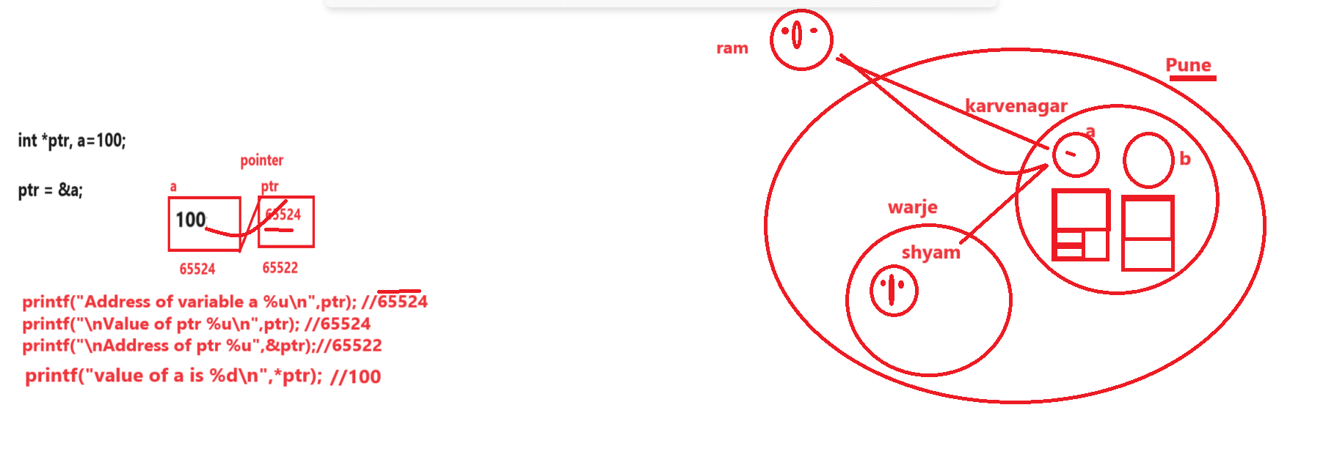
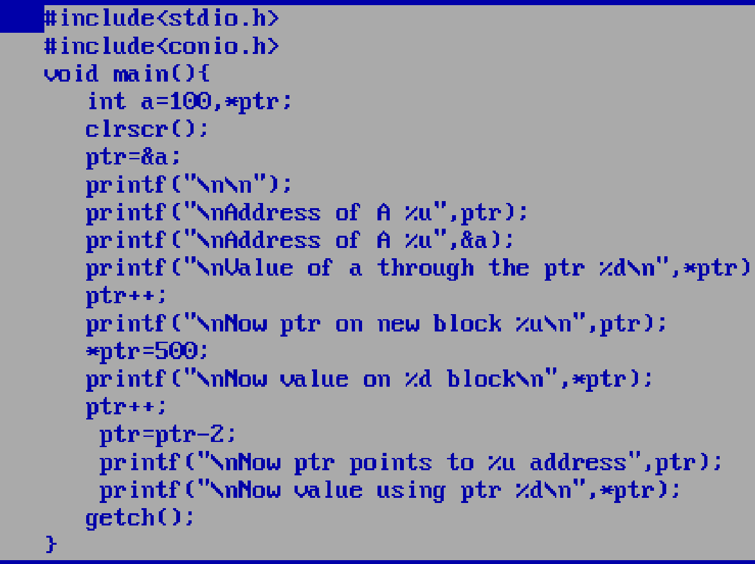

Q. what will be output of given code?
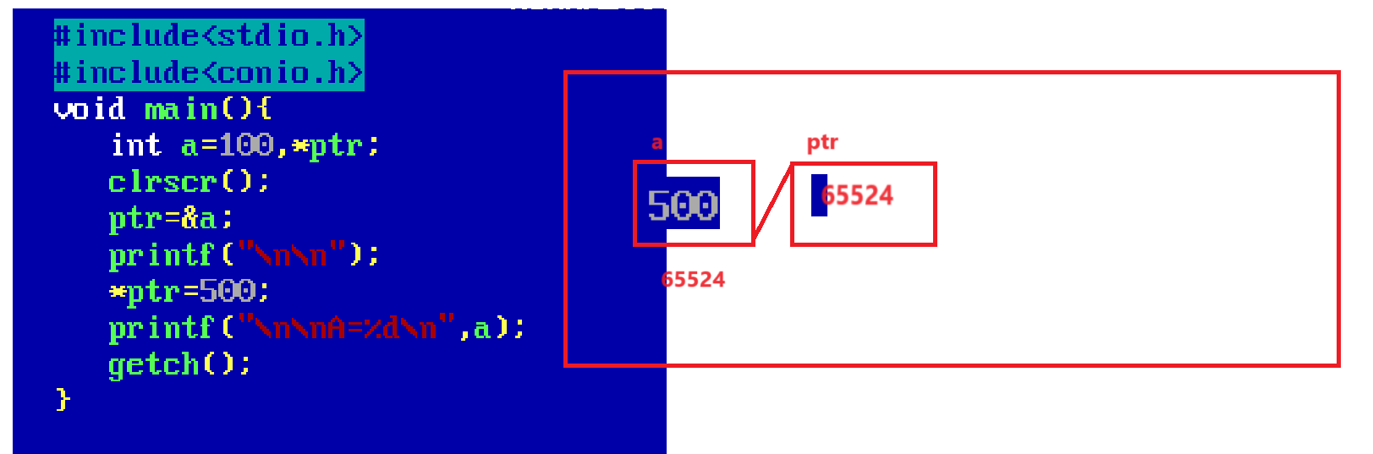
Note: if we think about above code we have statement int a=100,*ptr here we have normal variable name as which contain 100 value and we have statement ptr=&a; means here we store address of variable a i.e 65524 in ptr means our ptr points to variable a block again we have statement *ptr =500 means *(65524)=500 means we store 500 value on 65524 block and 65524 is block of variable a means we update the value on 65524 using ptr so updated value get override on 65524 means on variable a means new value of variable a is 500 so when we print the value of a then we get 500

Q. what will be output of given code?
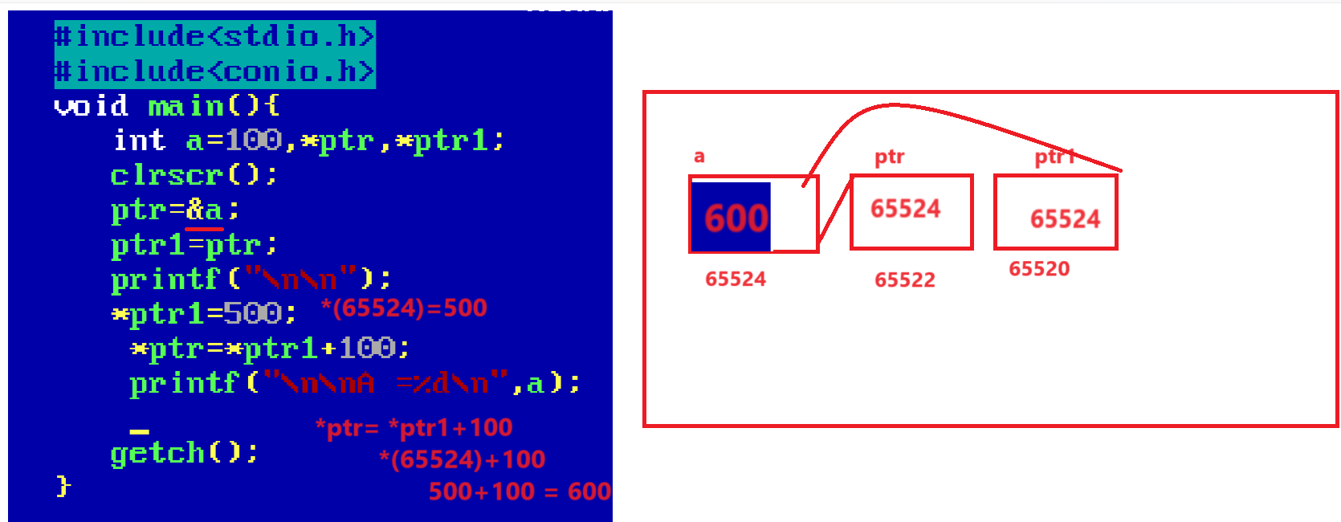
Output: A = 600
Note: if we think about above code we have statement ptr=&a; means we store address of variable in pointer variable ptr and we have statement ptr1=ptr means we store value of ptr means address of a in ptr1 means pointer ptr1 and ptr points to same memory block i.e to variable a so we have statement *ptr1=500 means *(65524)=500 means a=500 means we store 500 value in variable a using ptr1 and we have statement *ptr=*ptr1+100 means *(65524)+100 means 500+100 =600 in *(65524) means a=600 we update the value of variable a from 500 to 600 so the last value of variable a is 600
How to allocate dynamic memory or run time memory using pointer
_____________________________________________________________________________
when we increase a pointer value at program time then we have new block in memory at run time
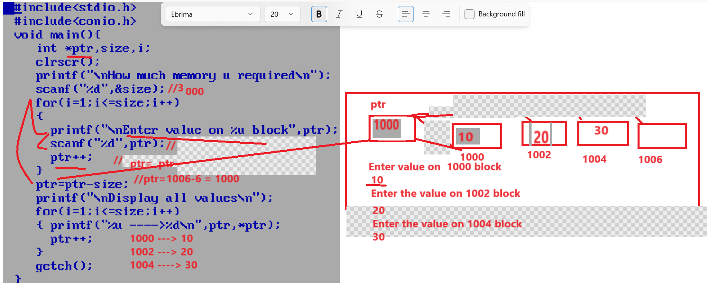
Application of pointer
____________________________________________________________________________
1) Access array by using pointer.
2) Access string by using pointer
3) Pointer with function
4) Pointer with structure
etc
Types of pointer
_______________________________________________
1) Void pointer or Generic pointer
2) dangling of pointer
3) Null Pointer
4) Far
5)huge
6) near
etc
Access array by using pointer.
___________________________________________________________
If we want o access array by using pointer we have to store base address of array in pointer variable

Q. what is base address?
_______________________________________________________________________
0th location address called as base address.

Q. How to Get base address of array?
_______________________________________________________________
if we want to get base address array we have two syntax
1) Use array without subscript
______________________________________________________________
Syntax : arrayvariablename; //get base address

2) use array using &arrayname[0]
Syntax: &arrayname[0]; //base address

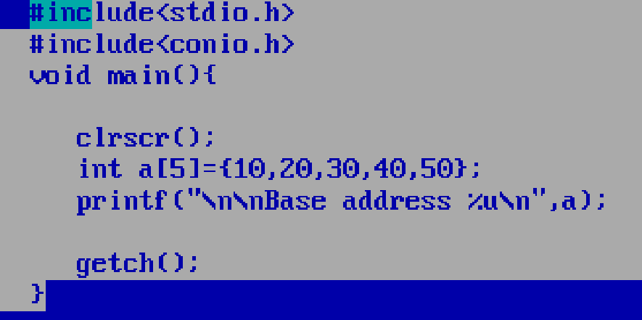

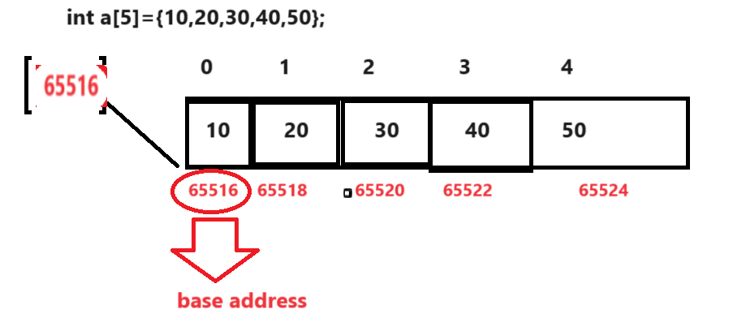

Example of Access Array using pointer
________________________________________________________________________________
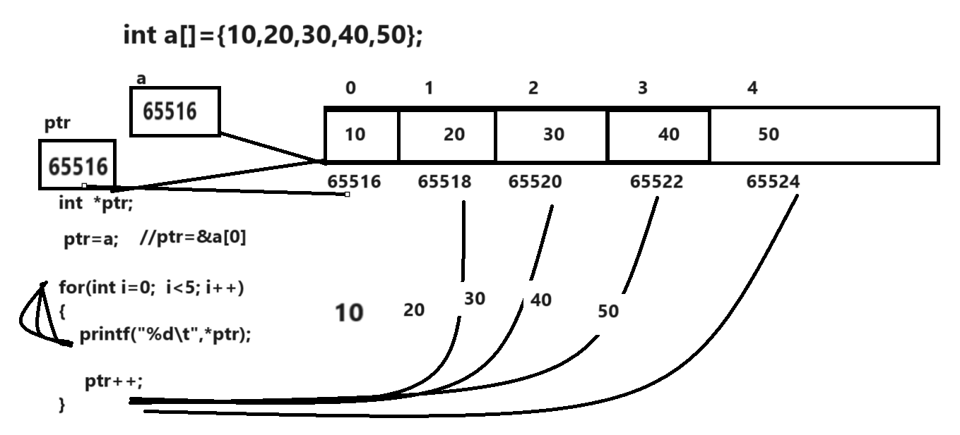

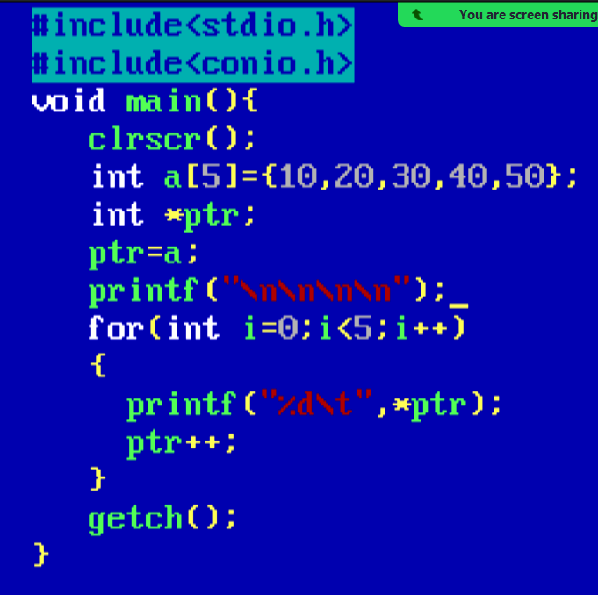

Q. what will be the output of code?
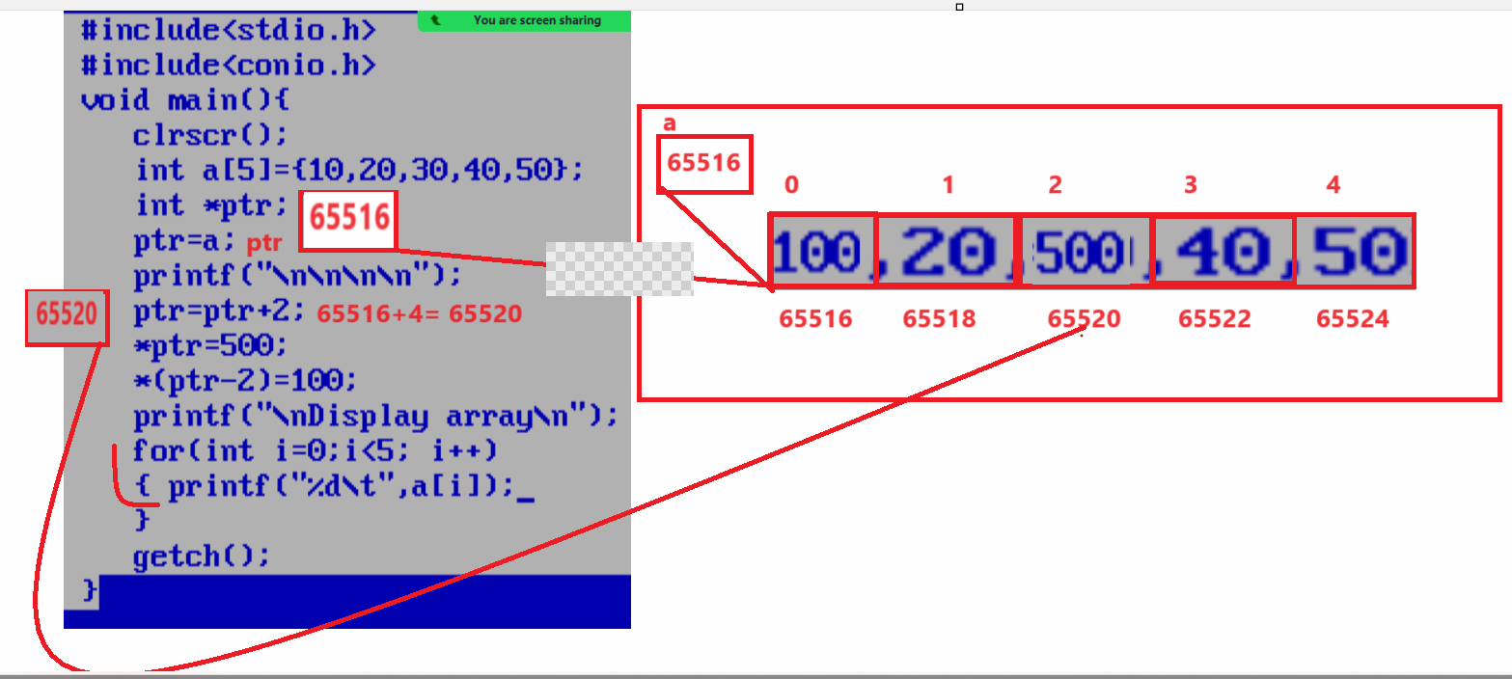
If we think about above code we have statement int a[5]={10,20,30,40,50} means we have array of size 5 and base address of array is 65516 and again we have one pointer name as int *ptr; so we have statement is ptr=a means we store base address in pointer variable means ptr=a indicate our pointer points to 65516 means points to base address again we have statement is ptr=ptr+2 means the meaning is ptr=65516+2*2 i.e 65520 means our pointer release 65516 address and move new address i.e 65520 and we have statement *ptr=500 means we store 500 value on address 65520 means the previous of 65520 i.e 30 get lost and 500 get override on 65520 again we have statement is *(ptr-2)=100 means *(65520-2*2)=*(65516)=100 means 100 value get override 65516 means updated value of 65516 is 100 means we change value 0th location after that we have loop
for(int i=0; i<5;i++){
printf(“%d\t”,a[i]);
}
this will print 100 20 500 40 50

Q. what will be output of given code?
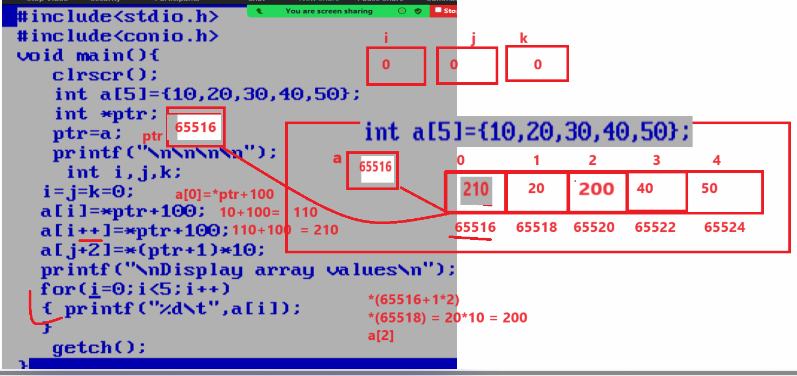
if we think about above code we have array int a[5]={10,20,30,40,50} and we have one pointer variable name as int *ptr and we have statement ptr=a means we store base address of array in ptr i.e 65516 in ptr variable and we have three variable name as int I,j,k so here i=j=k=0 means here we initialize the valueu of i,j,k is 0 and we have statement int a[i]=*ptr+100 here our ptr points *(65516) so we get value 10 so our equation is like as a[i]=*ptr+100 means a[i]=10+100 means a[0]=110 means 110 value get override on 0th location again we have statement is a[i++]=*ptr+100 here *ptr points to 65516 mean we get updated value on 65516 which is 110 so a[i++]=*ptr+100 means a[i++]=110+100 means a[i++]=210 here i++ is post operation so 210 initialize the value on ith index before increment and which 0 so 210 override on 0th location means on 110 after that i++ execute means after that i value is 1 then we have statement a[j+2]=*(ptr+1)*100 means a[0+2]=*(65516+1*2) means a[0]=*(65518)+10 and on 65518 address we have 20 so a[0+2]=20*10 which is 200 get stored on a[2] means previous value of a[2] get override by 200 so the updated value on a[2] is 200 and when we the print the array using for loop we get answer 210 20 200 40 50

Q. what is the meaning of arrayname[i]?
_________________________________________________________________________
arrayname[i] indicate base address + index * size.

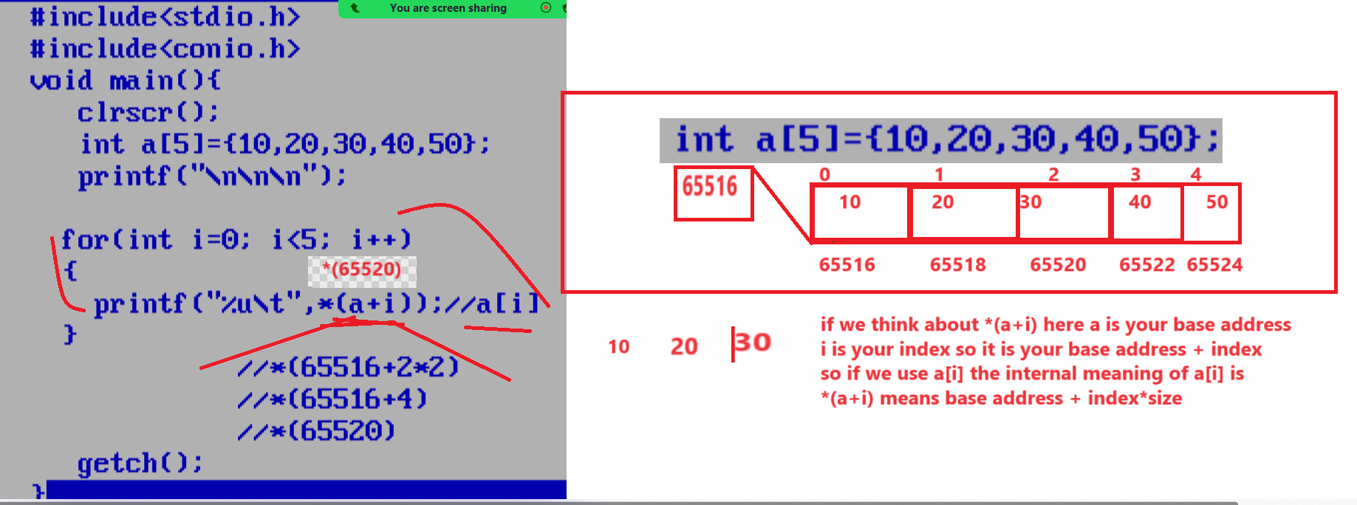

Q. what will be output of given code?
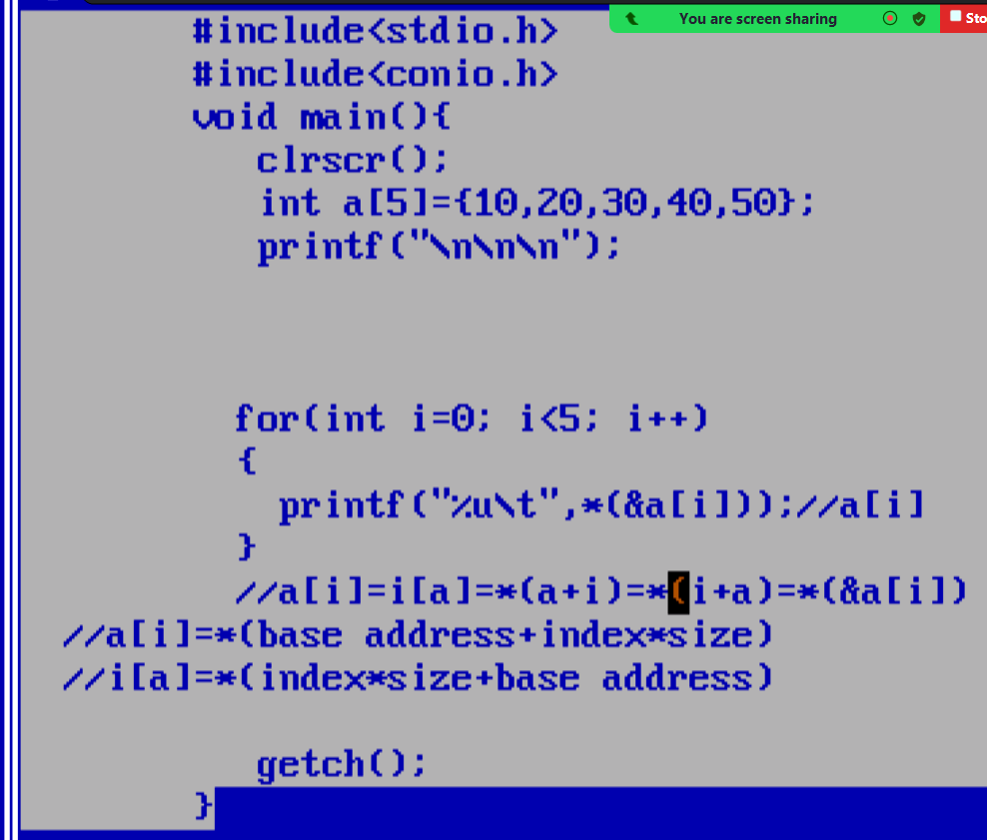

Q. Why array index start from 0th location?

