JAVA
____________________________________________________________________________

Q. what is JAVA?
___________________________________________________________________
JAVA is pure object oriented programming language

Q. what is object oriented?
___________________________________________________________________________
Object oriented is a concept of programming or it is standard methodology of programming
Based on four pillars and seven features

Pillar of OOP
1. Inheritance 2. Polymorphism 3. Encapsulation 4. Abstraction

Feature:
1. Class 2. Object 3. Inheritance 4. Data Abstraction and Encapsulation 5. Polymorphism 6. Dynamic binding 7. Message Passing.

Note: Java is not object oriented just it is programming language which implement the feature of OOP so we can say it is object oriented.

If we want to work with JAVA we need to know how to create program in it and execute it.

Steps to work with java application
_____________________________________________________________________
1. Install JDK
_________________________________________________________
Q. what is JDK?
________________________________________________________
JDK stands for java development kit
Def: JDK is software cluster or it is group of software which contains supporting software’s which help us to create and execute java application like as it contain compiler ,JVM etc

Q. what is compiler?
_________________________________________________________________
Compiler is application or software which is used for convert your source code in to byte code.

Q. What is byte code?
Byte code is machine understandable code means byte code is intermediate format which easily convert in machine code with the help of JVM

Q. Why java develop the byte code or what is benefit of byte code?
____________________________________________________________________________
Byte code is platform independent code

Q. what is platform?
________________________________________________________________________
Platform indicate operating system means we can say byte code can execute on any operating system so java is platform independent language
Example: suppose consider we design application by using windows and we can execute it on linux without any third party support
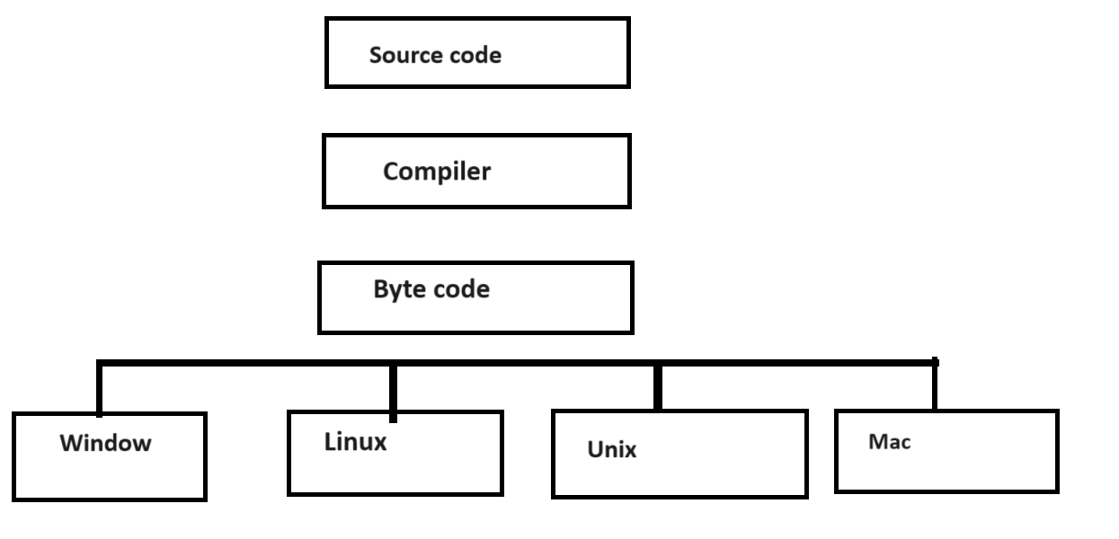
Q. what is JVM?
____________________________________________________________________________
JVM is also application or software which is used for convert your byte code in to machine code as well as it is application which responsible for run your java program means allocate memory for java application ,java objects ,perform garbage collection etc

Note: if we want to write java code we can use following things
Text Editor: notepad, word pad, sublime text, visual code studio
Tools /IDE : eclipse, spring tool suite, IntellJ

2. Create Application:
if we want to create application in java we need to write minimum single class without class we cannot create java application

generalize syntax:
access specifier class classname{
public static void main(String x[])
{ write here your logics
}
}
Example:
public class First{
public static void main(String x[])
{ System.out.println(“good morning”);
}
}

Code description
_____________________________________________________________________
public class First
____________________________________________________
Here public is access specifier
class is keyword for class declaration purpose and First is class name and user can give any name to his class.

Q. what is access specifier?
_________________________________________________________________________________
access specifier are the some keywords which is used for apply restrictions on class and its member.

There are four types of access specifier in JAVA
______________________________________________________________________________
private: private access specifier means member cannot access outside of class
public: public access specifier means member can access outside of class as well as outside of package
protected: protected access specifier means member can access only within child class
default: default access specifier means member can access outside of class but within package not outside of package

public static void main(String x[]): it is main function of java same like as main function in c or c++

String x[]: String x[] is command line argument

System.out.println(“good morning”): it is output statement of java same like as printf() in c language.

Meaning: System is class out is static reference of PrintStream class and System and PrintStream maintain HAS-A relationship between them and println() is overloaded method for display output on output screen.
Note: we will discuss this meaning in inheritance chapter.

Rules of class and function declaration in java
_____________________________________________________________________
Class Naming Rule: In Java Class naming convention start from capital means class name start with capital letter and if class name form by more than one word then every word first letter must be capital
Example: System: it contain single word so S is capital
Example: DataInputStream: here D I and S capital because this class is combination of three different words.
Example: we want to design class name as calculatetotalsalaryofemployee so write classname as per java standard
Java Standard: CalculateTotalSalaryOfEmployee

Method/Function Naming Standard of JAVA
____________________________________________________________________________
If we define any function in java then we have two rules.
1. If function contain single word then all letter of function should be small.
2.If function contain more than one word then first word first letter should be small and remaining word first letter must be capital

Example function with single word:
int read(): in this function contain single word so all characters small in function name.
Example function with multiple words:
_________________________________________________________________________
String readLine(): this function contain two words so the first word first letter is small and second word first letter is capital

Note: this type of function writing script name is camel case

Example: we want to design function name as getemployeesalarybymonth so write this function as per java standard.
Example: int getEmployeeSalaryByMonth()

3. Save Application: if we want to save program in java then by default we need to save in bin folder where JDK install and give class name and file name same with .java extension.

Example:
public class FirstApril
{
public static void main(String x[])
{
System.out.println("good morning");
}
}
Note: Your File name should be FirstApril.java because your class name is FirstApril.
Once we save your code you can compile java program

4. Compile Application

Q. What is compilation?
___________________________________________________________________
Compilation is process where we convert your source code to byte code in java

How to compile java program
______________________________________________________
Steps to compile java program
a. open command prompt
Start menu --- search ---- command prompt

b. Go where java file save
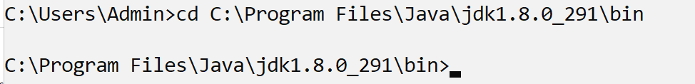
c. Type the command javac filename.java
_____________________________________________________________________________
Syntax : javac FirstApril.java
Note: when your java program get compile successfully then java compiler new file with extension of .class and store byte code in that file.
Means we can say After Compilation we have two files
.java which contain source code and .class which contain byte code so as per our example we have
two files
FirstApril.java --- it contain source code
FirstApril.class --- it contain byte code.

5. Run Application: if we want to run application then your java program run by JVM and for that we have command
Syntax: java filename
Example: java FirstApril

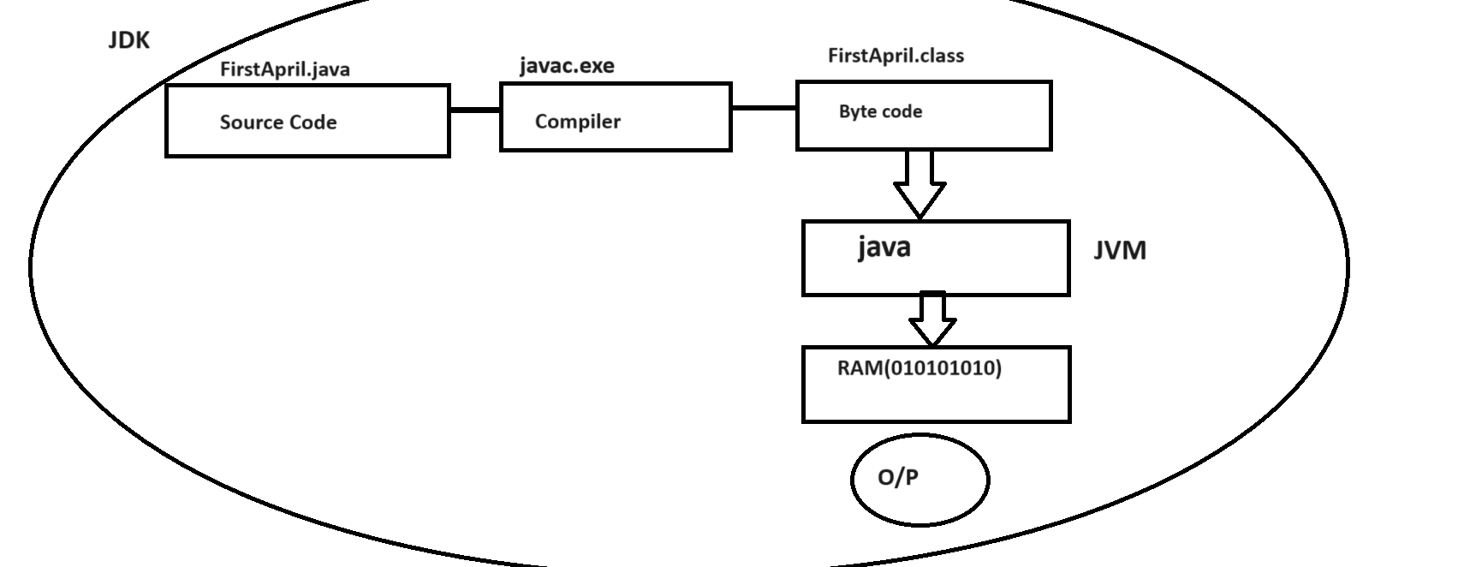
Data Type in java
____________________________________________________________________
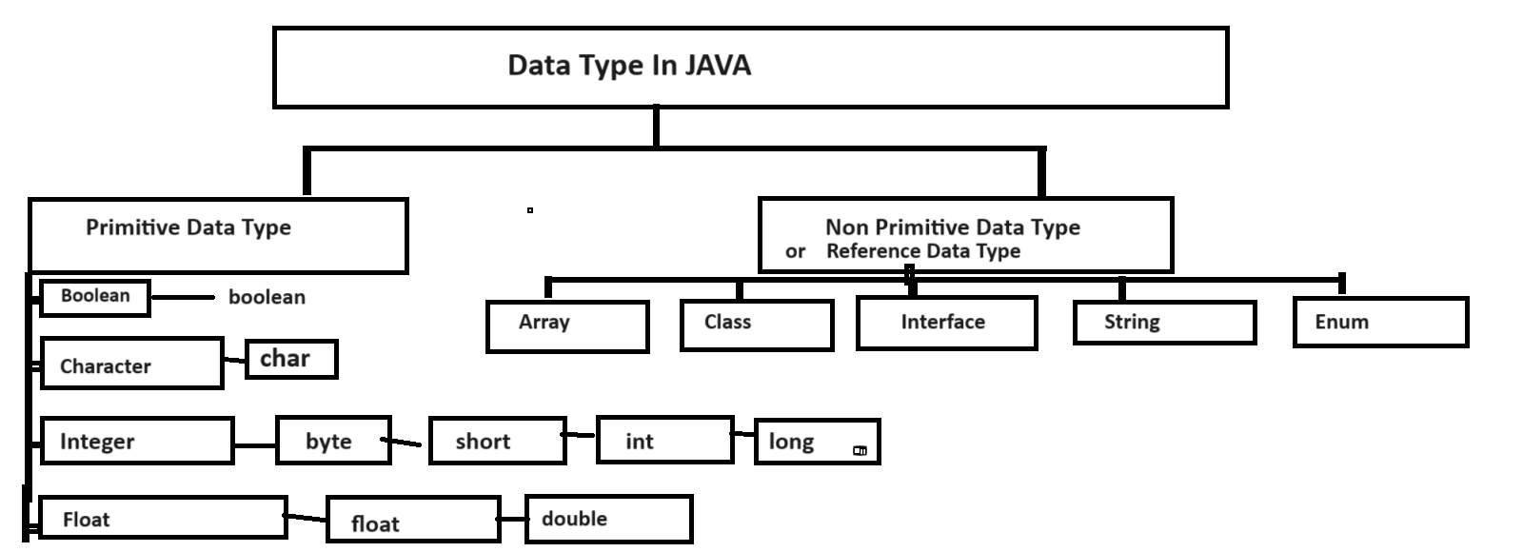

boolean: boolean data is used for store the true or false result the memory size of this data type is 1 byte
char: 2 byte of memory and store single character or multiple characters and range
-32768 to 32767
byte: store whole number between -128 to 127 and memory size is 1 byte
short: store the number between -32768 to 32767 and memory required is 2 byte
int : store the number between -2147483648 to 2147483647 and range is 4 byte
long : memory required 8 byte and store value
63
2 = - 92,23,37,20,36,85,47,75,808 to 92,23,37,20,36,85,47,75,807

float : 4 byte of memory and store 6 to 7 decimal points
double: 8 byte of memory and stoer 15 decimal points.

Operators in JAVA
_________________________________________________________________________
There are seven operators in JAVA

Arithmetic Operator : it is used for perform arithmetic operations
Operator | Meaning
+ | Addition
- | Substraction
* | Multiplication
/ | Division
% | Reminder or modules operator

Assignments: it is used for assign right hand value to left hand side variable
Operator | Meaning
= | Assign right hand value to left hand variable

Relational operator: It is used for comparison purpose and if comparison gets success return true as boolean result and if comparison get failed return false.
Operator | Meaning
< | Less than
> | Greater than
<= | Less than equal
>= | Greater than equal
!= | Not equal
== | equal

public class FirstApril
{
public static void main(String x[])
{
int a=100;

int b=50;

boolean result= a > b;

System.out.println("Result is "+result);
}
}

Logical Operator: Logical Operator is used for combine more than one condition and checks it

Operator | Meaning
&& | Logical AND if all conditions are true then condition is true otherwise false
|| | Logical OR if any one condition is true then condition is true otherwise condition is false means if all conditions are false then condition is false.
! | Logical NOT if your condition is true then false and if false then true

Increment and Decrement operator: Increment and decrement operator is used for increase value by 1 or decrease value by 1

Operator | Meaning
++ | Increase by 1
-- | Decrease by 1

There are two types of increment and decrement
_____________________________________________________________________________
Post increment or post decrement: if we think about post increment first value initialize at left hand side and then perform operation
Syntax: variablename op;

Example:
int a=10,b;
b=a++;
System.out.printf(“B is %d\n”,b);

Example with source code
public class TestIncApp
{
public static void main(String x[])
{
int a=10,b;
b=a++;
System.out.printf("A=%d\tB=%d\n",a,b);
}
}
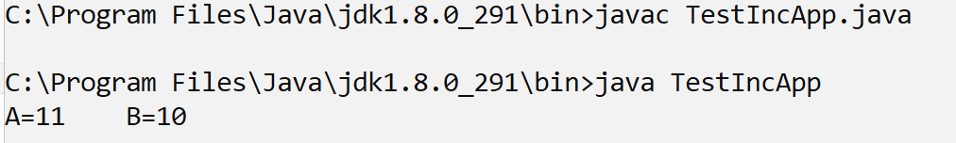

Pre Increment and Pre Decrement
_______________________________________________________________________________
Pre increment and pre decrement means first we perform operation and after that we want to shift value at left hand side.

Syntax: op variablename;

public class TestIncApp
{
public static void main(String x[])
{
int a=10,b;
b=++a;
System.out.printf("A=%d\tB=%d\n",a,b);
}
}

Conditional operator: conditional operator is used for to check the conditions
Operator | Meaning
? | Ternary operator
: | Colon

Syntax:
datatype variablename = exp1 ? exp2 : exp3;

Here exp1 is always condition and exp2 and exp3 are the options if exp1 is true then exp2 get executed and if exp1 is false then exp3 get executed and return result at left hand side

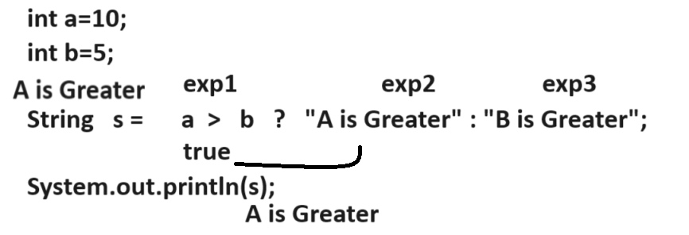
Example with source code
public class TestIncApp
{
public static void main(String x[])
{ int a,b,c;
a=10;
b=5;
String s= a > b ? "A is Greater" : "B is Greater";
System.out.println(s);
}
}
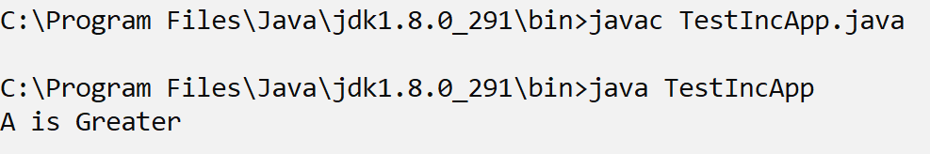

Bitwise operator: bitwise operator is used for perform operation on bits
If we want to work with bitwise operator we need to know the some following important things

1. Number System
2. Conversion between decimal to binary or binary to decimal number
3. AND, OR, Not operation on bits
4. One’s Complement and 2’s complement

Number System: Number system means decide how we can represent number in memory or computer system called as Number system.

There are four types of Number System
1. Decimal: decimal number system contains 0 to 9 digits so the base of decimal number system is 10 base help us identify number system or represent number system.

Example: (123)
10 – it is decimal number

2. Binary: binary number system means number system contain only two digit i.e 0 & 1 so the base of binary number system is 2

(10101)
2 – it is binary number

3. Octal: Octal number system means number system contain digit between 0 to 7 so the base of octal number system is 8.

(123)
8 – it is octal number
4. Hexa Decimal: Hexa decimal number system it contain values between 0 to 15 so the base of hexa decimal is 16 and from A to F A means 10 , B means 11,C means 12 ,D means 13 ,E means 14 and F means 15.

Example:
(1AB8) meaning is 110118
16 – it is hexa decimal number

How to convert decimal number in to binary number
________________________________________________________________________________
If we want to convert decimal number in to binary number we have to divide the decimal number by 2 and put its reminder at right hand side and divide the number until number 0 and put all reminders from bottom to top.

Example: find the binary number of decimal 5

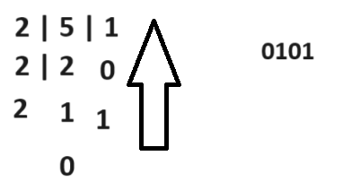

Means 0101 is binary of decimal 5

Example: find the binary decimal 14

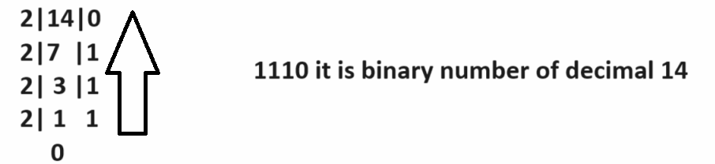

How to convert binary to decimal
___________________________________________________________________
if we want to convert binary number in to decimal we need to multiple every binary digit by 2 and maintain power of two from right to left and start power from 0 to n-1 and calculate the sum of all powers
Example: find the decimal number of 1110
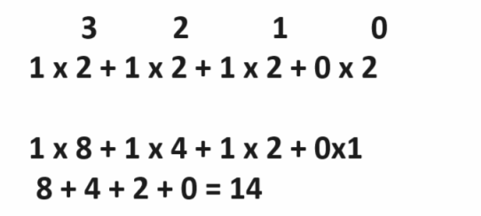
Decimal of 1110 is 14

Example: find the decimal of 1111
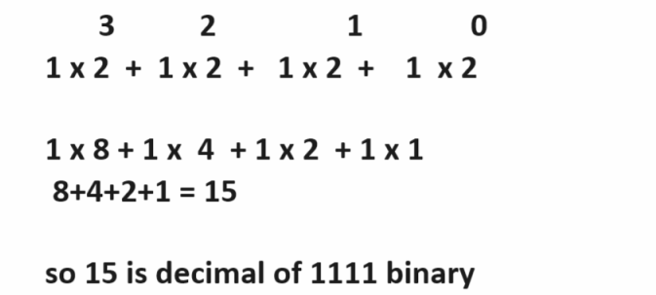

Binary AND Operation:
If we think about AND operation on bit if first input bit is 1 and second input bit is 1 then output is 1
If first input bit is 0 and second is 1 then output is 0 , if first input bit is 1 and second is 0 then 0 and if first is 0 and second is 0 then 0

Example:
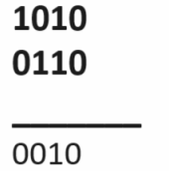

Binary OR operation: Binary OR operation if first and second input value is 0 then 0 otherwise 1
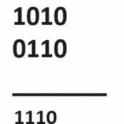

One’s Complement: one’s complement means it is negation operation in bitwise means in one’s complement we convert 1 to 0 and 0 to 1
Example:
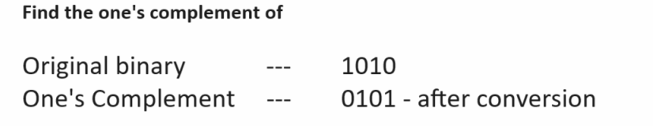

Example: WAP to declare two variables and calculate its addition
public class Add
{
public static void main(String x[])
{
int a=100;
int b=200;
int c=a+b;
System.out.printf("Addition is %d\n",c);
}
}
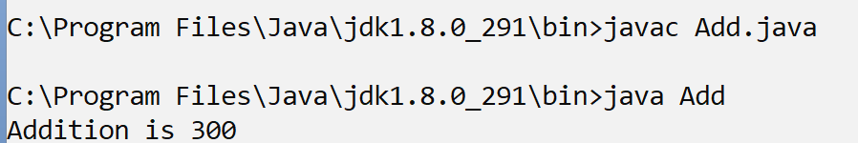
Note: if we think about above code we calculate the addition of fix values.
We want to accept two values from keyboard at program run time after that we want to calculate its addition.

How to accept the input from keyboard at program run time
__________________________________________________________________________________
If we want to accept the input from keyboard at program run time we have two ways

1. Use Command Line Arguments
2. Use Scanner class.

Q. what is command line arguments?
______________________________________________________________________
Command line arguments are parameter present in main function of type string array.
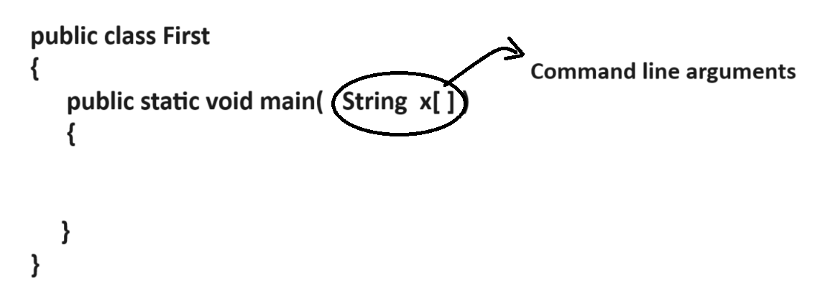
Q. Why use command line arguments?
_________________________________________________________________________
The major goal of command line argument is accept input at program run time and using command line argument we can accept infinite number of parameter at program run time but the first input is at position of zero.
Example: we want to accept input using command line argument and calculate its addition?
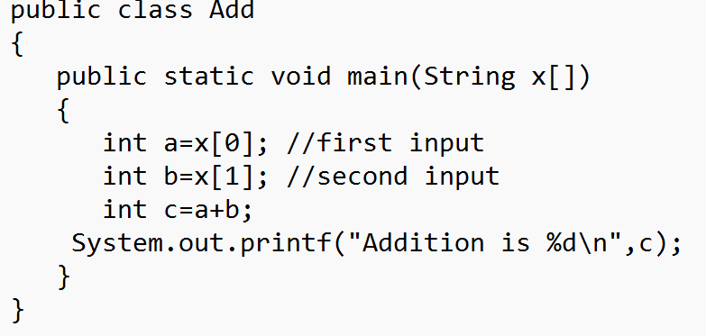
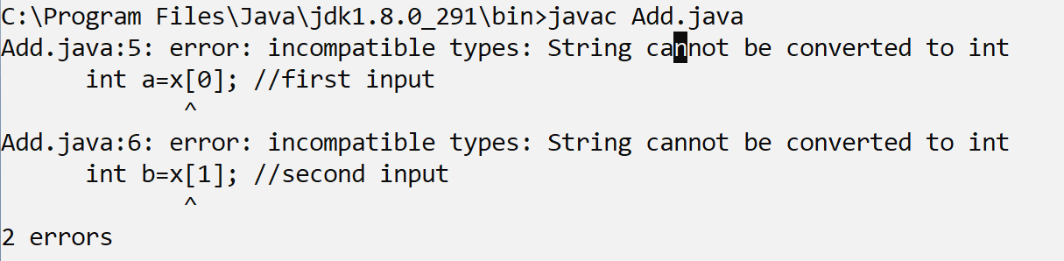
Note: if we think about above screen shot we get compile time error
Q. why?
Because we have string type for input and we want to accept the input of type integer so we try to store string value in to integer but we cannot store string value directly in integer so compiler will generate compile time error to us.

How to solve this type of error?
If we want to solve this type of error in java we need to convert string value to integer type or as per the input type.

How to convert String value in to integer value
_________________________________________________________________________________
If we want to convert String value to integer value in java we have following syntax
Syntax:
int variablename= Integer.parseInt(String): Here Integer is class and parseInt() function of Integer class and which is used for convert string value to integer value.

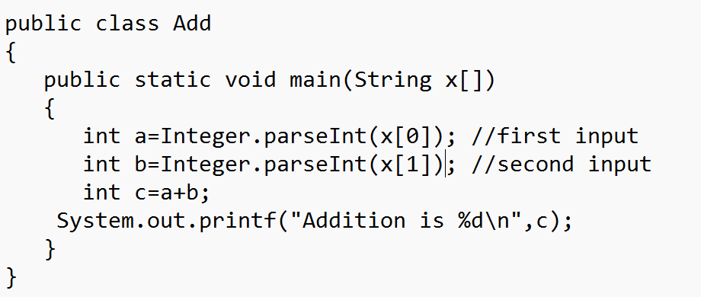

Output
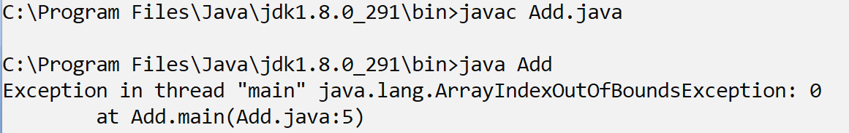
Note: if we think about above code we get run time error ArrayIndexOutOfBoundsException : 0
because if we think about command line arguments or when we accept input using command line argument then all input must be provide on same line where your java program run
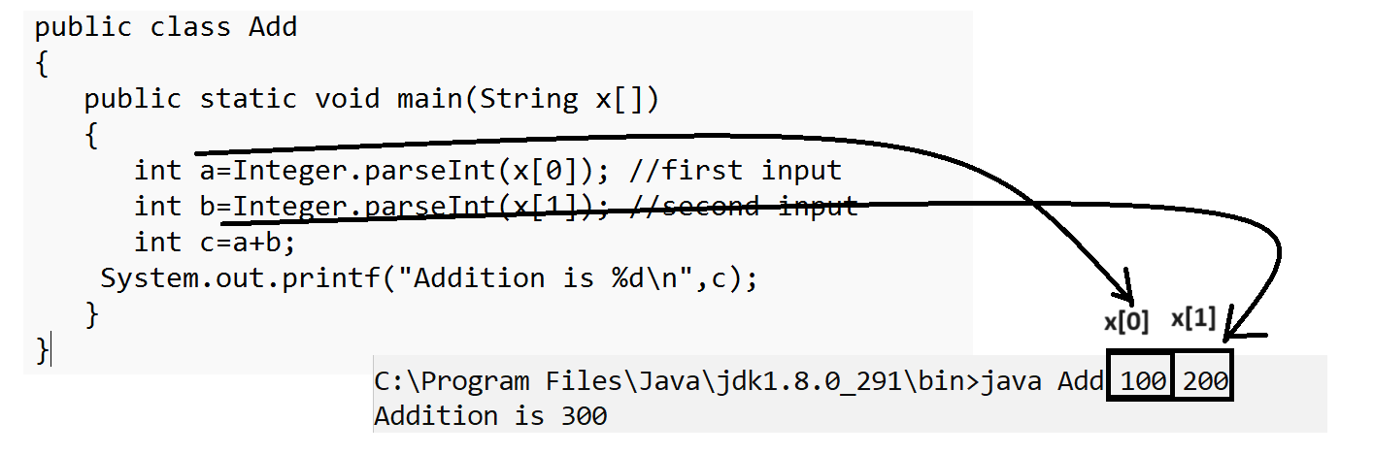
Note: if we think about above screen shot we get proper output
Addition is 300 because we accept two input from keyboard and we pass two input at program run time so there is no problem means command line argument say must be pass number of input at program run time which accept in program if we pass less input than number of input accepted in code then JVM return index of input which we not provide shown in following screen shot
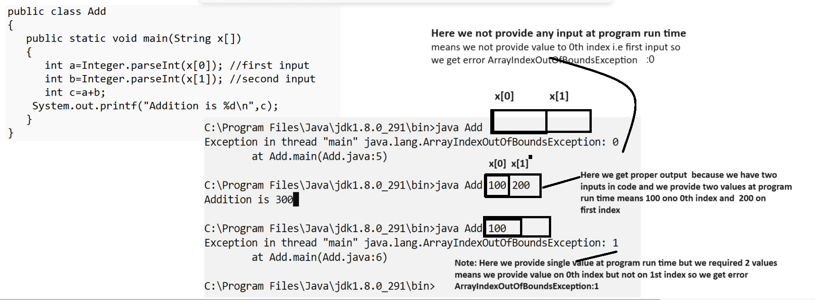

Example: WAP to accept radius from keyboard and calculate area of circle using Command line arguments.
public class AreaApp
{
public static void main(String x[])
{
float radius=Float.parseFloat(x[0]); //first input
float area=radius*radius*3.14f;
System.out.printf("Area of circle is %f\n",area);
}
}

Example: WAP to input the basic salary of employee and calculate its total salary by using following terms
da=30%
hra=30%
total = da + hra + bs

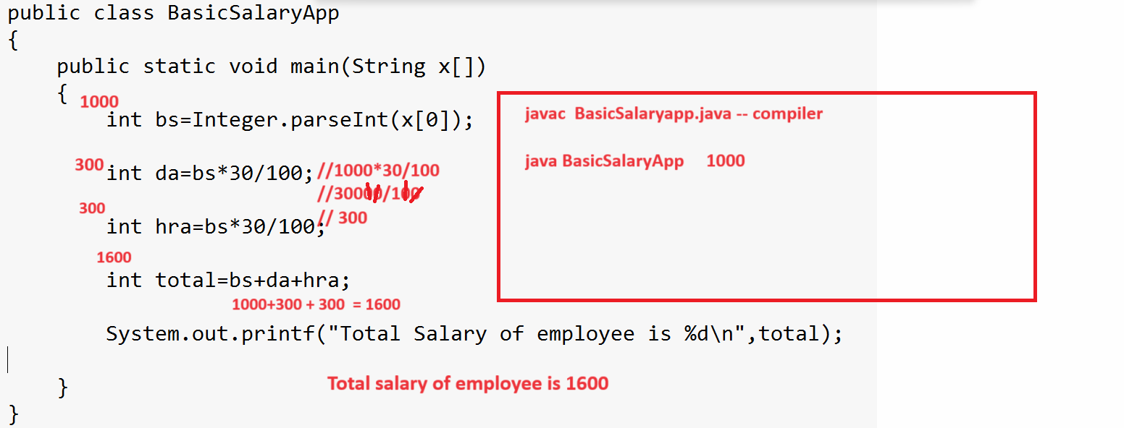

Example: WAP to input number from keyboard and check number is even or odd using condition operator.
public class EvenOddAPP
{ public static void main(String x[])
{ int no=Integer.parseInt(x[0]);
// exp1 exp2 exp3
String s= no%2==0 ? "EVEN" : "ODD";
System.out.println(s);
}
}
Scanner class
_________________________________________________________________________________
Scanner is a class from java.util package and which is used for accept the input at program runtime from keyboard like as scanf()

Steps to work with Scanner class
_______________________________________________________________________________
1. add java.util package in application
________________________________________________________________
Q. What is package?
_________________________________________________________
package is a collection of classes and interfaces it is like as header file in c language
If we want to add package in program we have import keyword and import is like as #include in c language.

Syntax:
import packagename.*: if we use * with package then we get all member from package for use in application
or
import packagename.member: if we use the member name then we get specific member from package in application.

Example: import java.util.*;
or
import java.util.Scanner;

2. Create object of Scanner class
__________________________________________________________________
Syntax: Scanner ref = new Scanner(System.in);
Example: Scanner xyz = new Scanner(System.in); //

3. Use its functions /method for accept the input
_________________________________________________________________
If we want to accept the input from keyboard using Scanner class we have some methods provided by Scanner class.

int nextInt(): this function is used for accept input from keyboard of type integer.
float nextFloat(): this function is used for accept input from keyboard of type float
double nextDouble(): this function is used for accept input from keyboard of type double
long nextLong(): this function is used for accept input of type long from keyboard
byte nextByte(): this function is used for accept input of type byte from keboard.
String nextLine(): this function is used for accept input of type string from keyboard.
etc
Note: these all methods are member of Scanner class so you can use these by using scannerobject.membername

import java.util.*; //step1
public class AddScanApp
{
public static void main(String x[])
{
Scanner xyz = new Scanner(System.in);//step2
System.out.println("Enter first value");
int a=xyz.nextInt(); //step3
System.out.println("Enter second value");
int b=xyz.nextInt();
int c=a+b;
System.out.printf("Addition is %d\n",c);
}
}
Output:
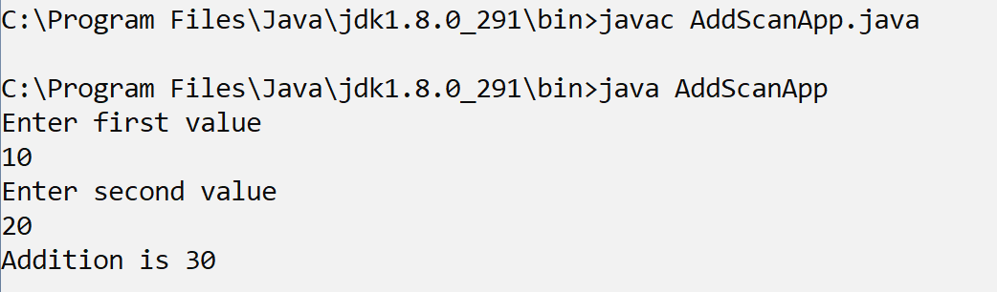

Example: WAP to input name id and per of student from keyboard and display it.
import java.util.*; //step1
public class StudentApplication
{
public static void main(String x[])
{ Scanner xyz = new Scanner(System.in);//step2
System.out.println("Enter name of student");
String name=xyz.nextLine();//step3
System.out.println("Enter id of student");
int id=xyz.nextInt();
System.out.println("Enter percentage of student");
float per=xyz.nextFloat();
System.out.printf("Name is %s\n",name);
System.out.printf("Id is %d\n",id);
System.out.printf("Percentage is %f\n",per);
}
}
Output:
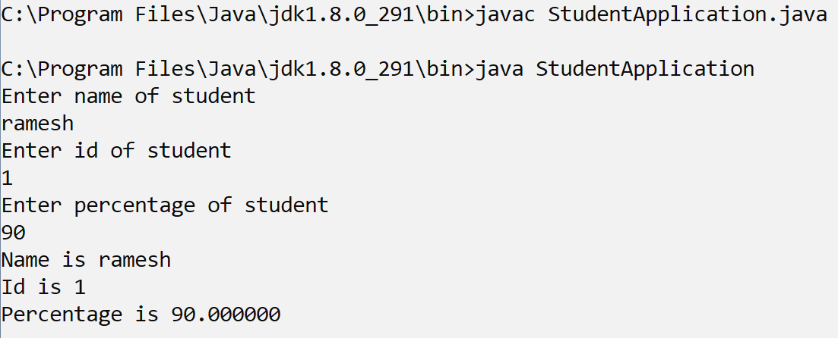

Example: WAP input the quantity and rate import java.util.*;//step1
public class GSTAPP
{
public static void main(String x[])
{ Scanner xyz = new Scanner(System.in);
int qty,rate,total,gstRate;
System.out.println("Enter quantity");
qty=xyz.nextInt();
System.out.println("Enter rate");
rate=xyz.nextInt();
total=qty*rate;
System.out.println("Bill without GST "+total);
gstRate=total*18/100;
total=total+gstRate;
System.out.println("Bill with GST "+total);
}
}
Example: WAP to input selling price and cost price of item and check seller made profit or loss using conditional operator.
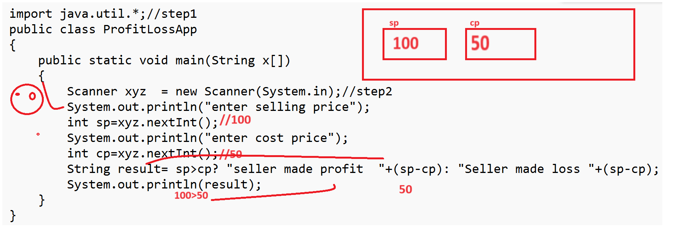
Interview Question
__________________________________________________________
Q. What is OOP?
Note: refer notes

Q. Explain feature of JAVA?
____________________________________________________________________
1. Pure Object oriented: We cannot create any java program without class or without inheritance so we can say it is pure object oriented language means JAVA utilize the OOP feature.
2. Platform independent: you can compile your java program on any operating system and we can execute it on other operating system so java is platform independent language.
3. Robust and Secure: java provide the some security API to us like spring security as well as provide some inbuilt object encryption and decryption like as serialization an deserialization so we can say it is security language and java manage the memory at program run time means allocation of object at run time as destroy the object at run time using garbage collection etc so we can say it is robust language.
4. Multi threaded: java implement the multi threading concept so using that we can perform multiple task by using thread simultaneously at program run time so we can say it is multi threaded language.
5. Ready Made API/Library: java provide some inbuilt API like as Collection framework, utility packages , database API etc java provide strong data structure implementation by using Collection Framework.
6. Support to multiple frameworks/technologies: java provide huge support to different technologies like as mobile application development as well as support to enterprise application development using like as DJB, spring framework etc
etc

Q. what is byte code and why use it?
Note: refer notes

Q. is JVM is platform dependent or independent?
JVM is platform dependent
Q. why JVM is platform dependent if java is platform independent language?
The Role of JVM is convert your byte code in to machine code and every operating system has different machine code generation algorithms so java design JVM separate for every operating system means compiler of Java is common in all operating system but JVM is separate for every OS when java design set up for particular operating system them compiler in all operating system setup is common but JVM is different for every operating system setup so JVM is platform dependent.

Q. What is JDK JVM and JRE or What is diff between JDK JRE and JVM?
________________________________________________________________________________
JDK stands for java development kit it is application which contain some compiler as well as JVM which is responsible create code and compile it and run time means using JDK we can develop the application and run the application and check the output

JRE stands for run time environment It is physical existence of JVM means JRE contain JVM and which is responsible for run the java application means using JRE we cannot compile java program just you can run time so normally JRE refer in test environment or in production environment

JVM stands for java virtual machine it is logically present in JRE means when run program the internally JVM get executed and the role is JVM is load the byte in code in memory and manage the memory for java application as well as create object at run time ,delete object from memory at run time as well as manage thread etc

Q. Why java main method is static?
Java main method present within class and java main method call by JVM when programmer run java program so JVM need to call main method without creating object of class so it is static because static method can call without object just can call by using class name and main method is public because public member can access anywhere in application means within package as well as outside of package so main method is accessible anywhere so it is public

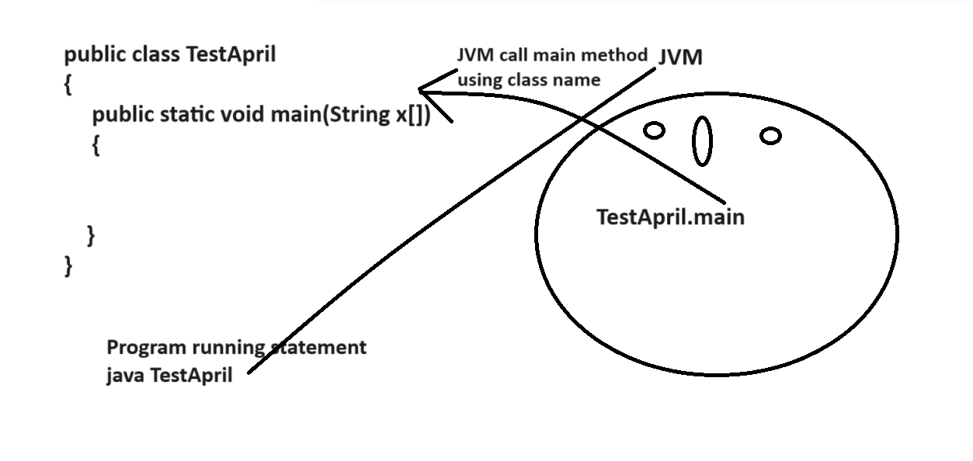

Q. Can we pass different parameter in main other than String []?
_________________________________________________________________________
public class DemoApril
{
public static void main(int x[])
{
}
}

If we think about above code our program get compile successfully but not run at program run time
Because compile think it is user define main method so program compile successfully when we run the program then JVM can run program or JVM knows only one syntax or signature of main public static void main(String x[]) and we not define this type of main method in program so JVM generate error at program run time shown in following screen short
