# BT305 Lab5

Rohit V. Sagvekar 200106056

1. Name and Roll number:

Ans : Rohit V. Sagvekar

200106056

1. The scatter plot showing the data overlaid with the logistic regression curve. Label the axes correctly.

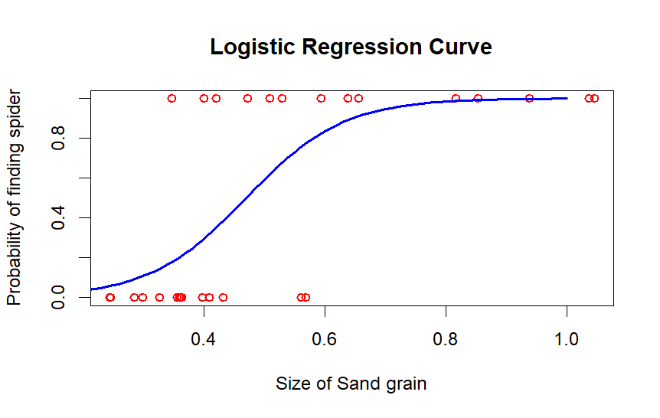

1. Confusion matrices for all three cut-offs.

|  |  |  |  |
| --- | --- | --- | --- |
|  |  | Actual |  |
|  |  | 0 | 1 |
| Predicted | 0 | 1 | 1 |
|  | 1 | 6 | 6 |

|  |  |  |  |
| --- | --- | --- | --- |
|  |  | Actual |  |
|  |  | 0 | 1 |
| Predicted | 0 | 4 | 1 |
|  | 1 | 3 | 6 |

|  |  |  |  |
| --- | --- | --- | --- |
|  |  | Actual |  |
|  |  | 0 | 1 |
| Predicted | 0 | 5 | 4 |
|  | 1 | 2 | 3 |

4. A bar plot showing the effect of the cut-off P on the sensitivity. Label the axes correctly.

