**Location**

**Location: Where is Nanded?**

**Nanded earlier known as 'Nandigram' is located to the southeastern part of Maharashtra State. Nanded is situated 650 kms away from Mumbai and 270 kms from Hyderabad. Nanded has a uniqueness of its own due to its historical, social and political importance. The tenth Guru of Sikkhs, Guru Gobind Singhji held his court and congregation here. This is the place where he recovered after assassins attacked him.**

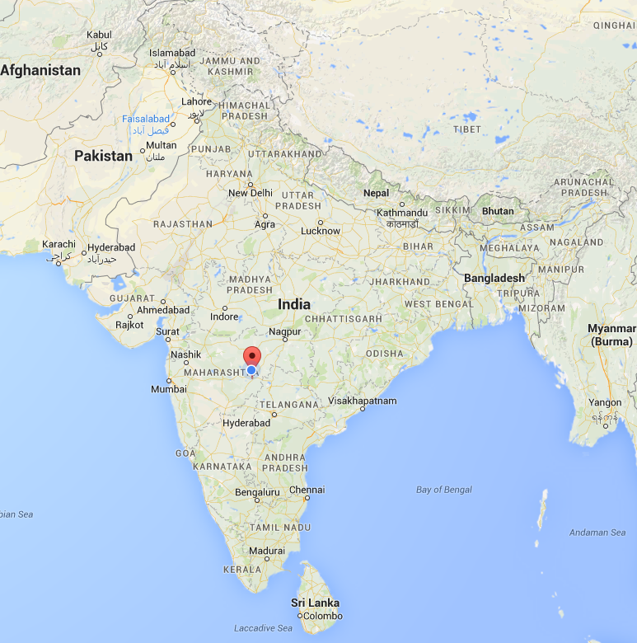

**For the details of the institute please visit** [**www.sggs.ac.in**](http://www.sggs.ac.in/)**.**