## FSK Modulation and Demodulation Using GNU Radio

**1. **Introduction****

Frequency Shift Keying (FSK) is a digital modulation technique that encodes binary data by shifting the frequency of a carrier signal. In FSK, binary symbols (0 and 1) are represented by two distinct frequencies. This technique is widely used in communication systems, including radio modems, telemetry, and Bluetooth. FSK modulation is robust to noise, making it suitable for low-bandwidth systems where data integrity is critical.

This report demonstrates the generation and demodulation of FSK signals using GNU Radio, an open-source software for implementing communication systems through software-defined radio (SDR). This project provides insight into FSK’s implementation and its evaluation in a simulated environment.

**2. **FSK Modulation****

#### 2.1 ****Principles of FSK Modulation****

FSK modulation uses two distinct frequencies to represent binary '0' and '1'. Let:

* f1f_1f1​ represent a '1' in binary data.
* f0f_0f0​ represent a '0' in binary data.

In the modulated signal, the carrier frequency shifts to f1f_1f1​ when transmitting a binary '1' and shifts to f0f_0f0​ when transmitting a binary '0'. This modulation method is straightforward and widely used due to its simplicity and reliability under low signal-to-noise conditions.

#### 2.2 ****Implementing FSK Modulation in GNU Radio****

##### ****Software Setup****

To implement FSK modulation, install GNU Radio and launch GNU Radio Companion (GRC), a graphical interface for creating and simulating flowgraphs.

##### ****Modulation Flowgraph Design****

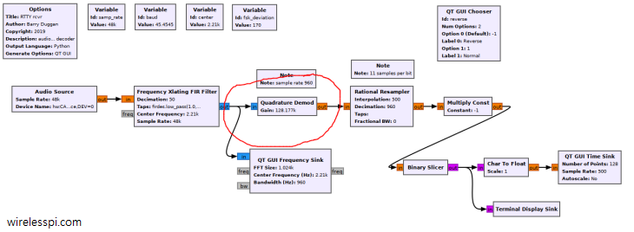

1. **Signal Source**: Generate a binary data stream as the input signal. Use a Random Source or Signal Source block configured to produce binary bits at a desired rate.
2. **FSK Modulator Block**: Use the Frequency Mod block, which can switch frequencies based on the input data stream. Configure this block with appropriate deviation and sensitivity values to achieve the desired frequency shifts.
3. **Carrier and Baseband Frequencies**: Set carrier frequencies for binary '0' and '1' (e.g., 2 kHz for '0' and 4 kHz for '1') and choose a sample rate that accommodates these frequencies.

##### ****Waveform Observation****

Run the flowgraph to observe the modulated FSK signal in the QT GUI Time Sink and QT GUI Frequency Sink blocks. The time-domain waveform shows shifts between f0f_0f0​ and f1f_1f1​, while the frequency domain illustrates the alternating frequency components.

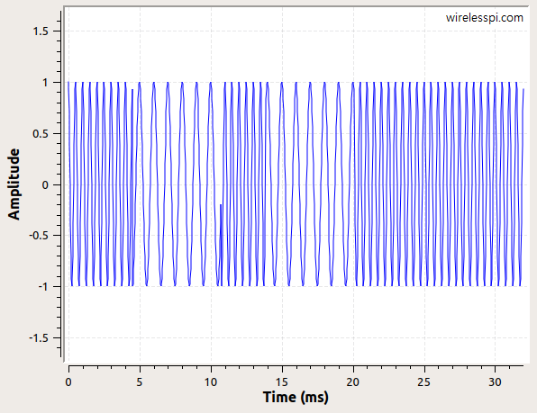

#### 2.3 ****Results of FSK Modulation****

The generated FSK waveform in the time domain displays alternating frequencies, clearly distinguishing between binary '0' and '1'. In the frequency domain, peaks appear at f0f_0f0​ and f1f_1f1​, confirming the presence of distinct frequencies for each binary state.

### 3. ****FSK Demodulation****

#### 3.1 ****Principles of FSK Demodulation****

FSK demodulation involves distinguishing between two frequencies to retrieve the original binary data. The demodulator detects each frequency and converts it back into binary symbols. For example, if the demodulator detects f0f_0f0​, it outputs '0', and if it detects f1f_1f1​, it outputs '1'. This process can be achieved using a quadrature demodulator, which estimates phase and frequency shifts.

#### 3.2 ****Implementing FSK Demodulation in GNU Radio****

##### ****Demodulation Flowgraph Design****

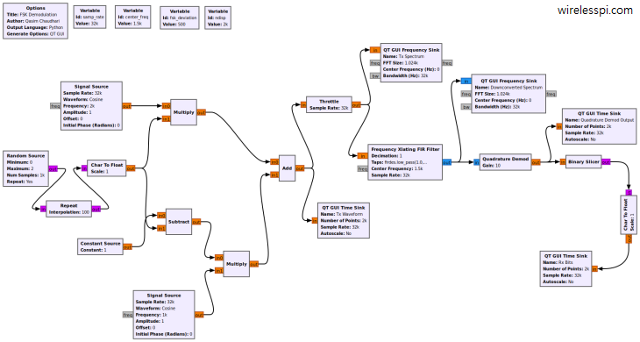

1. **Quadrature Demodulator**: This block calculates phase differences, helping to identify frequency shifts in the received signal. Configure the block to match the modulation settings for effective demodulation.
2. **Low-Pass Filter**: After quadrature demodulation, filter out unwanted high-frequency components and noise using a Low-Pass Filter block.
3. **Binary Slicer**: Convert the filtered analog signal into binary data using a Binary Slicer block. This step compares the incoming signal’s amplitude with a threshold, producing '1' or '0' based on the detected frequency.

##### ****Waveform Observation****

Run the demodulation flowgraph and observe the output in the QT GUI Time Sink block. The output waveform should match the original binary data stream, verifying the success of FSK demodulation.

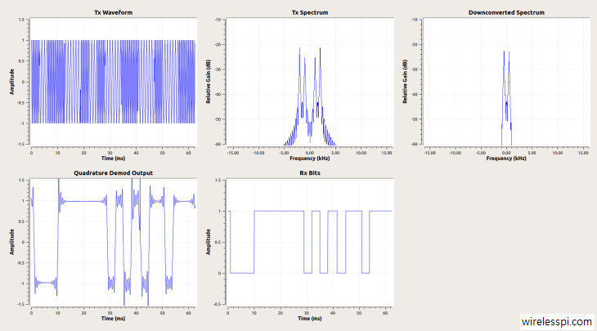

#### 3.3 ****Results of FSK Demodulation****

The demodulated signal displays a reconstructed binary data stream, closely matching the input to the modulator. This result confirms the successful demodulation of FSK in GNU Radio.

### 4. ****Analysis and Results****

#### 4.1 ****Performance Evaluation****

1. **Bit Error Rate (BER)**: To measure accuracy, calculate the Bit Error Rate (BER) by comparing the demodulated data with the original data under various noise conditions. Lower BER indicates higher accuracy in demodulation.
2. **Spectral Analysis**: Using the QT GUI Frequency Sink block, examine the frequency spectra of the modulated and demodulated signals. The peaks should align with f0f_0f0​ and f1f_1f1​, showing clear separation between the frequencies used for each binary symbol.

#### 4.2 ****Challenges Encountered****

* **Noise Interference**: Under high-noise conditions, demodulation may yield inaccurate results, increasing BER.
* **Synchronization**: Ensuring the carrier frequency in modulation matches the demodulator settings is essential. Mismatches may lead to errors in the reconstructed signal.

### 5. ****Applications of FSK in Communication****

FSK is used in various applications, including:

* **Radio Modems**: Low-cost radio systems in telemetry and low-bandwidth communication.
* **RFID**: Radio-frequency identification uses FSK to communicate between a tag and reader.
* **Bluetooth**: Uses a variation of FSK known as Gaussian Frequency Shift Keying (GFSK) for its low-power, short-range wireless communication.

#### 5.1 ****Advantages and Limitations of FSK****

* **Advantages**: Simple to implement, robust to noise, and suitable for low-bandwidth channels.
* **Limitations**: Lower data rates compared to advanced digital modulation schemes such as QAM or PSK, limiting its use in high-speed data applications.

### 6. ****Conclusion****

This report presented the modulation and demodulation of FSK signals using GNU Radio, highlighting FSK’s effectiveness in encoding binary data as frequency variations. The implementation demonstrates that GNU Radio is a powerful tool for simulating and analyzing digital modulation schemes, particularly FSK. Future work may include adding error correction techniques, implementing other modulation schemes like QPSK, or using SDR hardware for real-world testing.

### 7. ****References****

* GNU Radio Documentation
* Wireless pi
* Proakis, J. G., & Salehi, M. (2008). Digital Communications. McGraw-Hill.
* Sklar, B. (2001). Digital Communications: Fundamentals and Applications. Prentice Hall.

**Student Signature:**

**…………………………………….**

**…………………………………….**

**…………………………………….**

**…………………………………….**

**SIGNATURE OF THE CONCERNED LAB FACULTY MEMBER:**

**SIGNATURE: REMARKS:**

**….………………………… …………………………...**