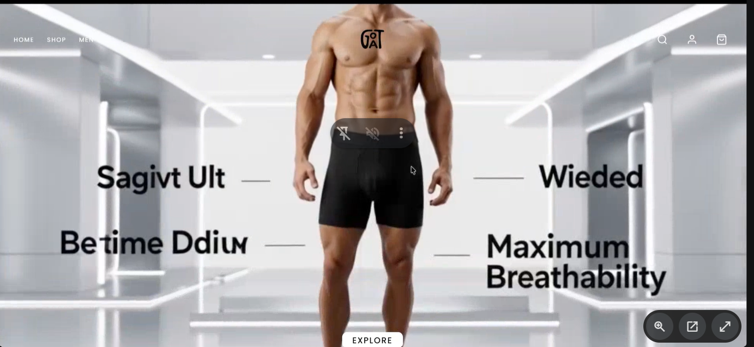
1 ) change the video.
2) Reduse the hight to show for below section like h-half .
3)get your favourite product
4) Discount banner
5)remove video add banner
Home
- Add testmorinal
- Add dommy
shop
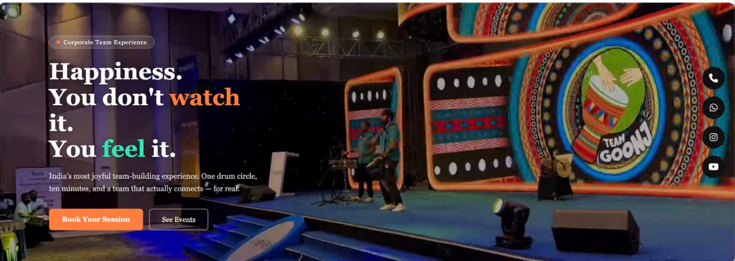
Add on top
min dynamic in video overlap and fixed text and video in bg .
left heading
description
button
In shop in banner name Shop
Product page
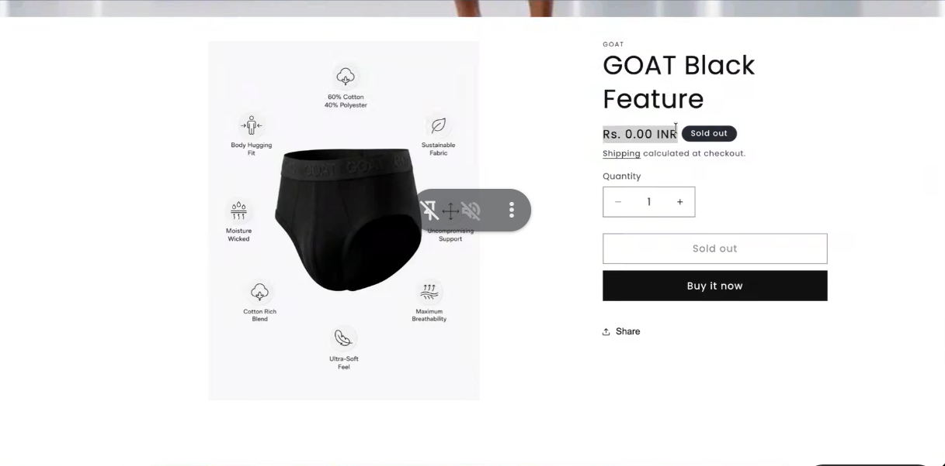
1) add gyrally
2) remove banner on product . and in event we can change the banner like Diwali
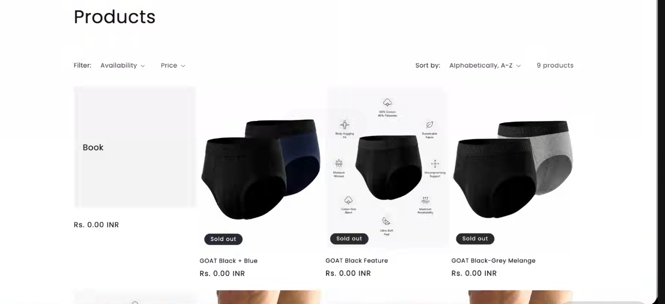
block add in between the hero product page .

Payment
add razerpay integrations
next date to call or update on message

