E-Commerce Sales Performance

- Project Overview
This Project Analyzes E-commerce sales performance using transactional data from 5000 orders Across various product categories the goal is to understand spending patterns according to the categories. Also to check which product category is doing more sales.
- Data Set Summary
- Rows: 5000
- Columns: 12
- Exploratory data Analysis using python
We began with data preparation and cleaning with python
- Data Loding: Imported the data set using pandas
- Initial Exploration: used df.info() to check structure and .describe() for summary statistics
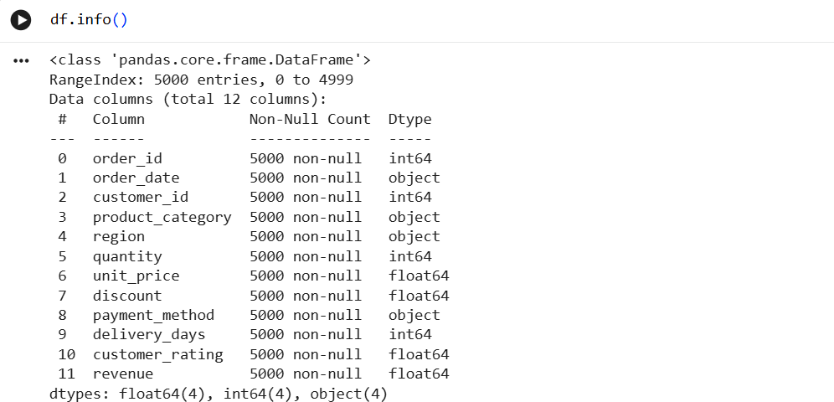
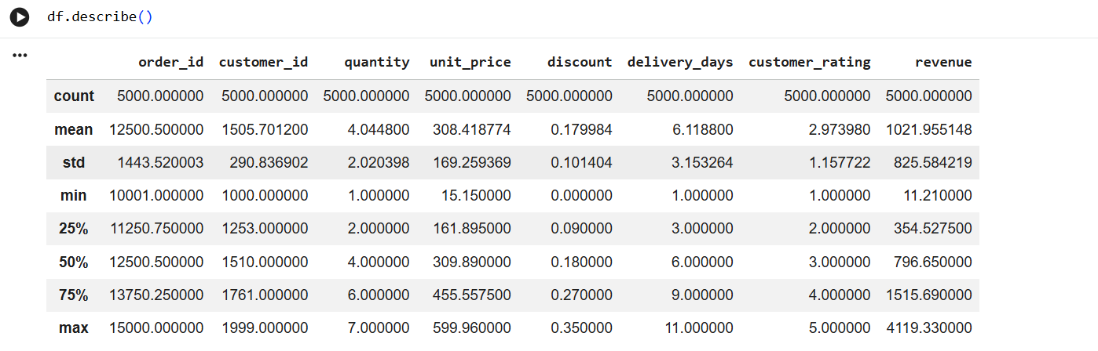
- Missing Data Handling: Checked for null Values not found any null values
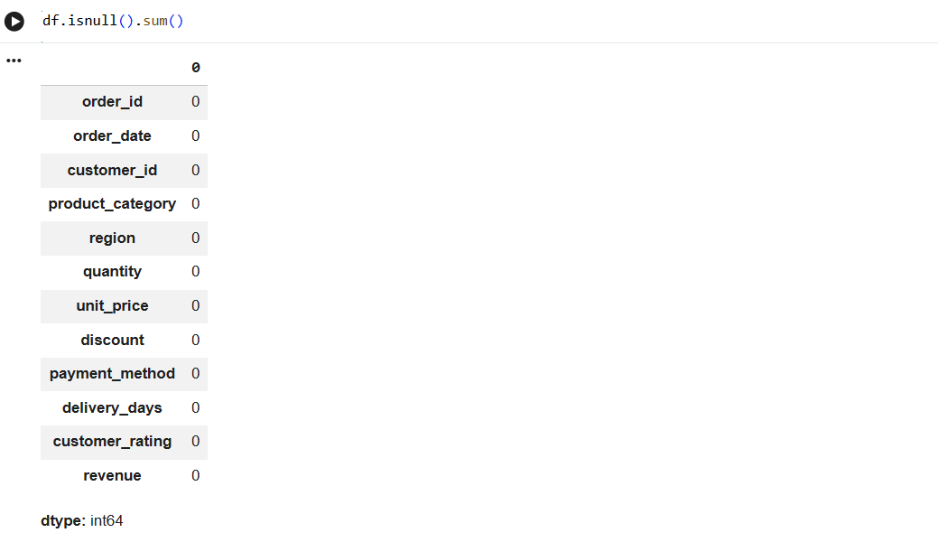
- Column standardization: checked if columns are properly named in snake case for better readability and documentation.
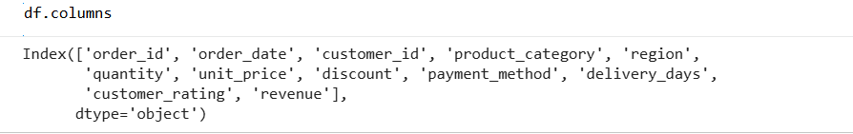
- Then used the data in Power BI for visualization
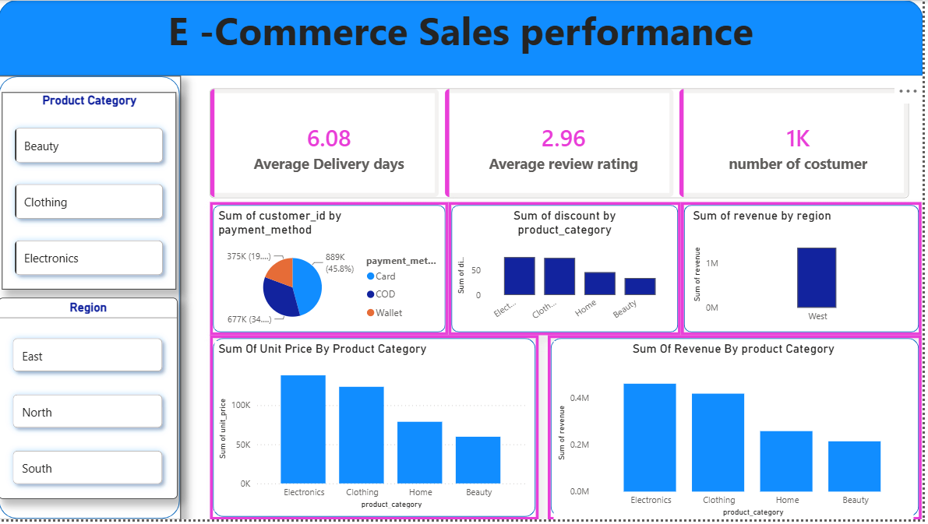
4.buisness recommendation
- Work on Delivery time: as delivery time is very high
- Product Positioning: Highlight top rated and best-selling products in campaigns
- Targeted Marketing: focus efforts on high revenue category
- Do a Survey: to check why the average rating is so low or check the feedbacks left by customers.

