Text-to-SQL Project
Ask questions in plain English → get answers from the PostgreSQL database
Database: nextgendb | 174 tables | Local AI (no internet needed)

1. What This Project Does
This project lets anyone get information from a large company database WITHOUT knowing SQL. You type a normal question such as “How many employees are active?” and the system:
- Understands your question using a local AI model.
- Writes the correct SQL query for you.
- Runs it on the database (read-only – it can never change data).
- Shows you the answer as a table.
Everything runs on this computer. No API key and no internet are required, so the data never leaves the machine.

2. How It Works (Overview)
The picture below shows the main parts and how a question flows through them.
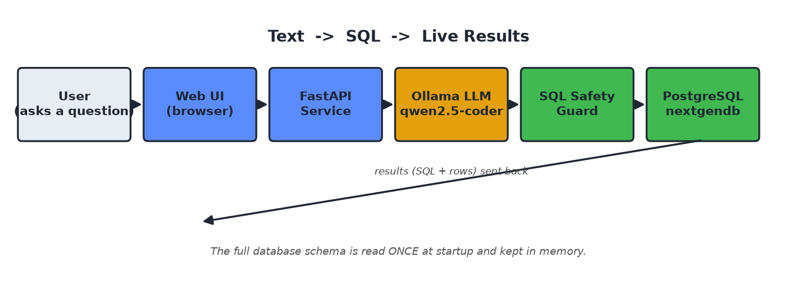
The full list of tables and columns is read from the database only once, when the service starts, and kept in memory so every question is answered quickly.

3. Step-by-Step Workflow
Here is exactly what happens for every question, from input to output:
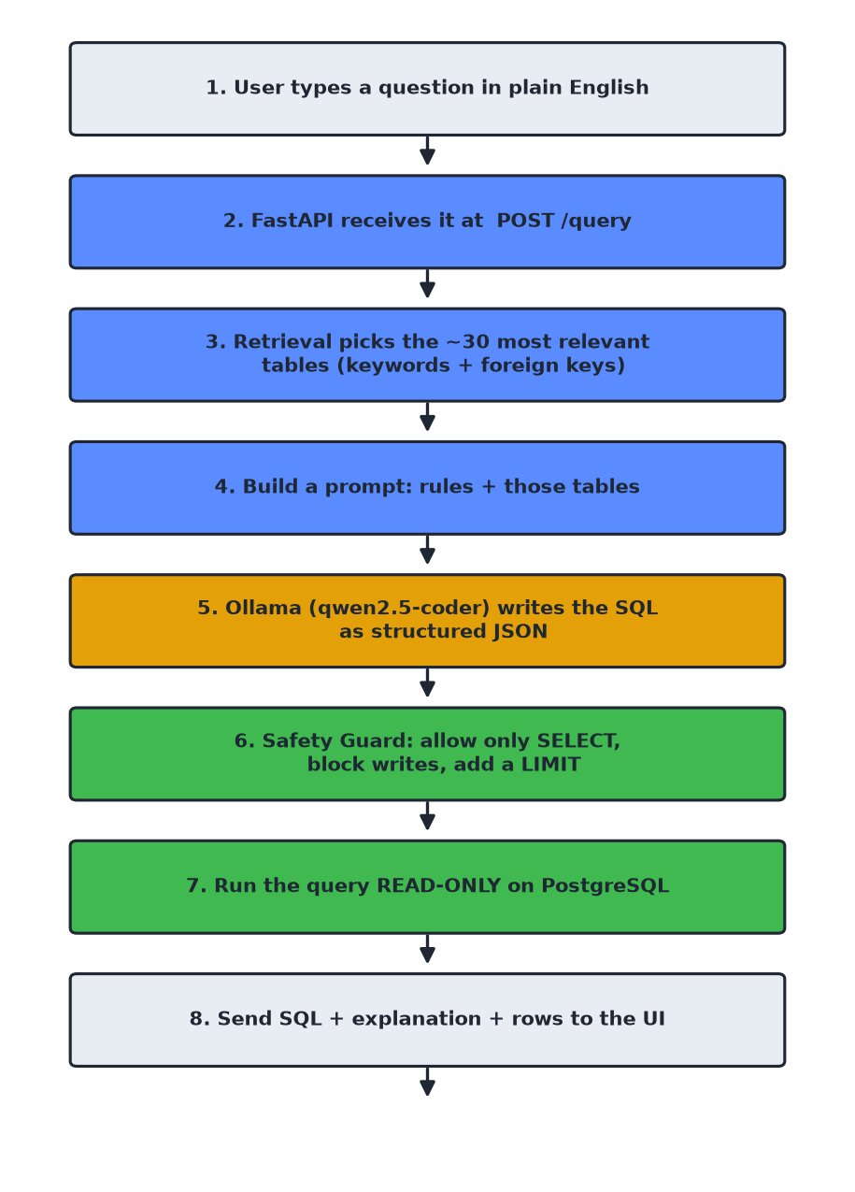

4. Input → Process → Output
Stage | What happens
INPUT | The user types a plain-English question in the web page (or sends it to the /query API).
PROCESS 1 – Find tables | The service scores all 174 tables by matching words in the question and following foreign keys, then keeps only the ~30 most relevant ones.
PROCESS 2 – Ask the AI | Those tables + a set of rules are sent to the local AI model (qwen2.5-coder), which returns the SQL as structured JSON.
PROCESS 3 – Check safety | A guard confirms the query is a read-only SELECT, blocks any dangerous keyword, and adds a row LIMIT.
PROCESS 4 – Run query | The SQL runs inside a READ ONLY database transaction with a time limit.
OUTPUT | The user gets the SQL, a short explanation, and the result rows – usually in about 8 seconds.

5. Technologies and Libraries Used

Programming language
- Python 3.11 – the whole service is written in Python.

Main libraries (installed with pip)
Library | What it is used for
FastAPI | Builds the web service and the /query API endpoint.
Uvicorn | The web server that runs FastAPI.
psycopg2 | Connects Python to the PostgreSQL database.
httpx | Sends the request to the local Ollama AI model.
Pydantic | Checks and structures the incoming request data.
python-dotenv | Loads settings from the .env file.
anthropic (optional) | Used only if you switch to Claude instead of the local model.

AI model (runs locally)
Tool | What it is used for
Ollama | Free program that runs AI models on your own computer.
qwen2.5-coder:7b | The AI model that turns English into SQL (good at code/SQL).
Flash attention + q8 KV cache | Ollama settings that let the model fit fully on the GPU, making it about 4× faster (~8 seconds per question).

Database
- PostgreSQL 17 – the existing nextgendb database with 174 tables that we query.

6. Project Files
File | Its job
app/main.py | The FastAPI service and API endpoints (/, /health, /schema, /query).
app/config.py | All settings (database, model, limits), read from .env.
app/db.py | Reads the schema at startup and runs queries read-only.
app/retrieval.py | Picks the most relevant tables for each question.
app/text2sql.py | Sends the prompt to the AI and gets back the SQL.
app/guard.py | Safety checks on the generated SQL.
app/static/index.html | The simple web page (user interface).
requirements.txt | The list of Python libraries to install.
run.ps1 | One command to set up and start everything on Windows.
.env / .env.example | Configuration values.

7. The Database (Simple ER Diagram)
The real database has 174 tables. To keep it simple, here is one small part of it – the ‘digitalsig’ schema – shown as an ER (Entity-Relationship) diagram. Boxes are tables; the red lines show how they are linked by keys.
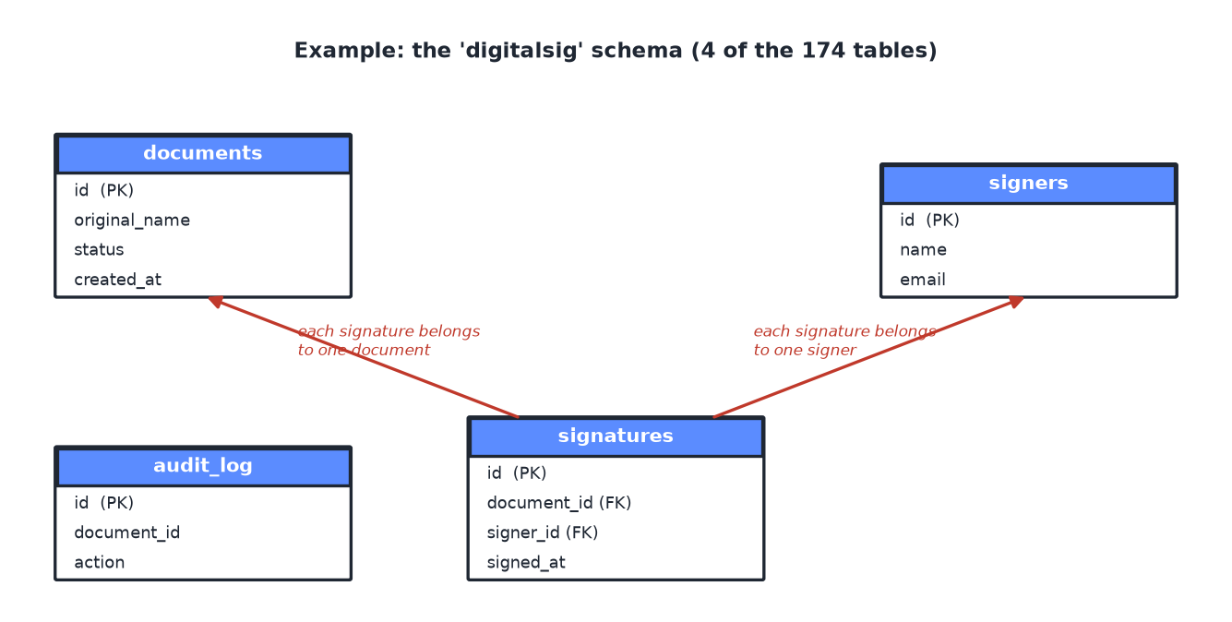
How to read it: a signature always points to one document and one signer. This ‘link by keys’ idea (called a foreign key) is what lets the AI join tables correctly when answering a question.

8. How the Data Is Kept Safe
- The AI is only allowed to produce SELECT (read) queries.
- A guard blocks words like INSERT, UPDATE, DELETE, DROP, etc.
- Every query runs in a READ ONLY database session – so even a mistake cannot change or delete data.
- A row LIMIT and a time limit stop very large or slow queries.

9. How to Run It
- Install Ollama and pull the model: ollama pull qwen2.5-coder:7b
- Turn on the GPU speed settings: setx OLLAMA_FLASH_ATTENTION 1 and setx OLLAMA_KV_CACHE_TYPE q8_0 (then restart Ollama).
- Start the service: run the run.ps1 file (it installs the Python libraries and starts the server).
- Open a browser at http://localhost:8000 and ask a question.

10. Example
Question typed by the user:
How many employees are active versus inactive?
SQL the AI produced:
SELECT is_active AS status, COUNT(*) AS count
FROM pers.employee_master
GROUP BY is_active;
Answer shown to the user:
status | count
true (active) | 965
false (inactive) | 112
(none) | 4

11. How to Use This Code on a New Computer (from the ZIP file)
Follow these steps to run the project after copying the ZIP file to a fresh Windows machine. Internet is needed ONLY for the installation/download steps below – after that the app runs offline.

A. Tools you must install (one time)
Tool | Where to get it | Why it is needed
Python 3.11 or newer | python.org/downloads (tick 'Add Python to PATH') | The project is written in Python.
Ollama | ollama.com or winget install --id Ollama.Ollama | Runs the local AI model on your computer.
The AI model | command: ollama pull qwen2.5-coder:7b | The model that turns English into SQL (~4.7 GB).
PostgreSQL access | the database already exists on the network | The app reads data from it (no install needed if it is reachable).

B. Step-by-step
- Copy the ZIP to the new computer and unzip it (e.g. to C:\TestToSql).
- Install Python 3.11+. Check it works: open PowerShell and run python --version
- Install Ollama: winget install --id Ollama.Ollama (or download from ollama.com).
- Download the AI model: ollama pull qwen2.5-coder:7b
- Turn on GPU speed settings (recommended): setx OLLAMA_FLASH_ATTENTION 1 then setx OLLAMA_KV_CACHE_TYPE q8_0 then close and reopen Ollama.
- Set up the config: copy .env.example to .env and, if the database is on a different address, edit PGHOST/PGPORT/PGUSER/PGPASSWORD in .env.
- Install the Python libraries and start the app in one command: right-click run.ps1 > Run with PowerShell (it makes a virtual environment, installs everything from requirements.txt, and starts the server).
- Open a browser at http://localhost:8000 and ask a question.

C. Install the libraries manually (if you don't use run.ps1)
python -m venv .venv
.venv\Scripts\pip install -r requirements.txt
.venv\Scripts\python -m uvicorn app.main:app --host 0.0.0.0 --port 8000
The file requirements.txt contains the exact list of libraries, so 'pip install -r requirements.txt' installs all of them automatically.

12. In Depth: How Ollama and the Libraries Work

Ollama – the local AI engine
Ollama is a free program that downloads AI models and runs them on your own computer (using the graphics card / GPU when available). While it runs, it opens a small web service on your machine at http://localhost:11434 that other programs can send requests to. Nothing is sent to the cloud.
How this project uses Ollama, step by step:
- When a user asks a question, our code (app/text2sql.py) builds a 'prompt' = a set of rules + only the relevant tables of the database.
- It sends that prompt to Ollama with an HTTP request (POST http://localhost:11434/api/chat) using the httpx library.
- The request also sets three important options: temperature = 0 (so the same question always gives the same SQL), num_ctx (the memory window, sized to fit the prompt), and format = a JSON schema (so the model MUST reply with {sql, explanation, tables}).
- Ollama runs the qwen2.5-coder model and sends back the answer as JSON.
- Our code reads the 'sql' field from that JSON and passes it to the safety guard.

The model: qwen2.5-coder:7b
- It is a '7 billion parameter' language model specially trained for writing code and SQL.
- It is stored on your disk (~4.7 GB) after the one-time 'ollama pull'. It does not need internet to run.
- Flash attention + q8 KV cache (the two setx settings) shrink the memory the model needs, so the whole model fits on an 8 GB GPU. That makes it about 4x faster (~8 seconds per question instead of ~30).

The Python libraries – what each one really does here
Library | How it is used in this project (in detail)
FastAPI | Defines the web service and its routes: '/' serves the web page, '/query' receives the question, '/schema' and '/health' give status. It reads the request, calls our logic, and returns the answer as JSON.
Uvicorn | The actual server program that runs FastAPI and listens on port 8000 for browser requests.
Pydantic | Describes the shape of the incoming request (a 'question' text and an 'execute' true/false). It automatically checks the request is valid before our code runs.
psycopg2 | The PostgreSQL driver. Used in app/db.py to (1) read the list of tables/columns/keys once at startup, and (2) run the generated query inside a READ ONLY transaction with a time limit, using a small pool of reusable connections for speed.
httpx | A modern HTTP client. Used in app/text2sql.py to send the prompt to the local Ollama service and receive the SQL back.
python-dotenv | Loads the settings from the .env file (database address, model name, limits) into the program when it starts.
anthropic (optional) | Only used if you switch the backend to Claude (needs internet + a key). In the normal local mode it is never called.

How all the pieces talk to each other
Browser (the web page) → FastAPI + Uvicorn (/query) → retrieval picks tables → text2sql builds the prompt → httpx → Ollama (local AI) → SQL comes back → safety guard checks it → psycopg2 runs it on PostgreSQL → rows return → FastAPI sends JSON → the web page shows the table.

Why it is NOT internet dependent
- The AI (Ollama + qwen2.5-coder) runs entirely on your computer – no cloud, no API key.
- The web page is self-contained (all its styling and code are inside the one HTML file – no external websites).
- The program only talks to two local places: the AI at localhost:11434 and the database on the local network.
- Internet is used ONLY once, to install Python, Ollama, the model, and the libraries. After that you can disconnect the internet and it still works.

