**TASK-2**

-> Create a Security group with port no. 80.

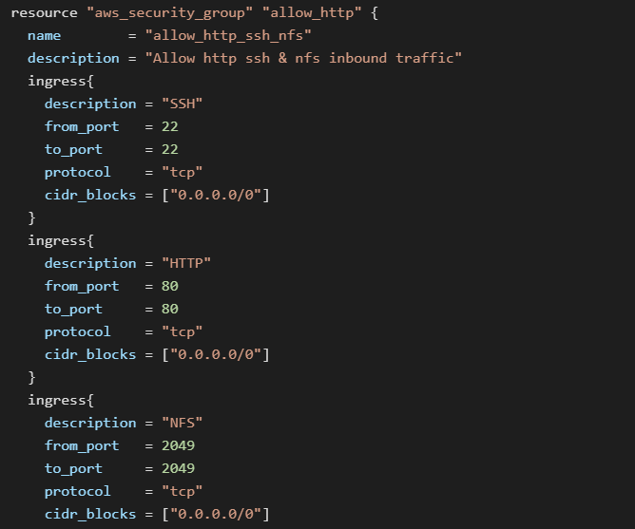

-> Launch EC2 instance in cloud.

-> In this Ec2 instance use the existing key and security group which we had created in step 1.

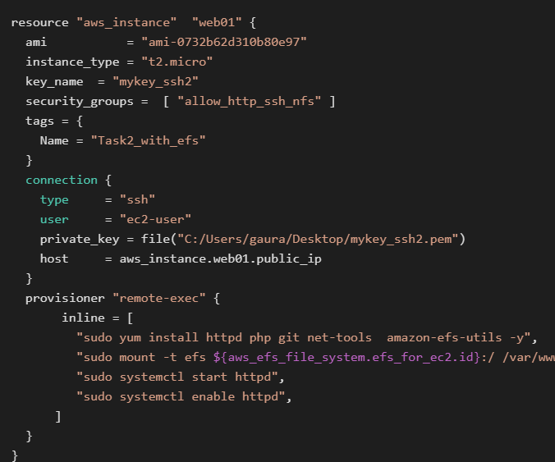

-> Launch one Volume using the EFS service in cloude and attach this in your VPC then mount this volume in this folder /var/www/html

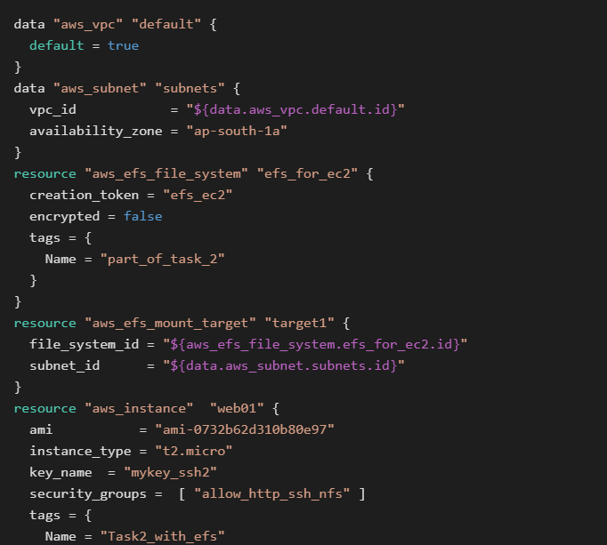

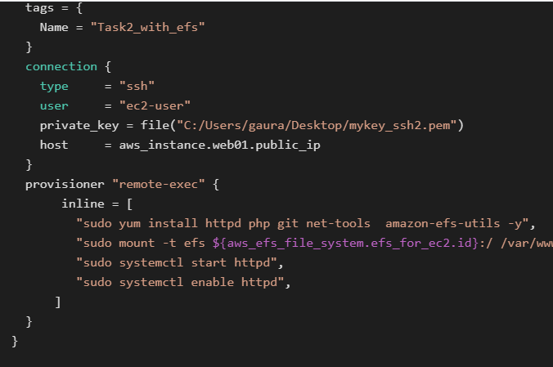

-> Create S3 bucket and copy/deploy the images from gitHub repos in the s3 bucket and change the permissions for public readable.

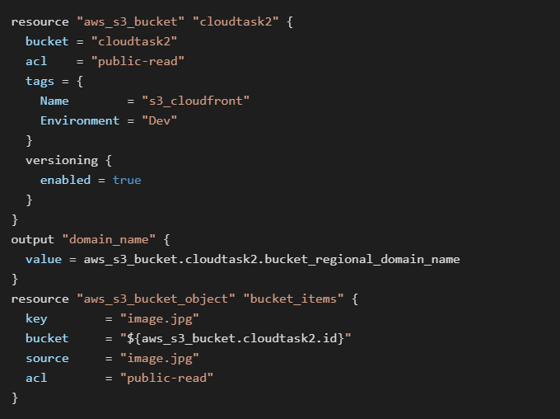

-> Create a Cloudfront using s3 bucket and use the Cloudfront URL to update in code in this folder /var/www/html

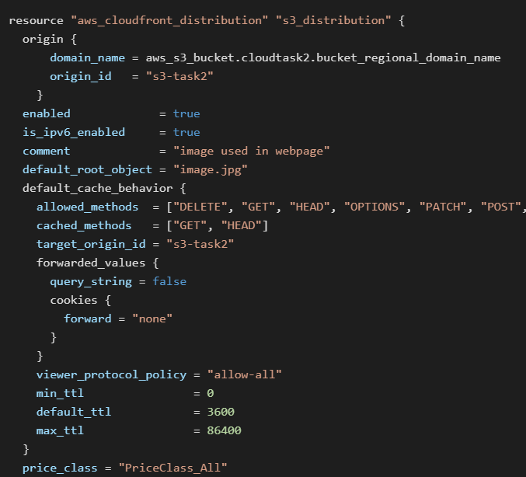

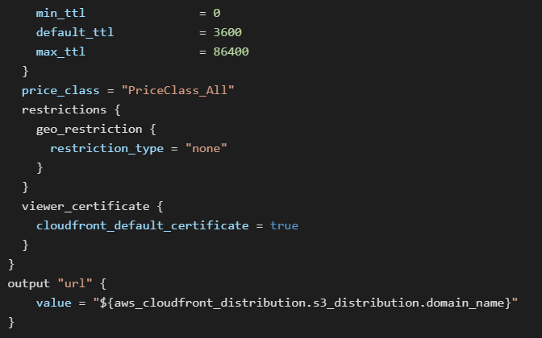

-> Developers has uploaded the code in github repo also repo has some images.

-> Copy the github repo codes in this folder /var/www/html

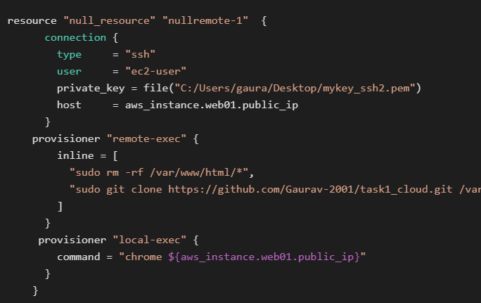

**Run the all commands in the command line-**

**terraform init**

**then**

**terraform apply**

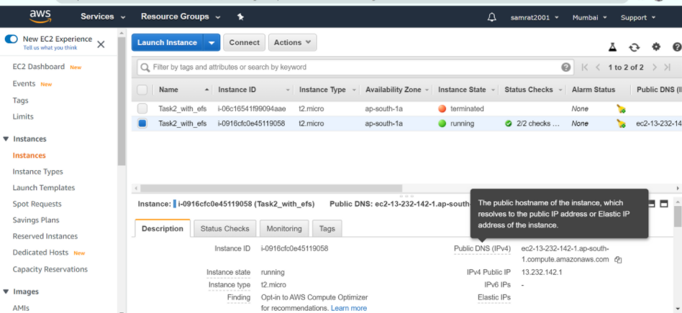

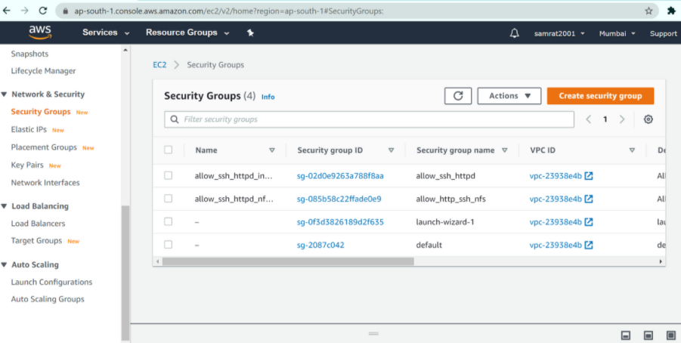

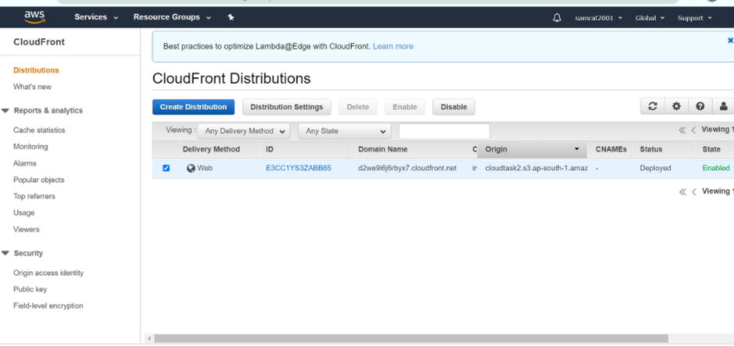

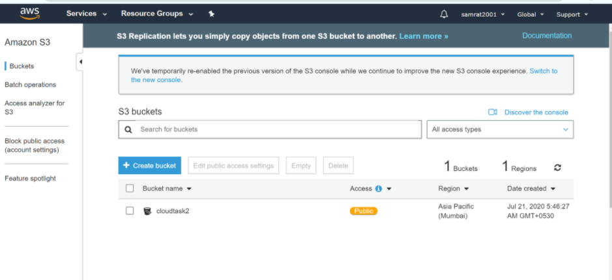

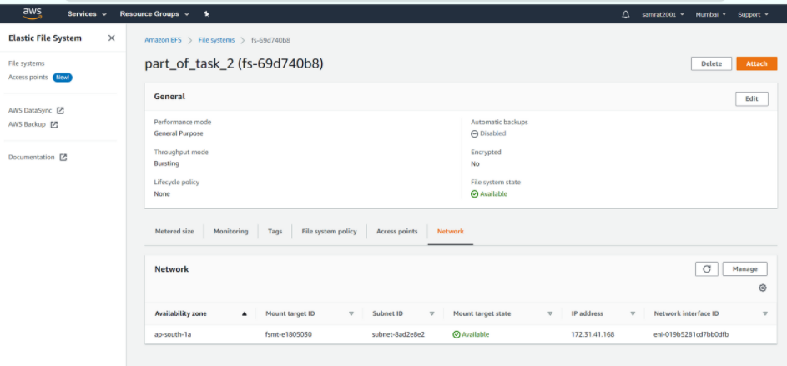

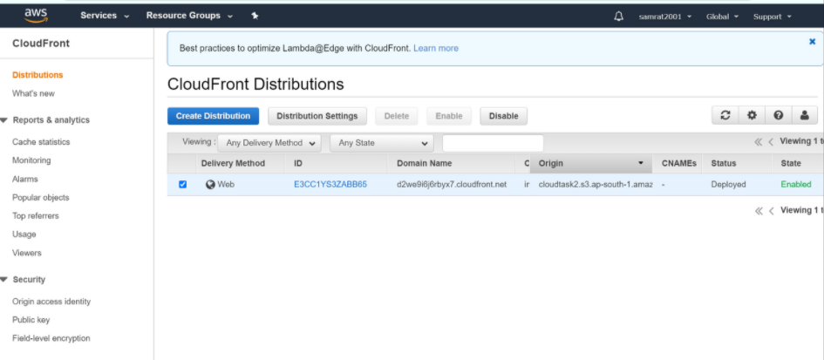

**Now infrastructure is ready**