# **Entity Relationship Diagram**

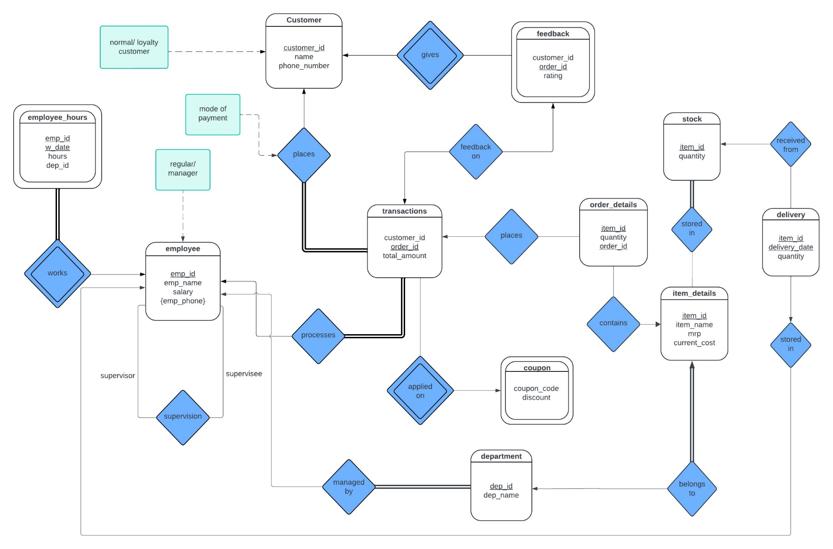

**Relational Schema**

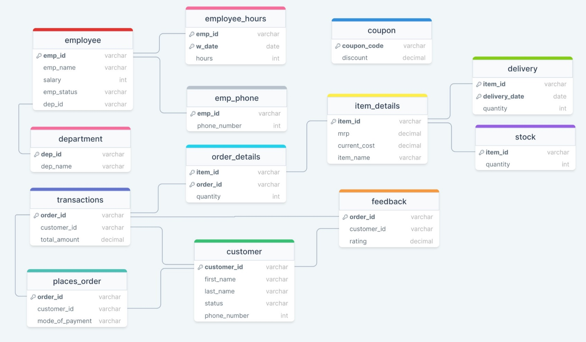

# **Tables gathered from ERD**

Department (dep_name, **dep_id**)

Stock (**item_id**, quantity)

Transactions (customer_id, **order_id**, total_amount)

Coupon (**coupon_code**, discount)

places_order (customer_id, **order_id**, mode_of_payment)

Order_details (**item_id**, quantity, **order_id**)

Delivery (quantity, **item_id, delivery_date**)

Customer (name, **customer_id**, status, phone_number)

Item_details (**item_id**, mrp, current_cost, item_name)

Feedback (**order_id**, customer_id, rating)

Employee (emp_name, **emp_id**, salary, emp_status, phone_number, dep_id)

Employee_hours (**emp_id**, hours, dep_id, **w_date**)

# **Normalisation**

**Functional dependencies:**

Department table: dep_id → dep_name

Stock table: item_id → quantity

Transactions table: order_id → customer_id, total_amount

Coupon table: coupon_code → discount

Places_order table: order_id → customer_id, mode_of_payment

Order_details table: (order_id, item_id) → quantity

Delivery table: (item_id, delivery_date) → quantity

Customer table: customer_id → name, status, phone number

Item_details table: item_id → mrp, current_cost, item_name

Feedback table: order_id → customer_id, rating

Employee table: emp_id → emp_name, salary, emp_status, phone_number, dep_name

Employee_hours table: (emp_id, w_date) → hours, dep_id

# **1NF:**

To convert the above schema to 1NF, we have to ensure that all the attributes have atomic values.

The tables Department, Stock, Transactions, Coupon, Places_order, Order_details, Delivery, Item_details, Feedback, Employee_hours have attributes with atomic values. Thus they are in 1NF.

In the **Employee** table, the **phone_number** is a multi-valued attribute.

We can create a new table Emp_phone to store multiple phone numbers of the employees

**Emp_phone(emp_id, phone_number)**

In the **customer** table, name is a complex attribute which can be divided into first name and last name.

**Customer(first_name, last_name, customer_id, status, phone_number)**

**After applying 1NF:**

Department table: dep_id → dep_name

Stock table: item_id → quantity

Transactions table: order_id → customer_id, total_amount

Coupon table: coupon_code → discount

Places_order table: order_id → customer_id, mode_of_payment

Order_details table: (order_id, item_id) → quantity

Delivery table: (item_id, delivery_date) → quantity

Customer table: customer_id → first_name, last_name, status, phone_number

Item_details table: item_id → mrp, current_cost, item_name

Feedback table: order_id → customer_id, rating

Employee table: emp_id → emp_name, salary, emp_status, dep_name

Emp_phone table: emp_id →phone_number

Employee_hours table: (emp_id, w_date) → hours, dep_id

## **2NF:**

To convert the given schema to 2NF, we need to ensure that all non-key attributes in each table depend on the entire primary key of that table.

The non-key attributes in the tables Department, Stock, Transactions, Coupon, Places_order, Order_details, Delivery, customer, Item_details, Feedback, employee, emp_phone depend on the entire primary key. Thus, these tables are in 2NF form.

**Order_details** Table**:**

Composite Primary Key: (order_id, item_id)

Non-Prime Attributes: quantity

quantity is dependent on the entire composite key (order_id, item_id) and not on any single part of it, so this table is in 2NF.

**Delivery** Table**:**

Composite Primary Key: (item_id, delivery_date)

Non-Prime Attributes: quantity

quantity is dependent on the entire composite key (item_id, delivery_date) and not on any single part of it, so this table is in 2NF.

**Employee_hours** table**:**

dep_id can be found using only emp_id which is only a part of the primary attribute. This table is not in 2NF, so we convert to 2NF by shifting dep_id to the **Employee** table.

Since emp_id has a total participation with employee, we add it as an attribute to the employee table

**Employee table:**

**emp_id → emp_name, salary, emp_status, phone_number, dep_id, dep_name**

**After 2NF:**

**Department table**: dep_id → dep_name

**Stock table**: item_id → quantity

**Transactions table**: order_id → customer_id, total_amount

**Coupon table**: coupon_code → discount

**Places_order table**: order_id → customer_id, mode_of_payment

**Order_details table**: (order_id, item_id) → quantity

**Delivery table**: (item_id, delivery_date) → quantity

**Customer table**: customer_id → first_name, last_name, status, phone_number

**Item_details table**: item_id → mrp, current_cost, item_name

**Feedback table**: order_id → customer_id, rating

**Employee table**: emp_id → emp_name, salary, emp_status, dep_id, dep_name

**Emp_phone table**: emp_id →phone_number

**Employee_hours table**: (emp_id, w_date) → hours

# **3NF**

To convert the schema to 3NF, we need to eliminate transitive dependencies. A transitive dependency occurs when a non-key attribute depends on another non-key attribute rather than the primary key.

The tables Department, Stock, Transactions, Coupon, Places_order, Order_details, Delivery, customer, Item_details, Feedback, employee_hours, emp_phone do not have any transitive dependencies. No non-key attributes depend on another non-key attribute.

Thus, they are in 3NF form.

Employee Table (3NF Version):

- **Primary Key**: emp_id

- **Attributes**: emp_name, salary, emp_status, phone_number, dep_id, dep_name

- dep_id and dep_name are non-prime attributes. However, we can derive dep_name from dep_id. employee table is not in 3nf form. We remove dep_name to eliminate the transitive dependency.

**After 3NF:**

**Department table**: dep_id → dep_name

**Stock table**: item_id → quantity

**Transactions table**: order_id → customer_id, total_amount

**Coupon table**: coupon_code → discount

**Places_order table**: order_id → customer_id, mode_of_payment

**Order_details table**: (order_id, item_id) → quantity

**Delivery table**: (item_id, delivery_date) → quantity

**Customer table**: customer_id → first_name, last_name, status, phone_number

**Item_details table**: item_id → mrp, current_cost, item_name

**Feedback table**: order_id → customer_id, rating

**Employee table**: emp_id → emp_name, salary, emp_status, dep_id

**Emp_phone table**: emp_id →phone_number

**Employee_hours table**: (emp_id, w_date) → hours

# **BCNF**

To convert the schema to BCNF, we need to ensure that all functional dependencies are dependencies on the primary key, and there are no non-trivial functional dependencies between non-key attributes.

There are no non-trivial functional dependencies between non-key attributes in the current schema, so it is already in BCNF.

# DDL

create table department(

dep_name varchar(20),

dep_id varchar(20),

primary key(dep_id)

);

create table item_details(

item_id varchar(20),

item_name varchar(50),

mrp number(6,2),

curr_cost number(6,2),

quantity int,

primary key(item_id),

);

create table customer(

first_name varchar(20),

last_name varchar(20),

customer_id varchar(20),

phone_number varchar(10),

status varchar(20),

primary key(customer_id)

);

create table transactions(

customer_id varchar(20),

order_id varchar(20),

total_amount number(5,2),

primary key(order_id),

foreign key(customer_id) references customer_details

);

create table order_details(

order_id varchar(20),

item_id varchar(20),

quantity int,

foreign key(order_id) references transactions,

foreign key(item_id) references item_details,

primary key(order_id, item_id)

);

create table feedback(

order_id varchar(20),

customer_id varchar(20),

rating number(1,1),

foreign key(order_id) references transactions,

foreign key(customer_id) references customer,

primary key(order_id)

);

create table employee(

emp_name varchar(20),

emp_id varchar(20),

emp_status varchar(10),

salary int,

dep_id varchar(20),

primary key(emp_id),

foreign key(dep_id) references department

);

create table employee_hours(

emp_id varchar(20),

hours int,

w_date date,

foreign key(emp_id) references employee_details,

primary key(emp_id, w_date)

);

create table delivery(

quantity int,

item_id varchar(20),

delivery_date date,

primary key(quantity, item_id, delivery_date),

foreign key(item_id) references item_details

)

create table stock(

quantity int,

item_id varchar(20),

primary key(item_id),

foreign key(item_id) references item_details

)

create table coupon(

discount number(1,2),

coupon_code varchar(20),

primary key(coupon_code)

)

create table emp_phone(

phone_number int,

emp_id varchar(20),

primary key(emp_id),

foreign key(emp_id) references employee

)

create table places_order(

order_id varchar(20),

customer_id varchar(20),

mode_of_payment varchar(20),

primary key(order_id),

foreign key(order_id) references transactions,

foreign key(customer_id) references customer

)