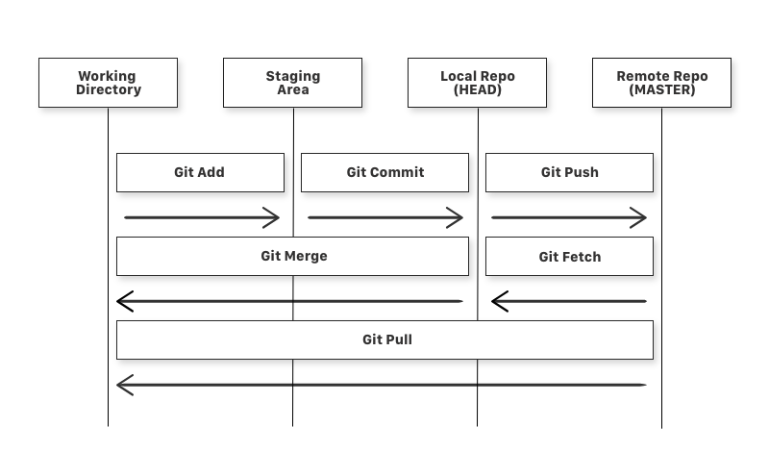# After creating a repository, follow the following steps for working through git Bash on local machine.

**git config --global user.name** "YOUR_USERNAME"

# The path C:/<directory> needs to be translated to the following format to work with git Bash

cd \c\<directory>

# Clone the remote repo locally

git clone https://github.com/RohitVMcGill/test-project.git

# Navigate to the project folder

cd test-project

# Add files to the staging area

git add .

# This command will show you the status of the repo

git status

# Commit to local repo

git commit -m "First commit"

# Push to remote repo

git push -u origin master