Procurement Command Center (PCC)
Application Layer
Low Level Design
Azure Container Apps · Azure AI Foundry · Fabric Gold · Azure AI Search

Purpose
This document is a focused low-level design for the PCC application layer and the agentic query flow — the part of the platform that takes a user's question through authentication, orchestration, and specialist agents, to a grounded, checked answer. It complements the full data-platform LLD by drilling into the application and AI-workload layers specifically.
Two views are provided: the Azure services that make up the application layer, and the end-to-end request flow through the agentic reasoning core. A detailed, step-by-step breakdown follows, in the same format as the platform LLD, so both documents can be read side by side.

1. Application Layer Architecture (Azure)
The application layer runs entirely on Azure Container Apps. The front door and backend API are separate regions inside that layer, Entra ID sits in front of every request, and the backend is the only component that reaches into the platform services below it.
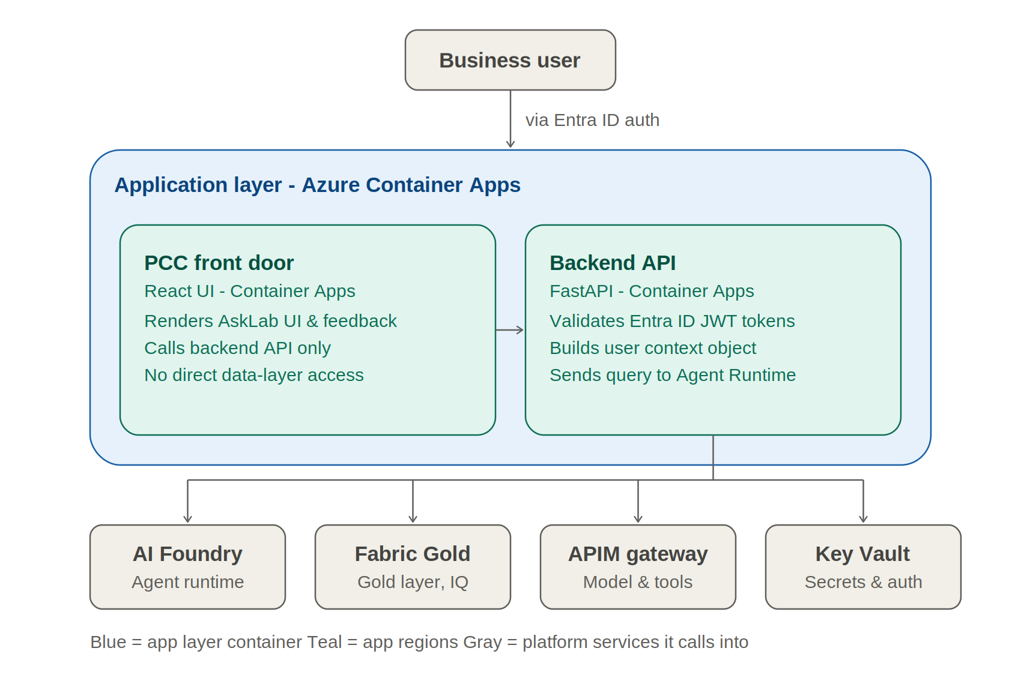

Key points
- Front door — React UI rendered via Container Apps; talks to the backend API only, never to data or AI services directly.
- Backend API — Python FastAPI on Container Apps; validates the Entra ID token, builds user context, and is the single entry point into the AI workload layer.
- Platform calls — The backend fans out to AI Foundry (agent runtime), Fabric Gold (curated data), the APIM/AI gateway (model and tool access), and Key Vault (secrets and identity) — never bypassed by the UI.

2. End-to-End Request Flow
Once a request reaches the backend, it moves through five stages: identity and intake, clarification, orchestration across three specialist agents, evidence joining and checking, and finally response composition with logging and governance running throughout.
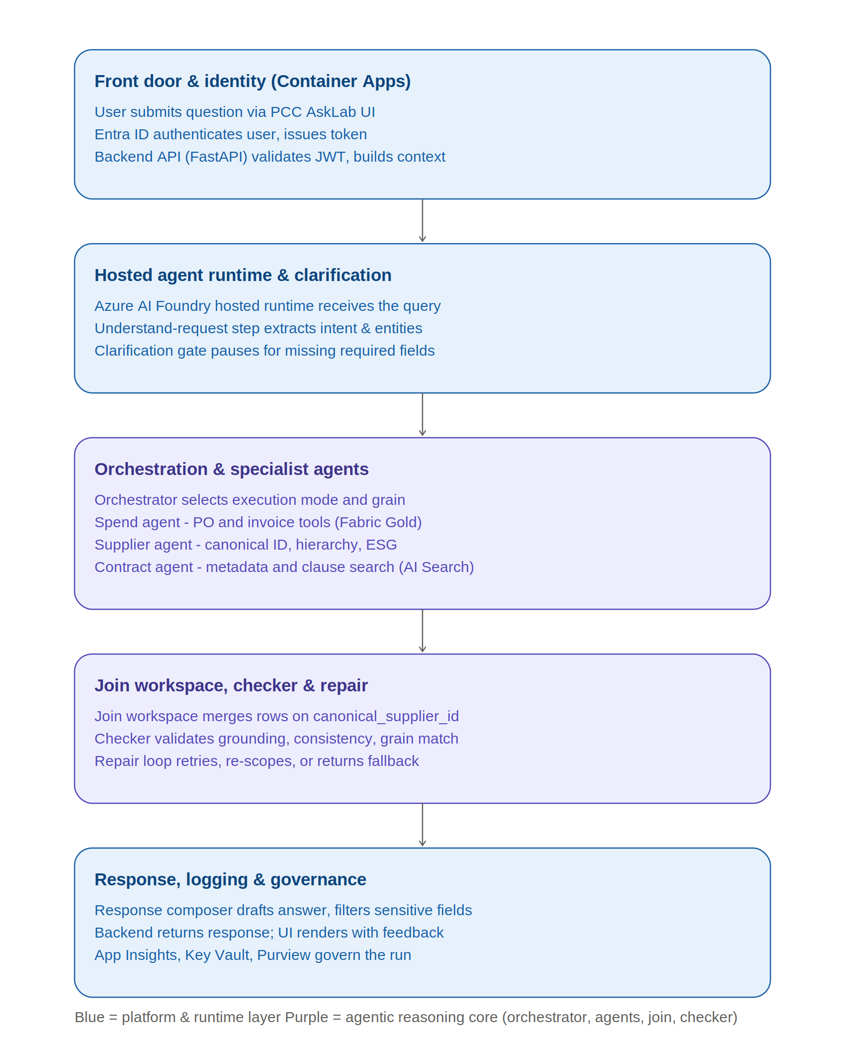

Key points
- Clarify before orchestrating — Incomplete prompts are paused for a targeted follow-up question rather than letting the orchestrator guess.
- Three agents only — Spend, Supplier, and Contract agents are the sole specialist paths; the orchestrator never queries a data source directly.
- Checked, not assumed — Every combined answer passes through a grain check and a checker before it reaches the user; unsupported answers fall back to a qualified response.

3. Detailed Low-Level Design
The following breaks the two diagrams above into implementation-level steps, following the same structure as the platform Low-Level Design document: what happens, why it happens, how to implement it, the technical components involved, and the dependency that must be in place first.
Step | What happens | Why it happens | How to implement | Technical components | Dependency / prerequisite
1 | User submits a question. | PCC AskLab is the business front door for procurement questions. | Serve the React AskLab UI through Azure Container Apps. | React UI, Azure Container Apps | UI deployment complete
2 | User authenticates with Entra ID. | The system must know who the user is before it acts on their behalf. | Implement Entra ID login; UI receives a token and passes it to the backend. | Microsoft Entra ID, MSAL | Step 1; Entra app registration configured
3 | Backend validates authorization. | Authentication alone is not enough — the backend must enforce what the user can do. | FastAPI middleware validates JWT, issuer, audience, expiry, scopes, and app roles. | Python FastAPI, Entra ID JWT validation | Step 2; token issued by Entra ID
4 | Backend builds user context. | Agents and tools need trusted user context for audit and authorization downstream. | Build a context object: user_id, roles, session_id, conversation_id, query_id. | Backend API, Cosmos DB, App Insights | Step 3; authorization must pass
5 | Query enters the hosted agent runtime. | The authorized query must enter the AI orchestration layer before any reasoning happens. | Backend sends query text, context, and correlation ID to the Foundry hosted runtime. | Azure AI Foundry Hosted Agent Runtime, APIM route | Step 4; runtime endpoint deployed
6 | Approved model access is confirmed. | Runtime and agents need controlled, cost-governed access to models. | Configure APIM / AI Gateway with approved OpenAI deployments, rate limits, logging. | APIM / AI Gateway, Azure OpenAI | Model routes configured ahead of any step needing model calls
7 | Runtime loads tools and context. | Agents cannot answer from the question alone they need governed data access. | Configure approved tool contracts for Fabric Gold, Fabric IQ, Cosmos, Supplier Lookup, Contract Metadata, AI Search. | Azure AI Foundry Hosted Agents, Agent Tool Layer | Steps 5–6; curated data sources ready
8 | Understand-request step parses the query. | Plain-English input must become structured intent before orchestration. | Extract intent, supplier, category, region, time window, contract need, requested grain. | Foundry agent logic, Azure OpenAI via gateway | Step 7
9 | Clarification gate checks completeness. | The system should never guess when required details are missing or ambiguous. | If supplier, category, time, region, or contract intent is unclear, return a targeted follow-up question. | Foundry agent logic, backend response | Step 8
10 | Orchestrator plans execution. | A query may need one agent, several agents, or a staged sequence of agents. | Classify the query as spend, supplier, contract, or combined; select agents and execution order. | Orchestrator Agent, Agent Tool Layer, APIM / AI Gateway | Step 9; request complete or clarified
11 | Grain is selected. | Answers must never mix entity-level and parent-level supplier results. | Determine entity, canonical, or parent grain and carry that flag through tools and the join. | Orchestrator Agent, Join Workspace logic, Supplier Lookup | Step 10
12 | Tool authorization is enforced. | Agents must not have unrestricted access to tools or data. | Apply per-agent, per-tool authorization; deny by default; validate role and scope on every call. | ToolAuth component, Managed Identity, RBAC, APIM policies | Step 4 (user context); Step 7 (tool contracts)
13 | Spend agent runs if spend-related. | Spend questions need curated PO, invoice, category, and time data. | Spend Agent calls authorized PO/Invoice tools over Fabric Gold with supplier, category, region, time filters. | Spend Agent, PO/Invoice Tool, Fabric Gold, Fabric IQ | Steps 10–12; curated PO/Invoice outputs ready
14 | Supplier agent runs if supplier-related. | Supplier questions need canonical identity, hierarchy, and enrichment context. | Supplier Agent resolves names via Live Supplier RAG, then calls Supplier Lookup and Ontology tools. | Supplier Agent, Supplier Lookup Tool, Fabric IQ, Bing Grounded Search | Steps 10–12; supplier/parent mapping ready
15 | Contract agent runs if contract-related. | Contract questions need structured metadata and approved evidence, not raw PDFs. | Contract Agent calls Contract Metadata and Contract Search tools over approved redacted chunks. | Contract Agent, Contract Metadata Tool, Azure AI Search | Steps 10–12; contract index ready
16 | Multi-agent questions invoke several agents. | Some questions need spend, supplier, and contract evidence together. | Orchestrator runs relevant agents in parallel or staged mode depending on dependency. | Orchestrator Agent, Spend/Supplier/Contract Agents | Steps 10–15 as relevant to the query
17 | Tool outputs are normalized. | Different source outputs must align on one key before they can be combined. | Return rows keyed by canonical_supplier_id with grain, source, filters, and confidence metadata. | Agent Tool Layer, Join Workspace | Steps 13–16
18 | Join workspace combines results. | No single source should dictate the combined answer. | Join PO, invoice, supplier, and contract rows on canonical_supplier_id using JOIN / INTERSECT. | Join Workspace service/module | Step 17
19 | Grain check validates consistency. | Parent-level and entity-level results must never be mixed in one answer. | Compare returned row grain against the selected grain flag; fail and repair if inconsistent. | Join Workspace, Checker | Step 11 (grain); Step 18 (joined result)
20 | Checker validates the evidence package. | The system must not return unsupported, incomplete, or inconsistent answers. | Validate grounding, completeness, consistency, source quality, and confidence of the combined evidence. | Checker component, Azure OpenAI via gateway | Step 19
21 | Repair loop handles execution issues. | The system should retry intelligently rather than return a weak answer. | On tool failure, weak evidence, or grain mismatch, return to the Orchestrator to retry, narrow scope, or re-plan. | Repair / replanning loop, Orchestrator Agent | Step 20
22 | Fallback handles missing or low-quality data. | The system must never hallucinate when data is unavailable or incomplete. | Return a qualified answer stating what could not be confirmed and why. | Fallback policy, Response Composer | Step 20 or Step 21
23 | Response composer builds the final answer. | The AskLab response must be concise, business-readable, and evidence-backed. | Generate the answer with evidence, caveats, assumptions, and source references. | Response Composer, Azure OpenAI via APIM / AI Gateway | Step 20 (validated) or Step 22 (fallback)
24 | Sensitive-field filter sanitizes the answer. | Must prevent leaking PII, signatories, or restricted contract metadata. | Apply an allowlist of surfaceable fields; suppress or redact anything outside it. | Sensitive field filter, policy config | Step 23
25 | Final response renders to the user. | The user needs a text-only, trustworthy AskLab response with a way to give feedback. | Backend returns the sanitized response with a trace ID; UI renders the answer and feedback controls. | Backend API, React AskLab UI, Cosmos DB (chat history) | Step 24
26 | Logging, monitoring, and governance run throughout. | Operations need traceability, and the platform must stay secure and compliant end to end. | Log every step via App Insights and Log Analytics; keep secrets in Key Vault; enforce posture via Defender and Purview. | App Insights, Log Analytics, Key Vault, Defender for Cloud, Microsoft Purview | Runs continuously across steps 1–25

