Freight Rate Prediction — Technical Report
Machine Learning Engineer Assessment

1. Data overview
The labeled development set (data/train_test.csv) contains 48,000 loads spanning 1 Jan 2025 to 31 Oct 2025. The validation set holds 12,000 loads from 1 Nov 2025 to 31 Dec 2025 — strictly after the training window. That single fact drives the entire validation strategy.
Column | Meaning
pickup / delivery | origin / destination city (64 each)
*_lat / *_lon | coordinates of each city
distance | billed road miles
equipment | Dry Van 57%, Reefer 25%, Flatbed 18%
weight | shipment weight (lb)
date | pickup date
market_index, quote_signal | market / pricing signals
posted_rate | TARGET — rate paid for the load (USD)

2. Key findings from exploration
- Distance is the dominant driver: correlation with posted_rate is 0.91 and the relationship is near-linear.
- Equipment carries a clear premium: mean rate-per-mile is $2.12 Dry Van < $2.29 Flatbed < $2.38 Reefer.
- Lane (origin to destination) is a strong regional-pricing proxy and ends up the second most important feature.
- Mild upward time drift through 2025 plus a small mid-week bump, captured with a linear day index and cyclical month / day-of-week features.
- The target is right-skewed (skew ~1.9); a log transform nearly symmetrises it (skew ~-0.5), so the model trains on log(posted_rate).
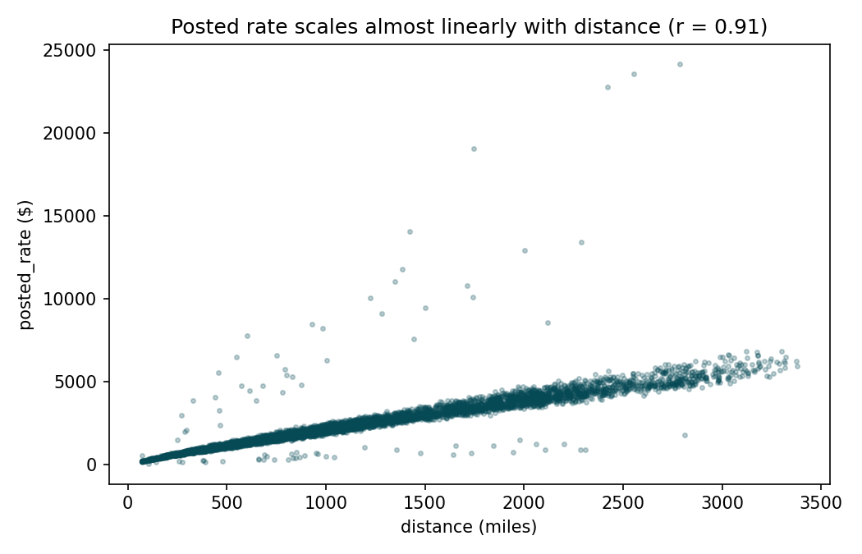
Figure 1. Posted rate scales almost linearly with distance.
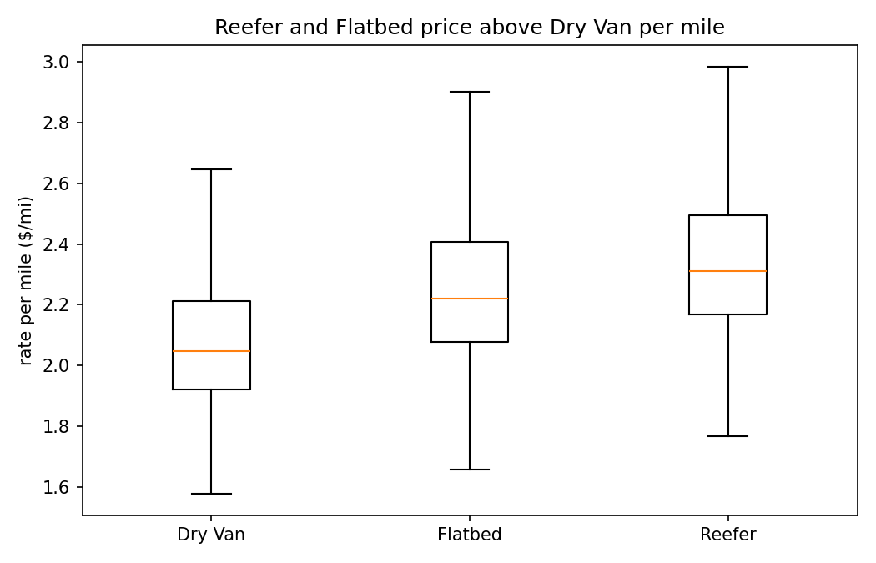
Figure 2. Reefer and Flatbed price above Dry Van per mile.

3. Data-quality issues and handling
Issue | Evidence | Handling
Impossible weights | 292 rows weight <= 0, min -47,500 lb | Clipped to 1,000-48,000 lb; out-of-band set to missing.
Missing weights | 300 train / 165 val NaN | Left as NaN; LightGBM handles missing natively, no rows dropped.
Missing market index | 374 train / 249 val NaN | Left NaN for model; median-backfilled for the December file.
Road vs straight-line distance | distance ~1.17x haversine | Kept billed distance; added haversine + circuity as secondary signals.
December file has only 7 columns | no coords / signals | Reference table of per-city coords + median signals backfills them.
All cleaning lives in src/features.py and runs identically for training, validation and December — there is no train/serve skew.
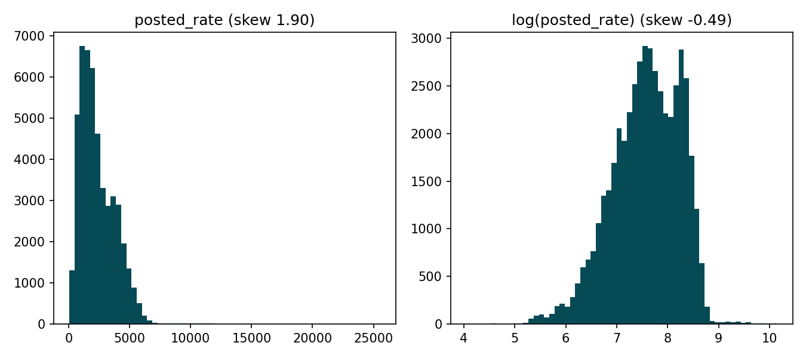
Figure 3. Target distribution: raw (skewed) vs log.

4. Train / validation split
Because the real validation period is the future relative to training, a random shuffle split would leak future information and overstate performance. Instead a temporal forward split is used:
- Sort the 48,000 rows by date.
- Hold out the most recent 20% by date (Sep-Oct 2025); train on the earlier 80% (Jan-Aug 2025).
- This mirrors the task: fit on the past, score on a later unseen window. Early stopping chose 172 boosting rounds.
- After measuring, the model is refit on all 48,000 rows with that round count, so it has seen every date closest to the Nov-Dec target period.
Holdout performance (Sep-Oct 2025):
Metric | Value | Reading
MAPE | 5.7% | within ~6% of actual on average
MAE | $133 | typical dollar error
RMSE | $641 | penalises rare high-rate long hauls
R2 | 0.82 | explains 82% of variance on unseen future dates

5. Model choice and reasoning
LightGBM gradient-boosted regression on log(posted_rate). The strongest relationship (distance to rate) is near-linear, but equipment, lane and market signals introduce non-linear interactions a booster captures without manual terms. It handles mixed numeric + high-cardinality categorical features (64x64 lanes) and missing values natively. Training on the log makes the loss relative — appropriate for a multiplicative price — and guarantees strictly positive predictions, which the scorer requires. Feature importance ranks distance > lane > quote_signal > weight > equipment > date features.

6. The fixed December chart
Running the provided score.py on the filled December inputs produces the chart below. Inputs are fixed (Lexington to Fort Wayne, 360 miles, Dry Van, 32,000 lb) with only the date changing, isolating the model's date/day-of-week response. Predictions sit around $848 (~$2.36/mile, consistent with training), with a small weekly oscillation from the day-of-week features.
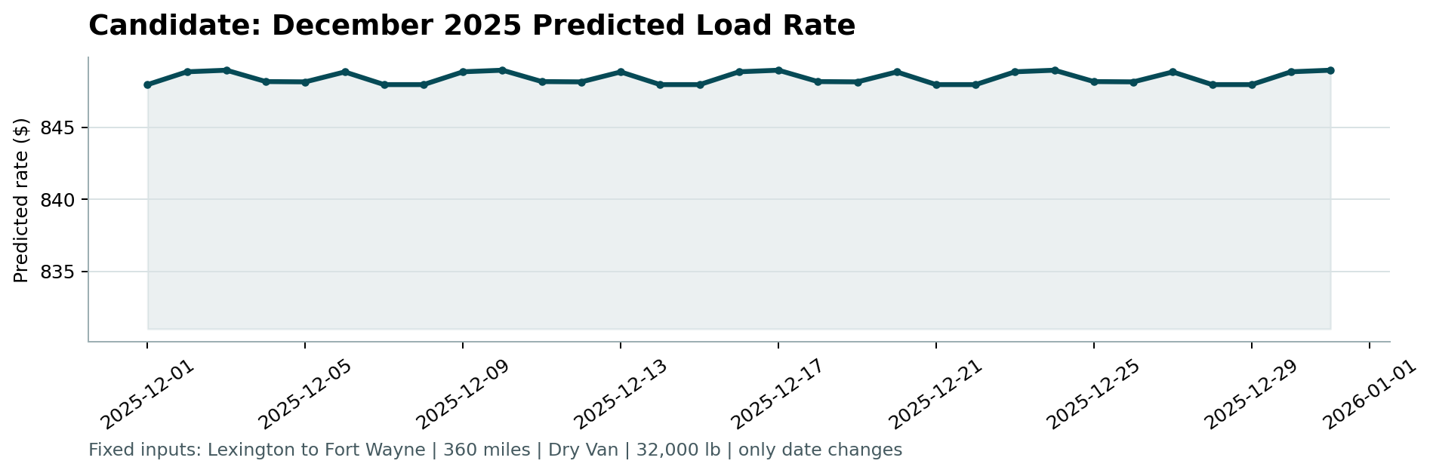
Figure 4. Candidate December 2025 predicted load rate.

7. Reproducing
python -m pip install -r requirements.txt
python -m src.train
python -m src.predict
python score.py --predictions validation_predictions.csv \
--december-predictions data/december_chart_inputs.csv

