[PROJECT NAME]
Autonomous Warehousing Bot with Web-Commanded Pick & Dispatch
Technical Documentation
Team Name: [FILL IN]
Team Members: [FILL IN]
Competition: [FILL IN] Date: [FILL IN]

Table of Contents

(In Word: right-click the box above → "Update Field" → "Update entire table" to populate this automatically.)

1. Executive Summary
AAM(automatic arms manipulator ) is a fully autonomous warehousing robot that picks and dispatches inventory with zero manual intervention beyond a single web command. A linear-actuator-driven forklift mechanism handles item retrieval, while an onboard navigation system guides the bot between racks and the dispatch zone. A custom web application lets any operator specify what to pick and from where, turning a physical warehouse task into a one-click digital action

[FILL IN] 2-4 sentences: what the bot does, the core problem it solves, and your headline result (e.g. success rate, cycle time). This is the first thing judges read — make it count.

2. Problem Statement & Innovation (25 pts — Innovation & Originality)

2.1 The Problem
Pick-and-place is one of the most repetitive, physically demanding tasks in warehouse operations — a human worker locates an item, retrieves it, and carries it to a dispatch point, over and over, for an entire shift. This work doesn't require judgment or creativity, yet it still depends entirely on manual human effort: workers tire, make errors under repetition, and become a hard limit on how fast a warehouse can operate. Scaling output means hiring more people to do the same repetitive motion, not solving the underlying inefficiency. What warehouses need is not more manual labor, but an autonomous agent — a system capable of receiving a task, reasoning about where to go and what to retrieve, and physically executing the pick-and-place cycle on its own, the way a human worker would, but without fatigue, error accumulation, or the need for direct supervision. [PROJECT NAME] is built to be exactly that agent: a self-directed system that takes a high-level instruction — "pick item X from rack Y" — and autonomously carries out the entire physical task from start to finish.

[FILL IN] What real warehousing pain point does this solve (labor cost, pick errors, speed, safety, space utilization)? Cite a stat or scenario if possible.

2.2 Our Approach
[FILL IN] What makes your solution different — the forklift + linear actuator mechanism, the web-based rack-commanding interface, your navigation method. Be specific about what's novel, not just what it does.

2.3 Comparison to Existing Solutions
- The core distinction is architectural: commercial AMRs and AGVs split compute across multiple boards by necessity — an industrial PC or NUC for navigation and fleet networking, a separate real-time microcontroller for motor and actuator timing, and frequently a third accelerator (Jetson-class) bolted on for vision. Each of those boundaries is a physical connection, a driver layer, and a failure point. AAM runs the entire stack — Nav2/SLAM, vision, task management on the Linux side; deterministic motor and linear actuator control on the real-time side — on a single board.
- Legacy AGVs also rely on engineered infrastructure — floor wiring, guide tape — requiring facility downtime before deployment. AAM is SLAM-based with ArUco-assisted precision alignment: no floor modification needed. We're using ArUco markers in this prototype as a fast, zero-cost way to validate the alignment approach;
- Commercial AMR fleets are typically closed — proprietary fleet managers, vendor-locked APIs — which is a common source of integration overhead. AAM's wms_bridge exposes the robot over plain HTTP/JSON from inside ROS 2, so any web team can command it without touching ROS or a vendor SDK.

Why Arduino UNO Q
UNO Q fits this project because its architecture matches the robot's two very different compute needs. Navigation and vision (SLAM, Nav2, ArUco detection, ROS 2 task management) are soft-real-time and need a full Linux stack — handled by the onboard Cortex-A53, running Docker, ROS 2 Humble, and CycloneDDS. Motor and actuator control are hard-real-time and jitter-sensitive — handled in isolation by the onboard STM32U585 (Cortex-M33), so vision/SLAM load never disturbs actuator timing.
Normally this split needs two boards (a Pi/Jetson-class SBC plus an Arduino or Nucleo) connected over external serial, with its own power sequencing and failure modes. UNO Q collapses that into one board with a built-in bridge between cores — which is why our bridge_client.py RPC layer (Section 5.4) can treat a motor command as a single reliable call instead of managing an external serial link.

3. System Architecture
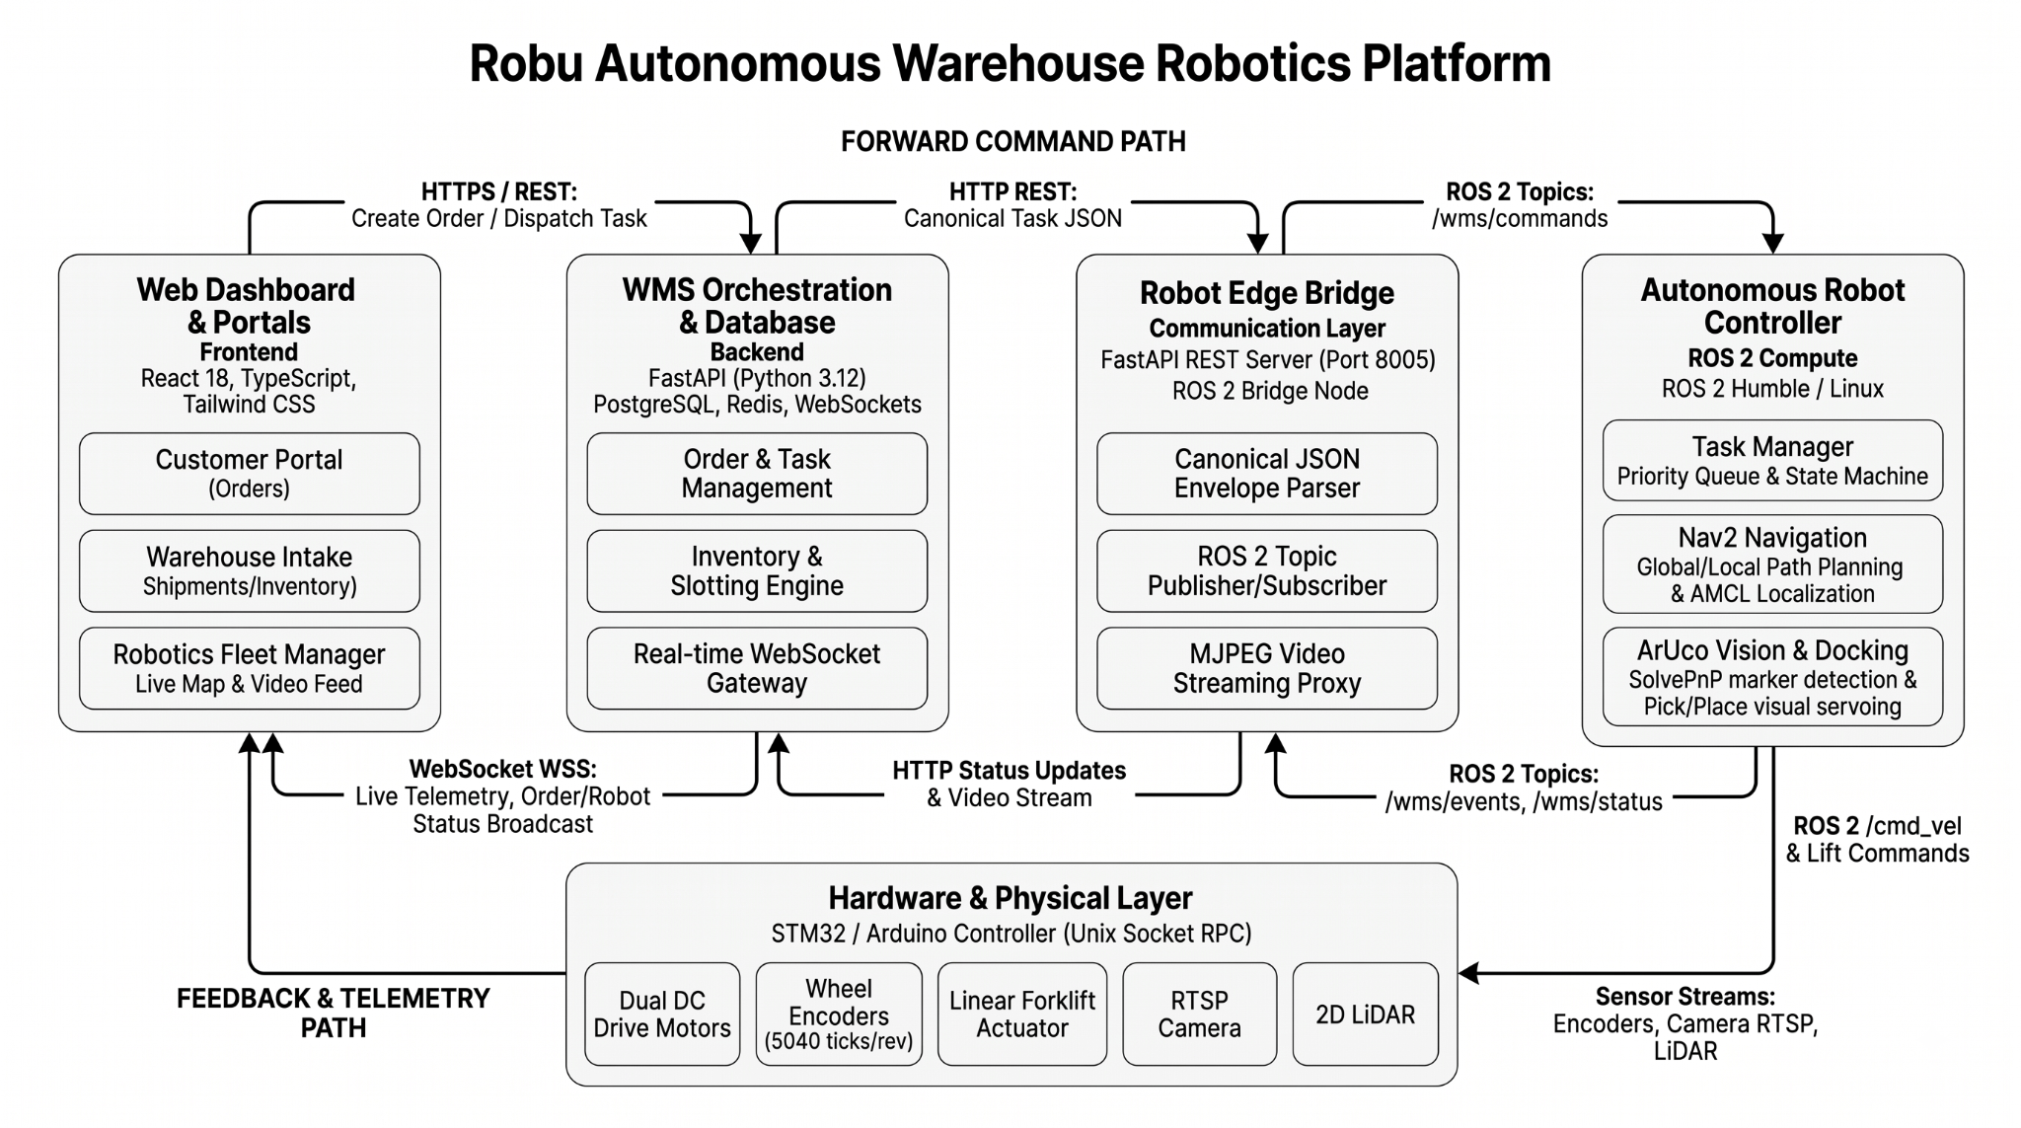

3.1 Hardware Architecture
[FILL IN] One paragraph overview of how mechanical + electrical subsystems fit together.

3.2 Software Architecture
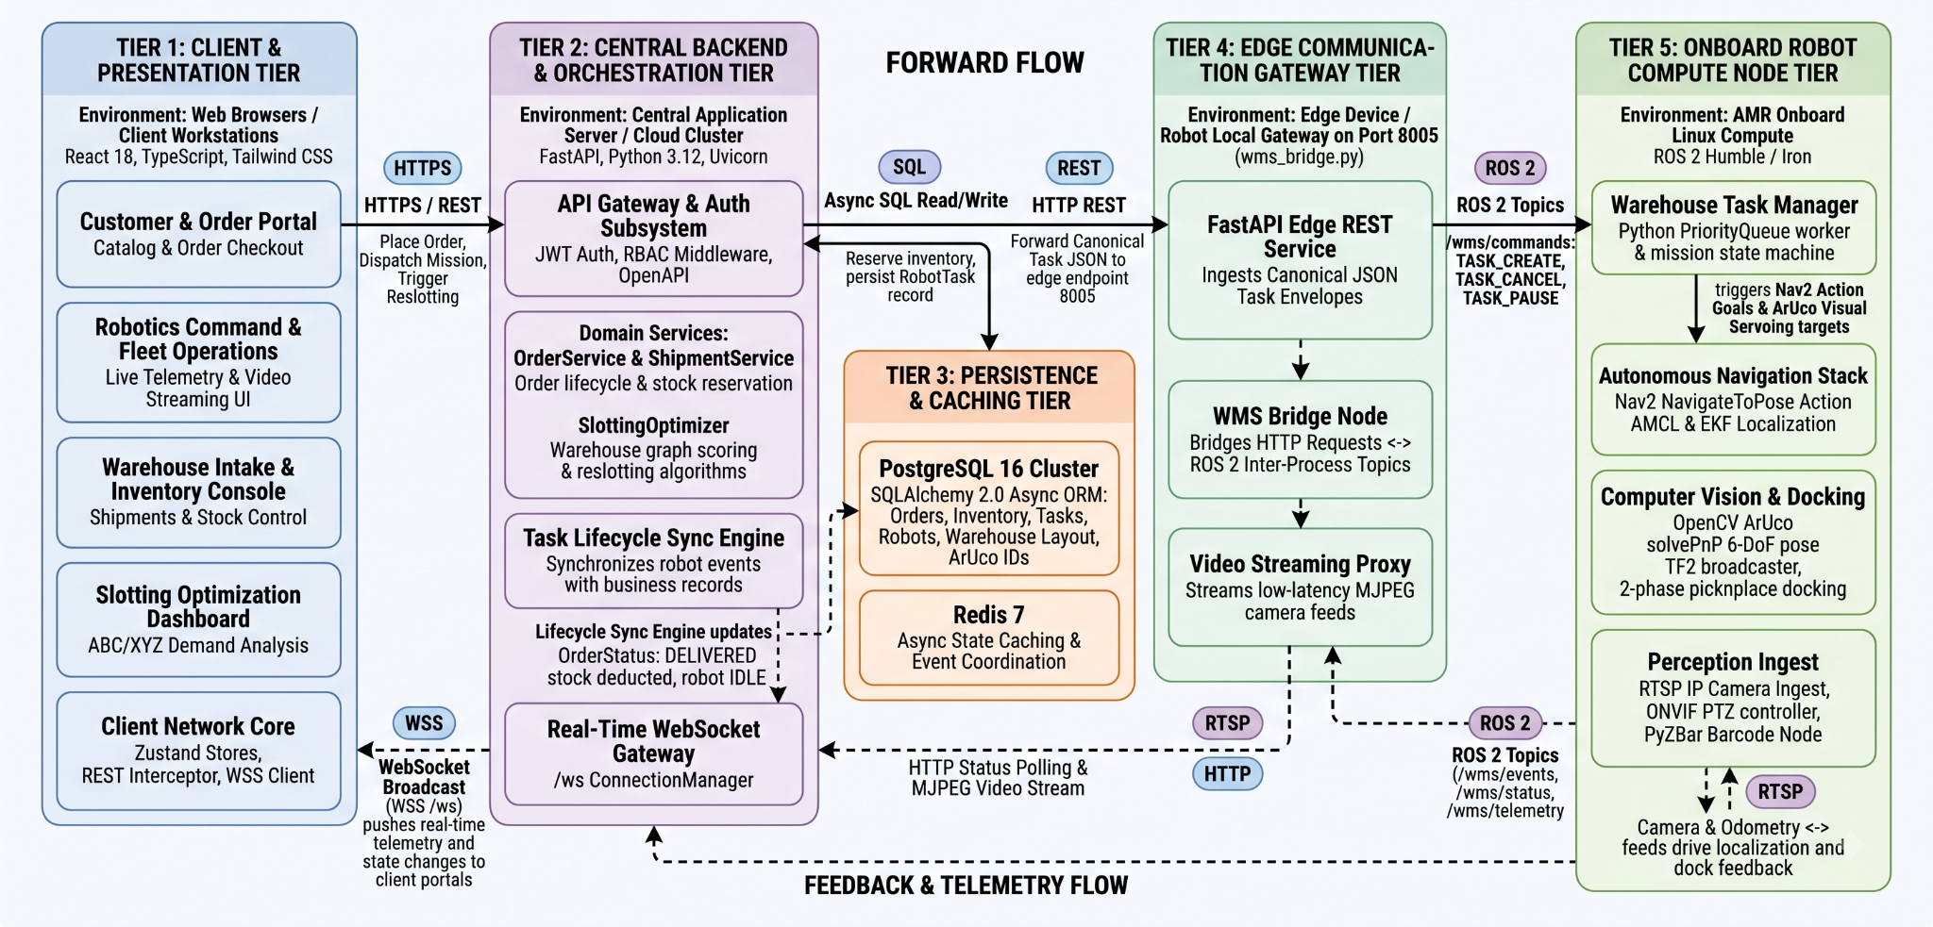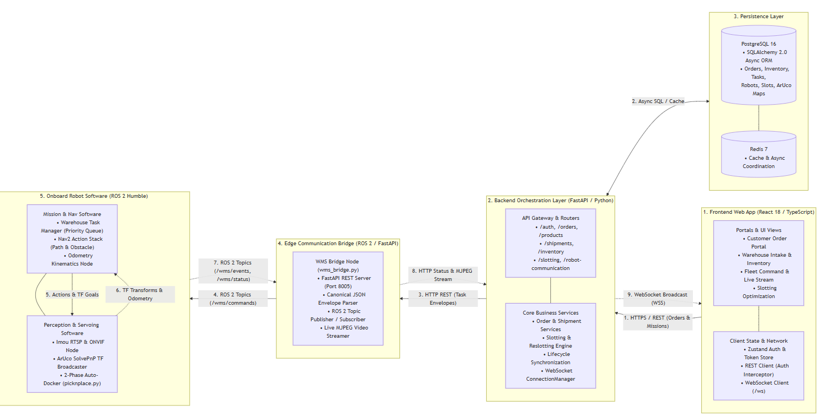

4. Hardware & Mechanical Design (part of 20 pts — Documentation)

4.1 Bill of Materials (BOM)
Sr. No. | Component | Spec / Model | Amount | Qty | Total
1 | motors | 12V 100 RPM Johnson Geared DC Motor - Grade A Quality | 429 | 2 | 858
2 | drive wheels | EasyMech Heavy Duty 100mm Disc Wheel Yellow 1 Pc | 224 | 2 | 448
3 | caster wheels | BOSNEY 4 Inch Caster Wheels, Casters Set Of 4, Heavy Duty Casters With Brake 2200 Lbs, Locking Industrial Swivel Top Plate Casters Wheels For Furniture And Workbench Cart(Two Hardware Kits Include) | Polyurethane, Dual Lock Industrial Swivel Plate Mount for Furniture/ Workbench/Cart, Hardware Kits for Installation | 1379 | 1 | 1379
4 | IMU | MPU-6050 Gyro Sensor 2 + Accelerometer. | 169 | 1 | 169
5 | ESTOP | Red Mushroom Cap LAY37-, 11ZS 1NO 1NC DPST, Emergency Stop Push, Button Switch AC 690V 10A, Switch Equipment Lift, Elevator Latching Self Lock | 107 | 1 | 107
6 | motor driver | L298N Based Motor Driver Module – 2A | 139 | 2
7 | linear actuator | Linear Actuator Stroke Length 200MM,7mm/S,1500N,12V | 3221 | 1 | 3221
8 | arduinoq | Official Arduino UNO Q Single Board Computer Model 4GB ABX00173 | 6549 | 1 | 6549
9 | encoders | OE-28 Hall Effect Two Channel Magnetic Encoder | 429 | 2 | 858
10 | buck converter | 24V/12V to 5V 5A Power Module DC-DC XY-3606 Power Converter | 125 | 1 | 125
11 | lidar | YDLIDAR X2 2D LiDAR Sensor 360° Scan 8m ROS Compatible | 5999 | 1 | 5999
12 | camera | Imou 360° 1080P Full HD Security Camera, Human Detection, Motion Tracking, 2-Way Audio, Night Vision, Dome Camera with WiFi & Ethernet Connection, Alexa Google Assistant, Up to 256GB SD Card Support | 2700 | 1 | 2700
13 | usb hub | Netech USB-C to 4 Port USB-A Hub | 599 | 1 | 599
14 | battery | 12v 12amp battery | 1800 | 1 | 1800
15 | robot chassis | Robot chassis | 10000 | 1 | 10000
16 | nuts | M4 nuts and bolts | 10 | 30 | 300
17 | 3d printer | 3d printed parts | 100 | 1 | 100
18 | wires | Jumper wires | 5 | 20 | 100
Total cost: ₹35,312

4.2 Forklift & Linear Actuator Design
[FILL IN] Why this mechanism (vs. gripper/conveyor etc.), load capacity, range of motion, how it interfaces with the chassis. Include a labeled photo or CAD render.

4.3 Chassis & Drivetrain
[FILL IN] Frame material, wheel/drive configuration, dimensions, weight.

4.4 Circuit Schematic
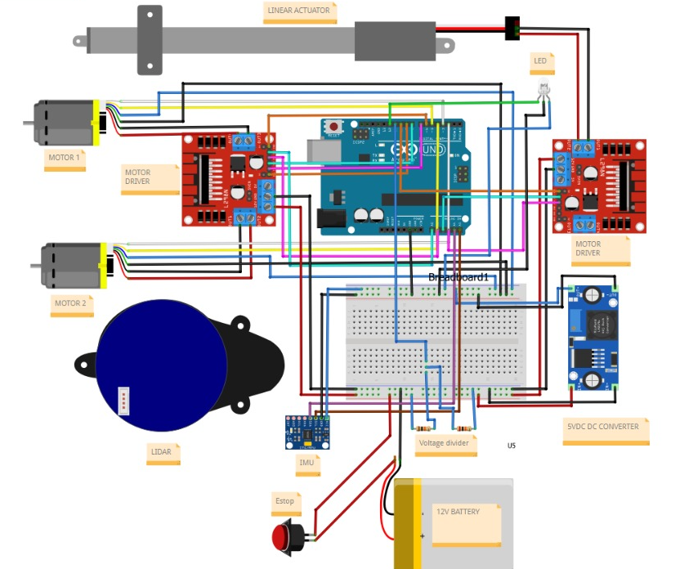

5. Software & Autonomy (part of 20 pts — Documentation)
The ROS 2 Brain
While the Arduino handles the "muscle" (moving the motors) and the Website acts as the "manager" (giving orders), we needed a "brain" to translate high-level commands into physical, real-world navigation. For this, we built a custom robotics stack using ROS 2 (Robot Operating System 2), the industry standard for modern autonomous systems.

Our ROS 2 workspace acts as the central nervous system of the forklift, handling everything from spatial awareness to priority task management.

5.1 The Navigation & Vision Algorithm
“How does it know where to go, and how does it actually pick up the item?”

To a human, driving to an aisle and picking up a box is easy. To a robot, the warehouse is just a blank void of math. We solved this in two distinct phases:

Global Navigation (Getting to the general area): We use Nav2 alongside a pre-mapped SLAM (Simultaneous Localization and Mapping) grid of the warehouse. Using its onboard LiDAR and wheel encoders (Odometry), the robot constantly tracks its exact coordinates. When the website orders a pick, the ROS 2 Task Manager calculates the most efficient route around obstacles to get within a few feet of the correct rack.
Visual Servoing (The precision pick): Standard LiDAR and wheel encoders are great for driving down aisles, but they aren't accurate enough to slide a forklift tine into a millimeter-precise slot. So, once the robot arrives at the rack, it switches to "Vision Mode". Using an onboard IP camera and OpenCV, the robot searches for an ArUco marker (a high-tech QR code) placed on the rack. The robot continuously calculates its distance and angle to this marker, micro-adjusting its wheels until it perfectly aligns with the payload.
5.2 The Priority Task Queue (State Machine)
We designed the robot to be fully asynchronous and capable of handling complex warehouse environments. Our custom ROS 2 Task Manager doesn't just blindly execute commands; it uses a PriorityQueue.

If the website queues three standard deliveries, but suddenly flags a "Priority 5" urgent dispatch, our ROS brain will instantly sort the urgent task to the front of the line.

The Pick-and-Place Lifecycle:

IDLE: Waiting for commands.
NAVIGATING_TO_PICK: Driving autonomously across the warehouse map.
ALIGNING: Using camera vision to perfectly center the forklift.
PICKING: Commanding the Arduino to raise the linear actuator.
NAVIGATING_TO_DISPATCH: Taking the payload to the shipping zone.
PLACING: Lowering the actuator and backing away. (At every step, ROS fires a real-time telemetry event back to the website so the warehouse manager can watch the progress live).

5.3 System Choices & Challenges Overcome
Building this bridge between the web, ROS 2, and the physical motors came with significant engineering challenges:

The Communication Bottleneck: Traditional robots suffer from connection drops. If our robot loses connection to the web server, it shouldn't crash into a wall. Solution: We designed a custom wms_bridge running a FastAPI server natively inside ROS 2. It accepts tasks wrapped in a strict "Canonical JSON Envelope" and operates entirely independently. If the Wi-Fi drops, the robot safely finishes its current physical task using its onboard map.
CPU Overhead & Video Streaming: We wanted the website to have a live, zero-latency video feed from the robot's camera. However, processing heavy ROS 2 image messages into a web video stream was eating up 100% of the CPU. Solution: We built a custom multi-threaded buffer using OpenCV (cv_bridge) that encodes the raw ROS images to lightweight JPEGs on the fly, capping it at a smooth 20 FPS. This gave us a flawless live MJPEG stream without lagging the robot's driving performance.
Hardware Resilience: Sometimes the serial connection between the ROS computer and the Arduino jitters. Instead of the robot freezing, we wrote a throttled daemon-safe hardware node. If a command fails to reach the Arduino, ROS catches the error, logs it, and safely retries without crashing the main navigation loop.

5.4 Code Structure & Organization
To keep our software scalable and modular, we strictly avoided writing "spaghetti code." Instead, we divided our ROS 2 workspace (aam_ws) into specialized packages, each handling one distinct responsibility. If a team member needs to update the camera logic, they don't have to touch the motor control code.

Here is the high-level architecture of our codebase:

text

aam_ws/src/
├── aamros/ # The Hardware Translation Layer
│ ├── robot_hardware_node.py # Bridges ROS 2 Twist commands to Arduino RPC calls
│ └── bridge_client.py # Daemon-safe socket manager to prevent crashes
│
├── armsbot_navigation/ # The "Brain" and State Machine
│ ├── task_manager.py # The PriorityQueue and mission lifecycle tracker
│ ├── wms_bridge.py # FastAPI server hosting the Web API and Video Stream
│ └── picknplace.py # The precision ArUco alignment and actuator script
│
├── armsbot_camera/ # The Vision Pipeline
│ └── imou_camera_node.py # Connects to IP camera, decodes RTSP, publishes to ROS
│
└── armsbot_description/ # Physical Modelling
├── urdf/robot.urdf.xacro # 3D physics model of chassis & forklift used for mapping
└── worlds/arms_warehouse # Simulation environments for testing before real-world drops
Key Code Highlights:

task_manager.py: This is where the core autonomy logic lives. It subscribes to /battery and /wms/commands, making real-time decisions on what task to execute next based on priority weighting.
wms_bridge.py: Rather than using heavy, complex ROS 2 WebSockets, we wrote this file to spin up a lightweight, asynchronous HTTP server using FastAPI and uvicorn inside a ROS node. This makes it incredibly easy for the web team to communicate with the robot using standard web POST/GET requests without needing to know anything about ROS.

5.1 Navigation Algorithm
[FILL IN] Explain in plain language first (1-2 sentences a non-technical judge can follow), then go technical: sensors used, algorithm type (line-following / grid-based / SLAM / etc.), how the bot localizes itself and the target rack.

5.2 Pick-and-Place State Machine
[FILL IN] Describe the sequence of states the bot moves through (e.g. IDLE → NAVIGATE_TO_RACK → ALIGN → LIFT → RETRIEVE → NAVIGATE_TO_DISPATCH → LOWER → RELEASE → IDLE). A simple flowchart works well here.

5.3 Website – Bot Communication
[FILL IN] How a command entered on the website (item + rack) reaches the bot. Include: tech stack used for the website, communication protocol, message/data format, and how the bot confirms task completion back to the website.

5.4 Code Structure
[FILL IN] A short module/file-level diagram or tree (not a full code dump) showing how your codebase is organized — e.g. /navigation, /actuator_control, /comms, /web_backend — plus a one-line description of each module's responsibility.

6. Operation Workflow (part of 20 pts — Documentation)
[FILL IN] Insert an end-to-end flowchart or numbered sequence: User selects item on website → Command sent → Bot navigates to rack → Picks via actuator → Navigates to dispatch → Releases → Confirms completion on website.

7. Testing & Performance Results (the strongest evidence for 40 pts — Functionality & Execution)
[FILL IN] This section carries the most weight. Quantify everything — judges score proven performance far higher than descriptive claims.

7.1 Test Summary
Metric | Result
Total test runs | ___
Successful pick-dispatch cycles | ___ / ___ (___%)
Average cycle time | ___ sec
Pick accuracy (correct rack/item) | ___%
Max load handled | ___ kg/g

7.2 Edge Cases & Reliability
To ensure the robot could operate continuously in a real-world warehouse environment, we aggressively tested and programmed solutions for several critical edge cases in the ROS 2 software stack:

- Wi-Fi / Network Dropouts:

The Edge Case: Warehouses are notorious for having Wi-Fi dead zones. If the robot loses connection to the WMS website mid-drive, does it crash or go rogue?
The Solution: We designed the task_manager.py state machine to be fully autonomous once a command is received. Because tasks are packaged in a strict JSON envelope, the robot downloads the entire mission parameters upfront. If Wi-Fi drops, the robot safely continues driving and picking using its onboard SLAM map and LiDAR. It caches its telemetry and simply re-syncs with the web dashboard once it drives back into network range.
- Low Battery Mid-Task:

The Edge Case: The robot running out of power and dying in the middle of a busy aisle, blocking other warehouse traffic.
The Solution: We built a real-time hardware-to-software bridge. The Arduino constantly reads the battery voltage, quantizes it, and sends it to the ROS 2 brain. We programmed a safety threshold so that if the battery dips below 15%, ROS 2 instantly fires a LOW_BATTERY alert payload to the web dashboard, allowing the manager to recall the robot before it dies on the floor.
- Task Queue Spikes (The Urgent Dispatch):

The Edge Case: The robot is assigned 10 standard pick tasks in a row, but suddenly a VIP order comes in that needs to be shipped immediately.
The Solution: Instead of a basic First-In-First-Out (FIFO) list, we implemented a mathematical PriorityQueue in the autonomy software. If the WMS flags a new task as "Priority 5", the ROS brain automatically bubbles it to the front of the line. The robot will finish its current physical movement, and instantly pivot to the urgent task without corrupting the rest of the queue.
- Hardware Communication Jitter:

The Edge Case: The internal serial connection between the ROS microcomputer and the Arduino motor controller experiences a split-second voltage drop or misses a packet.
The Solution: We programmed the robot_hardware_node to be "daemon-safe." If an RPC call fails, the robot doesn't crash the program. Instead, it enters a temporary holding state, logs the failure internally without spamming the CPU, and seamlessly re-engages the motors the exact millisecond the connection stabilizes.

[FILL IN] What edge cases did you test — misaligned item, rack out of range, obstacle in path, low battery, network drop? What happened and how did the bot handle or fail to handle it?

7.3 Iteration & Fixes
[FILL IN] Briefly note 1-2 things that failed in earlier testing and what you changed — shows engineering rigor.

8. Demonstration (15 pts — Presentation & Creativity)
[FILL IN] Link/QR code to a short (60-120 sec) demo video showing real autonomous operation — not just CAD renders or a static bot. Include 2-3 photos of the physical build here as well.

9. Challenges & Learnings
- Bridging the Web to the Robot:

- Challenge: ROS 2 is fantastic for robotics, but it is notoriously difficult to connect to standard web technologies. Traditional ROS WebSockets (like rosbridge) are heavy, complex, and prone to breaking.
- Learning: Instead of forcing the website to speak "ROS," we brought the web into ROS. We learned how to embed a lightweight asynchronous HTTP server (FastAPI) directly inside a ROS 2 node. This allowed our WMS website to command the robot using standard, simple JSON API requests, completely decoupling the web logic from the robot's internal complexity.
- Live Video Streaming vs. CPU Overload:

- Challenge: We wanted the web dashboard to have a live, zero-latency feed from the robot's IP camera. However, piping raw ROS sensor_msgs/Image data directly over the network instantly maxed out the robot’s CPU and caused the navigation to lag.
- Learning: We learned how to optimize data pipelines. We built a thread-safe buffering mechanism using cv_bridge that intercepts the ROS images, compresses them into lightweight JPEGs on the fly, and uses an asynchronous Python generator to serve an MJPEG stream capped at 20 FPS. This gave us a flawless live feed with almost zero impact on the CPU.
- Hardware Jitter and Software Resilience:

- Challenge: In the real world, physical connections aren't perfect. The serial/RPC connection bridging our ROS computer to the Arduino (STM32) would occasionally drop a packet or jitter. Initially, this caused the ROS hardware node to silently freeze or crash, meaning the robot just stopped moving.
- Learning: We learned the importance of "fault-tolerant" code. We rewrote the hardware node to catch these connection exceptions gracefully rather than crashing. By throttling the polling rate and adding a failure-tracking system, the robot now intelligently waits out a bad connection and instantly recovers the moment the link is re-established.
- Dependency Nightmares (Python 2 vs 3):

- Challenge: While setting up the camera node in our Docker container, the build kept failing deep inside a dependency called suds-passworddigest.
- Learning: We learned how to debug legacy software chains. We discovered that the standard onvif camera package was abandoned and still trying to use Python 2 syntax in a modern Python 3 environment. We solved it by hunting down and migrating our codebase to the actively maintained onvif-zeep fork, reinforcing the lesson that open-source robotics relies heavily on keeping dependencies modernized.

[FILL IN] 2-4 bullet points: what broke, what was hard, what you'd do differently. Judges value genuine problem-solving over a flawless narrative.
- ___
- ___

10. Future Scope
Our current prototype successfully proves the core concept of a web-commanded, autonomous warehousing bot. However, the architecture (ROS 2 + FastAPI + React) was intentionally chosen because it is highly scalable. To transition this system from a proof-of-concept to a deployment-ready industrial solution, we have identified the following upgrade paths:

- Multi-Bot Fleet Orchestration: A modern e-commerce fulfillment center requires dozens of robots working simultaneously to achieve 24/7 high-throughput picking. Our current WMS backend is already capable of tracking multiple agents. The next step is to upgrade our ROS 2 stack to support multi-robot namespaces and implement centralized traffic management (similar to Brightpick’s "Intuition" software), ensuring a swarm of robots can navigate the same aisles at 5+ mph without deadlocks or collisions.

- Advanced Depth-Sensing Computer Vision: Currently, we rely on ArUco markers (fiducials) placed on racks to mathematically calculate distance and depth during the precision alignment phase. Upgrading the hardware to a dedicated RGB-D (Depth-sensing) camera (such as an Intel RealSense or OAK-D) would allow the robot to navigate and align using pure Computer Vision and AI spatial mapping. This eliminates the need for physical QR codes on racks, making the system "infrastructure-free" and easier to deploy in existing warehouses.

- Hybrid Robotic Manipulation (Bin Picking): While our current linear actuator perfectly handles pallet and tote-level retrieval, future iterations could integrate a 6-axis robotic arm directly onto the chassis. Powered by Machine Learning object-detection models, the bot could drive to a rack, look inside a mixed bin, and pick individual, unstructured items (bottles, polybags, boxes) using a suction or pneumatic gripper. If the AI fumbles a pick, it can use reinforcement learning to improve on its next attempt.

- Dynamic Slotting & Order Buffering: Taking inspiration from state-of-the-art facilities, we can expand our WMS software to implement "Dynamic Slotting." When the robots are idle overnight, they can autonomously reorganize the warehouse—moving high-demand items closer to the human pack-out stations to minimize travel time for the morning shift. Furthermore, robots could temporarily buffer picked orders inside the racks until the exact moment a human packer needs them, smoothing out volume spikes during peak hours.

[FILL IN] 2-3 bullet points on how this could scale or improve beyond the competition (multi-bot fleet, obstacle avoidance upgrade, inventory analytics dashboard, etc.).
- ___
- ___

Appendix
[FILL IN] Full code repository link, additional CAD views, extended test logs, datasheets for key components.

