Software Specification

Project Name: Update Gold price Daily

Date: Friday, March 17, 2017

Created by: Rohit Badgujar

Software Requirement : Visual Studio And MS SQL

## 1 Daily Update Gold Price

### 1.1 Description

In this project, application ask for Date and Gold rate for that date. If Date already exists in database than it will update the data. If not than insert the new data.

### 1.2 Stimulus/Response Sequences (UI Description)

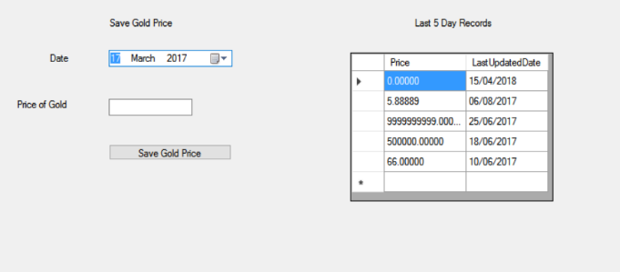

Picture 1.2.1

### 1.3 Functional Requirements

The Application is made to Capture to fields from User

* Date (by default todays Date)
* Price of Gold +ve integer >= 0
* On click Save Gold Price Button :
  + Price of Gold is Validated
  + Alert message if Validation return false
  + If validation returns true.
  + Update Price if Date already exist
  + If not exist Insert Price and Date in Table

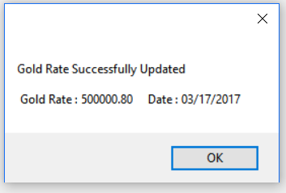

*Picture 1.3.1*

# Data Storage Requirements

## Tables

In order to support the proposed functionality, the following table structures need to be created.

Table Name DailyGoldRate (Find SQL schema “DailyGoldRate.sql” to create Table in Project folder)

## Procedure

In order to support the proposed functionality, the following SP structures need to be created.

SP Name UpdateDailyGoldPrice

(Find SQL schema “DailyGoldRate.sql” to create SP in Project folder)

# 3. Configuration Settings

Add Connection string in App.config of Project.