***FOLLOW THE STEPS FOR COMPLETE SIMULATION***

STEP 1. GO TO THE EDITOR SECTION AND GO TO THE IMPORT DATA AND SELECT THE DATA FILE .

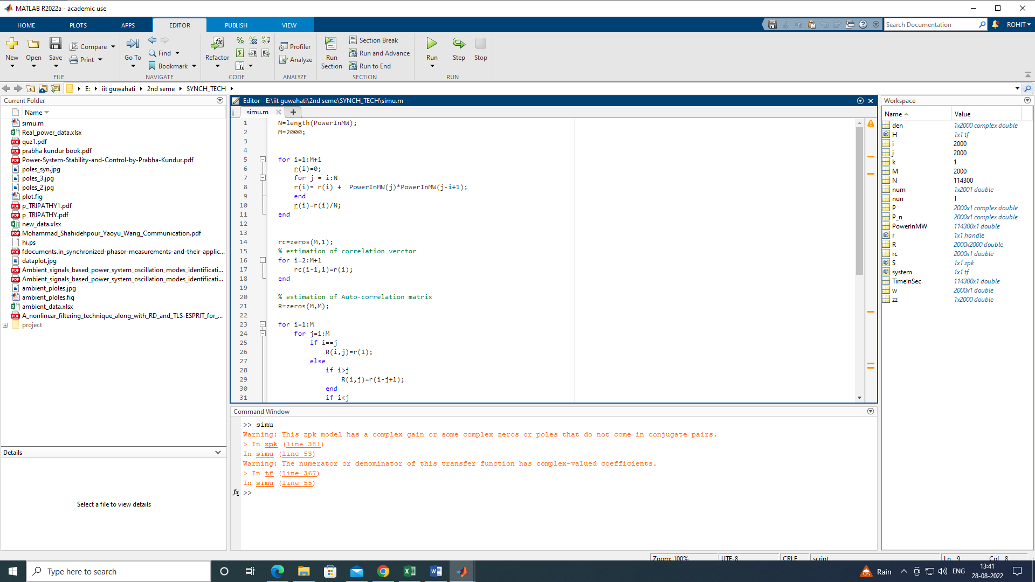

STEP 2. SELECT THE COLUMN VECTOR

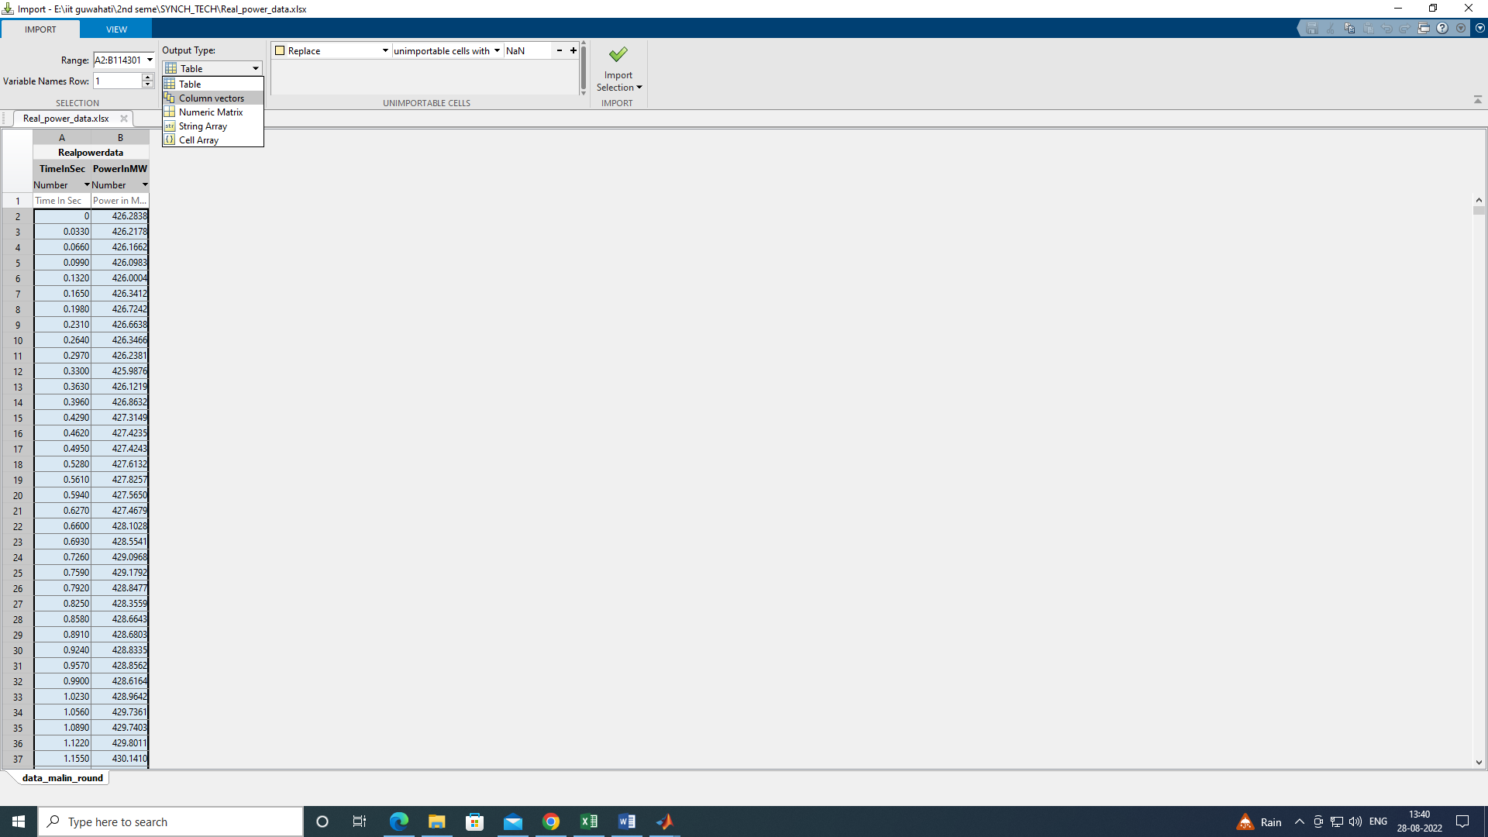

STEP 3. IMPORT THE DATA

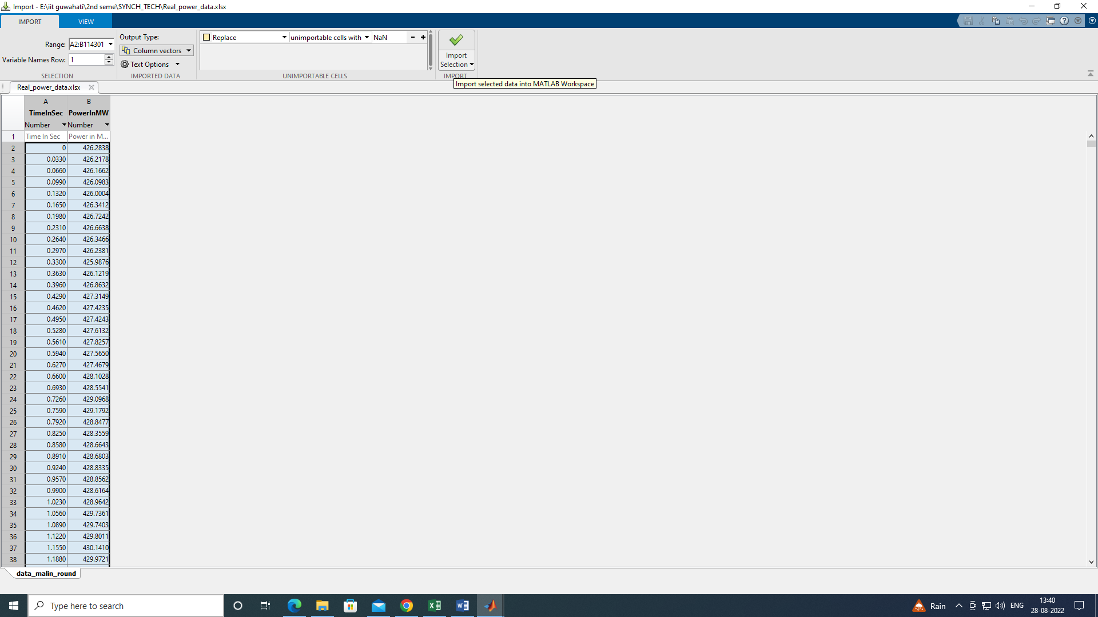

STEP 3. DATA ARE SUCCESFULLY IMPORTED

