Name:- Vaishnavi Ganesh Jedhe

Class:- TE A

Roll No.:- A47

CODES:-

**AccountCreate.apxc**

public class AccountCreate {

public String name {get; set;}

public String phoneNumber {get; set;}

public String selectedname {get; set;}

public String websiteURL {get; set;}

public List<SelectOption> lstnamesel {get; set;}

public AccountCreate(ApexPages.StandardController controller) {

lstnamesel = new List<SelectOption>();

lstnamesel.add(new SelectOption('','- None -'));

lstnamesel.add(new SelectOption('IT','IT'));

lstnamesel.add(new SelectOption('MECH','MECH'));

lstnamesel.add(new SelectOption('CHEM','CHEM'));

lstnamesel.add(new SelectOption('PHARMA','PHARMA'));

}

public PageReference createAccount() {

System.debug('test create');

if(!String.isEmpty(name)) {

Account accountRecord = new Account(

Name = name,

Phone = phoneNumber,

Industry = selectedname,

Website = websiteURL

);

INSERT accountRecord;

PageReference pg = new PageReference('/'+accountRecord.Id);

pg.setRedirect(true);

return pg;

} else {

ApexPages.addMessage(new ApexPages.Message(ApexPages.Severity.CONFIRM,'Please enter Account Name'));

}

return null;

}

public PageReference cancelAccount() {

PageReference pg = new PageReference('/'+Schema.SObjectType.Account.getKeyPrefix()+'/o');

return pg;

}

}

**AccountCreate.vfp**

<apex:page standardController="Account" extensions="AccountCreate">

<apex:form id="apexForm">

<apex:pageBlock title="Create Account:" id="pageBlockId">

<apex:pageMessages id="showmsg"></apex:pageMessages>

<apex:pageBlockSection columns="2">

<!--<div class="requiredInput">

<div class="requiredBlock"></div>

<apex:inputText value="{!name}" label="Account Name" required="true"/>

</div>-->

<apex:inputText value="{!name}" label="Account Name" required="true"/>

<apex:inputText value="{!phoneNumber}" label="Phone" />

<apex:selectList size="1" value="{!selectedname}" label="Industry">

<apex:selectOptions value="{!lstnamesel}"/>

</apex:selectList>

<apex:inputText value="{!websiteURL}" label="Website"/>

</apex:pageBlockSection>

<apex:pageBlockButtons>

<apex:commandButton action="{!createAccount}" value="Save"/>

<apex:commandButton action="{!cancelAccount}" value="Cancel"/>

</apex:pageBlockButtons>

</apex:pageBlock>

<!-- ACTION FUNCTIONS-->

<apex:actionFunction name="createFunction" action="{!createAccount}"/>

<apex:actionFunction name="cancelFunction" action="{!cancelAccount}"/>

</apex:form>

</apex:page>

Step 1: Sign up to Salesforce using the following link: https://developer.salesforce.com/signup After signing up go to Setup and click on Developer Console.

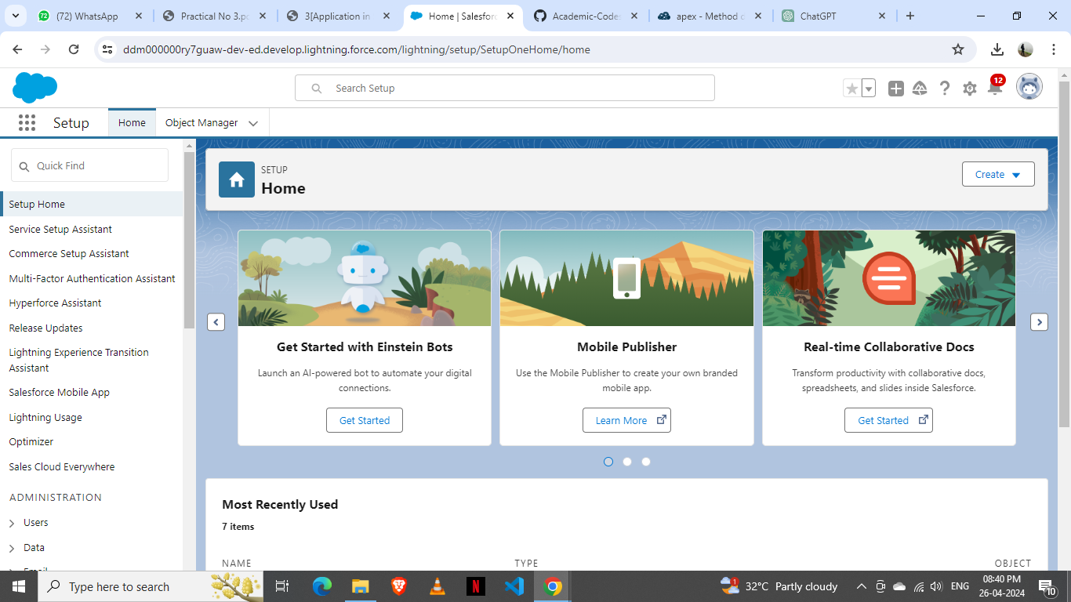

Step 2: Now, in Developer Console click on File -> New -> Apex Class and Name it as AccountCreate

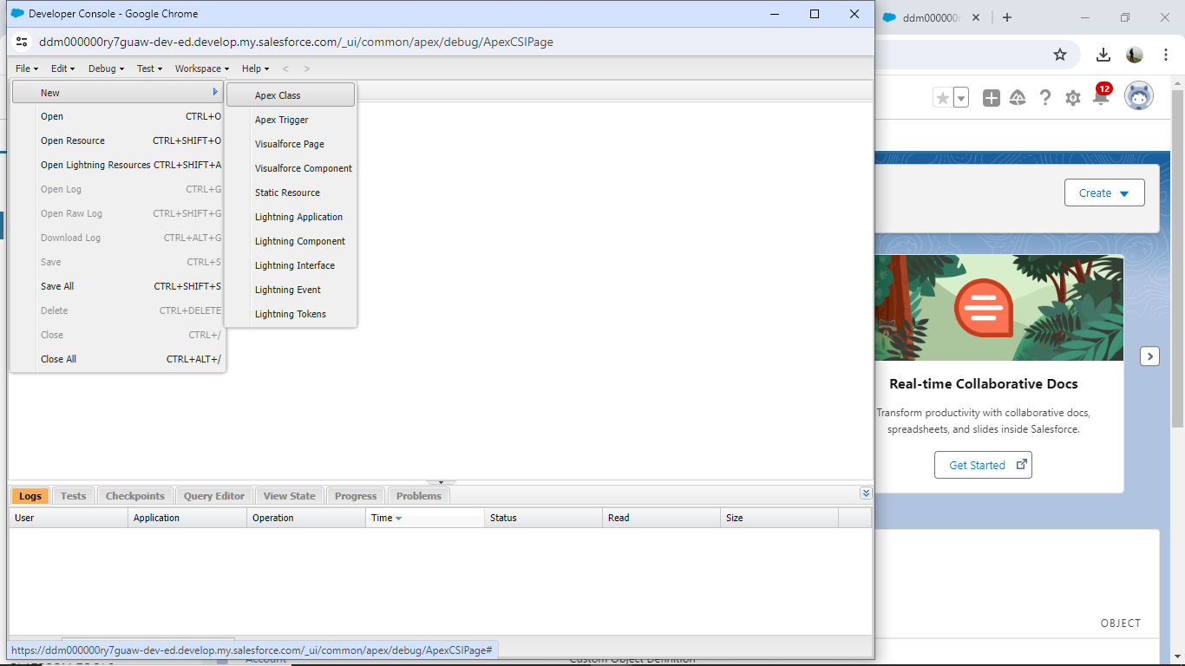

Step 3: Write the code for Apex Class

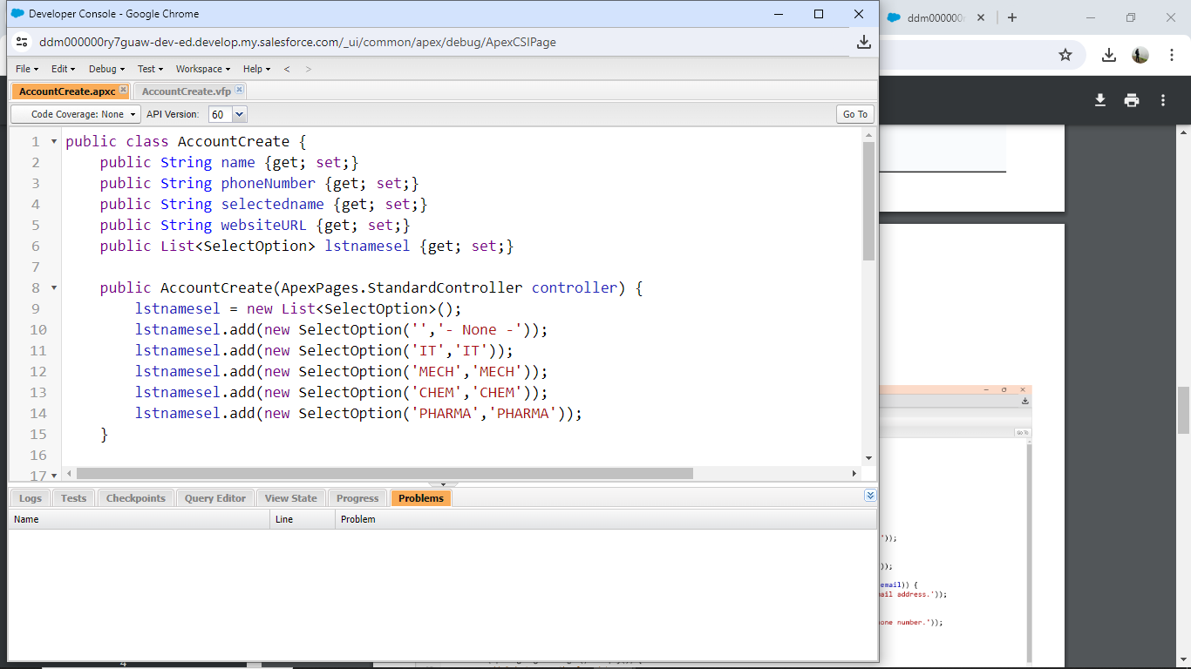

Step 4: Now, in Developer Console click on File -> New -> VisualForce Page and Name it as AccountCreate

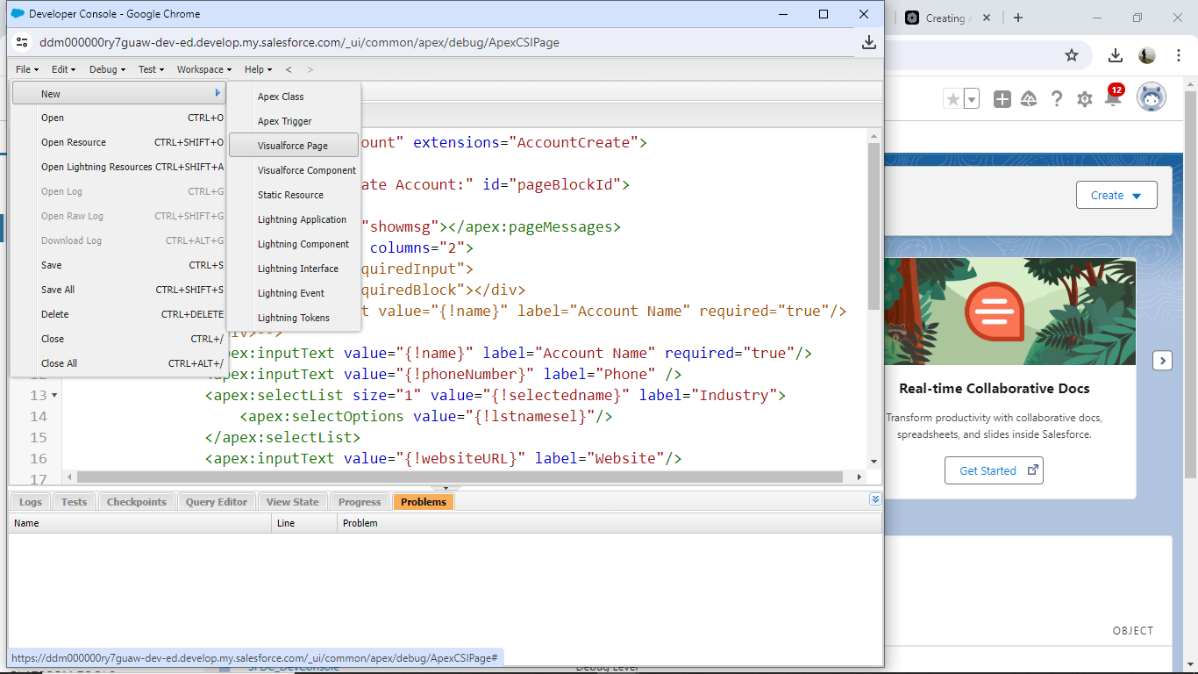

Step 5: Write code for VisualForce Page

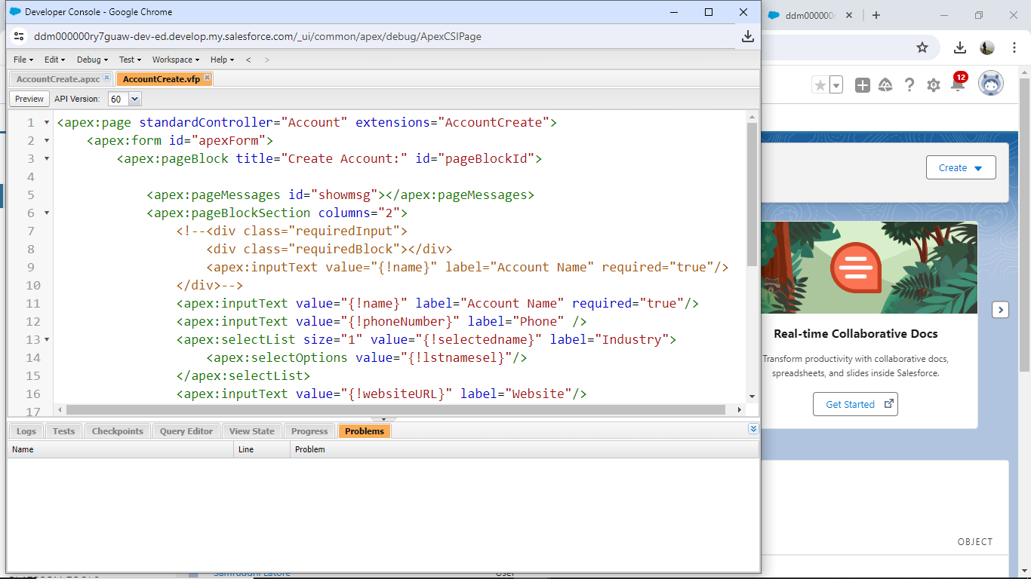

Step 6: Accessing the Visualforce Page: To access the Visualforce page, you can navigate to it directly by appending its name to your Salesforce instance URL. For example, if your Salesforce instance URL is https://yourinstance.salesforce.com, then you can access the Visualforce page at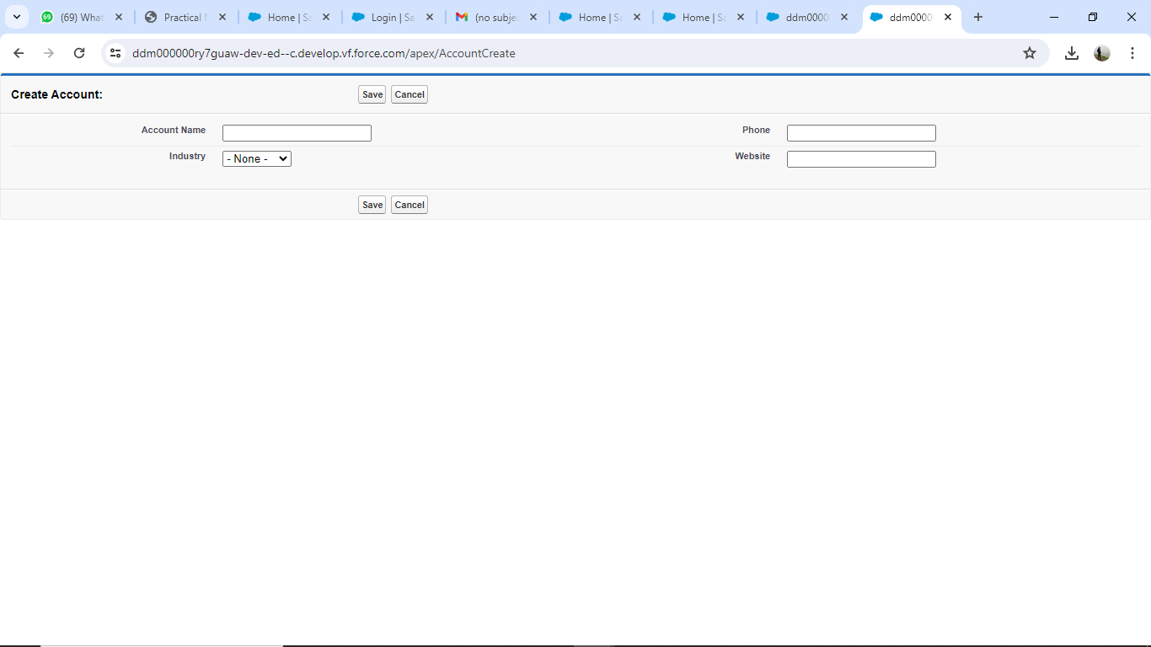

**My Application Link Is:**

[**https://ddm000000ry7guaw-dev-ed--c.develop.vf.force.com/apex/AccountCreate**](https://ddm000000ry7guaw-dev-ed--c.develop.vf.force.com/apex/AccountCreate)

