Heart Disease Risk Prediction
A leakage-free machine-learning pipeline for clinical triage
Problem-Based Learning (PBL) Project Report
AIDS Department
Student: Rohit Dnyaneshwar Mahale
PRN: 2125UDSM2043
Class: TY AIDS-B (Third Year), AIDS Department
Date: October 2026

Abstract
Cardiology capacity is limited, and a missed heart-disease patient is far costlier than an unnecessary referral. We built a decision-support model that predicts heart disease from eleven routine clinical measurements and converts the prediction into Low / Moderate / High risk tiers. Using the public Heart Failure Prediction dataset (918 patients), we replaced a basic notebook — which imputed impossible cholesterol zeros with the mean and compared five models on a single split — with a complete, leakage-free pipeline: zero-to-missing handling with a missing-value indicator, median imputation, IQR winsorising, scaling and encoding inside a scikit-learn Pipeline; clinically motivated feature engineering; seven algorithms compared by repeated stratified cross-validation; grid-search tuning; and threshold selection from out-of-fold predictions.
The final Random Forest reached, on a 184-patient hold-out set never used for any decision, recall 0.922, precision 0.847, F1 0.883 and ROC-AUC 0.926, meeting all four pre-declared KPIs. The ST-segment slope is by far the strongest predictor. The risk tiers separate patients well (observed disease rate 3.8 % / 27.5 % / 85.8 %), and at screening-population prevalence the model is projected to cut specialist referrals by about 65 % while still catching 92 % of sick patients. A Streamlit web application demonstrates the model. We also report limitations honestly: a small pooled legacy dataset, a thin female subgroup, and the need for local validation.

1. Problem Definition and Business Understanding

1.1 Problem statement
Cardiovascular disease is the world's leading cause of death (about 17.9 million deaths a year, WHO). In primary-care and screening settings, doctors must decide quickly who needs a cardiology work-up, while specialist time, ECG and stress-test capacity are limited. Patients with early disease who are not flagged may leave without follow-up; healthy patients who are flagged consume scarce slots.
Problem: given routine measurements taken at a screening visit, predict whether a patient has heart disease, so clinicians can prioritise high-risk patients for referral.

1.2 Objectives
- Build a reproducible, leakage-free ML pipeline that predicts HeartDisease.
- Achieve high recall (sensitivity ≥ 0.90) while keeping precision reasonable.
- Identify the clinical factors that drive risk and turn them into screening guidance.
- Deliver a risk-tier output (Low / Moderate / High) and a deployable web demo.

1.3 Stakeholders and business relevance
Stakeholder | Interest
General practitioners, screening-camp doctors | Fast, explainable second opinion at the point of care
Cardiology department, hospital administration | Better use of limited specialist, ECG and stress-test capacity
Patients | Earlier detection and treatment
Insurers, public-health programmes | Lower cost of late-stage treatment

1.4 Key performance indicators
KPI | Target | Rationale
Recall (sensitivity) | ≥ 0.90 | A missed patient (false negative) is the most dangerous and costly error
Precision | ≥ 0.80 | Keeps unnecessary referrals manageable
F1-score | ≥ 0.85 | Balance of the two
ROC-AUC | ≥ 0.90 | Threshold-independent ranking quality
Expected cost per 100 patients | Minimise | Converts model errors into business terms (FN assumed 10× FP)

Scope note: this is a triage prototype trained on a small public dataset. It is not a diagnostic device and does not replace clinical judgement.

2. Dataset and Data Understanding
Source: Heart Failure Prediction Dataset (Kaggle, fedesoriano, 2021), a combination of five independent heart-disease datasets (Cleveland, Hungarian, Switzerland, Long Beach VA, Stalog) with 11 common features and 918 unique patients (Open Database License). The target HeartDisease equals 1 for 508 patients (55.3 %) and 0 for 410 (44.7 %).

2.1 Data dictionary
Feature | Type | Description | Values / units
Age | Numeric | Age of patient | years (28–77)
Sex | Categorical | Sex of patient | M / F
ChestPainType | Categorical | Type of chest pain | TA, ATA, NAP, ASY (asymptomatic)
RestingBP | Numeric | Resting systolic blood pressure | mm Hg
Cholesterol | Numeric | Serum cholesterol | mg/dl (0 = not recorded)
FastingBS | Binary | Fasting blood sugar > 120 mg/dl | 1 / 0
RestingECG | Categorical | Resting ECG result | Normal, ST, LVH
MaxHR | Numeric | Maximum heart rate in exercise test | bpm (60–202)
ExerciseAngina | Binary | Exercise-induced angina | Y / N
Oldpeak | Numeric | ST depression induced by exercise | mm
ST_Slope | Categorical | Slope of peak-exercise ST segment | Up, Flat, Down
HeartDisease | Binary (target) | Heart disease present | 1 / 0

2.2 Data-quality audit
Check | Result
Shape | 918 rows × 12 columns
Missing values (NaN) | 0
Duplicate rows | 0
Cholesterol = 0 (impossible; means not measured) | 172 rows (18.7 %)
RestingBP = 0 (impossible) | 1 row
Oldpeak < 0 | 13 rows (valid: ST elevation, kept)
Class balance | 55.3 % disease / 44.7 % healthy

The dataset looks clean — no NaN, no duplicates — yet 172 patients have Cholesterol recorded as 0. These are not real measurements. Crucially, their disease rate is 88.4 % versus 47.7 % for patients with a recorded value, so the missingness itself is informative. Classes are reasonably balanced, so no resampling was needed.

3. Data Preprocessing and Cleaning
All transformations are implemented in a reusable module (heart_utils.py) as scikit-learn transformers inside one Pipeline. Every statistic — medians, IQR fences, scaler parameters, one-hot categories — is learned only from training data (and re-learned inside each cross-validation fold), which prevents leakage. The identical pipeline object is saved and used by the web application.
Problem found | Treatment | Justification
172 Cholesterol = 0, 1 RestingBP = 0 | Set to NaN, median imputation, plus Chol_Missing indicator | Zeros are impossible; mean-filling hid an informative signal; median is robust to skew
Outliers (BP 2.9 %, Cholesterol 3.1 %, Oldpeak 1.7 %, MaxHR 0.2 %) | IQR winsorising (1.5 × IQR), bounds learned on train | Keeps all rows in a small dataset while limiting leverage of extremes
Mixed feature scales | StandardScaler | Required by LR, KNN, SVM
Categorical features | One-hot encoding (binary → one column) | No false ordinal order
Duplicates / NaN | None found | —

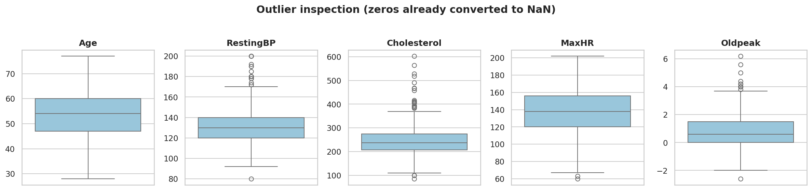
Figure 1. Outlier inspection with impossible zeros converted to NaN.
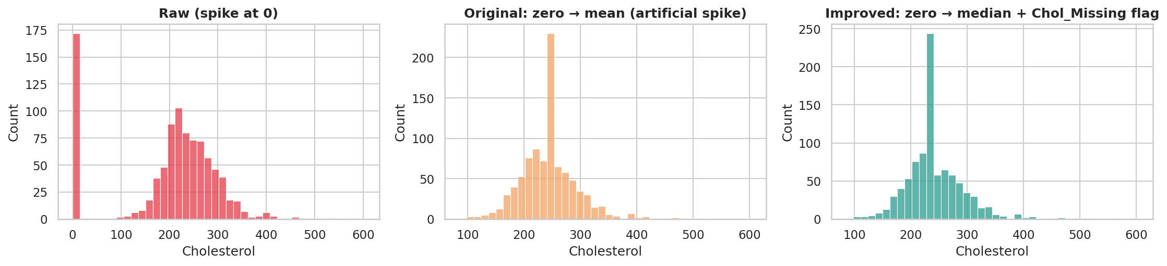
Figure 2. Cholesterol: raw data, original mean-fill, and the improved median-fill with missing flag.
The original strategy produced an artificial spike at the mean (≈ 245 mg/dl). The improved strategy keeps a realistic distribution and preserves the missingness signal. An ablation (Section 5.3) shows outlier clipping is performance-neutral on this dataset (ΔAUC ≤ 0.001); it is kept as a robustness safeguard for the deployed app, where users may enter extreme values.

4. Exploratory Data Analysis
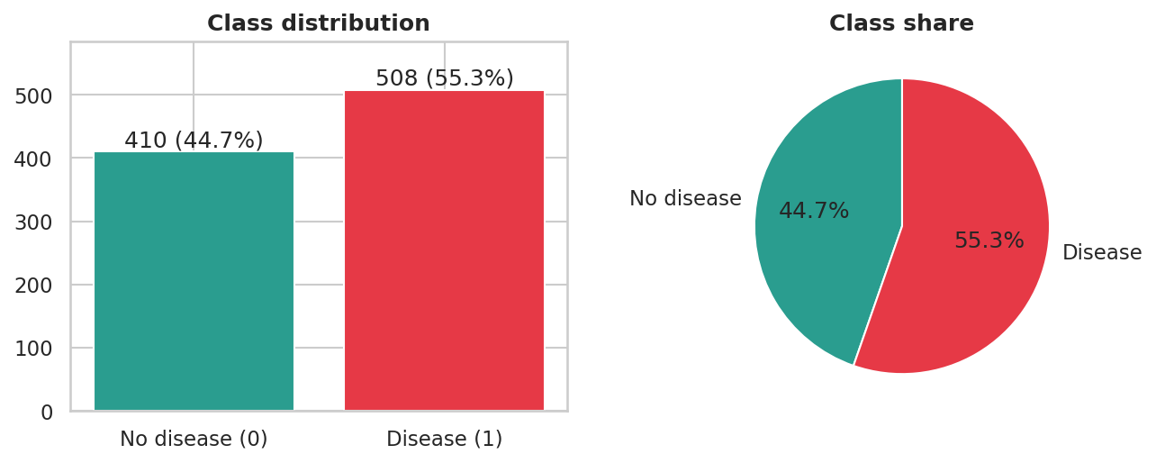
Figure 3. Class distribution of HeartDisease.
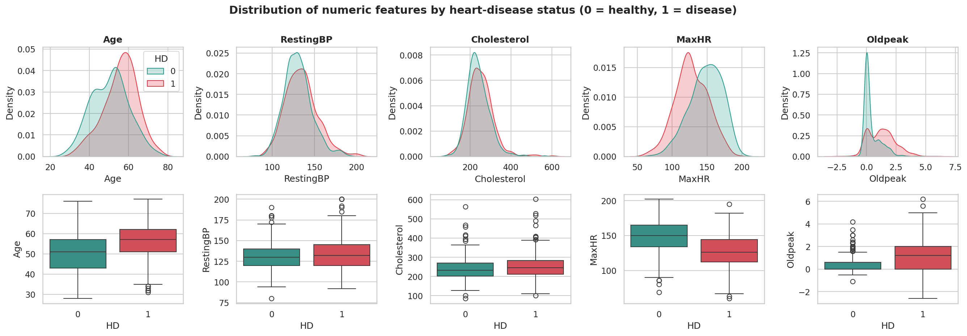
Figure 4. Numeric features by heart-disease status.
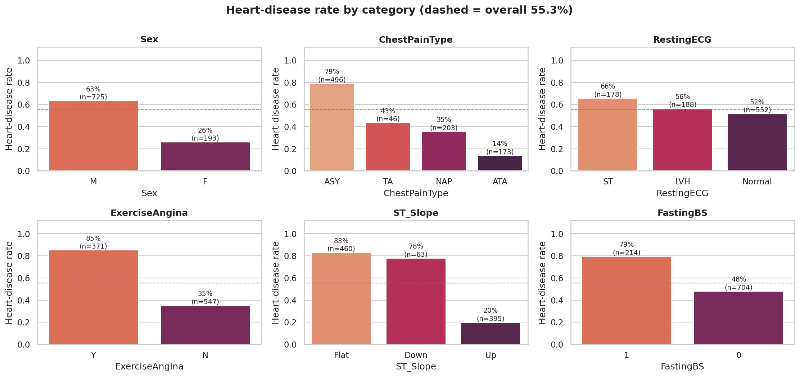
Figure 5. Heart-disease rate by category (dashed line = overall 55.3 %).

4.1 Statistical tests
Numeric features were compared with the Mann–Whitney U test (non-parametric, because distributions are skewed) and categorical features with the chi-square test and Cramér's V. All features differ significantly between classes (p < 0.01).
Feature | Test | Effect size | Observation
ST_Slope | Chi² | V = 0.62 | Flat 83 %, Down 78 %, Up 20 % disease
ChestPainType | Chi² | V = 0.54 | ASY 79 % vs ATA 14 %
ExerciseAngina | Chi² | V = 0.49 | Yes 85 % vs No 35 %
Oldpeak | Mann–Whitney | r = 0.47 | Median 1.2 vs 0.0 mm
MaxHR | Mann–Whitney | r = 0.47 | Median 126 vs 150 bpm
Sex | Chi² | V = 0.30 | Men 63 % vs women 26 %
Age | Mann–Whitney | r = 0.34 | Median 57 vs 51 years
RestingECG | Chi² | V = 0.11 | Weak association

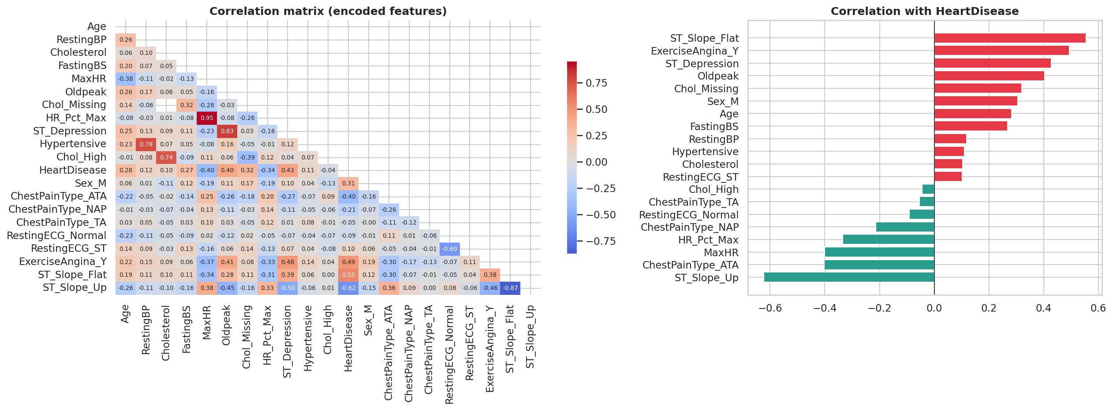
Figure 6. Correlation matrix of encoded features and correlation with the target.
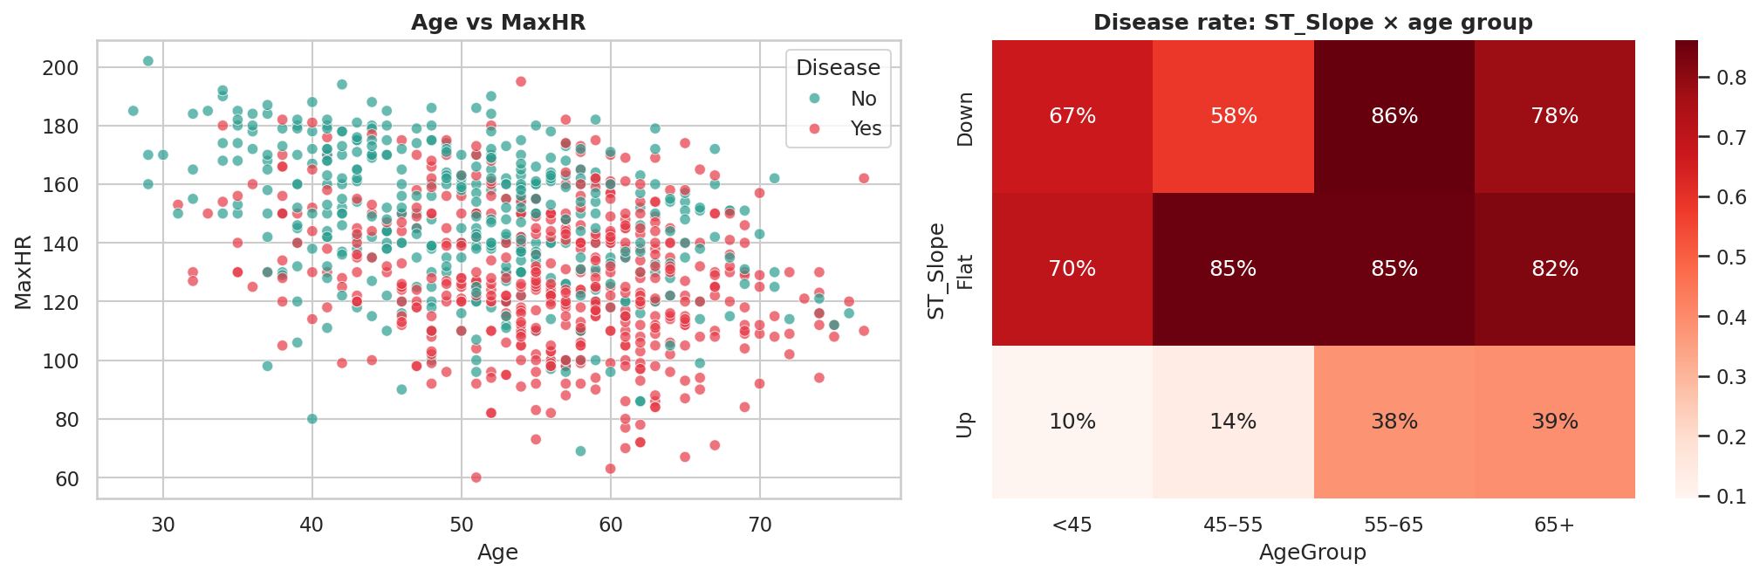
Figure 7. Age versus MaxHR, and disease rate by ST_Slope × age group.

4.2 Key insights
- ST_Slope is the strongest single predictor. A flat or downsloping slope signals 78–83 % disease; an upsloping slope only 20 %.
- Silent disease is the dangerous kind. Asymptomatic chest pain carries a 79 % disease rate.
- Exercise angina and low peak heart rate (and high Oldpeak) mark diseased patients; flat slope plus exercise angina gives 90 % disease (n = 272).
- Demographics: men 63 % vs women 26 %; disease rate rises with age (31 % under 45, 71 % at 55–65); fasting sugar > 120 mg/dl 79 % vs 48 %.
- Interaction: an upsloping ST segment is low-risk when young (10 % under 45) but rises with age (39 % at 65+), whereas a flat slope is high-risk at every age (70–85 %).
- Multicollinearity is confined to engineered features and their parents (for example MaxHR and HR_Pct_Max, r = 0.95), which regularised and tree-based models tolerate.

5. Feature Engineering, Selection and Leakage Control

5.1 Engineered features
Feature | Definition | Rationale
Chol_Missing | Cholesterol recorded as 0 | Missingness is informative (89.9 % vs 47.9 % disease)
HR_Pct_Max | MaxHR / (220 − Age) | Share of age-predicted maximum heart rate reached; fairer across ages
ST_Depression | Oldpeak ≥ 1 mm | Clinical threshold for significant ST depression (77.5 % vs 36.9 %)
Hypertensive | RestingBP ≥ 140 | Stage-2 hypertension cut-off
Chol_High | Cholesterol ≥ 240 (recorded) | High-cholesterol cut-off; found not useful (confounded with missingness)

5.2 Leakage-control checklist
- The data are split first; imputation medians, IQR fences, scaler and encoder are fit on training data only, inside the Pipeline.
- No target-derived features. Oldpeak, ST_Slope and ExerciseAngina come from a stress test — legitimate inputs for a cardiology work-up, but not available at a basic GP visit (see Limitations).
- Hyper-parameters were tuned only on the training set by cross-validation; the test set was used once for the final report.
- The decision threshold was chosen from out-of-fold training predictions, never from test data.

5.3 Ablation of preprocessing choices
Four preprocessing variants were compared by repeated stratified 5×3 cross-validation on the training set.
Variant | LR F1 | LR AUC | RF F1 | RF AUC
A: no FE, no outlier clipping | 0.863 | 0.920 | 0.876 | 0.925
B: no FE, + IQR clipping | 0.863 | 0.919 | 0.875 | 0.925
C: + FE, no clipping | 0.876 | 0.926 | 0.873 | 0.926
D: + FE + IQR clipping | 0.876 | 0.926 | 0.874 | 0.927

Feature engineering raises Logistic-Regression F1 from 0.863 to 0.876 and AUC from 0.920 to 0.926; clipping is neutral.

5.4 Feature selection
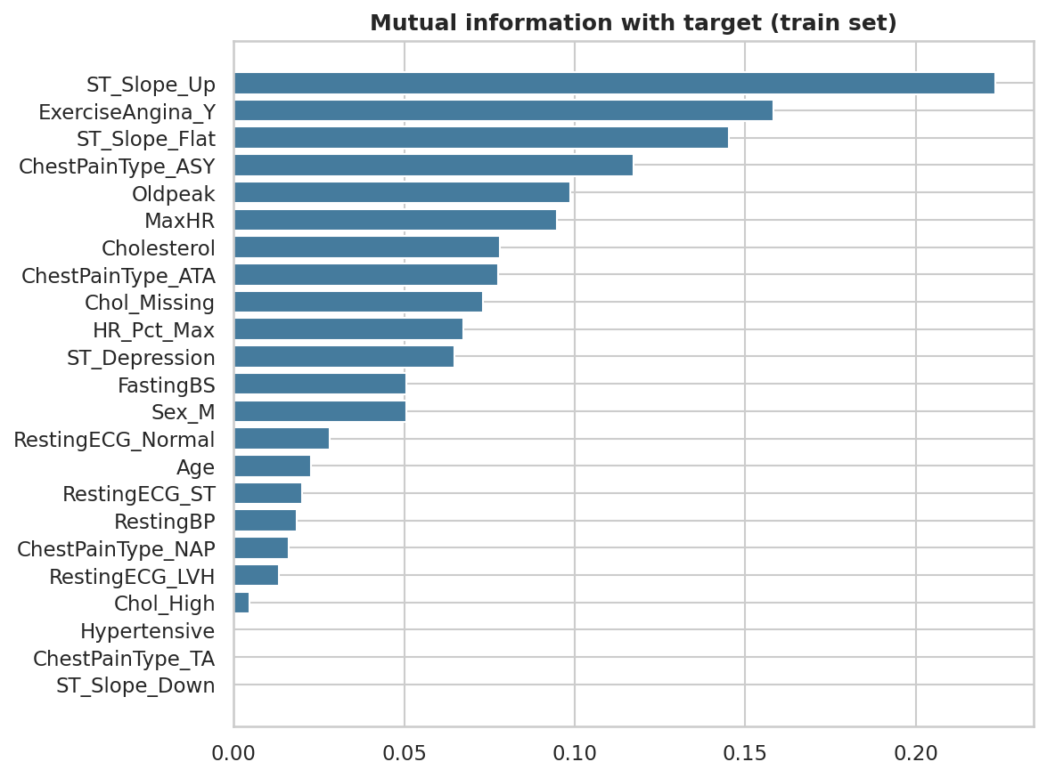
Figure 8. Mutual information between each pre-processed feature and the target (training set).
ANOVA-F and mutual-information rankings agree: ST_Slope_Up / Flat, ExerciseAngina_Y, ChestPainType_ASY, MaxHR and Oldpeak lead; Age, ChestPainType_NAP and RestingECG rank lowest. Selecting the top-k features inside the CV loop gave AUC 0.906 (k = 6), 0.921 (10), 0.929 (14), 0.928 (18) and 0.926 (all 23). The +0.004 gain at k = 14 is within cross-validation noise, so all features were retained.

6. Model Selection and Implementation

6.1 Methodology
- Stratified 80/20 hold-out split (734 training, 184 test patients); the test set stays locked until the final evaluation.
- Seven algorithms, each wrapped in the same leakage-safe pipeline, compared by repeated stratified 5×3 cross-validation.
- Grid-search tuning (5-fold, scoring ROC-AUC) of the five strongest models, plus a soft-voting ensemble of tuned LR, SVM and RF.
- Final model chosen by cross-validation only: highest CV ROC-AUC; ties within 0.002 go to the higher F1.
Algorithm | Why it is included
Logistic Regression | Interpretable linear baseline (odds ratios), preferred in clinical settings
KNN | Instance-based; captures local patient similarity
Gaussian Naive Bayes | Fast probabilistic baseline
Decision Tree | Human-readable rules, but high variance
SVM (RBF) | Strong on small tabular data
Random Forest | Bagged trees; handles non-linearity and interactions; robust to noise
Gradient Boosting | Sequential trees; often best on tabular data

6.2 Baseline comparison (default hyper-parameters)
Model | Accuracy | Precision | Recall | F1 | ROC-AUC
Random Forest | 0.856 | 0.853 | 0.897 | 0.874 | 0.927
Logistic Regression | 0.861 | 0.865 | 0.889 | 0.876 | 0.926
Gradient Boosting | 0.859 | 0.870 | 0.878 | 0.873 | 0.923
SVM (RBF) | 0.858 | 0.855 | 0.899 | 0.876 | 0.920
Naive Bayes | 0.848 | 0.865 | 0.863 | 0.863 | 0.912
KNN | 0.829 | 0.842 | 0.854 | 0.847 | 0.892
Decision Tree | 0.798 | 0.822 | 0.812 | 0.816 | 0.796
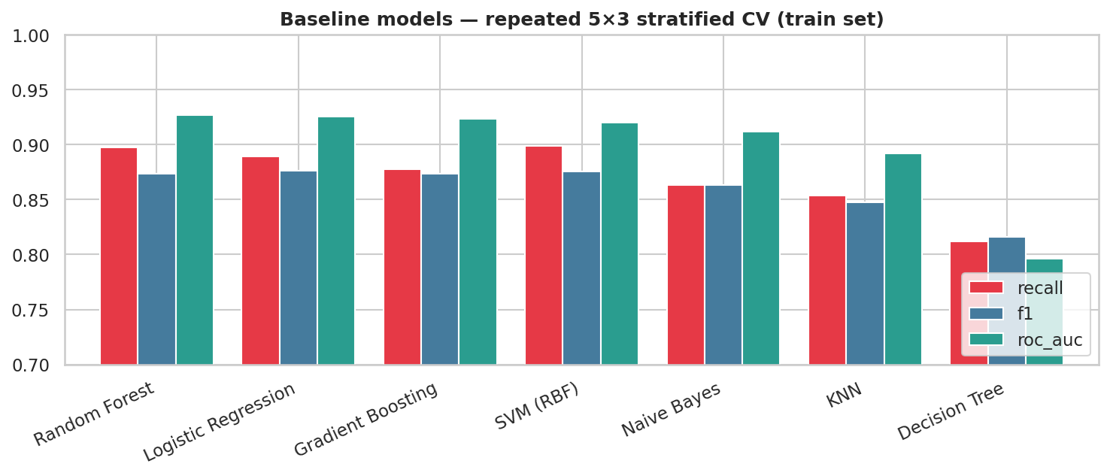
Figure 9. Baseline models under repeated stratified cross-validation.
Random Forest, Logistic Regression, SVM and Gradient Boosting cluster at CV AUC 0.92–0.93. The single Decision Tree is clearly the weakest (AUC 0.796), the classic high-variance behaviour that ensembling corrects.

6.3 Tuned models and final selection
Model (tuned) | Accuracy | Precision | Recall | F1 | ROC-AUC
Gradient Boosting | 0.860 | 0.856 | 0.901 | 0.877 | 0.932
Random Forest | 0.861 | 0.854 | 0.906 | 0.878 | 0.931
Voting Ensemble (LR+SVM+RF) | 0.860 | 0.858 | 0.898 | 0.877 | 0.930
Logistic Regression | 0.861 | 0.865 | 0.889 | 0.876 | 0.926
SVM (RBF) | 0.857 | 0.855 | 0.896 | 0.874 | 0.925
KNN | 0.860 | 0.862 | 0.893 | 0.876 | 0.918

Gradient Boosting and Random Forest tie on AUC (0.9316 vs 0.9314); by the pre-declared tie-break, Random Forest wins on F1 (0.878) and recall (0.906) — the clinically important KPI. Its tuned parameters are max_depth = 6, min_samples_leaf = 3, max_features = sqrt and 300 trees. The voting ensemble gave no gain, so its extra complexity is not justified.

7. Model Evaluation and Validation
Accuracy alone is misleading in a medical setting, so we report recall (the primary KPI), precision, specificity, F1, ROC-AUC, PR-AUC, MCC and Brier score, with bootstrap 95 % confidence intervals because the test set is small.

7.1 Threshold selection
Using out-of-fold training predictions, the standard threshold (0.50) is the highest-precision cut-off with recall ≥ 0.90 (out-of-fold recall 0.904, precision 0.852). A high-sensitivity threshold (0.35) reaches out-of-fold recall ≥ 0.95 (precision 0.808) for mass-screening settings.
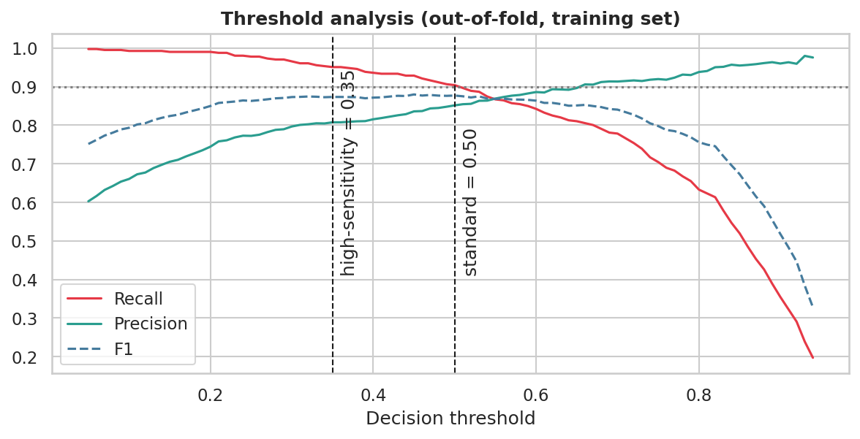
Figure 10. Recall, precision and F1 versus threshold (out-of-fold, training set).

7.2 Hold-out test performance
Metric | Standard (0.50) | 95 % CI | High-sensitivity (0.35)
Recall | 0.922 | 0.865 – 0.971 | 0.961
Precision | 0.847 | 0.779 – 0.909 | 0.797
Specificity | 0.793 | 0.699 – 0.875 | 0.695
F1-score | 0.883 | 0.833 – 0.924 | 0.871
Accuracy | 0.864 | 0.810 – 0.908 | 0.842
ROC-AUC | 0.926 | 0.883 – 0.962 | 0.926
PR-AUC | 0.925 | 0.869 – 0.970 | 0.925
MCC | 0.726 | — | 0.693

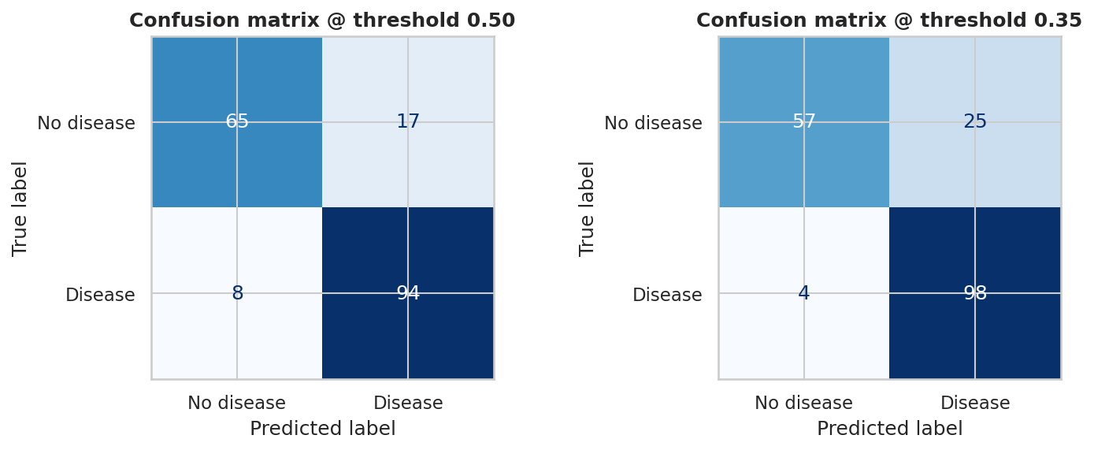
Figure 11. Confusion matrices at the standard (left) and high-sensitivity (right) thresholds.
At the standard threshold only 8 of 102 sick patients are missed and 17 of 82 healthy patients are flagged. At the high-sensitivity threshold about 4 sick patients are missed, at the cost of precision 0.797 and specificity 0.695. All four KPIs are met at the standard threshold (recall 0.922 ≥ 0.90, precision 0.847 ≥ 0.80, F1 0.883 ≥ 0.85, AUC 0.926 ≥ 0.90). Cross-validated AUC (0.931) and test AUC (0.926) agree, so there is no sign of optimistic tuning.
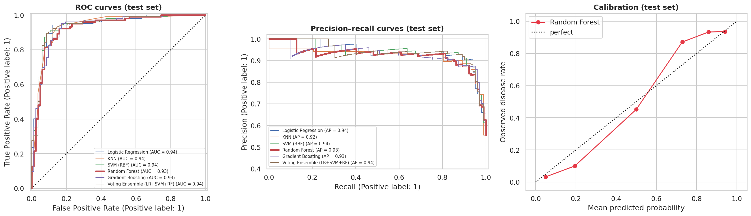
Figure 12. ROC curves, precision–recall curves and calibration on the test set.
On the test set the tuned models reach AUC 0.926–0.940 (LR 0.936, SVM 0.940, RF 0.926). With a ±0.04 confidence interval these are statistically indistinguishable, matching the cross-validation result. We kept the pre-declared choice rather than switching after inspecting test data; Logistic Regression is a near-equal, fully interpretable fallback. Random-Forest probabilities are slightly compressed (predicted 0.20 → observed ≈ 0.10), so scores should be read as risk ranks; probability calibration is listed as future work.
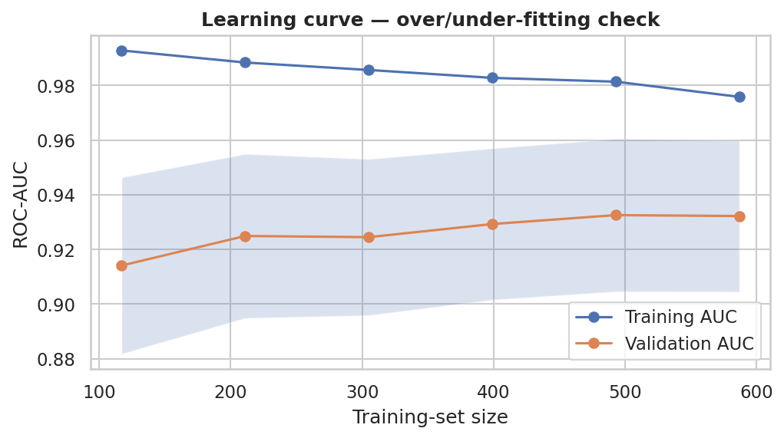
Figure 13. Learning curve (training AUC 0.976 vs validation AUC 0.932 — mild over-fitting).

7.3 Interpretation
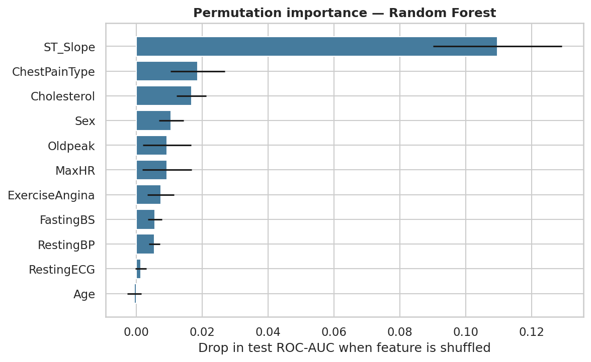
Figure 14. Permutation importance on the test set (drop in AUC when a feature is shuffled).
ST_Slope dominates (−0.110 AUC when shuffled), followed by ChestPainType (0.019), Cholesterol including its missing flag (0.017) and Sex (0.011). An interpretable logistic-regression companion gives odds ratios: cholesterol not recorded ×3.7, asymptomatic chest pain ×2.9, male ×2.8, flat ST slope ×2.7, exercise angina ×2.2, fasting sugar > 120 ×2.1; an upsloping ST segment is protective (×0.31).

7.4 Error analysis and fairness
The 8 false negatives look healthy on the stress test: 7 of 8 have an upsloping ST segment, their median MaxHR is 159 (125 for correctly caught cases) and their median Oldpeak is 0.45 (1.5); 6 of 8 have non-asymptomatic chest pain. The model therefore misses atypical, stress-test-normal presentations, and "low risk" must never be read as "no risk".
Subgroup (test set) | n | Disease rate | Recall | Precision | AUC
Women | 38 | 15.8 % | 0.833 | 0.455 | 0.964
Men | 146 | 65.8 % | 0.927 | 0.890 | 0.905
Age < 50 | 70 | 38.6 % | 0.889 | 0.750 | 0.923
Age 50–60 | 81 | 58.0 % | 0.915 | 0.860 | 0.920
Age 60+ | 33 | 84.8 % | 0.964 | 0.931 | 0.864

Recall is high for men and older patients. The female subgroup contains only 6 sick patients, giving more false alarms (precision 0.455) — an early fairness flag that calls for more female data before any real use.

8. Business Insights and Recommendations

8.1 Risk tiers
Out-of-fold probabilities for all 918 patients were grouped into three tiers (Low < 0.20, Moderate 0.20–0.50, High ≥ 0.50), giving honest estimates of how each tier behaves.
Tier | Patients | Share of patients | Observed disease rate | Share of all cases
Low risk | 240 | 26.1 % | 3.8 % | 1.8 %
Moderate risk | 142 | 15.5 % | 27.5 % | 7.7 %
High risk | 536 | 58.4 % | 85.8 % | 90.6 %
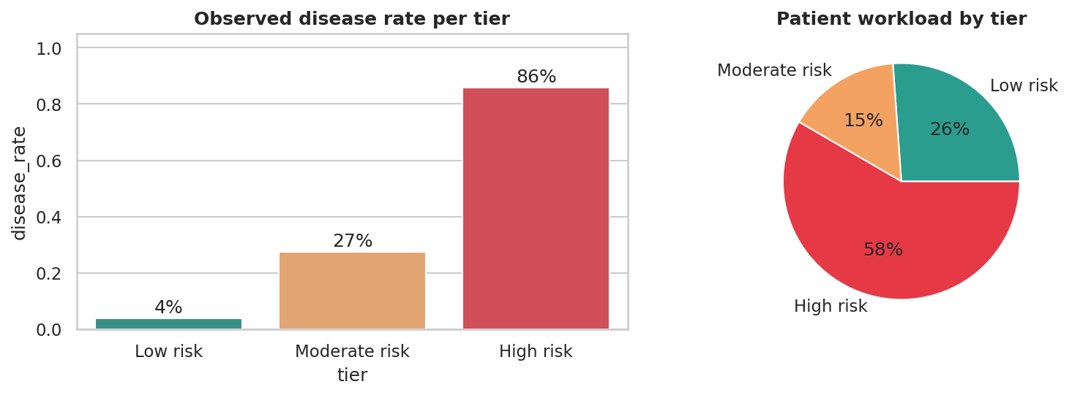
Figure 15. Observed disease rate and workload by risk tier.

8.2 Cost and workload impact
With an illustrative assumption that a missed patient costs ten times an unnecessary referral, the value of the model depends strongly on how common the disease is in the population being screened.
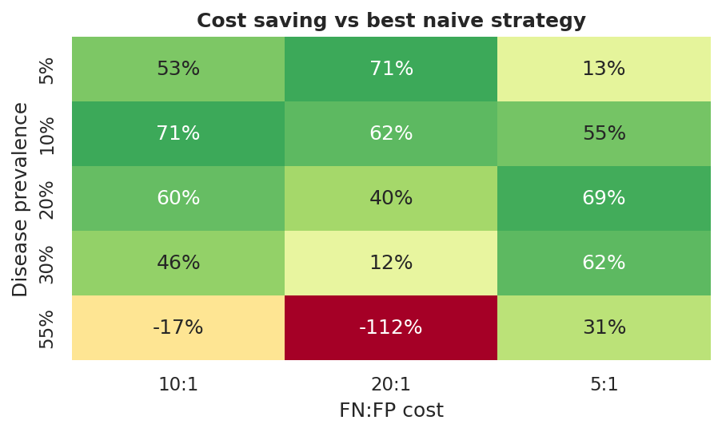
Figure 16. Cost saving of the model versus the best naive strategy (refer everybody or nobody).
- Screening populations (10–30 % prevalence): expected cost falls by about 46–71 % at a 10:1 cost ratio.
- Already-referred populations such as this dataset (55 % prevalence): referring everyone is hard to beat at the standard threshold, so the value is prioritisation. The high-sensitivity mode is cheaper than referring everybody (35.3 vs 44.6 cost units per 100 patients, −21 %).
- Projected workload (20 % prevalence, sensitivity 0.92, specificity 0.79): per 1,000 patients about 350 are referred instead of 1,000 (−65 %), while about 184 of 200 sick patients (92 %) are caught.

8.3 Recommendations
# | Recommendation | Evidence | Owner
1 | Adopt 3-tier triage: Low → routine advice and annual re-screen; Moderate → GP review and repeat tests within weeks; High → fast-track cardiology | Tier disease rates 3.8 % / 27.5 % / 85.8 % | Hospital admin, cardiology
2 | Choose the threshold by setting: 0.50 where cardiology capacity is tight; 0.35 (recall 96 %) for community screening camps | Section 7.1; cost analysis | Medical director
3 | Always record ST-segment slope and exercise-angina status | ST_Slope is the top feature; Flat/Down 78–83 % vs Up 20 % | Cardiology, lab staff
4 | Make a lipid profile mandatory | 19 % have no cholesterol value; 88 % of them are sick | Data quality, IT
5 | Target outreach at silent high-risk groups: men over 55, diabetics, asymptomatic patients | ASY 79 % vs ATA 14 %; men 63 % vs women 26 %; FastingBS 79 % vs 48 % | Public-health team
6 | Keep the clinician in the loop; show probability, not just a label; never discharge a symptomatic low-risk patient on the model alone | 8 false negatives had normal-looking stress tests | Doctors
7 | Pilot before deployment: validate on local data, add female patients, monitor subgroup recall and drift | Female subgroup n = 38; 1980s–90s source data | Data-science team

9. Deployment and Reproducibility
The trained pipeline, thresholds and tier boundaries are saved to model/heart_model.joblib (refit on all 918 patients with the tuned hyper-parameters; the metrics above come from the train-only model). A Streamlit application (app.py) loads the artifact and provides:
- Input of the 11 clinical measurements, including a "cholesterol not measured" option.
- Estimated risk score, risk tier, referral decision and recommended action, with a Standard / High-sensitivity toggle.
- A "Why this score?" chart: the change in predicted risk when each input is replaced by a typical training value.
To run: pip install -r requirements.txt, then streamlit run app.py. The notebook Heart_Disease_Prediction_Final.ipynb reproduces every number and figure in this report (random seed 42).

10. Limitations and Future Work
- Small, pooled legacy data (918 patients, 1980s–90s): possible population shift; external validation on local hospital data is required.
- Stress-test inputs: Oldpeak, ST_Slope, ExerciseAngina and MaxHR need an exercise test and are unavailable at a basic GP visit. A "GP-lite" model without them is a useful follow-up.
- Informative missingness: the 172 missing cholesterol values are not missing at random; median imputation plus an indicator is pragmatic, not perfect.
- Uncertainty: the 184-patient test set gives wide confidence intervals, and the cost ratios are illustrative assumptions.
- Future work: SHAP explanations, probability calibration, larger multi-centre data, a broader fairness audit, and MLOps monitoring for drift.

11. Individual Contribution
This is an individual project. All stages — problem definition, data understanding, preprocessing, exploratory analysis, feature engineering, modelling, evaluation, business recommendations, the Streamlit application, this report and the presentation — were carried out by the author, Rohit Dnyaneshwar Mahale (PRN 2125UDSM2043).

12. Conclusion
Starting from a basic notebook, we built a complete, leakage-free pipeline that identifies heart-disease patients with recall 0.92 and ROC-AUC 0.93 on unseen data, explains its predictions, and converts them into three actionable risk tiers and a web demo. The most important lessons were practical: impossible zeros carry signal and should be flagged rather than averaged away; the ST-segment slope is the dominant predictor; and a model's business value depends on the prevalence of the population it serves. Before real-world use, the model needs local validation, more data for women, and clinician oversight.

References
- fedesoriano. Heart Failure Prediction Dataset. Kaggle, 2021.
- World Health Organization. Cardiovascular diseases (CVDs) — fact sheet.
- Pedregosa F. et al. Scikit-learn: Machine Learning in Python. Journal of Machine Learning Research 12 (2011).
- Detrano R. et al. International application of a new probability algorithm for the diagnosis of coronary artery disease. American Journal of Cardiology 64 (1989).

