**Outcomes:**

The data has more male customers than Female

1. Male population is nearly 4 times of Female population

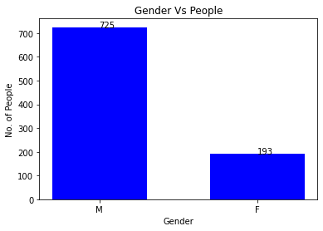

63% of male has HeartDisease

26% of Feamale has HeartDisese

CONCLUSION 1 :

Male Gender has more Heart Disease Patients

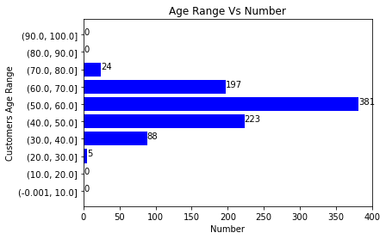

Most of the people are from age range 30-60

CONCLUSTION 2 :

Potential age range of customers is 30-60

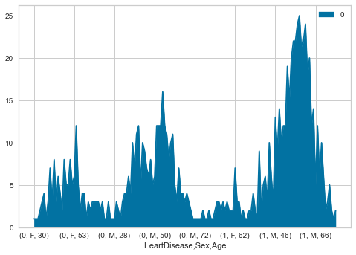

From the above area Map we can see:

CONCLUSION 3:

1. Females with Heart disease are very less and Male with Heart Disease are more
2. Either in male or in Females always the dominating age is 30-60

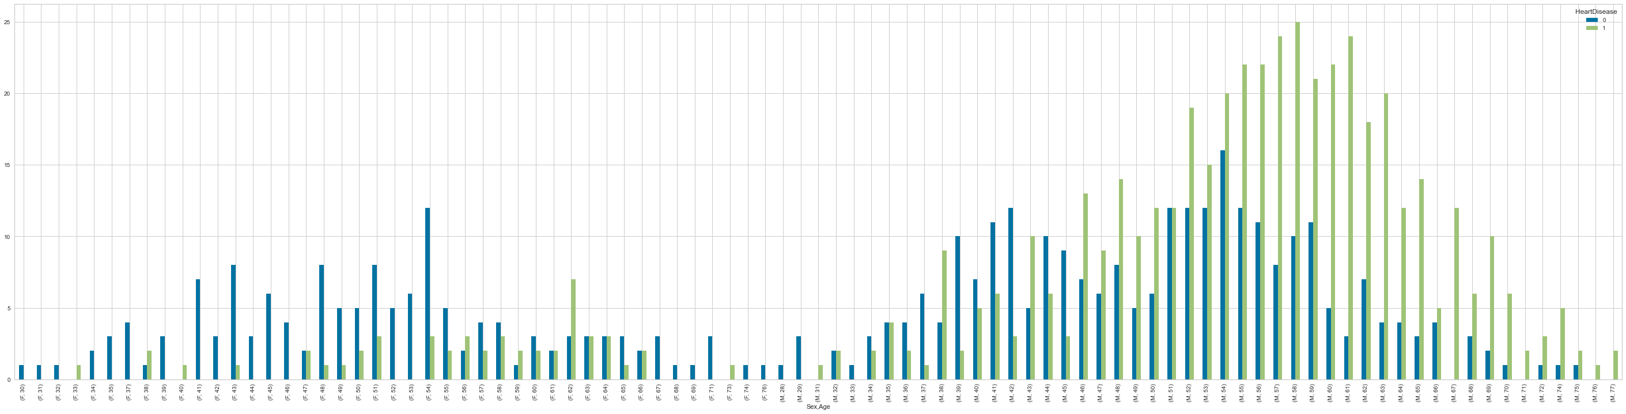

CONCLUSION 4:

1. Male is Dominating in Strength as well as in Heart Disease Count and follows age range
2. Female is less in Strength as well as in Heart Disease Count

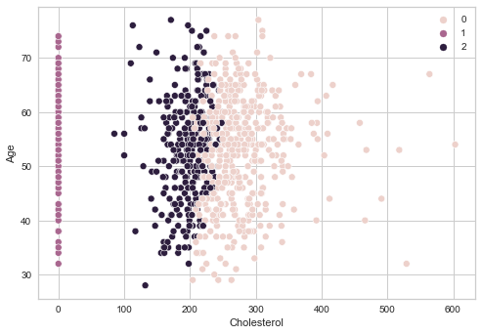

CONCLUSION 5: Target Segments: Age, Sex, Cholesterol, MaxHR, RestingBP.

1. Male Gender is target Sex Group
2. Age range is above 4
3. cholesterol, Age is the major target segment

**Target Segment will have patients showing characteristics as follows-**

1. Age above 50
2. heart disease
3. MaxHR > 150
4. Cholestrol valyues > 200