**Vikas**

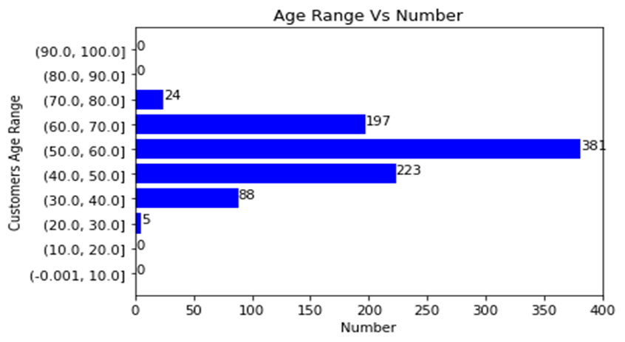

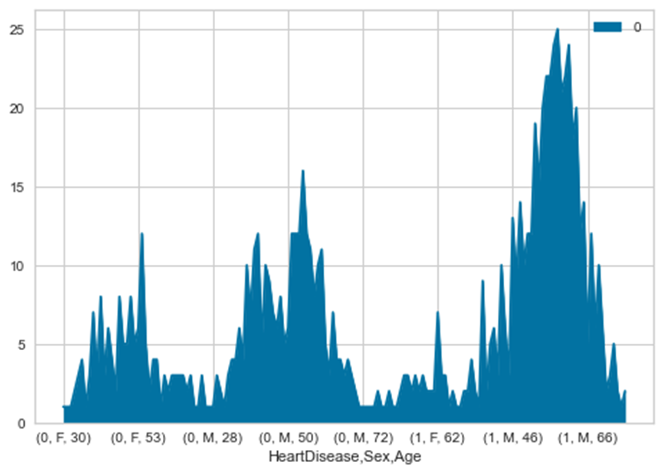

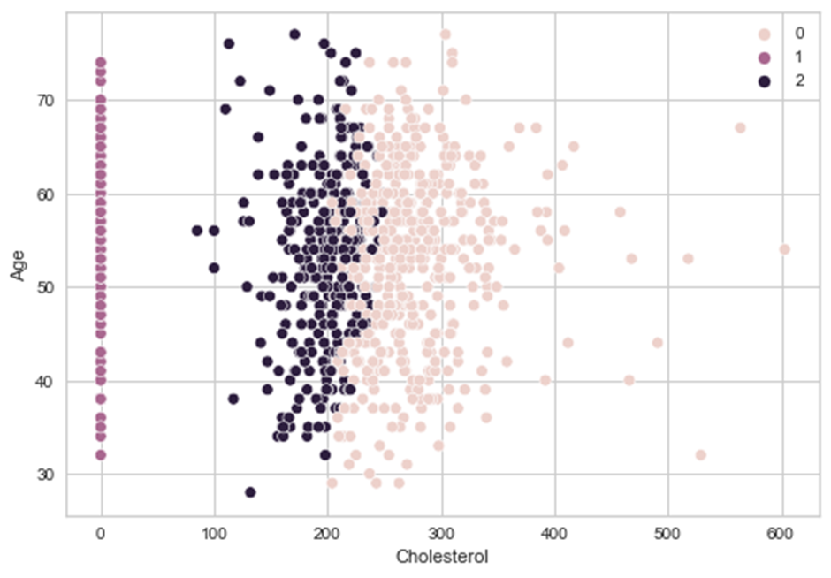

**## Concluding insights**

1. 63% of males has and 26% of females were found to had heart disease.
2. Male Gender has more Heart Disease Patients.
3. Most of the people with heart disease are in the age range of 30-60 independent of gender.

**##Target Segments:**

Target Segments: Age, Sex, Cholesterol, and heart disease.

1. Male Gender is the target Sex Group.
2. People with ages ranging from 45-to 60 are the target customers.
3. People Cholestrol greater than 200 are the target customers of any gender.
4. People MaxiumHR greater than 1500 are the target customers.