**Blood Pressure:**

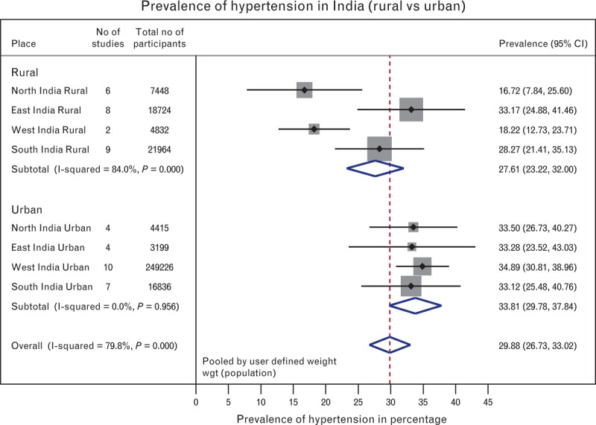**Results:**

1. Overall prevalence for hypertension in India was 29.8% (95% confidence interval: 26.7–33.0).
2. Significant differences in hypertension prevalence were noted between rural and urban parts [27.6% (23.2–32.0) and 33.8% (29.7–37.8); P = 0.05]. Regional estimates for the prevalence of hypertension were as follows: 14.5% (13.3–15.7), 31.7% (30.2–33.3), 18.1% (16.9–19.2), and 21.1% (20.1–22.0) for rural north, east, west, and south India; and 28.8% (26.9–30.8), 34.5% (32.6–36.5), 35.8% (35.2–36.5), and 31.8% (30.4–33.1) for urban north, east, west, and south India, respectively.
3. Overall estimates for the prevalence of awareness, treatment, and control of BP were 25.3% (21.4–29.3), 25.1% (17.0–33.1), and 10.7% (6.5–15.0) for rural Indians; and 42.0% (35.2–48.9), 37.6% (24.0–51.2), and 20.2% (11.6–28.7) for urban Indians.

**Conclusion:**

About 33% of urban and 25% of rural Indians are hypertensive. Of these, 25% rural and 42% urban Indians are aware of their hypertensive status. Only 25% rural and 38% of urban Indians are being treated for hypertension. One-tenth of rural and one-fifth of urban Indian hypertensive population have their BP under control.

**Target Regions:**

As we can see BP is prevailing in all the places over India with very small variations in rural and urban regions.

From the data, we have north and south regions are having small variations in rural and urban regions, east and west regions are similar in rural and urban regions.

Any region is good for setting up the service for blood pressure. In the east and western parts setting the service in urban regions has an added advantage.

**Mode of Service Preferred:**

Reach customers by using an online platform and providing door service. This is to reach more customers as all are distributed equally across India in both rural and urban areas.

**Pricing:**

As the location of service is changing pricing with respect to the region standards is preferred.

**VITAMINS**

**Results:**

Chennai-based Metropolis Healthcare studied 14,96,683 samples over three years and found an increasing trend of deficiency in vitamin D, vitamin B12, and vitamin B9 (Folic Acid) among all age groups of Indians.

The samples tested across four zones showed that 75% of the population was deficient in three vital vitamins. While 21.02% were deficient in vitamin B12 and 15.06% were deficient in vitamin B9, 81.28% of all samples were deficient in vitamin D.

**Mode of Service Preferred:**

Reach customers by using an online platform and providing door service. This is to reach more customers as all are distributed equally across India in both rural and urban areas.

**Pricing:**

As the location of service is changing pricing with respect to the region standards is preferred.

**Heart Disease**

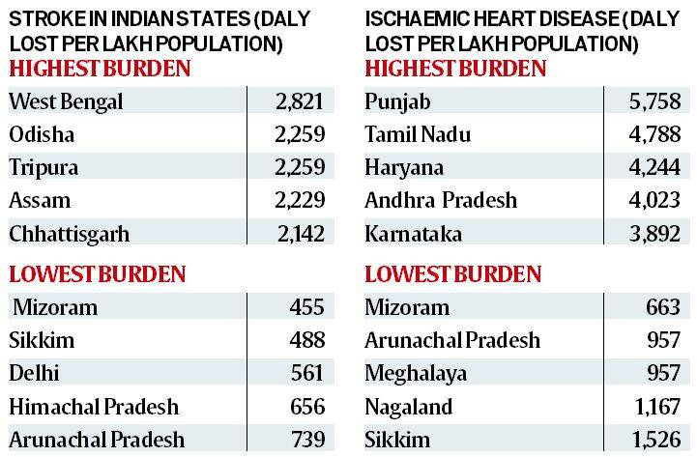

**Results:**

Disability Affected Life Years (DALYs) is a measure of overall disease burden, expressed as the number of years lost due to ill-health, disability or early death.

While the rate of DALYs for ischemic heart disease was 3,062 per 100,000 people for India, it was the highest in Punjab (5,759) followed by Tamil Nadu (4,788) and Haryana (4,244).

Other states with higher DALYs than the national average was Andhra Pradesh (4,023), Maharashtra (3,658), Karnataka (3,892) and Gujarat (3,736).

**Target Regions:**

Punjab, Tamil Nadu, Andhra Pradesh (Preferred Southern Part of India)

**Mode of Service Preferred:**

Reach customers by using an online platform and providing door service. This is to reach more customers as all are distributed in the north and southern parts of India.

**Pricing:**

As the location of service is changing pricing with respect to the region standards is preferred.