AWS_task1

-> create the user name called Raju

-> enable  Multi-Factor Authentication (MFA) to raju user

 -> create the Group called Devops and Add the Administrator-access Permission for Devops group .

 -> added Raju in Devops Group

 -> login as user raju with username -> password -> using MFA code

 -> create Role for system Manager ssm (To access the private-subnet Ec2)

Raju

XXXXXX

<https://XXXXXXXXX.signin.aws.amazon.com/console>

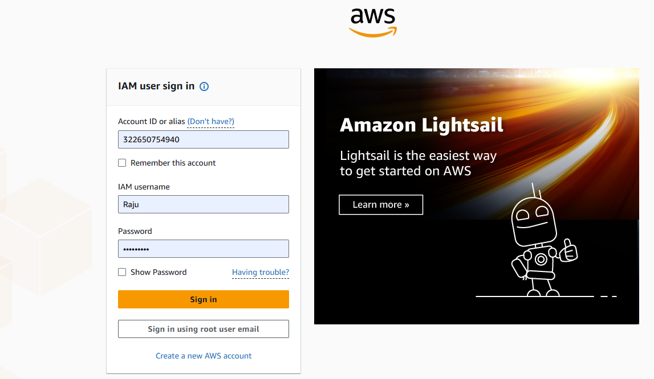

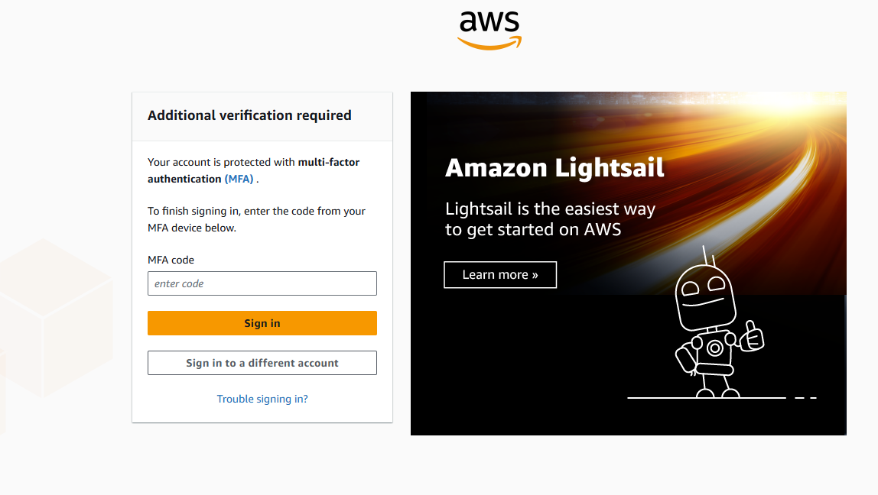

Devops group created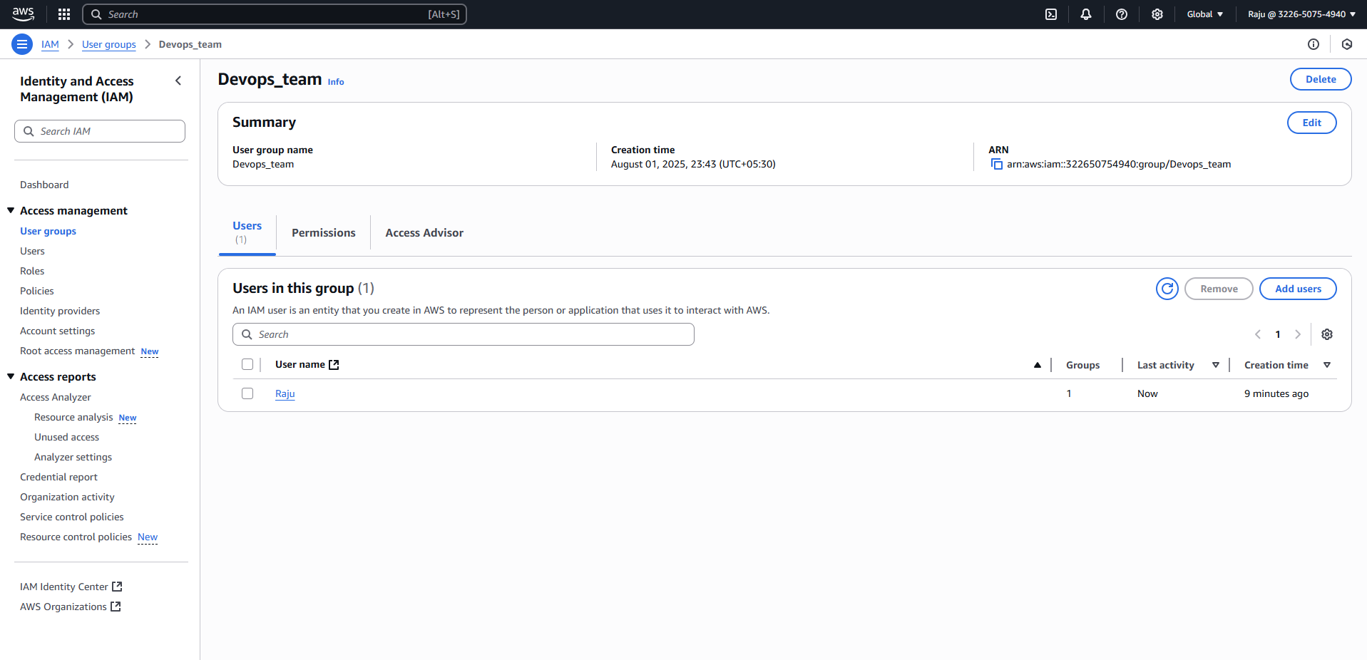

Raju user created and added to Devops group

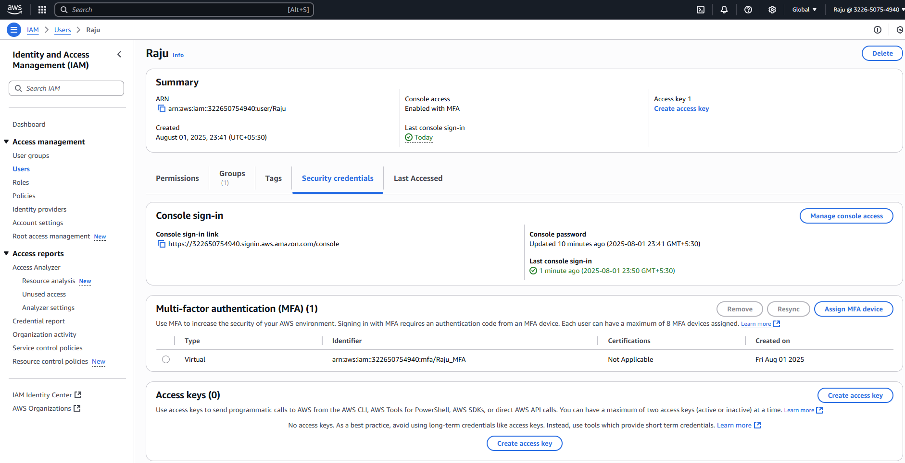

Enabled administrator access.

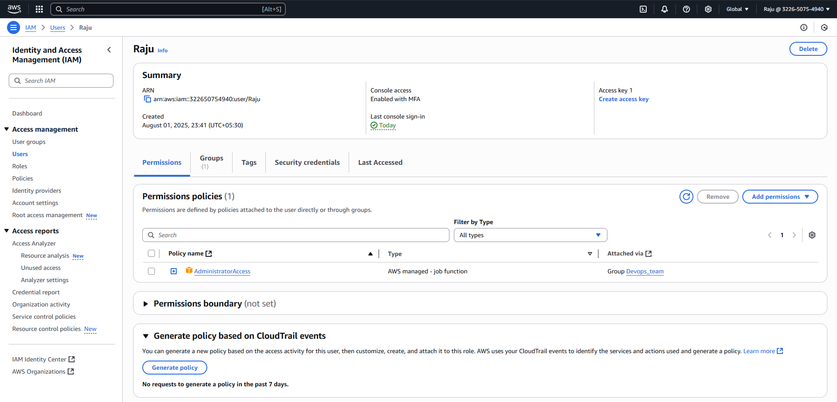

SSM role created.