AWS_task4

-> create VPC  in any Aws region .

-> Attach IGW  to vpc.

-> create 2-public subnets with outbound to internet

-> 2-private subnets .

-> create the NAT gateway for Private Subnets.

-> And associate subnets and routes for public-RouteTables and Private-Route .

-> create linux-ec2 in private subnets and Attach System Managers (SSM)role login into ec2 using system manager (SSM)

-> Install webserver (Apache) and start and enable the apache server. '

-> Add HTTP and ICMP rule in inbound rule in security Group which is attached to Linux ec2.

->Backup and restoring the Activity

-> Take the backup Image of the linux-ec2 using AMI After taking the backup Terminate the EC2 .

-> Restore the ec2 instance with the created Image (AMI). in the same VPC and Same Subnet.

Monitoring Task

---------------------------

-> Create Cloud-watch alarm if Cpu % reach more then 80% using (SNS and cloud watch)

VPC created with private and public subnet with NAT and IGW .

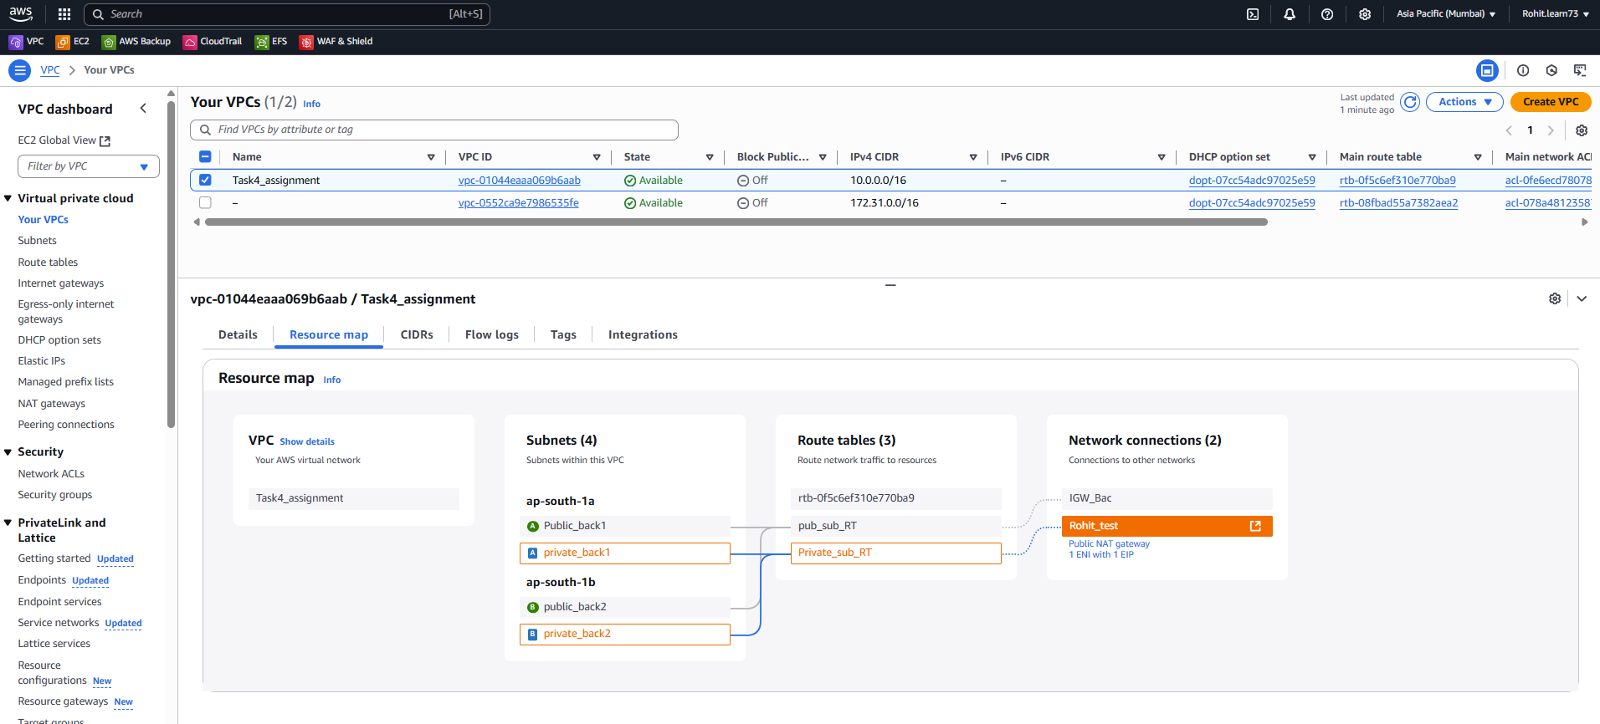

Login using SSM to the EC2 in private subnet:

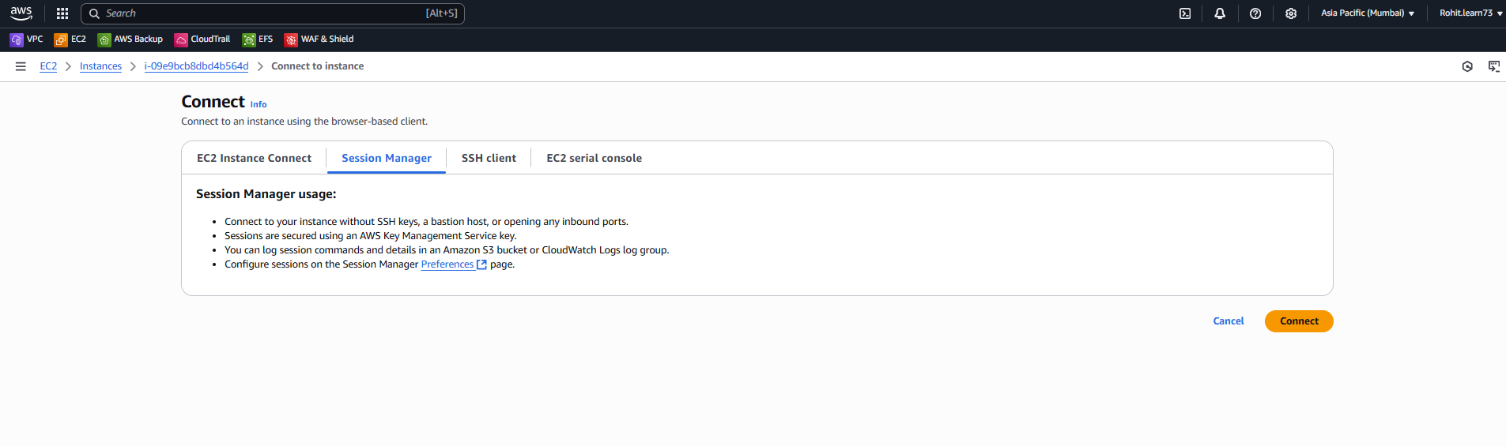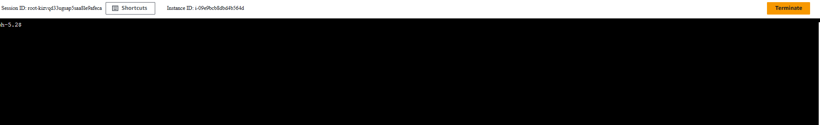

Apache server installed:

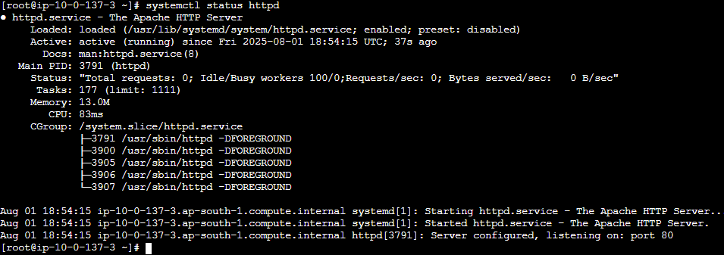

Backup taken:

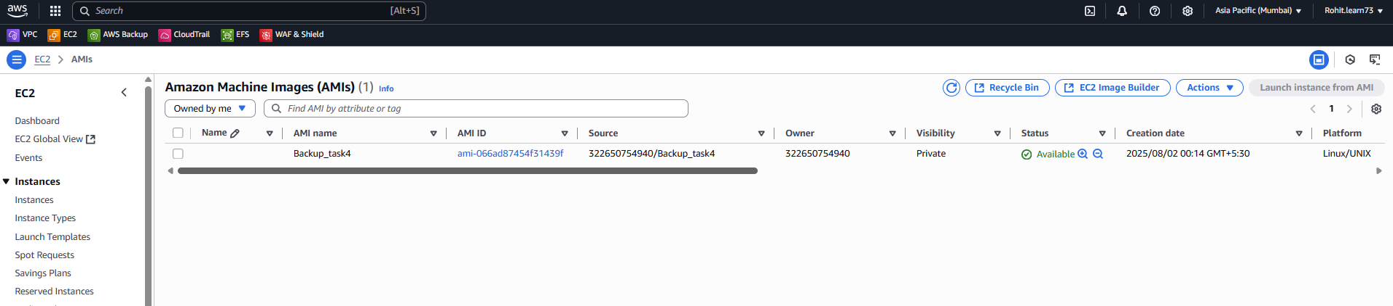

Instance terminated

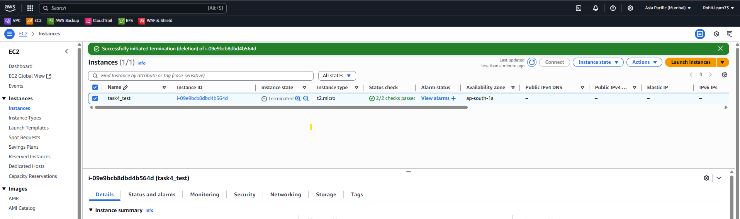

Backuped up instance in same subnet from AMI

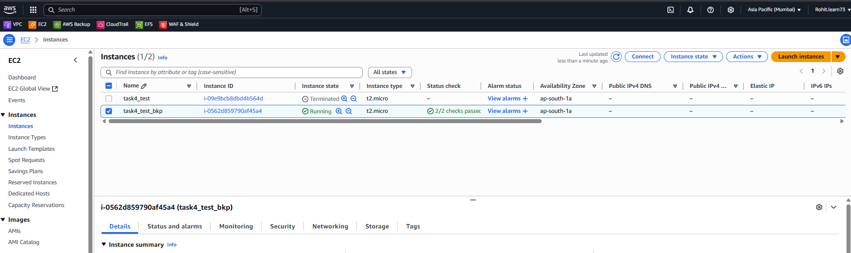

Cloudwatch alarm & SNS:

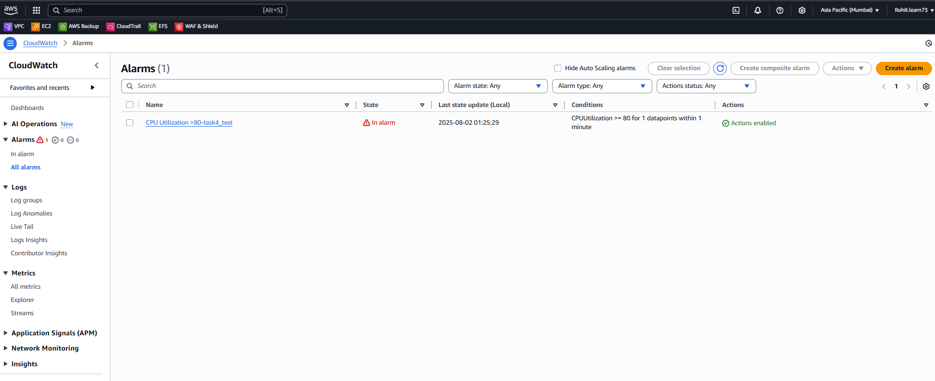

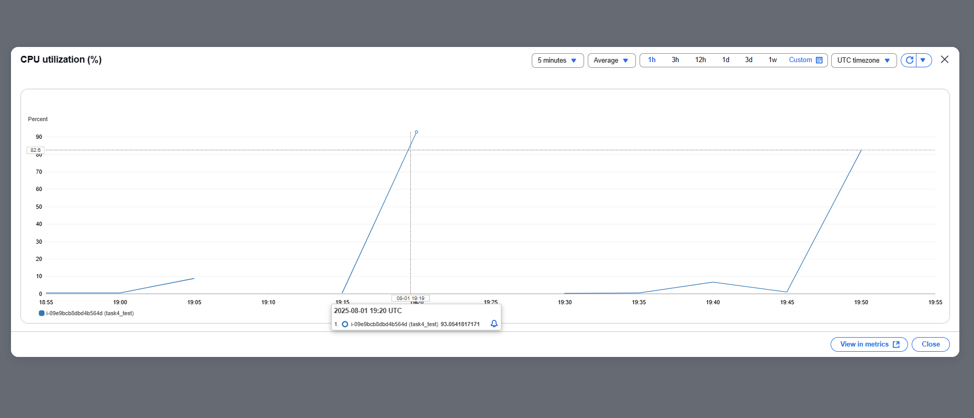

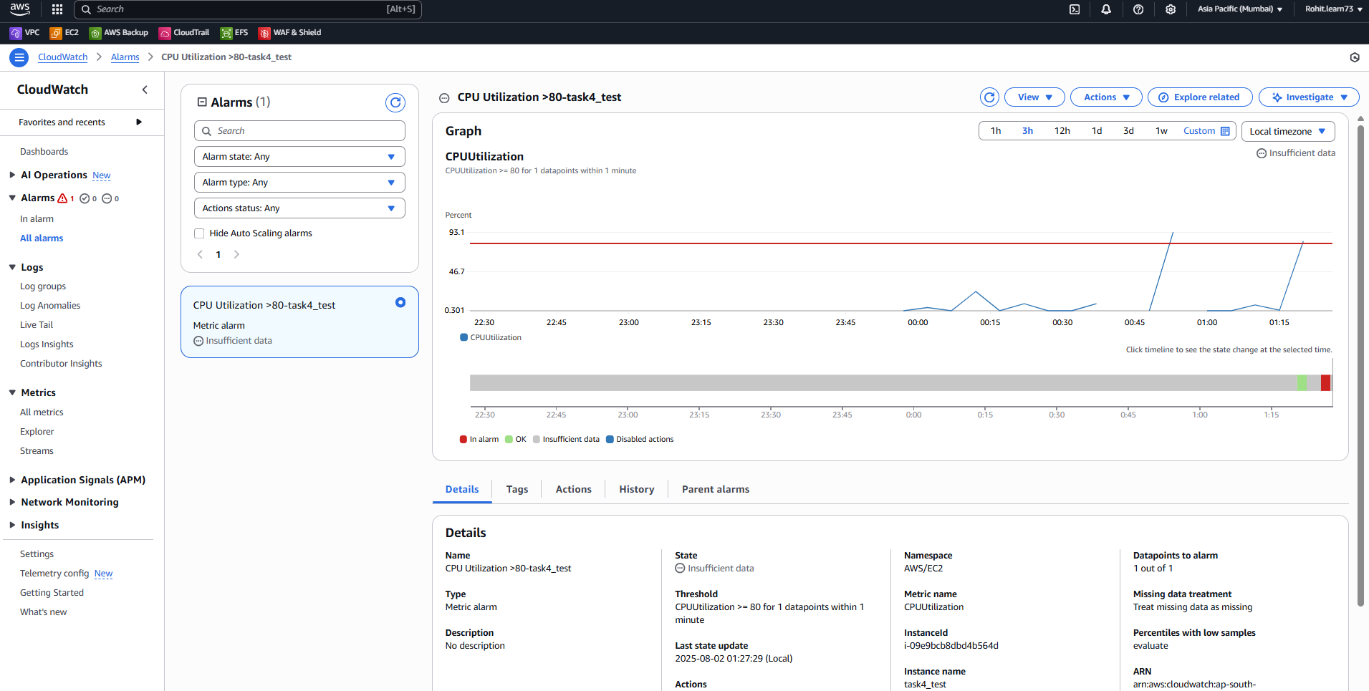

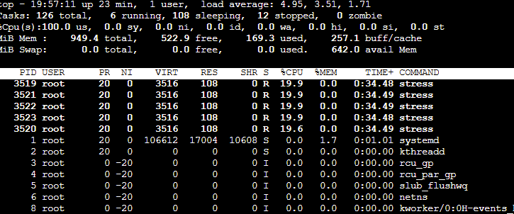

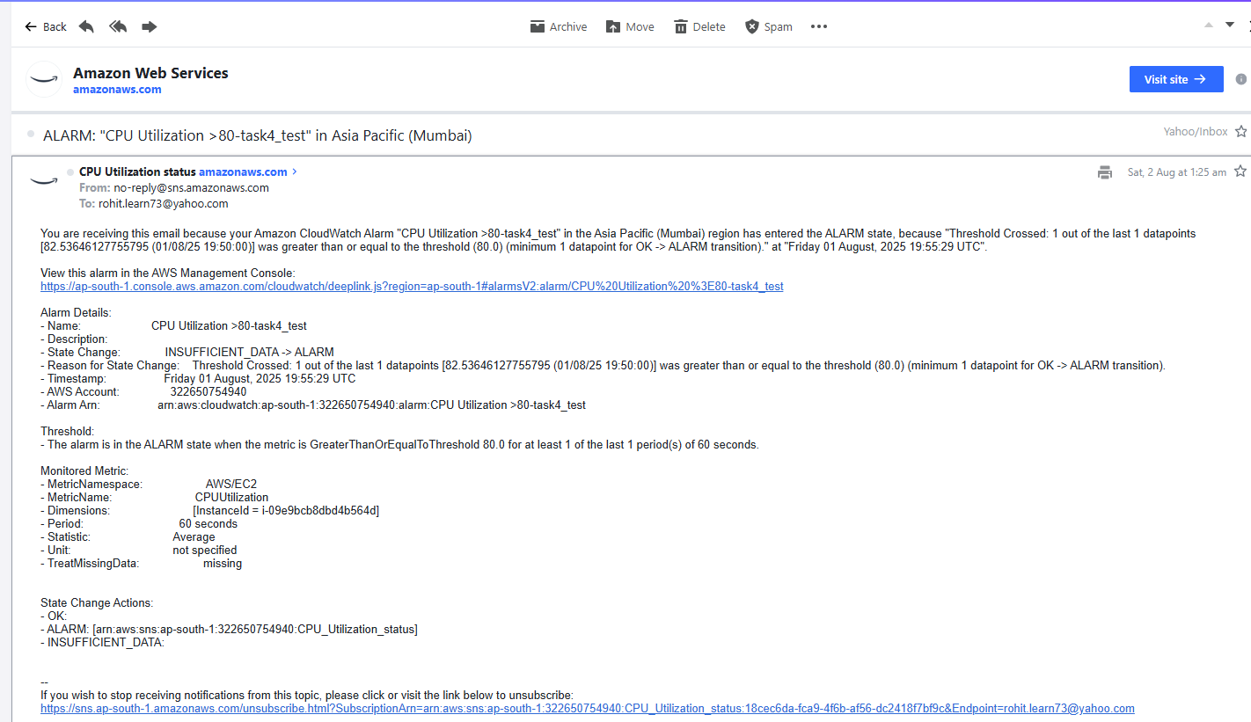

Instance crossed