LeaveManagement React App — Developer Guide
Oct 11, 2026 · @GAURAV

Overview
LeaveManagement is a single-page React app where employees apply for leave and an admin approves or rejects it. It calls three ASP.NET Core Web API services with fetch: Auth1 (register, login, token refresh), EmployeeLeave (employee list) and LeaveSer (leave requests). All data lives in the backend's SQL Server database.
Two roles, one app
Role | Can do | Lands on
Employee | Register, log in, apply for leave, see own requests with status and admin remark | Employee Dashboard
Admin | Log in, see pending leave requests, approve or reject with a remark, view registered employees | Admin Dashboard
Main features
- Self-registration through Auth1; the server hashes the password and rejects a duplicate email.
- JWT login. The token is renewed automatically when it expires, and the login survives a page refresh.
- Inactive accounts are blocked right after login.
- Apply leave with date rules checked in the browser and again by LeaveSer: no past dates, To Date not before From Date, no overlap with your own Pending or Approved leave.
- Admin review of pending requests: confirm dialog, remark required on reject.
- Dashboards with count cards, plus loading, error and retry states.
- Light and dark theme follow the operating system setting.
The code comments refer to a BRD (business requirements document) by section, for example "BRD 5.2" for role-based routing and "BRD 7.1" for the User table. The first version ran on mock data in src/data/mockData.ts; that file was removed when the API was connected.

Tech stack
The front end still uses only React and React DOM at runtime. HTTP calls use the browser's built-in fetch, so there is no axios, router or UI library. The backend is three .NET 8 Web APIs sharing one SQL Server database.
Front end (React/LeaveManagement)
Package | Version (package.json) | Role
react, react-dom | ^19.2.8 | UI library and browser renderer
typescript | ~6.0.2 | Static types; tsc -b runs before every build
vite | ^8.3.0 | Dev server with hot reload and API proxy; production bundler
@vitejs/plugin-react | ^6.1.1 | JSX transform and React Fast Refresh
babel-plugin-react-compiler + @rolldown/plugin-babel | ^1.0.0 / ^0.2.3 | React Compiler: memoises components automatically, so no manual useMemo / useCallback
oxlint | ^1.81.0 | Linter; enforces the Rules of Hooks
@types/react, @types/react-dom, @types/node | 19.x / 24.x | Type definitions
Back end (EmployeeLeave/EmployeeLeave.sln)
Piece | Version | Role
ASP.NET Core Web API | .NET 8 | Three services: Auth1, EmployeeLeave, LeaveSer
Entity Framework Core + SqlServer | 8.0.26 | Database access to the LeaveManagement database
JwtBearer authentication | 8.0.26 | Validates the JWT that Auth1 issues (shared issuer, audience and key)
ASP.NET Core Identity PasswordHasher | 8.x | Hashes passwords in Auth1
Swashbuckle (Swagger) | 6.6.2 | API explorer at /swagger on each service
Shared state in the front end is held with React's built-in useReducer + Context (see State management). Styling is plain CSS with CSS variables in src/index.css.

Project structure
The new src/api/ folder is the only code that talks to the backend; pages call its functions and never use fetch directly. pages/ holds one folder per user type, store/ holds shared state, and components/ holds small reusable pieces.
LeaveManagement/
├─ index.html page shell, loads src/main.tsx
├─ vite.config.ts React plugin, React Compiler, /api proxy to the 3 services
├─ .env.example override the proxy targets (copy to .env.local)
├─ package.json scripts and dependencies
└─ src/
├─ main.tsx entry: mounts <AppProvider><App/></AppProvider>
├─ App.tsx decides which screen to show
├─ index.css all styles and theme variables
├─ api/
│ ├─ http.ts apiFetch(): fetch wrapper, token, refresh, ApiError
│ ├─ session.ts tokens + user in localStorage
│ ├─ authApi.ts register(), login(), logout() -> Auth1
│ ├─ employeeApi.ts getEmployees(), getEmployeeById() -> EmployeeLeave
│ ├─ leaveApi.ts applyLeave(), getMyLeaves(), getPendingLeaves(),
│ │ approveLeave(), rejectLeave() -> LeaveSer
│ ├─ dto.ts request/response shapes exactly as the API sends them
│ └─ mappers.ts toUser(), toLeave(): DTO -> front-end types
├─ types/index.ts User, Leave, Role, LeaveStatus
├─ data/lookups.ts DEPARTMENTS (id+name), ROLE_IDS, LEAVE_TYPES
├─ utils/date.ts today(), formatDate(), dayCount()
├─ utils/jwt.ts decodeJwt(), readUserId()
├─ store/
│ ├─ appReducer.ts AppState, AppAction, appReducer()
│ ├─ AppContext.ts AppContext + useApp() hook
│ └─ AppProvider.tsx useReducer + Context, restores the saved session
├─ components/ Header, StatCard, StatusBadge, Tabs
└─ pages/
├─ auth/ LoginPage, RegisterPage
├─ employee/ EmployeeDashboard, ApplyLeave, MyLeaves
└─ admin/ AdminDashboard, LeaveRequests, LeaveActionDialog, EmployeeList
Backend solution (DotnetCoreApi/EmployeeLeave/)
EmployeeLeave.sln
├─ Auth1/ AuthController: Register, Login, Refresh (Employees + Refresh tables)
├─ EmployeeLeave/ EmployeeController: list, get by id (Employees table)
├─ LeaveSer/ LeaveController: apply, my-leaves, pending, approve, reject (Leave table)
└─ AuthLeave/ older auth project, not in the solution and not used by the app
src/App.css and the images in src/assets/ are left over from the Vite template; nothing imports them.

Getting started
Start the three backend services first, then npm run dev in the React project. In development, Vite forwards every /api/... call to the right service, so no URL or CORS setup is needed.
1. Backend
- Make sure SQL Server is reachable with the ERPConnection string in each service's appsettings.json (database LeaveManagement, tables Employees, Refresh, Leave).
- Open EmployeeLeave/EmployeeLeave.sln in Visual Studio and set Auth1, EmployeeLeave and LeaveSer as multiple startup projects, or run dotnet run --launch-profile https in each folder.
- Check each Swagger page opens: https://localhost:7113/swagger, https://localhost:7181/swagger, https://localhost:7299/swagger.
Service | HTTPS (proxy default) | HTTP | Path prefix
Auth1 | https://localhost:7113 | http://localhost:5101 | /api/Auth
EmployeeLeave | https://localhost:7181 | http://localhost:5056 | /api/employee
LeaveSer | https://localhost:7299 | http://localhost:5160 | /api/leave
The proxy uses the HTTPS ports because every service calls UseHttpsRedirection(). A plain HTTP call answers 307, and a browser that follows that redirect to another origin fails on CORS. To use other addresses, copy .env.example to .env.local and set AUTH_API_URL, EMPLOYEE_API_URL and LEAVE_API_URL.
2. Front end
- Install Node.js (a current LTS release).
- In React/LeaveManagement, run npm install.
- Run npm run dev and open the URL Vite prints (normally http://localhost:5173).
- Register an employee, or log in with an account that already exists in the Employees table.
Script | Command | What it does
dev | vite | Dev server with hot reload and the /api proxy
build | tsc -b && vite build | Type-checks, then bundles to dist/
preview | vite preview | Serves the built dist/ locally (no proxy)
lint | oxlint | Lints the source
Admin account: registration always creates an Employee (role 2). To get an admin, set Role = 1 on a user in the Employees table. LeaveSer treats role 1 as admin (Roles:Admin in its appsettings.json).

Routing and navigation
There is no React Router. App.tsx chooses the screen with plain if checks on every render: logged-out users see Login or Register, and logged-in users see the dashboard for their role. Inside a dashboard, a Tabs bar switches between two sub-views held in local state.
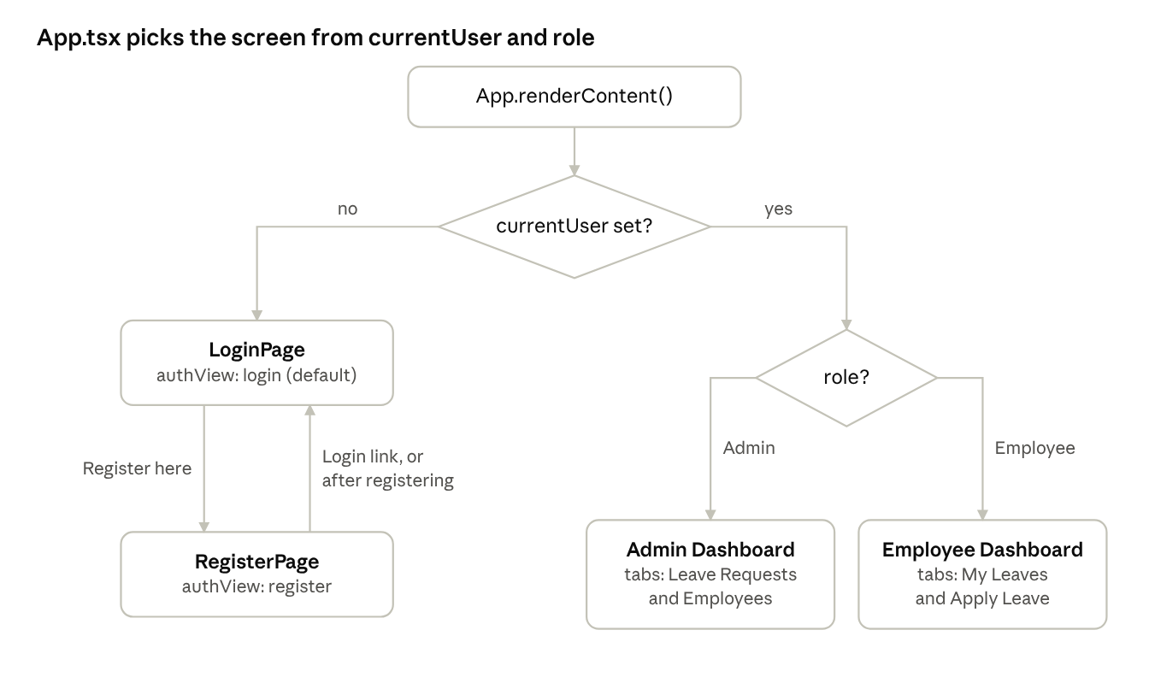
screen selection in App.tsx · 2 decisions, 4 screens
Dispatching LOGIN or LOGOUT changes currentUser, and App walks this tree again on the next render. The Logout button in Header is always visible when logged in, so every dashboard leads back to LoginPage.
Screen state | Owned by | Values
Logged in or not | state.currentUser (global store) | User or null
Login vs Register | authView in App | "login" | "register"
Employee tab | tab in EmployeeDashboard | "my-leaves" | "apply"
Admin tab | tab in AdminDashboard | "leaves" | "employees"
Approve / Reject dialog open | pendingAction in LeaveRequests | { leave, action } or null
On startup, AppProvider reads the saved session from localStorage, so a page refresh lands straight on the dashboard instead of the login page. A refresh still resets the active tab, because screens are not URLs, and the browser Back button leaves the app. See Known gaps.

Authentication flow
Auth1 issues a JWT access token (valid 30 minutes) and a refresh token (valid 1 day). The React app keeps both in localStorage and sends Authorization: Bearer <token> on every call to EmployeeLeave and LeaveSer, which validate the same JWT settings. App.tsx stays the route guard: it shows a dashboard only when state.currentUser is set.
Register (pages/auth/RegisterPage.tsx → authApi.register)
- The form validates in the browser first: name, email format, 10-digit mobile starting 6–9, department, password at least 6 characters, matching confirm password.
- It sends POST /api/Auth/Register with { employeeName, email, mobileNo, department, password, role: 2, isActive: 1 }. department is the number from DEPARTMENTS.
- Auth1 hashes the password with PasswordHasher, sets CreatedDate and saves the row. A duplicate email returns 409; the message shows at the top of the form.
- Model-validation errors (400) come back per field, and ApiError.fieldErrors puts each one under its input.
- On success, App switches to the login view with "Registration successful. Please log in."
Login (pages/auth/LoginPage.tsx → authApi.login)
- POST /api/Auth/Login with { uname: email, pass: password }. A wrong email or password returns 401 "Invalid Username and Password".
- The response is { accesstoken, refreshtoken, userRole }. The tokens are saved in the session right away, so the next call can use them.
- The login response has no name or department. readUserId() decodes the token and reads the nameid claim (UserID).
- GET /api/employee/{id} loads the profile, and toUser() converts it.
- If isActive is 0, the session is cleared and the page shows "Your account is inactive. Please contact the admin." Auth1 itself does not check this.
- Otherwise the user is saved in the session and LOGIN is dispatched. App renders the dashboard for role (1 = Admin, anything else = Employee).
Token refresh (api/http.ts)
- When any authorised call returns 401, apiFetch sends POST /api/Auth/Refresh with { username: email, token: refreshToken }.
- If Auth1 returns a new accesstoken, the session is updated and the original call is retried once.
- If the refresh fails (token expired after 1 day or replaced by a newer login), the session is cleared and the app returns to the login page with "Your session has expired. Please log in again."
- Several calls failing at the same moment share one refresh request.
Logout (components/Header.tsx)
authApi.logout() removes the saved session, then LOGOUT clears currentUser, users and leaves. Auth1 has no logout endpoint, so the refresh token stays in its Refresh table until the next login replaces it.
Page refresh
AppProvider initialises currentUser from the saved session, so the user stays logged in. The dashboard then reloads its data from the API.

API layer and backend services
Every backend call goes through apiFetch() in src/api/http.ts, called only from the service modules in src/api/. Pages import functions like applyLeave() and get back front-end types, so they never see URLs, tokens or raw JSON.
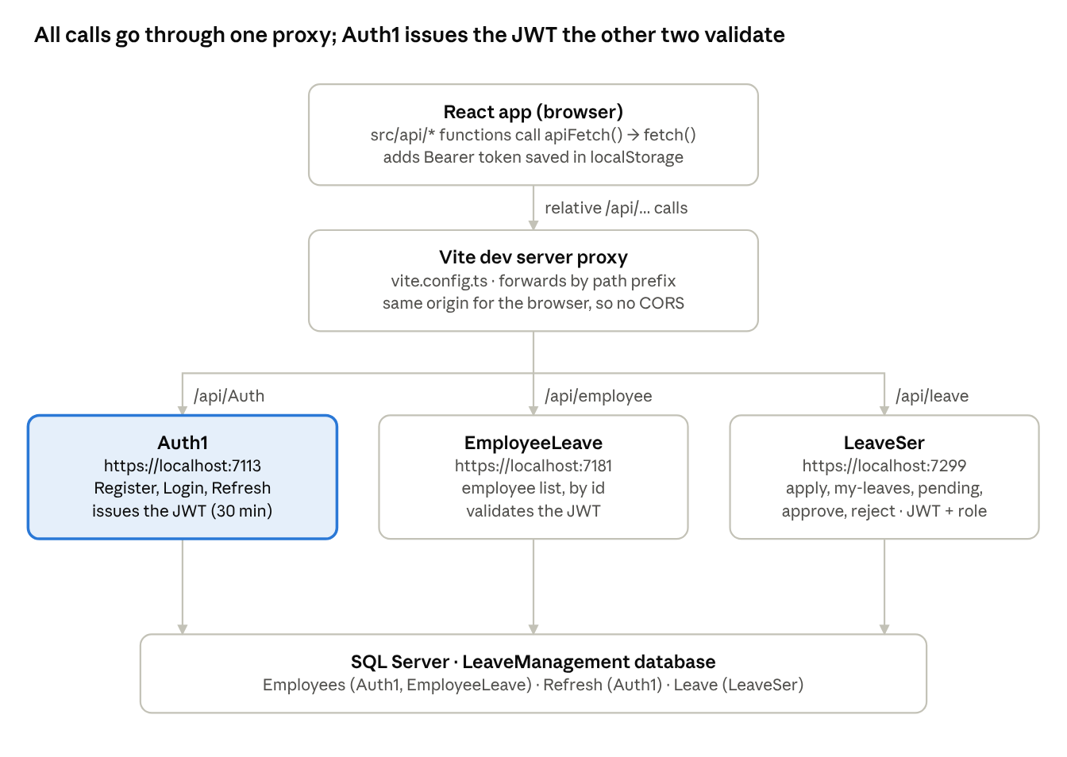
front end to backend · 1 proxy, 3 services, 1 database
The browser only ever talks to the Vite dev server. Auth1 signs the token, and EmployeeLeave and LeaveSer accept it because all three share the same Jwt:Issuer, Jwt:Audience and Jwt:Key.
Endpoints used by the app
Front-end function | Method and path | Service | Auth | Returns
register(request) | POST /api/Auth/Register | Auth1 | none | { message }; 409 if email exists
login(email, password) | POST /api/Auth/Login | Auth1 | none | { accesstoken, refreshtoken, userRole }; 401 if wrong
(inside apiFetch) | POST /api/Auth/Refresh | Auth1 | none | { accesstoken }
getEmployees() | GET /api/employee | EmployeeLeave | any logged-in user | EmployeeDto[]
getEmployeeById(id) | GET /api/employee/{id} | EmployeeLeave | any logged-in user | EmployeeDto; 404 if missing
applyLeave(request) | POST /api/leave/apply | LeaveSer | any logged-in user | { message, leaveId }; 400 on a date rule
getMyLeaves() | GET /api/leave/my-leaves | LeaveSer | any logged-in user | own LeaveDto[], newest applied first
getPendingLeaves() | GET /api/leave/pending | LeaveSer | Admin (role 1) | Pending LeaveDto[]; 403 otherwise
approveLeave(id, remark) | PUT /api/leave/approve/{id} | LeaveSer | Admin | { message, leave }
rejectLeave(id, remark) | PUT /api/leave/reject/{id} | LeaveSer | Admin | { message, leave }; 400 if remark empty
LeaveSer takes the employee id from the JWT's nameid claim, never from the request body, so an employee can only apply for or list their own leave.
What apiFetch() does
- Sends JSON with Accept and Content-Type: application/json.
- Adds Authorization: Bearer <accessToken> unless the call passes auth: false (login, register).
- On 401, refreshes the token once and retries (see Authentication flow).
- Parses the JSON body and returns it typed as T.
- On any other failure, throws an ApiError with message, status and fieldErrors.
- If the server can't be reached at all, it throws "Cannot reach the server. Check that the API services are running."
A typical service function and its page call:
// src/api/leaveApi.ts
export async function applyLeave(request: ApplyLeaveRequest): Promise<number> {
const result = await apiFetch<{ message: string; leaveId: number }>("/api/leave/apply", {
method: "POST",
body: request
});
return result.leaveId;
}
// src/pages/employee/ApplyLeave.tsx
try {
await applyLeave({ leaveType, fromDate, toDate, reason: reason.trim() });
onApplied();
} catch (err) {
setError(errorMessage(err));
}
Error shapes the services return, all turned into one ApiError by toApiError():
Source | Body | Example
Custom exceptions caught by each service's ExceptionHandling middleware | { statusCode, message } | 409 "User name already exists", 400 "Leave cannot be applied for past dates.", 404 "Leave not found with id: 7"
BadRequest("...") / Unauthorized("...") in a controller | Plain text | 401 "Invalid Username and Password"
[ApiController] model validation | ProblemDetails { title, errors: { Field: ["msg"] } } | 400 with errors.MobileNo
Any other exception | { statusCode: 500, message, error } | 500 "An unexpected error occurred."
From API data to front-end types (dto.ts, mappers.ts)
- JSON keys are camelCase from ASP.NET: UserID arrives as userID, Accesstoken as accesstoken.
- toUser() turns department (number) into a name via DEPARTMENTS, role 1 into "Admin", and isActive (0/1) into a boolean.
- toLeave() cuts ISO date-times (2026-10-15T00:00:00) to yyyy-mm-dd and turns a null remark into "".
Dev proxy (vite.config.ts): none of the services has a CORS policy. The app calls relative paths, and Vite forwards /api/Auth, /api/employee and /api/leave to ports 7113, 7181 and 7299, with secure: false to accept the local ASP.NET dev certificate. The proxy runs only in npm run dev.

State management
The API is the source of truth; the useReducer store inside AppProvider holds a client-side copy of what it last returned. A page calls a function in src/api/, waits for the response, then dispatches it. The reducer stores it, and React re-renders everything that reads the store.
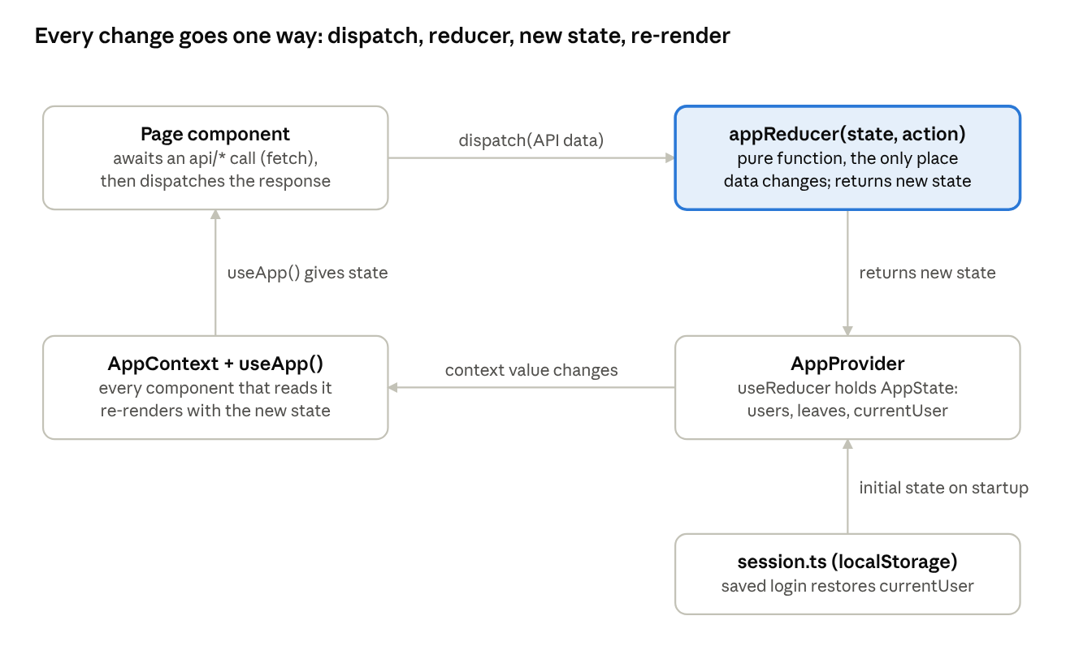
state data flow · one-way loop
The reducer (highlighted) is still the only place store data changes. It is pure: it never calls the API or touches localStorage. Those side effects happen in the page or in src/api/ before the dispatch.
The pieces (src/store/)
- appReducer.ts — AppState, the AppAction union and appReducer().
- AppProvider.tsx — useReducer(appReducer, null, init), where init reads currentUser from the saved session. A useEffect registers setSessionExpiredHandler, so http.ts can log the user out when a token can't be refreshed.
- AppContext.ts — creates the context and exports useApp().
State
Field | Filled by | Holds
currentUser | LOGIN after a successful login, or the saved session on startup | The logged-in User, or null
users | SET_USERS from GET /api/employee (admin dashboard) | All employees
leaves | SET_LEAVES from GET /api/leave/my-leaves (employee) or GET /api/leave/pending (admin) | That user's leave list
Actions
Action | Payload | What the reducer does
LOGIN | user | Sets currentUser and empties users and leaves
LOGOUT | none | Clears currentUser, users and leaves
SET_USERS | users | Replaces the employee list
SET_LEAVES | leaves | Replaces the leave list
UPDATE_LEAVE | leave | Swaps in the leave returned by approve or reject, matched by leaveId
LOGIN and LOGOUT empty the lists so one user never sees data left over from the previous one. The old REGISTER, APPLY_LEAVE, APPROVE_LEAVE and REJECT_LEAVE actions are gone: the server creates the records now, so the page refetches or uses the server's response instead of building records itself.
Global vs local state: only data several screens share goes in the store. Form fields, the active tab, search text, the open dialog and the per-screen loading / error / submitting flags stay in useState inside the component that uses them. Tokens live in localStorage through session.ts, not in React state.

Employee flows
An employee works on EmployeeDashboard, with two tabs: My Leaves (the default) and Apply Leave. Every number and row comes from GET /api/leave/my-leaves. Leave balances are not tracked; the cards count requests by status.
Dashboard (pages/employee/EmployeeDashboard.tsx)
- On open, a useEffect calls getMyLeaves() and dispatches SET_LEAVES. An ignore flag drops the result if the dashboard closes before the response arrives.
- While loading, My Leaves shows "Loading your leave requests...". On failure, a red alert shows the error with a Try again link.
- reload() sets loading, clears the error and bumps reloadKey, which re-runs the effect. The same call is used after applying.
- The heading shows "Welcome, {name}", Employee ID and department (mapped from the department number).
- Four StatCards: Total Requests, Pending, Approved, Rejected. The list is shown newest first.
Apply Leave (pages/employee/ApplyLeave.tsx)
- The employee picks a Leave Type, From Date, To Date and Reason (up to 500 characters). Past dates are blocked in the date picker, and "Total: N days" appears once both dates are valid.
- On submit, validate() checks the same rules the API enforces, so most mistakes never reach the server:
  - all fields filled;
  - From Date not in the past;
  - To Date not before From Date;
  - Reason at least 5 characters (the API needs 3);
  - no overlap with the employee's own Pending or Approved leave, checked against the list already loaded.
- If valid, it calls applyLeave(), which sends POST /api/leave/apply with { leaveType, fromDate, toDate, reason }. The button shows "Submitting..." and is disabled meanwhile.
- LeaveSer checks the dates again, including overlap against the database. A failure returns 400 with a message such as "You already have a leave applied for these dates.", shown in the red alert.
- On success, the dashboard switches to My Leaves, shows "Leave request submitted. Status: Pending.", and reloads the list from the API.
My Leaves (pages/employee/MyLeaves.tsx)
A read-only table: Leave Type, From, To, Reason, Applied On, a coloured status badge, and the Admin Remark ("-" when empty). Dates are shown as dd-mm-yyyy by formatDate. When the list is empty it shows "You have not applied for any leave yet." A decision made by the admin appears the next time the list loads.
Overlap rule, the same in ApplyLeave.tsx and in LeaveSer (two ranges overlap when each starts on or before the other ends):
fromDate <= l.toDate && toDate >= l.fromDate
In the browser this works on plain strings, because yyyy-mm-dd dates sort the same alphabetically as by date.

Admin flows
The admin works on AdminDashboard, with two tabs: Leave Requests (the default) and Employees. LeaveSer only exposes pending leaves to the admin, so the screen shows the queue to decide on, not a full history. A leave can be decided only once: Pending becomes Approved or Rejected.
Dashboard (pages/admin/AdminDashboard.tsx)
- On open, a useEffect runs getEmployees() and getPendingLeaves() in parallel with Promise.all, then dispatches SET_USERS and SET_LEAVES.
- If either call fails, a red alert shows the error with a Try again link. A non-admin token gets 403 from /api/leave/pending.
- employees = users whose role is Employee (the admin is excluded).
- Four StatCards: Employees, Active, Inactive, Pending Requests. There are no Approved or Rejected totals, because the API has no endpoint that returns them.
- Tabs switches between LeaveRequests and EmployeeList.
Leave Requests (pages/admin/LeaveRequests.tsx)
- Shows the pending leaves, sorted by From Date, earliest first. A Refresh button reloads both lists.
- Each row shows the employee name and ID, looked up in state.users because a leave carries only employeeId. It also shows leave type, dates, reason, applied date and status badge.
- Approve and Reject open LeaveActionDialog for that row.
- After a decision, the row stays in the list with its new status, action date and remark until the next refresh, then drops out because it is no longer pending.
Approve / Reject dialog (pages/admin/LeaveActionDialog.tsx)
- Shows the employee, leave type, dates with day count and reason, plus an Admin Remark box.
- The remark is optional for Approve and required for Reject. The browser checks it first, and LeaveSer rejects an empty remark with 400 too.
- Confirm calls approveLeave(id, remark) or rejectLeave(id, remark), which send PUT /api/leave/approve/{id} or /reject/{id} with { adminRemark }. The buttons are disabled and show "Saving..." meanwhile.
- LeaveSer sets Status, AdminRemark and ActionDate and returns the updated leave. UPDATE_LEAVE swaps it into the list, and the dialog closes.
- If the call fails, the dialog stays open with the server's message, for example "Leave is already Approved." when another admin acted first.
- Cancel, or a click on the dark overlay, closes the dialog when it is not saving.
Employees (pages/admin/EmployeeList.tsx)
A read-only table from GET /api/employee: Employee ID, name, email, mobile, department name, and an Active / Inactive badge. The search box filters by name, email or department as you type. The backend has no endpoint to activate, deactivate or edit employees.

Components and UI
Four small shared components cover everything repeated across pages; each one only takes props and renders, except Header, which reads the store.
Component | Props | Used by | What it renders
Header | none (reads useApp()) | App | Brand name; when logged in, the user's name, role and a Logout button that also clears the saved session
StatCard | label, value, tone? (default / pending / approved / rejected) | Both dashboards | One count card, coloured by tone via class stat-{tone}
StatusBadge | status (Pending / Approved / Rejected / Active / Inactive) | MyLeaves, LeaveRequests, EmployeeList | A pill with class badge-{status in lower case}
Tabs<T> | tabs, active, onChange | Both dashboards | A tab bar with role="tablist" and aria-selected; generic, so T is the union of tab keys and a typo fails to compile
Styling
- All styles are in src/index.css, with plain class names (card, btn btn-primary, field, table, badge, alert).
- Colours, radius and shadow are CSS variables on :root (--primary, --success, --danger, --warning and their -soft versions).
- A prefers-color-scheme: dark block redefines those variables, so dark mode follows the OS with no extra code.
- .table-wrapper lets wide tables scroll sideways on small screens.
Forms and validation
- Every input is controlled: its value lives in useState, and onChange updates it.
- Forms use noValidate, so the browser's own popups are off and the code shows its own messages.
- Validation runs on submit. Register shows an error under each field (field-error); Login, Apply Leave and the dialog show one alert at a time.
- Each <label htmlFor> matches its input id, so clicking a label focuses the field and screen readers announce it.
Every submit that calls the API is async. It keeps a submitting flag that disables the button and changes its label ("Signing in...", "Submitting...", "Saving..."), and on failure it shows errorMessage(err) in the same alert used for browser-side validation.

Types and models
There are two layers of types. src/api/dto.ts describes the JSON exactly as the backend sends it, and src/types/index.ts holds the front-end models that pages use. src/api/mappers.ts converts one into the other, so a change in the API stays inside src/api/.
User (front end) ← EmployeeDto (EmployeeLeave)
Front-end field | Type | From API field | Conversion
userId | number | userID | none
employeeName | string | employeeName | none
email | string | email | none
mobileNo | string | mobileNo | none
department | string | department (int) | departmentName(id) via DEPARTMENTS
role | "Employee" | "Admin" | role (int) | 1 → Admin, anything else → Employee
isActive | boolean | isActive (int) | non-zero → true
createdDate | string yyyy-mm-dd | createdDate (ISO) | first 10 characters
The API never returns the password (EmployeeDto leaves it out), so the front-end User has no password field any more.
Leave (front end) ← LeaveDto (LeaveSer)
Front-end field | Type | Notes
leaveId | number | Primary key from the Leave table
employeeId | number | UserID taken from the JWT when the leave was applied
leaveType | string | Free text in the API (max 50); the UI offers LEAVE_TYPES
fromDate, toDate | string yyyy-mm-dd | Cut from ISO date-times; inclusive range
reason | string | 3–500 characters in the API, at least 5 in the UI
status | "Pending" | "Approved" | "Rejected" | Same strings as LeaveSer's LeaveStatus constants
adminRemark | string | null in the API becomes ""
appliedDate | string yyyy-mm-dd | Set by the server
actionDate | string | null | null until approved or rejected
Request types (dto.ts)
- RegisterRequest — { employeeName, email, mobileNo, department: number, password, role: number, isActive: number }.
- ApplyLeaveRequest — { leaveType, fromDate, toDate, reason }, dates as yyyy-mm-dd.
- Login sends { uname, pass }, refresh sends { username, token }, approve and reject send { adminRemark }.
Lookups (src/data/lookups.ts): the backend stores department and role as numbers and has no endpoint to list them, so the ids live here. DEPARTMENTS (IT=1, HR=2, Finance=3, Sales=4, Operations=5) and Employee role 2 are assumptions and must match the database; Admin role 1 comes from LeaveSer's Roles:Admin setting.
Store types (src/store/appReducer.ts): AppState = { currentUser: User | null; users: User[]; leaves: Leave[] }. AppAction is a discriminated union, so inside switch (action.type) TypeScript knows which payload each case has.

Error handling, loading states and notifications
Every API failure becomes an ApiError, and errorMessage(err) turns any thrown value into text for an inline alert. Loading and saving are tracked with local useState flags; there are still no toasts, spinners or error boundaries.
Situation | What the user sees | Where
Browser-side validation, one at a time | Red alert alert-error above the form | LoginPage, ApplyLeave, LeaveActionDialog
Browser-side validation per field | Red field-error under the input | RegisterPage
Server model-validation (400 ProblemDetails) | Messages placed under the matching fields via fieldErrors, plus the first one on top | RegisterPage
Server rule broken (400 / 409) | The server's message in the red alert | Register, Apply Leave, Approve / Reject dialog
Wrong login (401 plain text) | "Invalid Username and Password" | LoginPage
List failed to load | Red alert with the error and a Try again link | Employee and Admin dashboards
Loading a list | "Loading ..." in place of the empty-list message | MyLeaves, LeaveRequests, EmployeeList
Saving | Button disabled with "Signing in...", "Registering...", "Submitting..." or "Saving..." | Every form
Token can't be refreshed | Back to the login page; the call throws "Your session has expired. Please log in again." | Any screen
Services not running | "Cannot reach the server. Check that the API services are running." or a 5xx message | Any call
Store used outside the provider | useApp() throws "useApp must be used inside <AppProvider>" | AppContext.ts
Avoiding stale updates: each dashboard effect keeps an ignore flag that its cleanup sets. A response that arrives after the user has logged out or left the screen is dropped instead of being written into the store.
How success messages travel between screens: the form unmounts as soon as the screen changes, so the parent owns the message. The child calls a callback (onRegistered, onApplied) only after the API call succeeds, and the parent sets both the message and the next view.

Key React concepts used in this project
The app uses a small set of core React ideas: components and props, useState, useReducer with Context, derived data, conditional rendering and lifting state up. Since the API was connected, it also uses useEffect for loading data and async / await with fetch (points 14–18).
1. Components and props. A component is a function that returns JSX. Data goes down as props, and events come back up as callback props.
<StatCard label="Pending" value={count("Pending")} tone="pending" />
<ApplyLeave onApplied={() => { setTab("my-leaves"); setMessage("..."); }} />
2. useState for local UI state. State that only one component cares about stays in that component: form fields, the active tab, the selected filter, the open dialog.
const [filter, setFilter] = useState<Filter>("Pending");
const [pendingAction, setPendingAction] = useState<PendingAction | null>(null);
3. Updating object state immutably. RegisterPage keeps all fields in one object and copies it on each change. Writing values.email = x would not re-render the page.
setValues(prev => ({ ...prev, [field]: value }));
4. useReducer for shared state. All state-change logic lives in one pure function, appReducer(state, action). It returns a new state and never mutates the old one (it uses ...state, .map, and spread arrays). Components describe what happened with dispatch({ type: "LOGIN", user }) instead of changing data themselves.
5. Context to avoid prop drilling. AppProvider puts { state, dispatch } into AppContext. Any component calls useApp() to read it. React 19 lets you render <AppContext value={...}> directly, without .Provider.
6. Custom hook with a safety check. useApp() wraps useContext and throws a clear error when it is used outside the provider. Callers also get a non-null type, so they skip the null check.
7. Derived data instead of duplicated state. Counts, myLeaves, employees and filtered lists are calculated during render from state, not stored separately, so they can never get out of sync. The React Compiler memoises these calculations automatically.
8. Conditional rendering. Screens and pieces appear based on state: {user && <div>...}, tab === "apply" ? <ApplyLeave/> : <MyLeaves/>, {pendingAction && <LeaveActionDialog/>}.
9. Lists and keys. Every .map() that produces rows gives each row a stable key (leave.leaveId, emp.userId), so React can match rows between renders.
10. Lifting state up. When two siblings need the same value, the parent owns it. App owns authView and loginMessage, which RegisterPage changes and LoginPage displays.
11. Controlled forms and events. value + onChange on every input. event.preventDefault() stops the browser from reloading the page on submit. e.stopPropagation() keeps a click inside the dialog from reaching the overlay.
12. TypeScript patterns. String literal unions ("Pending" | "Approved" | "Rejected"), discriminated unions for actions, Omit / Pick / Partial<Record<...>>, a generic component (Tabs<T extends string>), and a non-null assertion (state.currentUser!) where App already guarantees a logged-in user.
13. StrictMode. main.tsx wraps the app in <StrictMode>. In development, React renders components twice to expose impure code. The reducer is pure, so this is safe.
14. useEffect to load data. A dashboard fetches its list after it renders, inside useEffect. The cleanup sets ignore = true, so a late response is dropped. Changing reloadKey re-runs the effect, which is how Refresh and Try again work.
useEffect(() => {
let ignore = false;
getMyLeaves()
.then(leaves => { if (!ignore) dispatch({ type: "SET_LEAVES", leaves }); })
.catch((err: unknown) => { if (!ignore) setLoadError(errorMessage(err)); })
.finally(() => { if (!ignore) setLoading(false); });
return () => { ignore = true; };
}, [dispatch, reloadKey]);
15. fetch and async / await. fetch returns a Promise of a Response. await pauses the async function until it arrives. response.ok is false for any 4xx or 5xx status, and fetch itself rejects only when the network fails, so apiFetch checks both.
16. Async event handlers. Form submits are async functions. They set submitting, await the API call, and use try / catch to turn a thrown ApiError into an alert. The flag is reset only on failure, because on success the component goes away.
17. Lazy reducer initialisation. useReducer(appReducer, null, init) calls init once on the first render. Here it reads the saved session from localStorage without doing that on every render.
18. Keeping the reducer pure. Side effects (HTTP calls, localStorage, token refresh) live in src/api/ and in event handlers. The reducer only computes new state, which keeps it safe under StrictMode's double rendering and easy to test.

Known gaps and suggested improvements
The app now runs end to end on the real API. The most important remaining issues are three backend security gaps, and two missing endpoints that limit the admin screen.
Backend: security
Gap | Risk | Suggested fix
Register accepts whatever role and isActive the request sends | Anyone can register as Admin with role: 1 | Ignore those fields in Auth1 and always save Role = 2, IsActive = 1
Login does not check IsActive | An inactive user still gets a valid token; only the React app blocks them | Return 401 / 403 from Auth1 when IsActive = 0
GET /api/employee is open to every logged-in user | An employee can list all employees' emails and phone numbers | Add [Authorize(Policy = "AdminOnly")] to the list endpoint
Database password and JWT key are in appsettings.json | Secrets end up in source control | Move them to User Secrets or environment variables
Backend: missing features
Gap | Effect on the app | Suggested fix
No admin endpoint for all leaves | The admin sees only Pending; no Approved / Rejected history or totals | Add GET /api/leave (AdminOnly), optionally with ?status=
No CORS policy | The React app works only through the Vite dev proxy | Add AddCors with the front-end origin, or host the built app on the same origin
No department or role master endpoint | Ids are hard-coded in lookups.ts and may not match the database | Add GET /api/departments and load it on the Register page
No activate / deactivate or cancel-leave endpoints | The admin can't manage accounts; employees can't withdraw a request | Add PUT /api/employee/{id}/status and PUT /api/leave/cancel/{id}
No logout endpoint | The refresh token stays valid for 1 day after logout | Add POST /api/Auth/Logout that deletes it
Front end
Area | Gap today | Suggested change
Token storage | Tokens are in localStorage, which any script on the page can read | Move the refresh token to an HttpOnly cookie set by Auth1
Routing | No URLs: Back leaves the app and a refresh resets the tab | Add React Router with /login, /register, /employee, /admin and a role guard
Production build | The /api proxy exists only in npm run dev | Use a VITE_API_BASE_URL per service once CORS is enabled, or a reverse proxy
Leave rules | No balance per type; day count includes weekends and holidays | Add balances and a working-day calculation (needs backend support)
Accessibility | The dialog doesn't close on Escape or trap focus | Use the native <dialog> element
Tests | No automated tests | Add Vitest for appReducer, mappers and toApiError, and mock fetch for the API modules
Clean-up | App.css, src/assets/* and the README are left from the Vite template | Delete the unused files; point the README to this guide

