LeaveManagement React App — Developer Guide
Oct 6, 2026 · @GAURAV

Overview
LeaveManagement is a single-page React app where employees apply for leave and an admin approves or rejects it. It runs fully in the browser on mock data: there is no backend call yet, and every reducer action is already mapped to the ASP.NET Core Web API endpoint that will replace it (see API layer).
Two roles, one app
Role | Can do | Lands on
Employee | Register, log in, apply for leave, see own requests with status and admin remark | Employee Dashboard
Admin | Log in, see all leave requests, filter by status, approve or reject with a remark, view registered employees | Admin Dashboard
Main features
- Employee self-registration with field validation (email format, unique email, 10-digit mobile, password rules).
- Login with email and password; inactive accounts are blocked.
- Apply leave with date rules: no past dates, To Date not before From Date, no overlap with your own Pending or Approved leave.
- Admin review: Pending / Approved / Rejected / All filter, confirm dialog, remark required on reject.
- Dashboards with count cards (total, pending, approved, rejected).
- Light and dark theme follow the operating system setting.
The code comments refer to a BRD (business requirements document) by section, for example "BRD 5.2" for role-based routing and "BRD 7.1" for the User table. The data types mirror those BRD tables so the swap to the real API is a straight mapping.

Tech stack
The app uses only React and React DOM at runtime; there is no router, HTTP client or UI library. Everything else is build and lint tooling.
Package | Version (package.json) | Role
react, react-dom | ^19.2.8 | UI library and browser renderer
typescript | ~6.0.2 | Static types; tsc -b runs before every build
vite | ^8.3.0 | Dev server with hot reload, production bundler
@vitejs/plugin-react | ^6.1.1 | JSX transform and React Fast Refresh
babel-plugin-react-compiler + @rolldown/plugin-babel | ^1.0.0 / ^0.2.3 | React Compiler: memoises components automatically, so no manual useMemo / useCallback
oxlint | ^1.81.0 | Linter; enforces the Rules of Hooks
@types/react, @types/react-dom, @types/node | 19.x / 24.x | Type definitions
State is held with React's built-in useReducer + Context (see State management). Styling is plain CSS with CSS variables in src/index.css.

Project structure
Code is grouped by role: pages/ holds one folder per user type, store/ holds all shared state, and components/ holds small reusable pieces.
LeaveManagement/
├─ index.html page shell, loads src/main.tsx
├─ vite.config.ts React plugin + React Compiler
├─ package.json scripts and dependencies
└─ src/
├─ main.tsx entry: mounts <AppProvider><App/></AppProvider>
├─ App.tsx decides which screen to show
├─ index.css all styles and theme variables
├─ types/index.ts User, Leave, Role, LeaveStatus
├─ data/mockData.ts seed users, seed leaves, DEPARTMENTS, LEAVE_TYPES
├─ utils/date.ts today(), formatDate(), dayCount()
├─ store/
│ ├─ appReducer.ts AppState, AppAction, appReducer()
│ ├─ AppContext.ts AppContext + useApp() hook
│ └─ AppProvider.tsx useReducer + Context provider
├─ components/
│ ├─ Header.tsx brand, logged-in user, Logout
│ ├─ StatCard.tsx one count card
│ ├─ StatusBadge.tsx coloured status pill
│ └─ Tabs.tsx generic tab bar
└─ pages/
├─ auth/ LoginPage, RegisterPage
├─ employee/ EmployeeDashboard, ApplyLeave, MyLeaves
└─ admin/ AdminDashboard, LeaveRequests, LeaveActionDialog, EmployeeList
src/App.css and the images in src/assets/ are left over from the Vite template; nothing imports them.

Getting started
Install once, then npm run dev starts the app with hot reload. No environment variables or API URL are needed yet, because all data is mock data.
- Install Node.js (a current LTS release).
- In React/LeaveManagement, run npm install.
- Run npm run dev and open the URL Vite prints (normally http://localhost:5173).
- Log in with a test account shown on the login page.
Script | Command | What it does
dev | vite | Dev server with hot module reload
build | tsc -b && vite build | Type-checks, then bundles to dist/
preview | vite preview | Serves the built dist/ locally
lint | oxlint | Lints the source
Test accounts (from src/data/mockData.ts)
Role | Email | Password | Note
Admin | admin@company.com | admin123
Employee | rahul@gmail.com | rahul123 | Has 3 leaves (Approved, Pending, Rejected)
Employee | sneha@gmail.com | sneha123 | Has 1 Pending leave
Employee | amit@gmail.com | amit123 | Inactive: login is blocked
State lives only in memory. A page refresh resets everything to the seed data, including new registrations and leave requests.

Routing and navigation
There is no React Router. App.tsx chooses the screen with plain if checks on every render: logged-out users see Login or Register, and logged-in users see the dashboard for their role. Inside a dashboard, a Tabs bar switches between two sub-views held in local state.
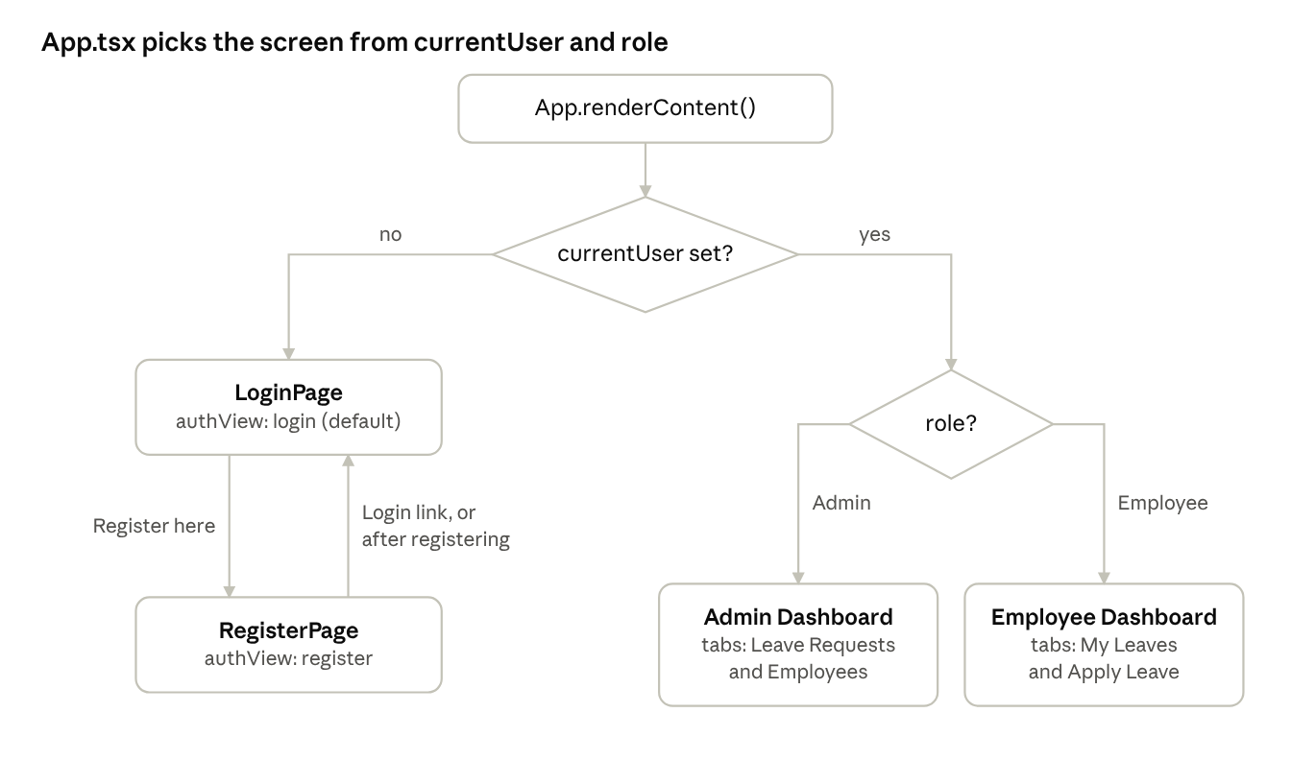
screen selection in App.tsx · 2 decisions, 4 screens
Dispatching LOGIN or LOGOUT changes currentUser, and App walks this tree again on the next render. The Logout button in Header is always visible when logged in, so every dashboard leads back to LoginPage.
Screen state | Owned by | Values
Logged in or not | state.currentUser (global store) | User or null
Login vs Register | authView in App | "login" | "register"
Employee tab | tab in EmployeeDashboard | "my-leaves" | "apply"
Admin tab | tab in AdminDashboard | "leaves" | "employees"
Approve / Reject dialog open | pendingAction in LeaveRequests | { leave, action } or null
Because screens are not URLs, the browser Back button leaves the app and a refresh returns to the login page. See Known gaps.

Authentication flow
Logging in is just putting a User object into state.currentUser; logging out sets it back to null. There is no token, cookie or localStorage yet, and App.tsx acts as the route guard by checking currentUser on every render.
Register (pages/auth/RegisterPage.tsx)
- The form keeps all six fields in one values object (useState<FormValues>), updated by setField(field, value).
- On submit, validate() builds a FormErrors object, one message per bad field:
  - name required;
  - email required, valid format, and not already in state.users;
  - mobile required and matching ^[6-9]\d{9}$ (non-digits are stripped while typing);
  - department selected;
  - password at least 6 characters, and Confirm Password matches.
- If there are no errors, it dispatches REGISTER. The reducer adds the user with the next userId, role: "Employee", isActive: true and today's createdDate.
- onRegistered() tells App to switch to the login view and show "Registration successful. Please log in."
Login (pages/auth/LoginPage.tsx)
- Email and password are required.
- It looks up a user whose email matches (case-insensitive) and whose password matches exactly.
- No match shows "Invalid email or password." A match with isActive: false shows "Your account is inactive. Please contact the admin."
- Otherwise it dispatches LOGIN with that user, and App re-renders into the right dashboard.
Logout (components/Header.tsx)
The Logout button dispatches LOGOUT. currentUser becomes null, so App shows the login screen again.
Route guard
App.renderContent() returns the Admin Dashboard when currentUser.role === "Admin", the Employee Dashboard for any other logged-in user, and the login or register page when nobody is logged in. A logged-out user has no way to reach a dashboard, because nothing else renders one.

API layer
There is no HTTP layer yet: every "API call" is a reducer action or a filter on in-memory state. The comments in appReducer.ts and the pages name the BRD endpoint each one stands in for, which gives the backend contract.
Front-end today | File | Planned endpoint
dispatch({ type: "REGISTER" }) | RegisterPage.tsx | POST /api/auth/register
state.users.find(...) + dispatch({ type: "LOGIN" }) | LoginPage.tsx | POST /api/auth/login
dispatch({ type: "APPLY_LEAVE" }) | ApplyLeave.tsx | POST /api/leave/apply
Filter state.leaves by employeeId | EmployeeDashboard.tsx | GET /api/leave/my-leaves
Filter state.leaves by status === "Pending" | LeaveRequests.tsx | GET /api/leave/pending
dispatch({ type: "APPROVE_LEAVE" }) | LeaveRequests.tsx | PUT /api/leave/approve/{id}
dispatch({ type: "REJECT_LEAVE" }) | LeaveRequests.tsx | PUT /api/leave/reject/{id}
Filter state.users by role === "Employee" | AdminDashboard.tsx | GET /api/employee
How to switch to the real API (the plan written in appReducer.ts): call the endpoint first, then dispatch with the response. For example, in ApplyLeave.handleSubmit:
const res = await fetch("/api/leave/apply", {
method: "POST",
headers: { "Content-Type": "application/json", Authorization: `Bearer ${token}` },
body: JSON.stringify({ leaveType, fromDate, toDate, reason })
});
if (!res.ok) { setError(await res.text()); return; }
dispatch({ type: "APPLY_LEAVE", leave: await res.json() });
When this happens, the reducer should store the server's record (with its real leaveId) instead of generating one with nextId(), and login should keep the JWT the API returns.

State management
All shared data lives in one useReducer store inside AppProvider, shared through React Context. Components never change data directly: they dispatch an action, the reducer returns a new state, and React re-renders everything that reads it.
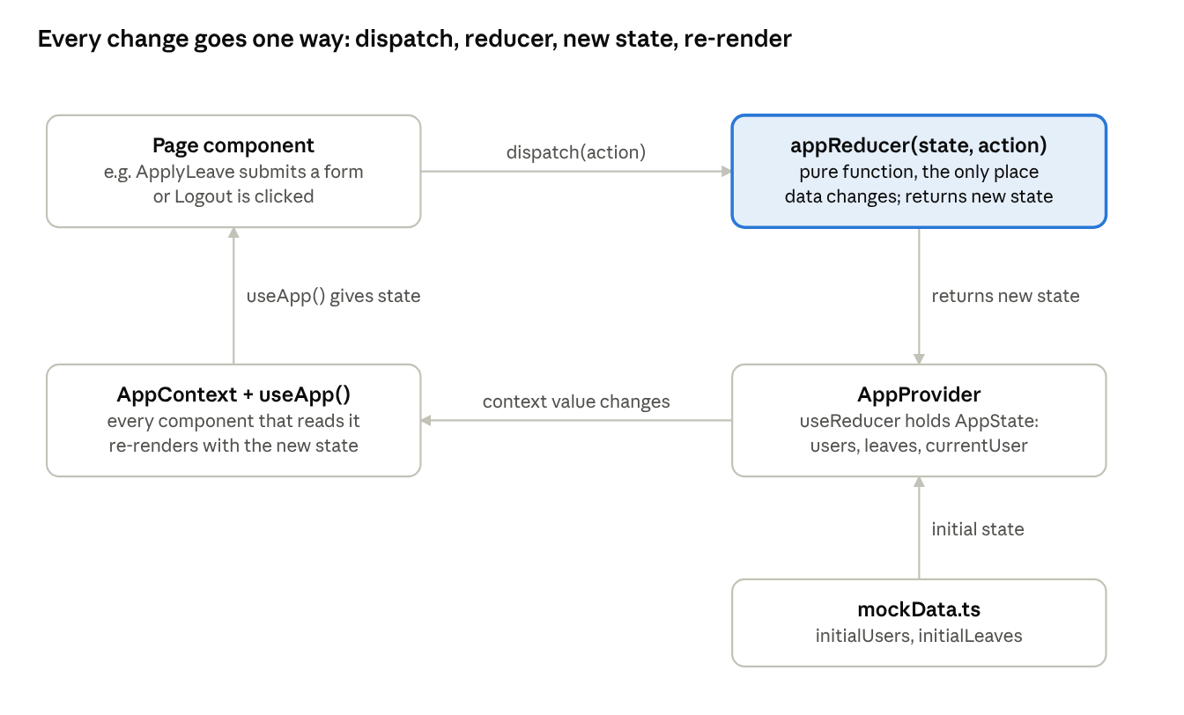
state data flow · one-way loop
The reducer (highlighted) is the only place data changes, so every rule about a new user or leave (ids, default status, dates) is in one file.
The pieces (src/store/)
- appReducer.ts — AppState, the AppAction union and appReducer(). nextId() picks max id + 1 for new records.
- AppProvider.tsx — calls useReducer(appReducer, { users: initialUsers, leaves: initialLeaves, currentUser: null }) and renders <AppContext value={{ state, dispatch }}>.
- AppContext.ts — creates the context and exports useApp().
Actions
Action | Payload | What the reducer does
REGISTER | name, email, mobile, department, password | Adds a user with the next userId, role Employee, active, today's date
LOGIN | user | Sets currentUser
LOGOUT | none | Sets currentUser to null
APPLY_LEAVE | leaveType, fromDate, toDate, reason | Adds a Pending leave for currentUser (ignored if nobody is logged in)
APPROVE_LEAVE | leaveId, remark | Sets that leave to Approved, saves remark and actionDate
REJECT_LEAVE | leaveId, remark | Same, with status Rejected
Global vs local state: only data that several screens need goes in the store (users, leaves, who is logged in). Form fields, the active tab, the status filter, search text and the open dialog stay in useState inside the component that uses them.

Employee flows
An employee works on one screen, EmployeeDashboard, with two tabs: My Leaves (the default) and Apply Leave. Leave balances are not tracked yet; the dashboard counts requests by status.
Dashboard (pages/employee/EmployeeDashboard.tsx)
- Heading: "Welcome, {name}" with Employee ID and department.
- myLeaves = state.leaves filtered to employeeId === currentUser.userId, newest first (by leaveId, descending).
- Four StatCards: Total Requests, Pending, Approved, Rejected.
- A Tabs bar switches between the two tabs. Changing tab clears the success message.
Apply Leave (pages/employee/ApplyLeave.tsx)
- The employee picks a Leave Type (Casual, Sick, Earned, Unpaid), From Date, To Date and Reason.
- The date pickers block past dates (min={today()}), and To Date cannot go before From Date. A "Total: N days" line appears once both dates are valid (dayCount, inclusive).
- On submit, validate() returns the first problem it finds, shown in one red alert:
  - any field empty;
  - From Date in the past;
  - To Date before From Date;
  - Reason shorter than 5 characters;
  - dates overlapping one of the employee's own Pending or Approved leaves (Rejected leaves do not count).
- If valid, it dispatches APPLY_LEAVE. The reducer adds the leave with status: "Pending", an empty remark, today's appliedDate and actionDate: null.
- onApplied() switches back to My Leaves and shows "Leave request submitted. Status: Pending."
My Leaves (pages/employee/MyLeaves.tsx)
A read-only table of the employee's requests: Leave Type, From, To, Reason, Applied On, a coloured status badge, and the Admin Remark ("-" when empty). Dates are shown as dd-mm-yyyy by formatDate. If the list is empty, it shows "You have not applied for any leave yet."
Overlap check, as the code writes it (two ranges overlap when each starts on or before the other ends):
fromDate <= l.toDate && toDate >= l.fromDate
This works on plain strings because yyyy-mm-dd dates sort the same alphabetically as by date.

Admin flows
The admin works on AdminDashboard, with two tabs: Leave Requests (the default, showing Pending) and Employees. A leave can be acted on only once: Pending becomes Approved or Rejected, and the action buttons disappear.
Dashboard (pages/admin/AdminDashboard.tsx)
- employees = state.users filtered to role === "Employee" (the admin is excluded).
- Four StatCards: Employees, and Pending / Approved / Rejected counts across all leaves.
- Tabs switches between LeaveRequests and EmployeeList.
Leave Requests (pages/admin/LeaveRequests.tsx)
- Filter chips choose the view: Pending (default), Approved, Rejected or All. Rows are sorted by From Date, earliest first.
- Each row shows employee name and ID (looked up from state.users), leave type, dates, reason, applied date and status badge.
- Pending rows have Approve and Reject buttons. Clicking one stores { leave, action } in pendingAction, which opens the dialog.
- Rows already decided show the action date and the admin remark instead of buttons.
Approve / Reject dialog (pages/admin/LeaveActionDialog.tsx)
- The dialog shows the employee, leave type, dates with day count, and reason, plus an Admin Remark box.
- The remark is optional for Approve and required for Reject ("Please enter a remark for rejection.").
- Confirm calls onConfirm(remark). LeaveRequests.handleConfirm dispatches APPROVE_LEAVE or REJECT_LEAVE with the leaveId and remark, then closes the dialog.
- The reducer sets status, adminRemark and actionDate = today() on that one leave. The employee sees the new status and remark next time they open My Leaves.
- Cancel, or a click on the dark overlay, closes the dialog without changes. Clicks inside the dialog call stopPropagation() so they don't close it.
Employees (pages/admin/EmployeeList.tsx)
A read-only table: Employee ID, name, email, mobile, department, and an Active / Inactive badge. The search box filters by name, email or department as you type (case-insensitive). The admin cannot yet activate, deactivate or edit employees.

Components and UI
Four small shared components cover everything repeated across pages; each one only takes props and renders, except Header, which reads the store.
Component | Props | Used by | What it renders
Header | none (reads useApp()) | App | Brand name; when logged in, the user's name, role and a Logout button
StatCard | label, value, tone? (default / pending / approved / rejected) | Both dashboards | One count card, coloured by tone via class stat-{tone}
StatusBadge | status (Pending / Approved / Rejected / Active / Inactive) | MyLeaves, LeaveRequests, EmployeeList | A pill with class badge-{status in lower case}
Tabs<T> | tabs, active, onChange | Both dashboards | A tab bar with role="tablist" and aria-selected; generic, so T is the union of tab keys and a typo fails to compile
Styling
- All styles are in src/index.css, with plain class names (card, btn btn-primary, field, table, badge, alert).
- Colours, radius and shadow are CSS variables on :root (--primary, --success, --danger, --warning and their -soft versions).
- A prefers-color-scheme: dark block redefines those variables, so dark mode follows the OS with no extra code.
- .table-wrapper lets wide tables scroll sideways on small screens.
Forms and validation
- Every input is controlled: its value lives in useState, and onChange updates it.
- Forms use noValidate, so the browser's own popups are off and the code shows its own messages.
- Validation runs on submit. Register shows an error under each field (field-error); Login, Apply Leave and the dialog show one alert at a time.
- Each <label htmlFor> matches its input id, so clicking a label focuses the field and screen readers announce it.

Types and models
Two types in src/types/index.ts mirror the BRD database tables: User (BRD 7.1) and Leave (BRD 7.2). All dates are yyyy-mm-dd strings.
User
Field | Type | Notes
userId | number | Primary key; new users get max + 1
employeeName | string
email | string | Stored in lower case on register; unique
mobileNo | string | 10 digits, starts with 6–9
department | string | One of IT, HR, Finance, Sales, Operations
password | string | Plain text in mock data only
role | Role = "Employee" | "Admin" | Register always creates "Employee"
isActive | boolean | false blocks login
createdDate | string | yyyy-mm-dd
Leave
Field | Type | Notes
leaveId | number | Primary key
employeeId | number | User.userId of the applicant
leaveType | string | One of LEAVE_TYPES
fromDate, toDate | string | yyyy-mm-dd, inclusive range
reason | string | At least 5 characters
status | LeaveStatus = "Pending" | "Approved" | "Rejected" | Starts as Pending
adminRemark | string | Empty until the admin acts
appliedDate | string | Set on apply
actionDate | string | null | null until approved or rejected
Store types (src/store/appReducer.ts)
- AppState = { users: User[]; leaves: Leave[]; currentUser: User | null }.
- AppAction is a discriminated union: each action has a different type string and its own payload. Inside switch (action.type), TypeScript knows exactly which payload is available.
- Payloads reuse the models with utility types: Omit<User, "userId" | "role" | "isActive" | "createdDate"> for register, Pick<Leave, "leaveType" | "fromDate" | "toDate" | "reason"> for apply. The reducer fills in the rest.

Error handling, loading states and notifications
All feedback is shown inline on the page through small pieces of local state. There are no toasts, spinners or error boundaries, because nothing is asynchronous yet.
Kind | How it's shown | Where
Validation error, one at a time | Red alert alert-error box above the form | LoginPage, ApplyLeave
Validation error per field | Red field-error text under the input | RegisterPage, LeaveActionDialog
Success message | Green alert alert-success box | Login (after registering), Employee Dashboard (after applying)
Empty list | empty paragraph, e.g. "No pending leave requests." | MyLeaves, LeaveRequests, EmployeeList
Store used outside the provider | useApp() throws "useApp must be used inside <AppProvider>" | AppContext.ts
How success messages travel between screens: the form can't show the message itself, because it unmounts as soon as the screen changes. So the parent owns the message. The child calls a callback (onRegistered, onApplied), and the parent sets both the message and the next view. App does this for registration and EmployeeDashboard does it for applying leave.
Once the real API is added, each submit will also need a loading flag (to disable the button) and a try / catch that puts server errors into the same alert.

Key React concepts used in this project
The app uses a small set of core React ideas: components and props, useState, useReducer with Context, derived data, conditional rendering, and lifting state up. It never needs useEffect, because nothing is fetched or subscribed to yet.
1. Components and props. A component is a function that returns JSX. Data goes down as props, and events come back up as callback props.
<StatCard label="Pending" value={count("Pending")} tone="pending" />
<ApplyLeave onApplied={() => { setTab("my-leaves"); setMessage("..."); }} />
2. useState for local UI state. State that only one component cares about stays in that component: form fields, the active tab, the selected filter, the open dialog.
const [filter, setFilter] = useState<Filter>("Pending");
const [pendingAction, setPendingAction] = useState<PendingAction | null>(null);
3. Updating object state immutably. RegisterPage keeps all fields in one object and copies it on each change. Writing values.email = x would not re-render the page.
setValues(prev => ({ ...prev, [field]: value }));
4. useReducer for shared state. All state-change logic lives in one pure function, appReducer(state, action). It returns a new state and never mutates the old one (it uses ...state, .map, and spread arrays). Components describe what happened with dispatch({ type: "LOGIN", user }) instead of changing data themselves.
5. Context to avoid prop drilling. AppProvider puts { state, dispatch } into AppContext. Any component calls useApp() to read it. React 19 lets you render <AppContext value={...}> directly, without .Provider.
6. Custom hook with a safety check. useApp() wraps useContext and throws a clear error when it is used outside the provider. Callers also get a non-null type, so they skip the null check.
7. Derived data instead of duplicated state. Counts, myLeaves, employees and filtered lists are calculated during render from state, not stored separately, so they can never get out of sync. The React Compiler memoises these calculations automatically.
8. Conditional rendering. Screens and pieces appear based on state: {user && <div>...}, tab === "apply" ? <ApplyLeave/> : <MyLeaves/>, {pendingAction && <LeaveActionDialog/>}.
9. Lists and keys. Every .map() that produces rows gives each row a stable key (leave.leaveId, emp.userId), so React can match rows between renders.
10. Lifting state up. When two siblings need the same value, the parent owns it. App owns authView and loginMessage, which RegisterPage changes and LoginPage displays.
11. Controlled forms and events. value + onChange on every input. event.preventDefault() stops the browser from reloading the page on submit. e.stopPropagation() keeps a click inside the dialog from reaching the overlay.
12. TypeScript patterns. String literal unions ("Pending" | "Approved" | "Rejected"), discriminated unions for actions, Omit / Pick / Partial<Record<...>>, a generic component (Tabs<T extends string>), and a non-null assertion (state.currentUser!) where App already guarantees a logged-in user.
13. StrictMode. main.tsx wraps the app in <StrictMode>. In development, React renders components twice to expose impure code. The reducer is pure, so this is safe.

Known gaps and suggested improvements
The front end covers the main BRD flows end to end. The biggest gaps are the missing backend, persistence and URL routing.
Area | Gap today | Suggested change
Backend | All data is mock data; nothing reaches the ASP.NET Core API | Add a small api/ module with one function per endpoint (see API layer); call it before each dispatch
Persistence | A refresh resets all state; the user is logged out | Keep the JWT (and optionally the user) in localStorage or a cookie, and load data from the API on startup with useEffect
Security | Passwords are plain text in state, and currentUser carries the password | Let the API hash and check passwords; never send the password back; keep only id, name and role on the client
Routing | No URLs: the browser Back button and refresh do not keep the screen; links can't be shared | Add React Router with /login, /register, /employee, /admin and a role-checking guard component
Leave rules | No leave balance per type; day count includes weekends and holidays; employees can't cancel a pending request | Add balances, a working-day calculation and a Cancel action (PUT /api/leave/cancel/{id})
Admin | Can't activate or deactivate employees; no department column or search on leave requests | Add an Active toggle on EmployeeList and more filters on LeaveRequests
Async UX | No loading or server-error states | Add an isSubmitting flag per form and try / catch into the existing alert
Accessibility | The dialog doesn't close on Escape or trap focus | Use the native <dialog> element, or add an Escape handler and focus trap
Type safety | count(status: string) accepts any string | Type the parameter as LeaveStatus
Clean-up | App.css, src/assets/* and the README are left from the Vite template | Delete the unused files; replace the README with setup steps and test accounts

