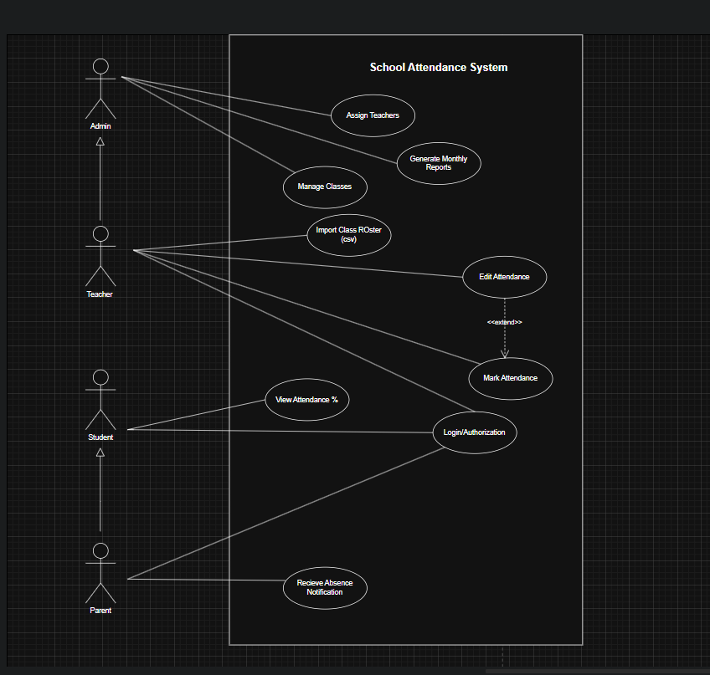
Fig 1: Use Case Diagram
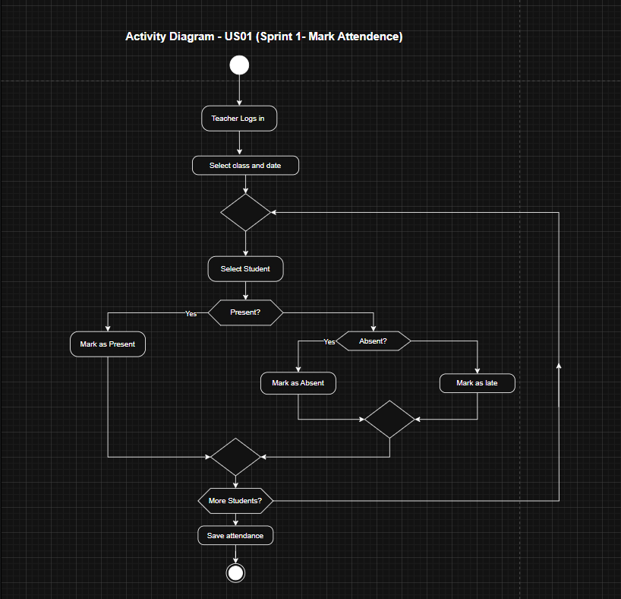

Fig 2: Activity Diagram – US01 (Sprint 1 - Mark Attendance)
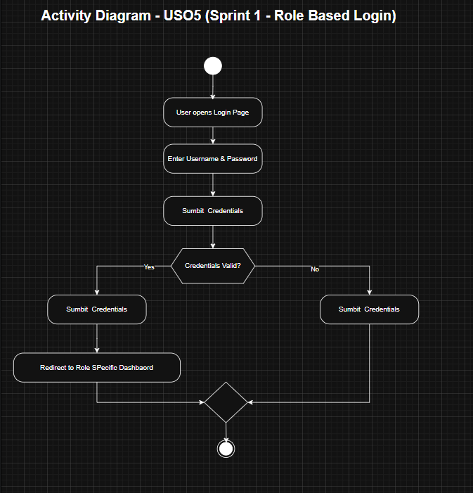

Fig 3: Activity Diagram – USO5 (Sprint 1 – Role Based Login)
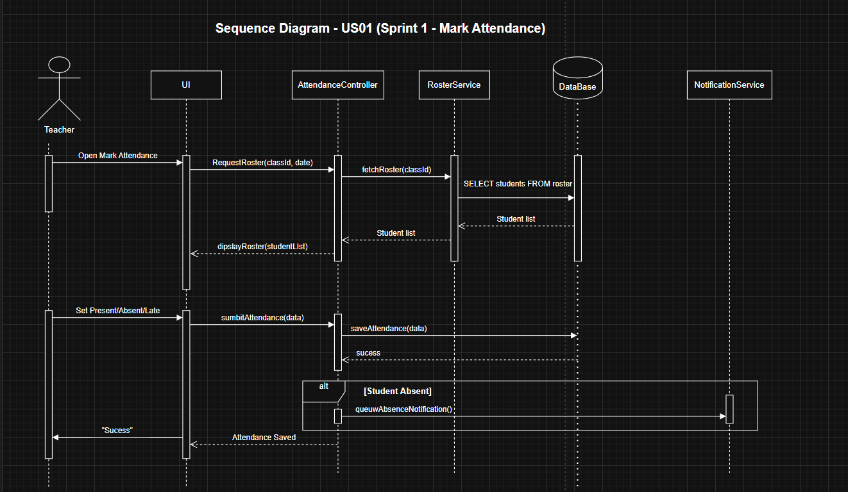

Fig 4: Sequence Diagram – USO1 (Sprint 1- Mark Attendance)

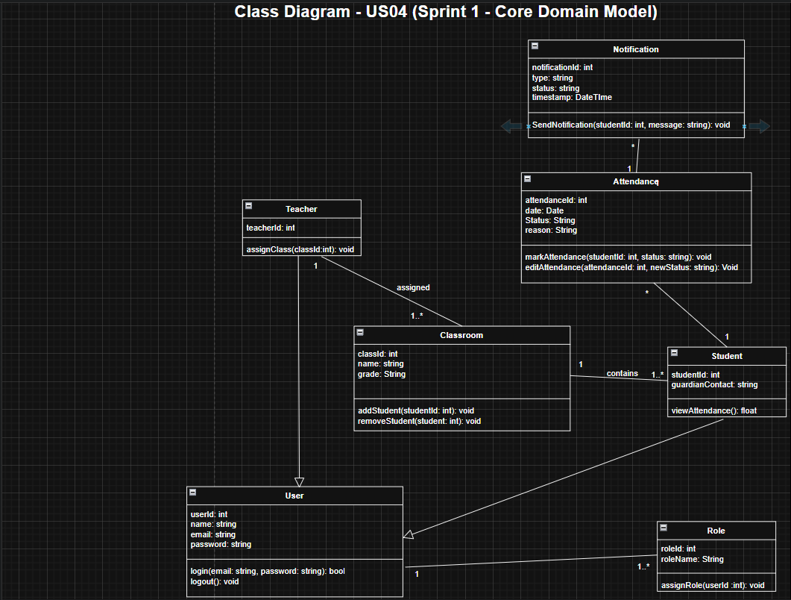

Fig 5: Class Diagram – USO4 (Sprint1 – Core Domain Model)
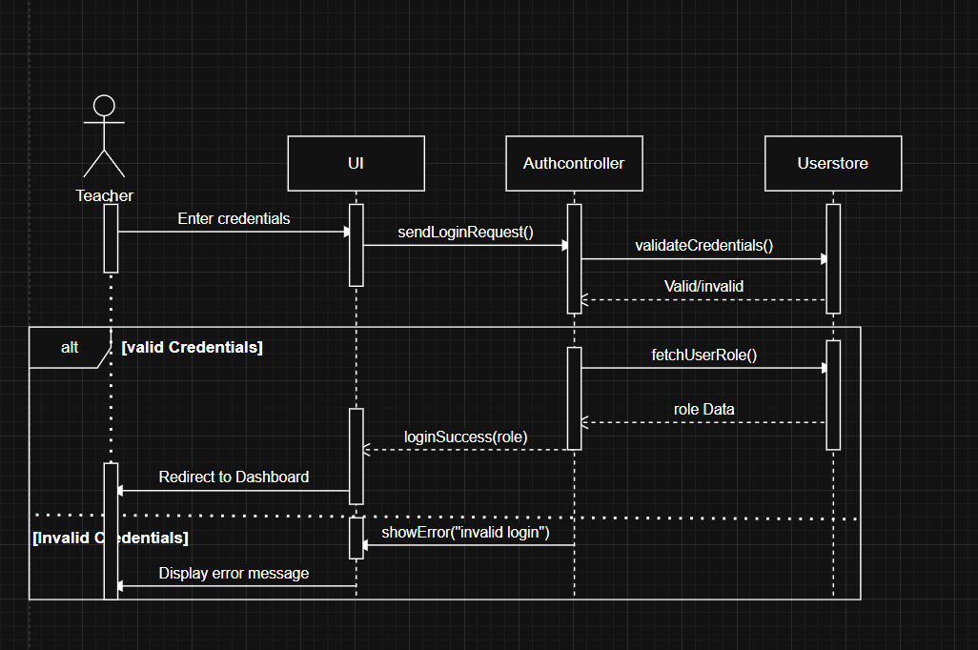
Fig 6: Sequence Diagram

