Data Visulaization and Techniques- Experiment 6B
Rohith . P – 231401086

1. Bar Chart :
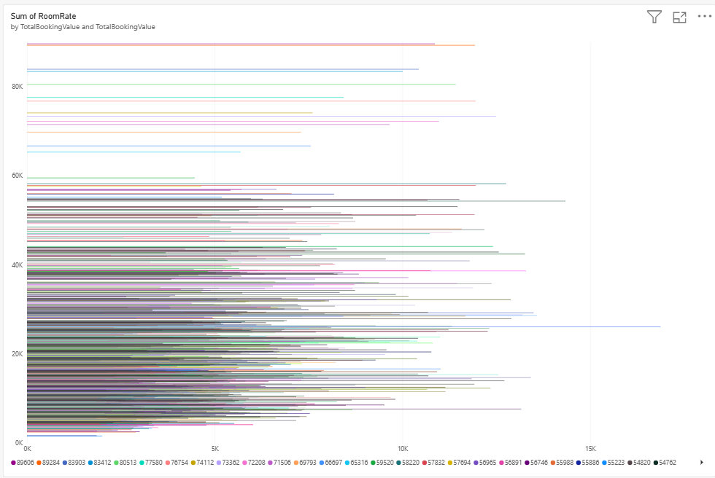

2. Pie Chart
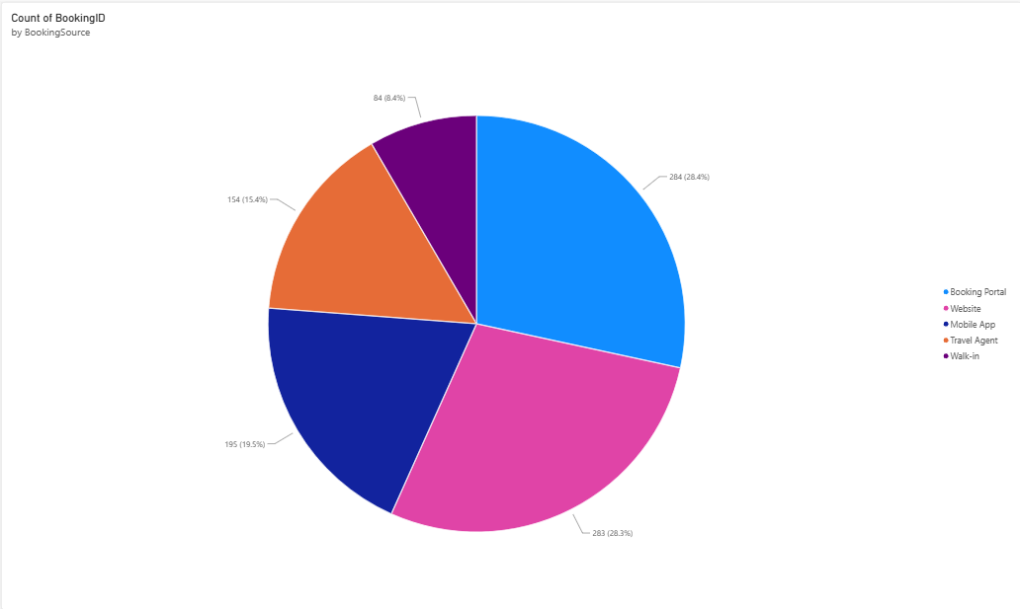

3. KPI Card
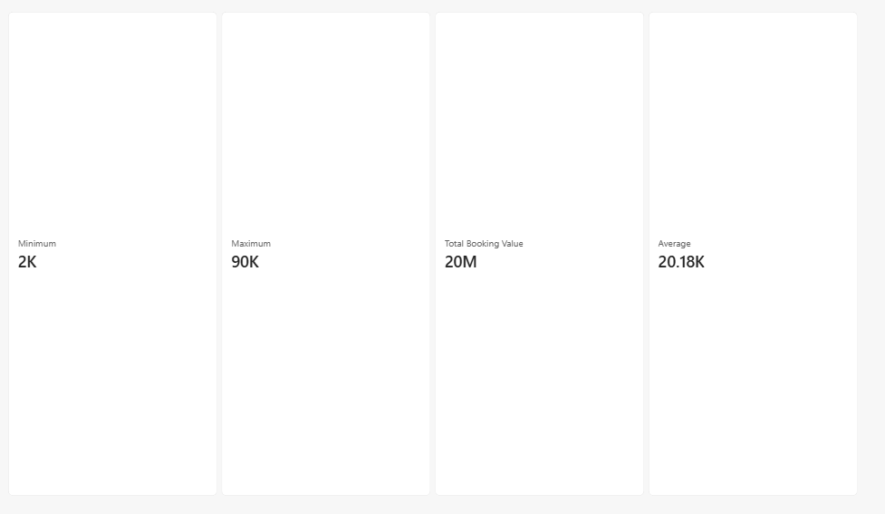

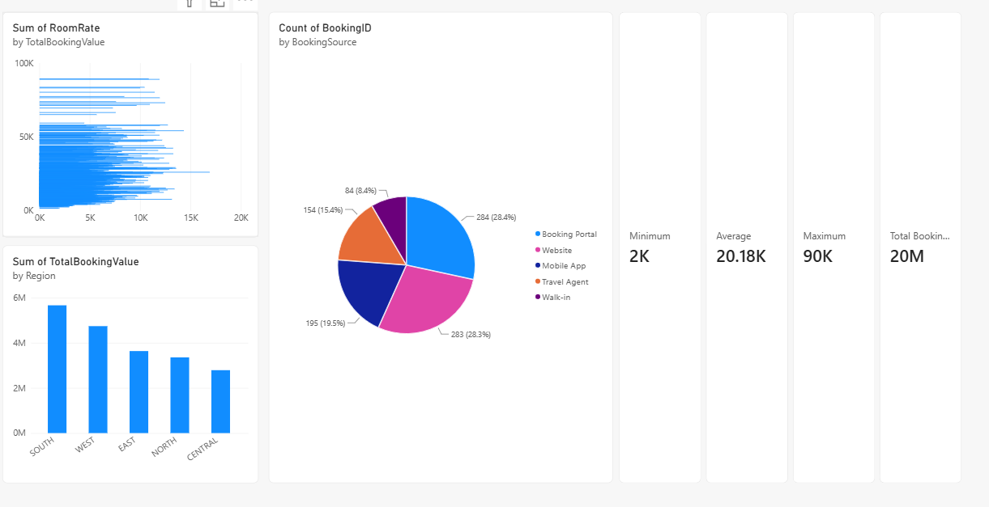
4. Dashboard

