Blue : FastText Red : TF-IDF_VMD

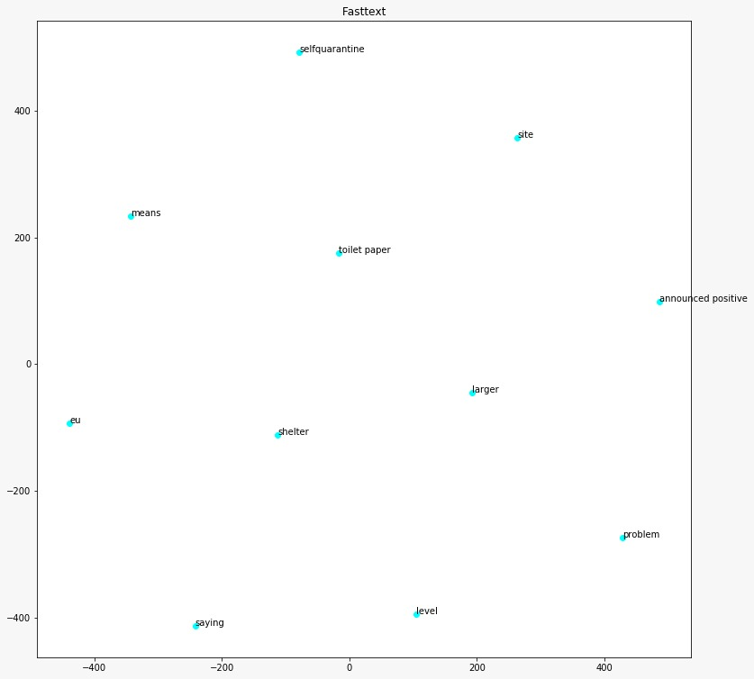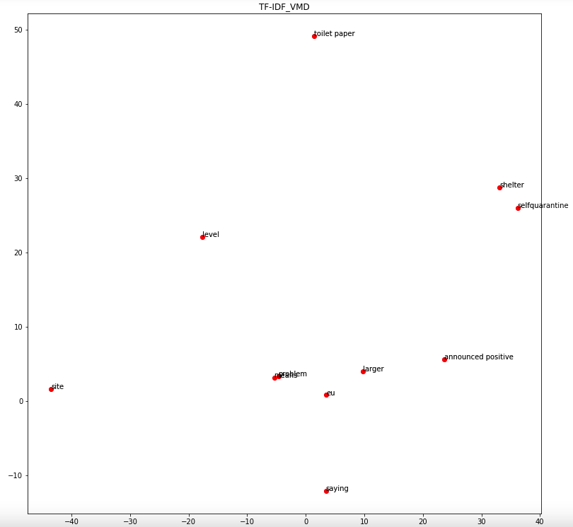

The words “shelter” and “self-quarantine” are closer indicating better sematic relations

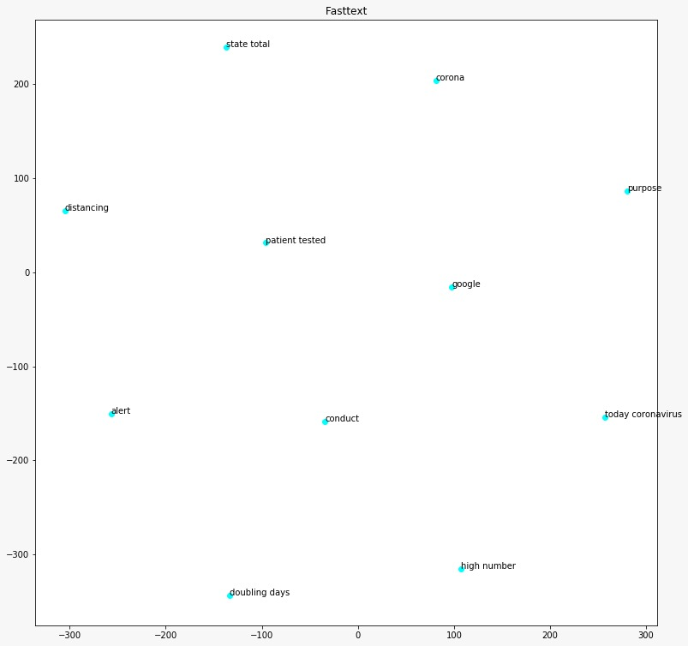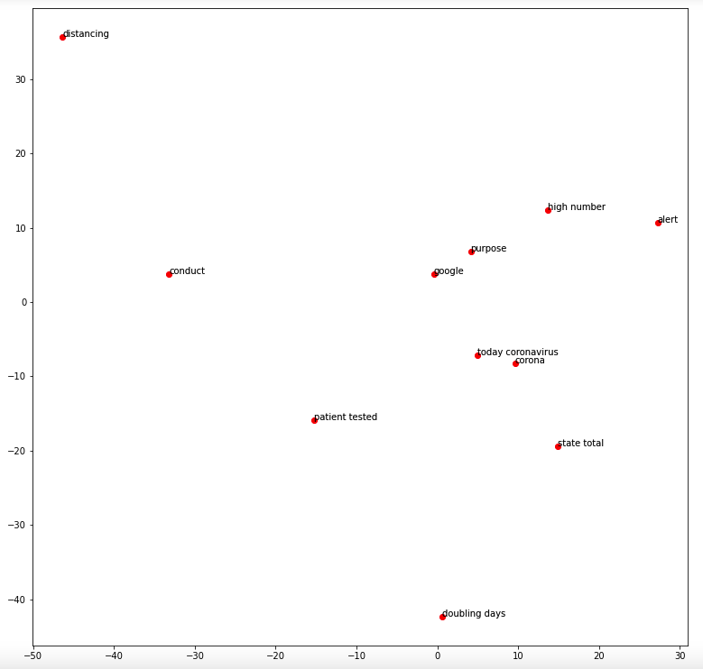

The words “Today coronavirus” and “corona” are closer indicating better sematic relations

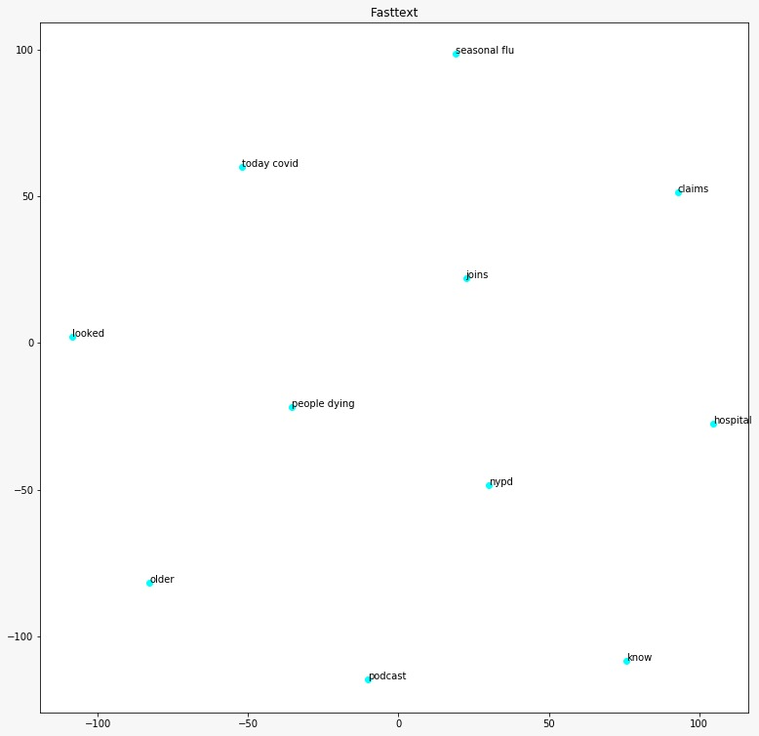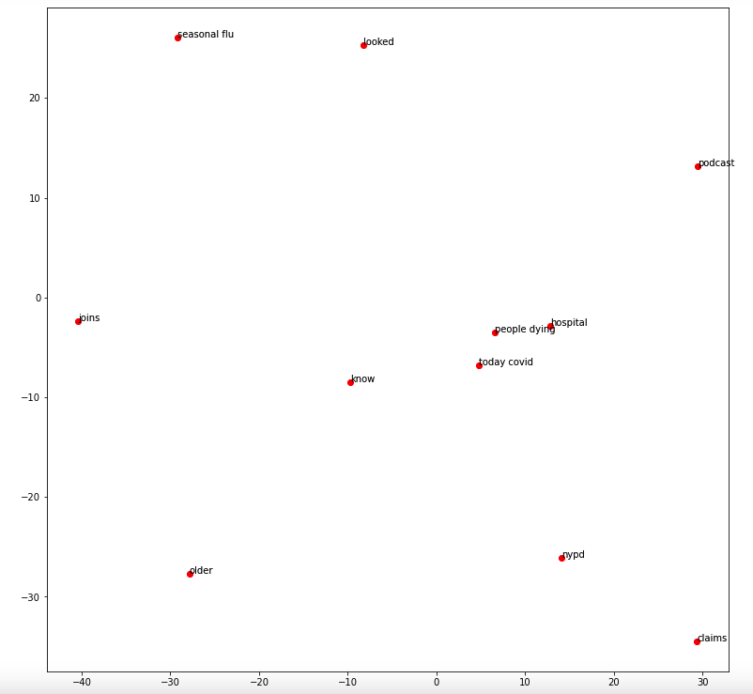

The words “today covid”,”people dying” and “hospital” are closer indicating better sematic relations