Application Launch Screen: SignUp Page:

Login Page: Events Page: 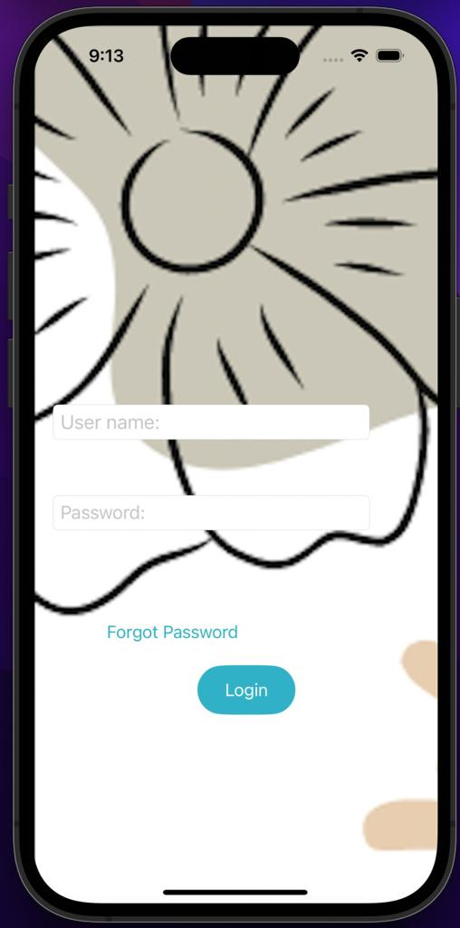

More Page: Speakers List:

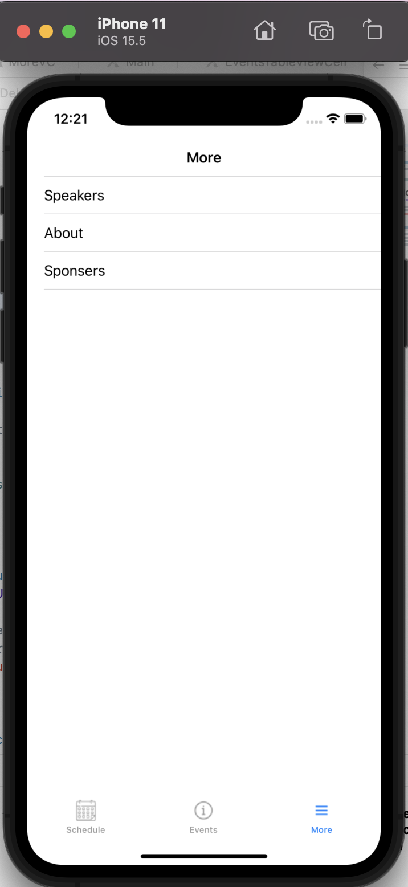

Sponsors List:

