ASSIGNMENT - 4.5

NAME: U. Rohith
HT NO: 2303A52198
BATCH: 35

Lab 4: Advanced Prompt Engineering: Zero-shot, one-shot, and few-shot

Techniques
TASK 1: EMAIL CLASSIFICATION :
Task 1(a): Prepare Sample Email Data:
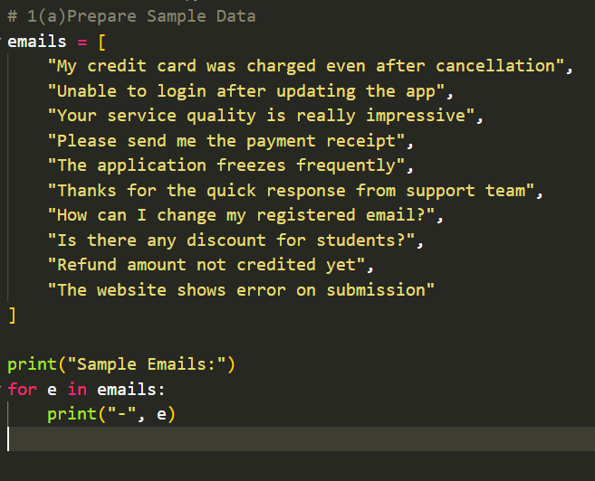
1(b) Zero-Shot Prompting :
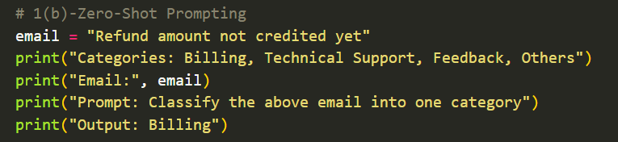
Output:
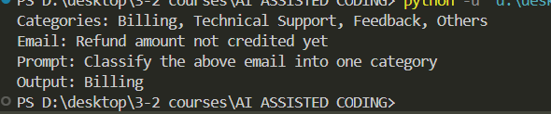
1(c) One-Shot Prompting :
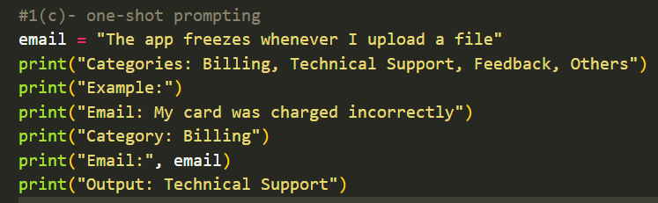
Output:
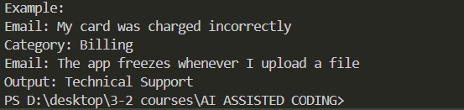
1(d) Few-Shot Prompting :
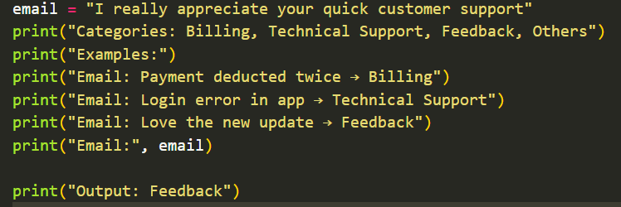
Output:
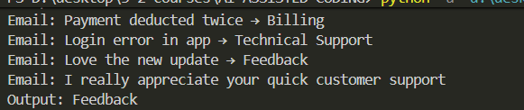
1(e) Evaluation :
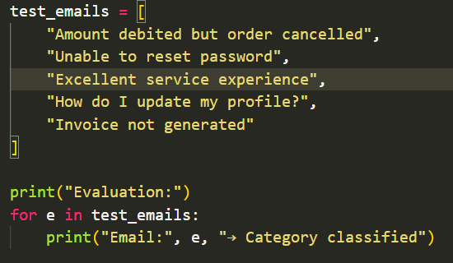
Output :
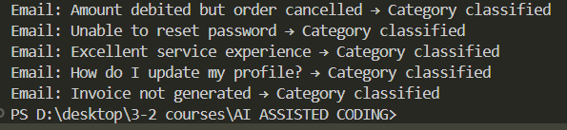

Task 2: Travel Query Classification :
2(a) Prepare Labeled Travel Queries :
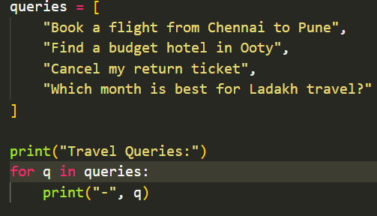
2(b) Zero-Shot Prompting :
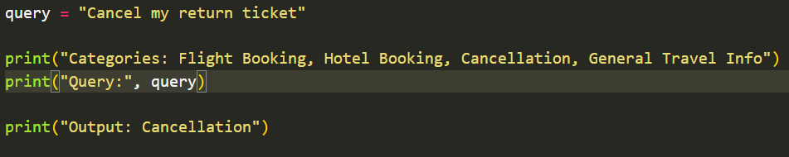
Output :
2(c) One-Shot Prompting :
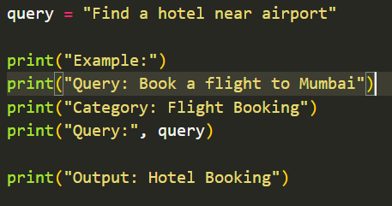
Output :
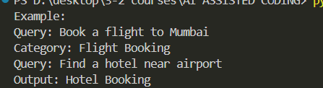
2(d) Few-Shot Prompting :
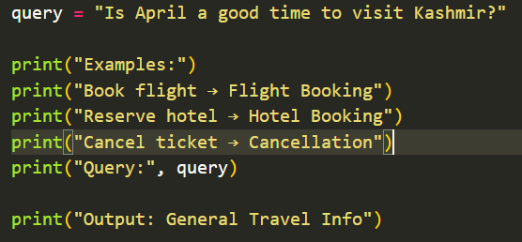
Output :
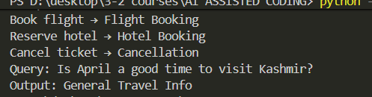
2(e) Comparison :
Few-shot prompting gives more consistent responses.
Task -3: Programming Question Type Identification:
3(a) Prepare Programming Queries :
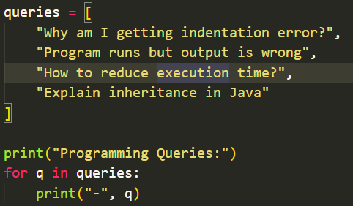
3(b) Zero-Shot Prompting :
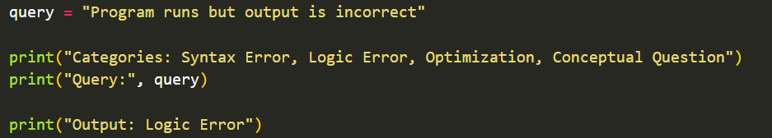
Output :
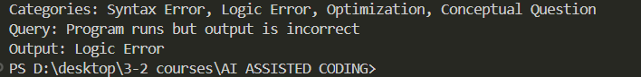
3(c) One-Shot Prompting :
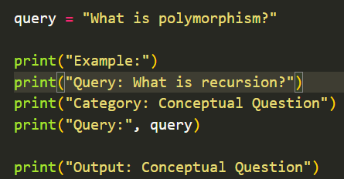

Output :
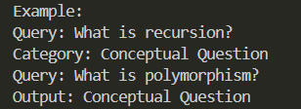
3(d) Few-Shot Prompting :
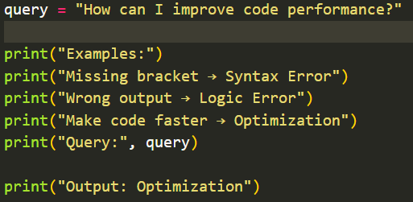
Output :
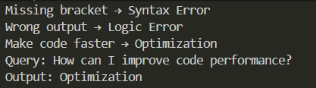
3(e) Analysis :
Few-shot prompting improves technical accuracy.
Task -4 : Social Media Post Categorization :
4(a) Prepare Posts :
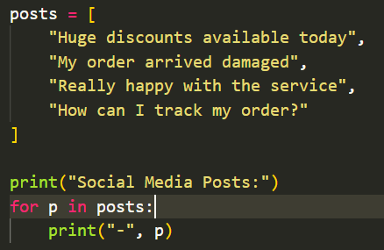
4(b) Zero-Shot Prompting :
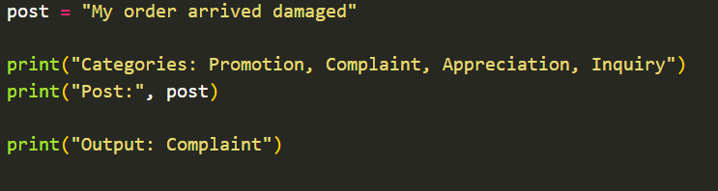
Output :
4(c) One-Shot Prompting :
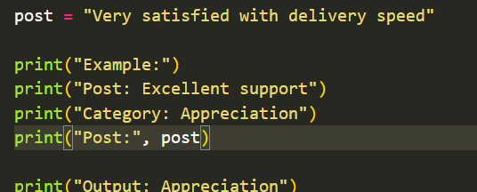
Output :
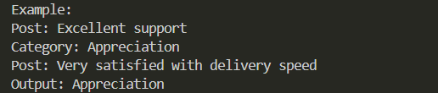
4(d) Few-Shot Prompting :
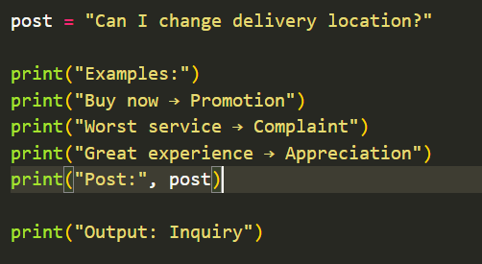
Output :
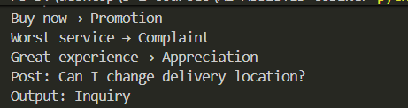
4(e) Analysis :
Few-shot prompting handles informal language better.

