Name: Nikhil Pulambatla
Regno:128003182
Rollno:41
Exercise-6:Congestion control
Aim:To simulate and analyse TCP flow control and TCP congestion control using NS-2, GAWK, and XGraph tools.

Output:
Congestion control:
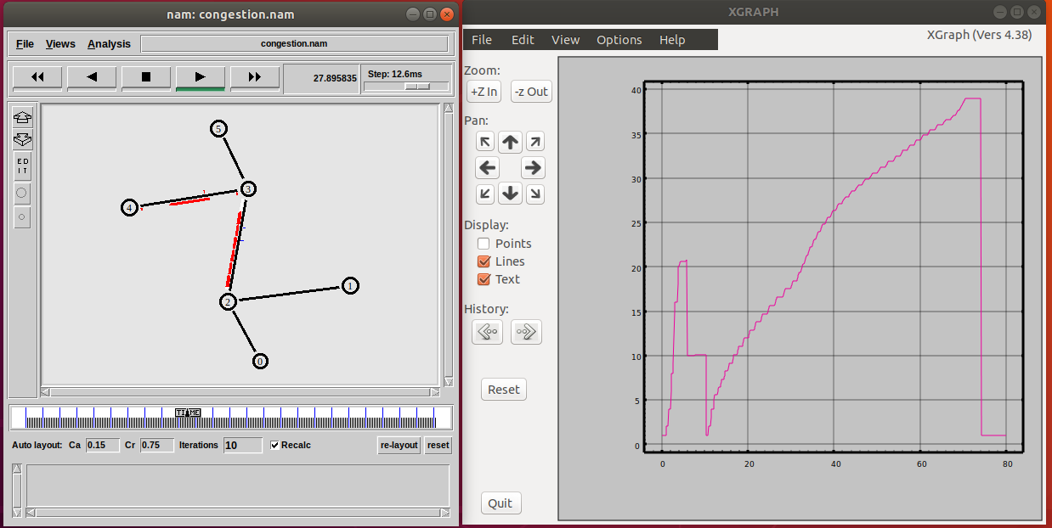

Reno:
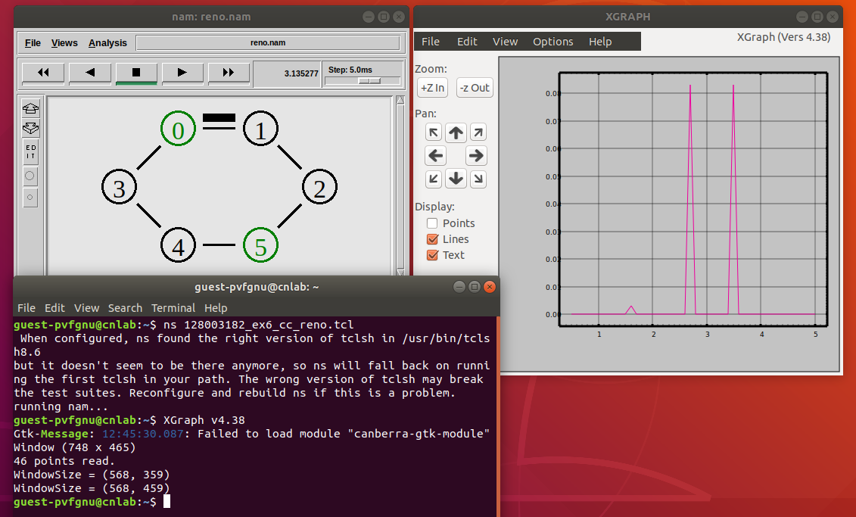
NewReno:
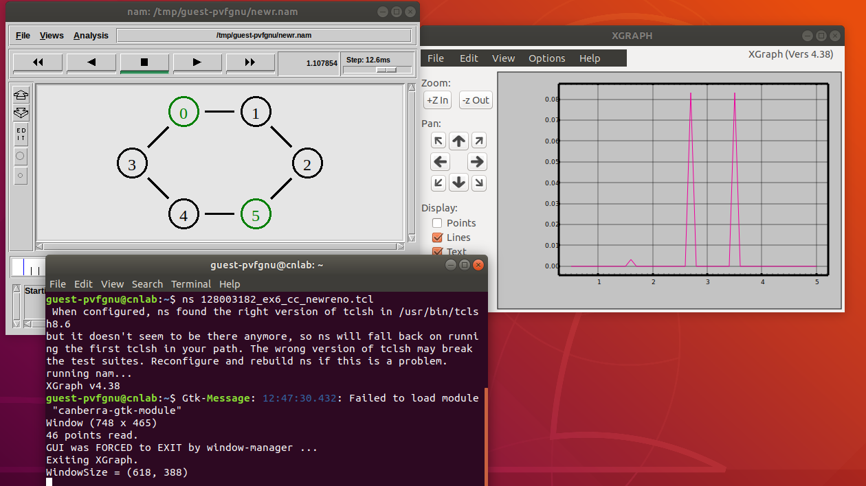

Tahoe:
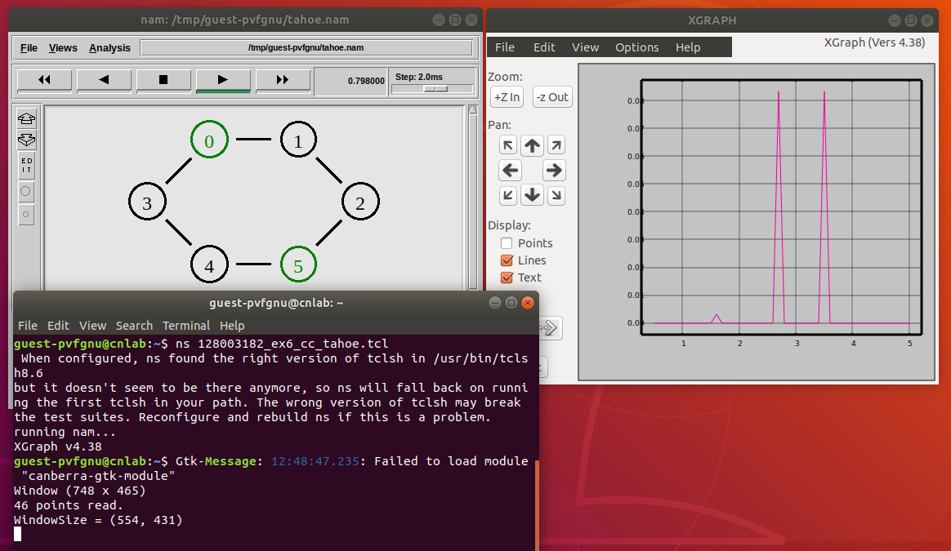

Sack:
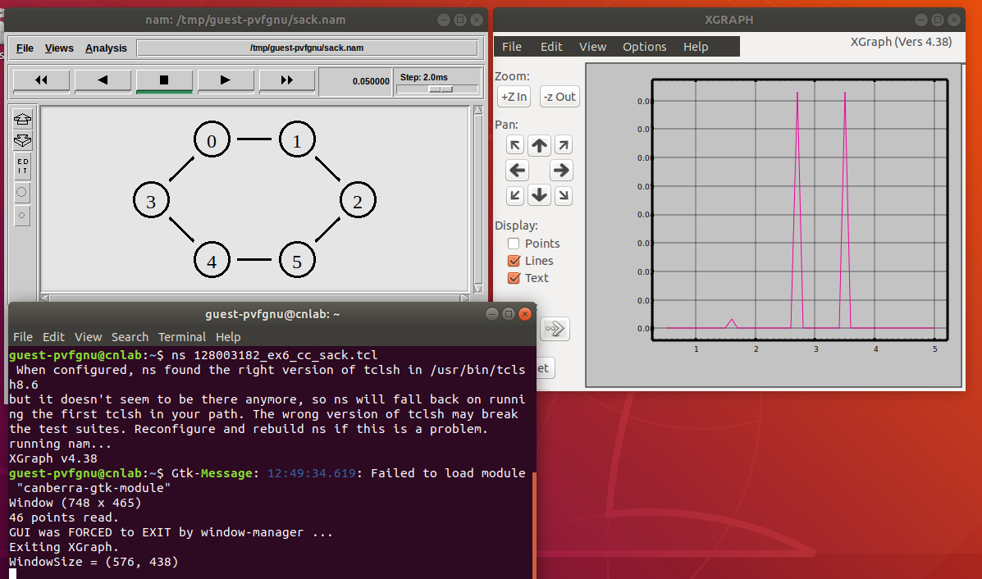

Vegas:
