Exercise 07

Simulation and comparative analysis of distance vector routing and link state routing
TOOLS: NS-2
OBJECTIVES: To simulate and study the link state routing algorithm using simulation.

OUTPUT:

Distance vector routing

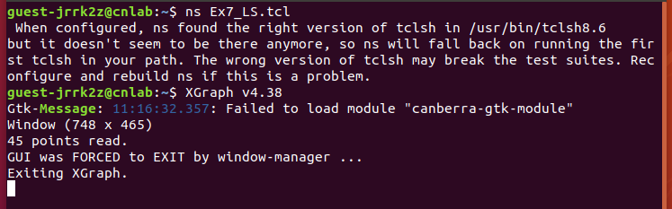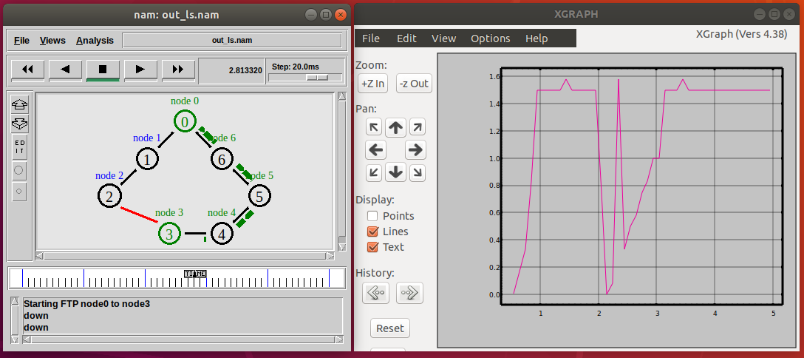
Link state routing

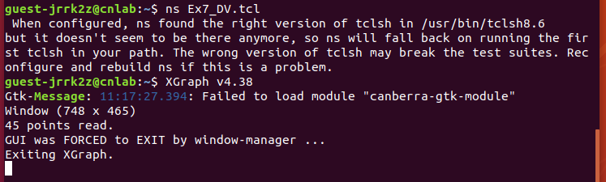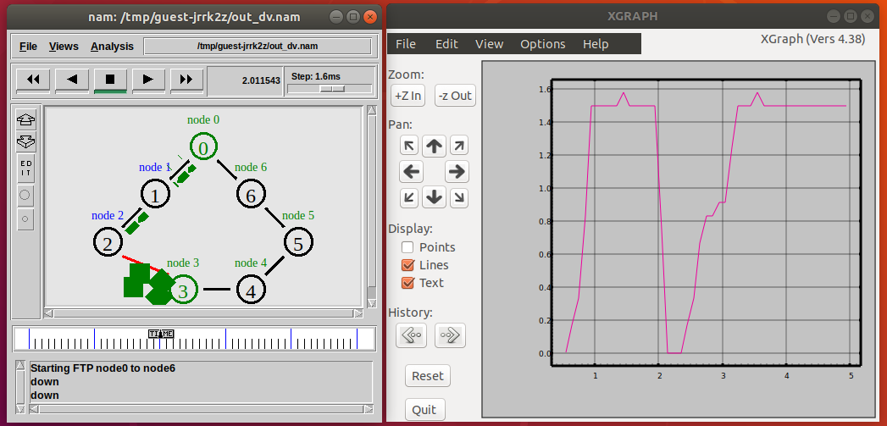

Comparative analysis:

