Data Set Insights
The dataset comprises the top 100 football players from the year 2019, providing a comprehensive analysis of their attributes. It includes categorical variables such as nationality, club, age, and on-field position, which help in understanding player demographics and team distribution. Additionally, the dataset records financial metrics, including player wages and market values, offering insights into their monetary worth in the football market.
Beyond these attributes, the dataset contains a range of quantitative performance statistics that measure various technical and physical abilities. These include Crossing , Finishing, Heading Accuracy, Short Passing, Volleys, Dribbling, Curve, FK Accuracy, Long Passing, Ball Control, Acceleration, Sprint Speed, Agility, and more. These metrics provide valuable information about a player's skills, playing style, and overall effectiveness on the field.

Here is an insight about Goalkeepers-

Goalkeepers –

The scatter plot shows a clear negative correlation between age and market value.
- As goalkeepers age, their market value tends to decrease.
- The R² value is 0.5831, indicating a moderate to strong correlation, meaning age explains about 58.31% of the variance in market value.
- Younger goalkeepers (around 25 years old) tend to have higher market values, while older goalkeepers (around 40 years old) see a sharp decline.

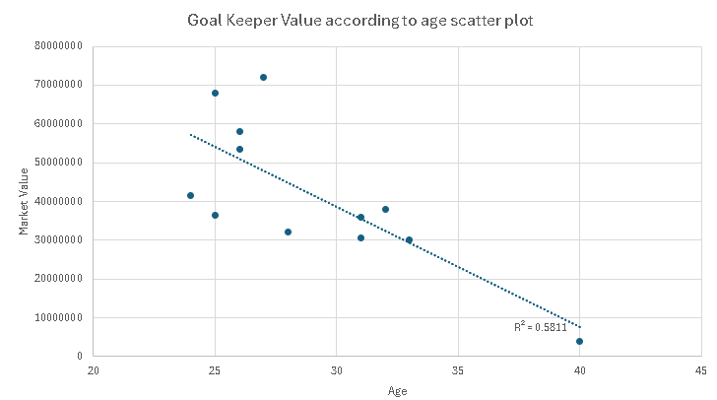

Non-Goalkeepers.
- The scatter plot shows a weaker negative correlation between age and market value.
- The R² value is 0.123, meaning age explains only 12.3% of the variance in market value, suggesting that other factors (performance, position, club, etc.) influence value more than age.
- The market value distribution appears more spread out with no clear pattern like in the goalkeeper plot.
- Unlike goalkeepers, non-goalkeepers tend to have less drastic value drops with age, though a slight decline is still noticeable.

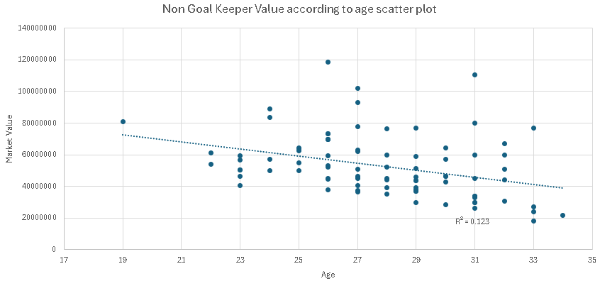

Here is an interesting insight .The scatter plot shows a positive correlation between player wages and market value, indicating that higher-valued players generally earn more. However, the distribution suggests variability, as players with similar market values receive different wages, likely due to factors such as experience, performance, or contract negotiations.
A few outliers stand out with exceptionally high wages compared to their market value, possibly representing star players or those with unique contractual agreements. Additionally, the trend suggests diminishing returns, where wage growth does not increase proportionally beyond a certain market value (around 8M-10M). This pattern implies that while market value influences wages, other factors contribute significantly to salary determination.
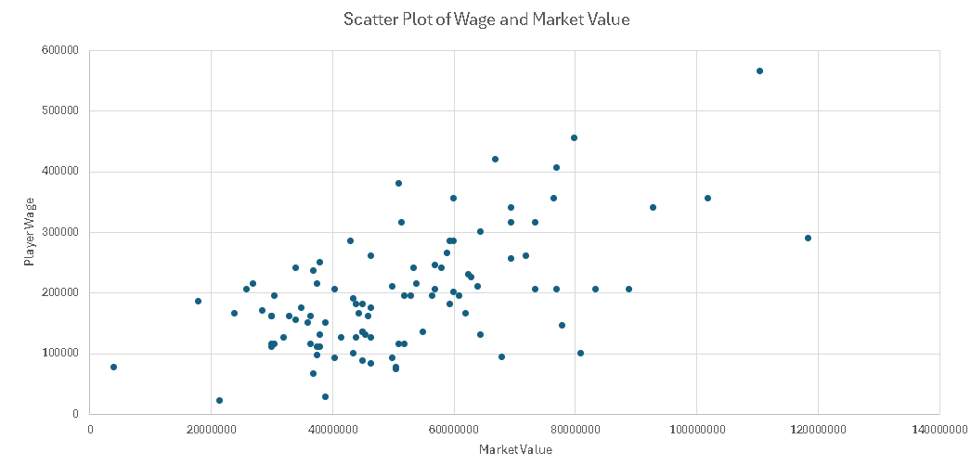e

The graph shows the wage distribution of players across different football clubs, categorized into wage brackets ranging from 21,000 to over 471,000. Clubs like Real Madrid and FC Barcelona have players earning across almost all wage categories, with some players exceeding 471,000 in wages. Manchester City and Paris Saint-Germain also have multiple players in the higher wage brackets (above 321,000), indicating strong financial investment in top talent. In contrast, clubs like Vissel Kobe, Valencia CF, and Lazio have most of their players earning below 170,000, suggesting a more balanced or conservative wage structure. Juventus, Liverpool, and Manchester United display a mix of mid-to-high wage earners, with a significant number of players in the 271,000–370,999 range. This wage disparity highlights the financial power of top European clubs compared to others, influencing squad depth and overall

