Week 2 Assignment: Python Fundamentals for Data Analytics

Task – 1:
Source Code:-
import numpy as np
arr = np.array([10, 20, 30, 40, 50, 60, 70, 80, 90, 100])
print("Array:", arr)
print("Shape:", arr.shape)
print("Size:", arr.size)
print("Data Type:", arr.dtype)
one_dimensional = np.array([1, 2, 3, 4, 5])
print("One-dimensional array:", one_dimensional)
two_dimensional = np.array([[1, 2, 3], [4, 5, 6]])
print("Two-dimensional array:")
print(two_dimensional)

Output Screenshot:-
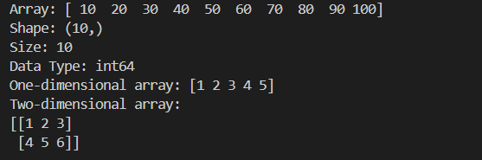

Explanation:-
NumPy is a Python library used for numerical and scientific computing. A NumPy array stores multiple values efficiently. The shape shows the dimensions of the array, size gives the total number of elements, and dtype shows the data type of the elements. A one-dimensional array contains values in a single row, while a two-dimensional array contains rows and columns.

Task – 2:
Source Code:-
import numpy as np
arr = np.array([10, 20, 30, 40, 50, 60, 70, 80, 90, 100])
print("Original Array:", arr)
print("Element at index 2:", arr[2])
print("Element at index 6:", arr[6])
print("Sliced Array:", arr[2:7])
two_dimensional = np.array([
[1, 2, 3, 4],
[5, 6, 7, 8],
[9, 10, 11, 12]
])
print("Two-dimensional Array:")
print(two_dimensional)
print("First Row:", two_dimensional[0])
print("Second Row:", two_dimensional[1])
print("First Column:", two_dimensional[:, 0])
print("Third Column:", two_dimensional[:, 2])
print("Element at Row 2, Column 3:", two_dimensional[1, 2])
reshaped_array = arr.reshape(2, 5)
print("Reshaped Array:")
print(reshaped_array)

reshaped_array_3d = arr.reshape(2, 5, 1)
print("3D Reshaped Array:")
print(reshaped_array_3d)

Output Screenshot:-
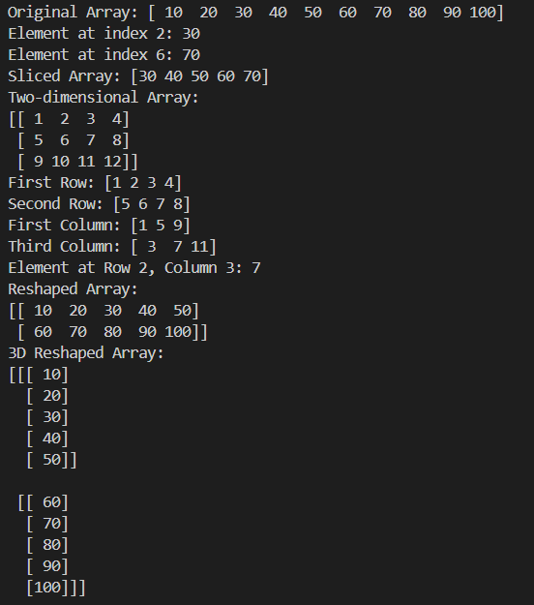

Explanation:-
NumPy indexing is used to access individual elements using their position. Slicing extracts a portion of an array using a start and end index. In a two-dimensional array, rows and columns can be accessed using row and column indices. The reshape() function changes the dimensions of an array without changing its elements.

Task – 3:
Source Code:-
import numpy as np
data = np.array([10, 20, 30, 40, 50])
print("Dataset:", data)
print("Addition:", data + 5)
print("Subtraction:", data - 5)
print("Multiplication:", data * 2)
print("Division:", data / 2)
print("Mean:", np.mean(data))
print("Median:", np.median(data))
print("Minimum:", np.min(data))
print("Maximum:", np.max(data))
print("Standard Deviation:", np.std(data))
print("Sum:", np.sum(data))

Output Screenshot:-
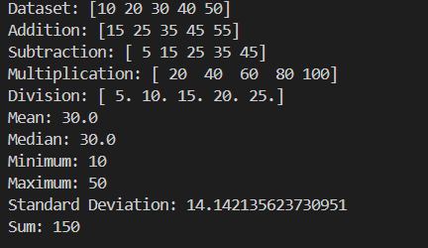
Explanation:-
NumPy provides built-in functions for performing mathematical and statistical operations efficiently. Arithmetic operations such as addition, subtraction, multiplication, and division can be performed directly on arrays. Functions like mean(), median(), min(), max(), std(), and sum() are used to calculate common statistical values from the dataset.
Task – 4:-
Source Code:-
import pandas as pd
series = pd.Series([85, 90, 78, 92, 88])
print("Pandas Series:")
print(series)
data = {
"Name": ["Ravi", "Priya", "Arun", "Sneha", "Kiran"],
"Age": [20, 21, 19, 22, 20],
"Marks": [85, 90, 78, 92, 88]
}
df = pd.DataFrame(data)
print("\nDataFrame:")
print(df)
print("\nColumn Names:")
print(df.columns)
print("\nIndex:")
print(df.index)
df["Grade"] = ["A", "A+", "B", "A+", "A"]
print("\nUpdated DataFrame:")
print(df)

Output Screenshot:-
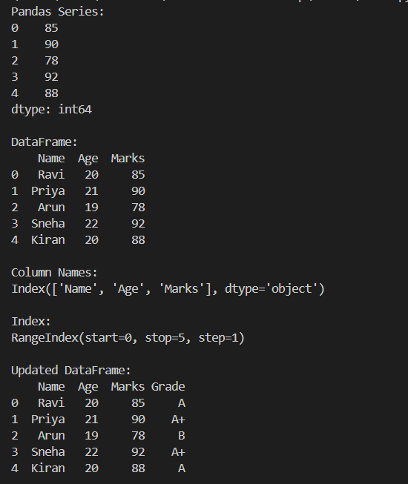
Explanation:-
Pandas is a Python library used for data manipulation and analysis. A Series is a one-dimensional data structure, while a DataFrame is a two-dimensional structure containing rows and columns. The columns attribute displays the column names, and the index attribute displays the row indexes. A new column can be added by assigning values to a new column name.

Task – 5:-
import pandas as pd
df = pd.read_csv("students.csv")
print("First 5 Rows:")
print(df.head())

print("\nLast 5 Rows:")
print(df.tail())
print("\nNumber of Rows and Columns:")
print(df.shape)
print("\nColumn Names:")
print(df.columns)
print("\nData Types:")
print(df.dtypes)
print("\nDataset Information:")
df.info()
print("\nStatistical Description:")
print(df.describe())

Output Screenshot:-
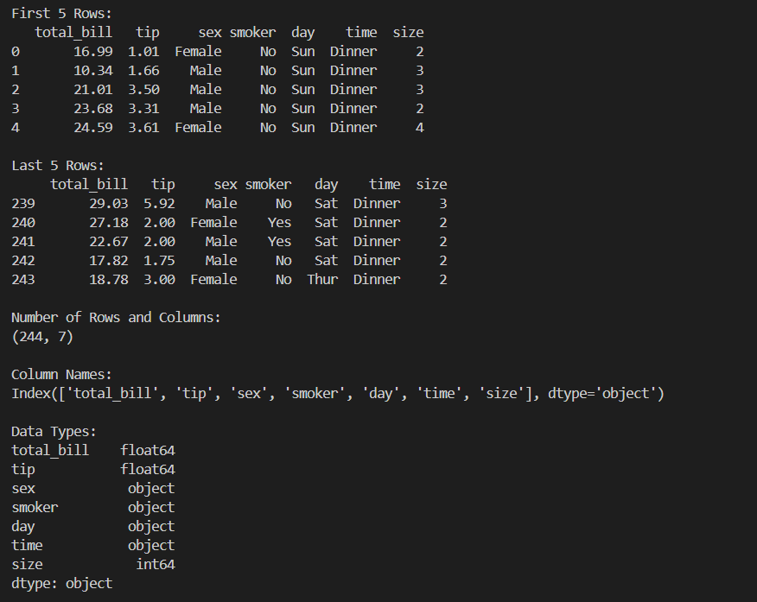
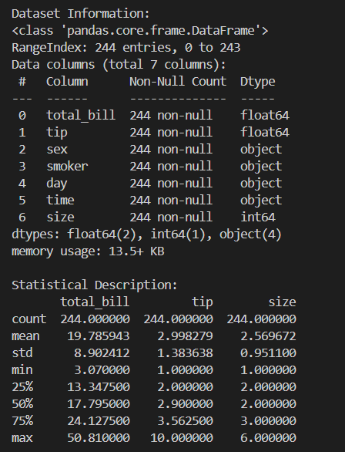

Explanation:-
Pandas provides several functions to inspect and understand a CSV dataset. read_csv() loads the CSV file into a DataFrame. head() and tail() display the first and last five rows. shape gives the number of rows and columns, while columns displays the column names. dtypes shows the data type of each column. info() provides general information about the dataset, and describe() gives statistical summaries of numerical columns.

Task – 6:-
Source Code:-
import pandas as pd
data = {
"Name": ["Ravi", "Priya", "Arun", "Sneha", "Kiran"],
"Age": [20, 21, 19, 22, 20],
"Marks": [85, 90, 78, 92, 88],
"Department": ["CSE", "ECE", "CSE", "ECE", "CSE"]
}
df = pd.DataFrame(data)
print("Original DataFrame:")
print(df)
print("\nSelected Columns:")
print(df[["Name", "Marks"]])
print("\nSelected Rows:")
print(df.iloc[0:3])
print("\nMarks Greater Than 85:")
print(df[df["Marks"] > 85])
print("\nMultiple Conditions:")
print(df[(df["Marks"] > 85) & (df["Department"] == "ECE")])
print("\nAscending Order:")
print(df.sort_values(by="Marks"))
print("\nDescending Order:")
print(df.sort_values(by="Marks", ascending=False))

Output Screenshots:-
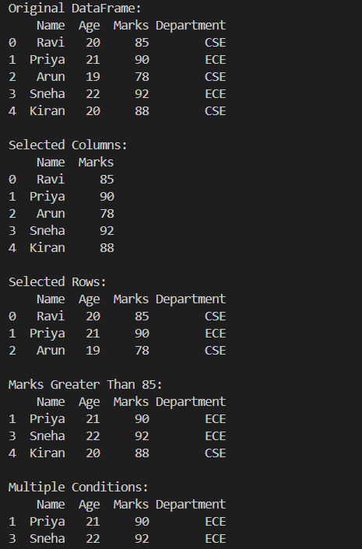

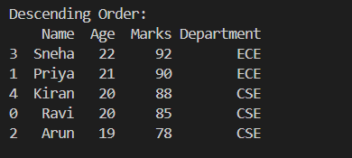

Explanation:-
Pandas allows specific columns and rows to be selected using column names and iloc. Filtering is used to retrieve records that satisfy a condition. Multiple conditions can be combined using operators such as &. The sort_values() function sorts data in ascending order by default, while ascending=False sorts the data in descending order.

Task – 7:
Source code:-
import pandas as pd
import numpy as np
data = {
"Name": ["Ravi", "Priya", "Arun", "Sneha", "Kiran"],
"Age": [20, 21, np.nan, 22, 20],
"Marks": [85, np.nan, 78, 92, 88],
"Department": ["CSE", "ECE", "CSE", np.nan, "CSE"]
}
df = pd.DataFrame(data)
print("Dataset Before Handling Missing Values:")
print(df)
print("\nMissing Values:")
print(df.isnull())
print("\nMissing Values in Each Column:")
print(df.isna().sum())
removed_df = df.dropna()
print("\nDataset After Removing Rows With Missing Values:")
print(removed_df)
filled_df = df.copy()
filled_df["Age"] = filled_df["Age"].fillna(filled_df["Age"].mean())
filled_df["Marks"] = filled_df["Marks"].fillna(filled_df["Marks"].mean())
filled_df["Department"] = filled_df["Department"].fillna("Unknown")
print("\nDataset After Filling Missing Values:")
print(filled_df)

Output Sreenshot:-

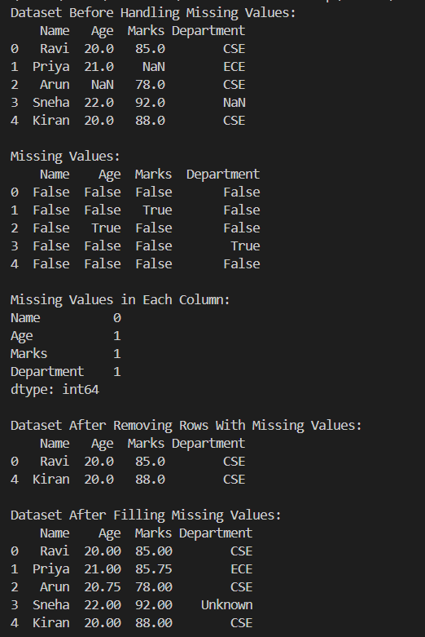

Explanation:-
Missing values are empty or unavailable values in a dataset. isnull() and isna() identify missing values, while isna().sum() counts them in each column. dropna() removes rows containing missing values, whereas fillna() replaces missing values with suitable values such as the mean or "Unknown". Handling missing data is important because missing values can affect calculations, analysis, and the accuracy of data-driven results.

Task – 8:
Source code:-
import pandas as pd
students = pd.DataFrame({
"Student_ID": [101, 102, 103, 104, 105],
"Name": ["Ravi", "Priya", "Arun", "Sneha", "Kiran"],
"Department": ["CSE", "ECE", "CSE", "ECE", "CSE"]
})
marks = pd.DataFrame({
"Student_ID": [101, 102, 103, 104, 105],
"Marks": [85, 90, 78, 92, 88],
"Attendance": [90, 95, 85, 98, 92]
})
print("Students DataFrame:")
print(students)
print("\nMarks DataFrame:")
print(marks)
merged_df = pd.merge(students, marks, on="Student_ID")
print("\nMerged DataFrame:")
print(merged_df)
data1 = pd.DataFrame({
"Student_ID": [106, 107],
"Name": ["Anil", "Divya"],
"Department": ["ECE", "CSE"]
})
concatenated_df = pd.concat([students, data1], ignore_index=True)
print("\nConcatenated DataFrame:")
print(concatenated_df)

grouped = merged_df.groupby("Department")["Marks"].agg(
["sum", "mean", "count", "min", "max"]
)
print("\nGroupBy Results:")
print(grouped)
pivot_table = pd.pivot_table(
merged_df,
values="Marks",
index="Department",
columns="Attendance",
aggfunc="mean"
)
print("\nPivot Table:")
print(pivot_table)

Output Screenshot:-
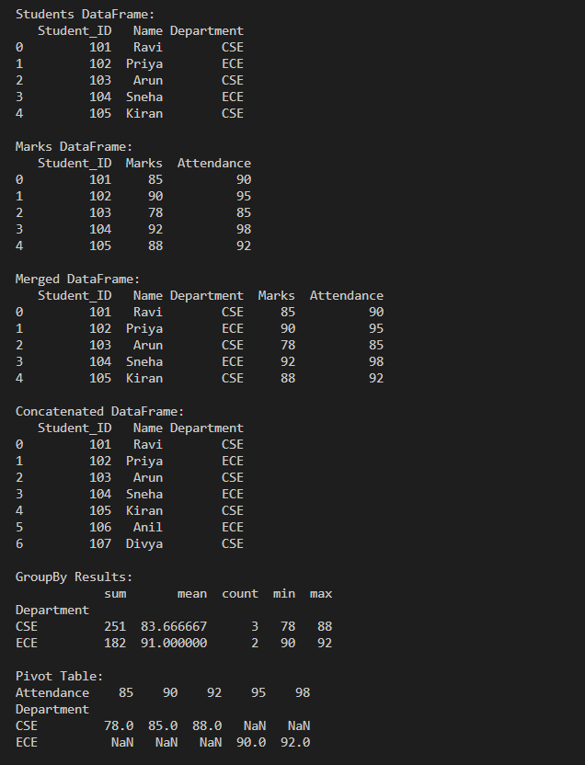

Explanation:-
merge() combines DataFrames using a common column such as Student_ID. concat() joins DataFrames along rows or columns. groupby() groups data based on a selected column and allows aggregate operations such as sum, mean, count, minimum, and maximum. A pivot table summarizes data by arranging it according to selected rows, columns, and values, making it easier to analyze patterns in a dataset.

Task- 9:
Source code:-
import pandas as pd
data = {
"Name": ["Ravi", "Priya", "Arun", "Sneha", "Kiran"],
"Age": [20, 21, 19, 22, 20],
"Marks": [85, 90, 78, 92, 88],
"Department": ["CSE", "ECE", "CSE", "ECE", "CSE"]
}
df = pd.DataFrame(data)
df["Result"] = ["Pass", "Pass", "Pass", "Pass", "Pass"]
file_name = "processed_students.csv"
df.to_csv(file_name, index=False)
print("Processed DataFrame:")
print(df)
exported_df = pd.read_csv(file_name)
print("\nExported CSV Data:")
print(exported_df)
print("\nFile exported successfully:", file_name)

Output Screenshot:-
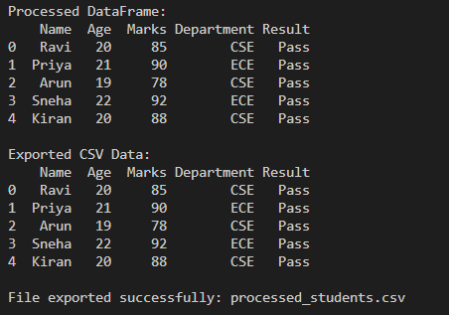

Explanation:-
The to_csv() function is used to export the processed DataFrame into a CSV file. index=False prevents Pandas from adding the DataFrame index as an extra column. The exported file is then read again using read_csv() to verify that it contains the processed data. The file processed_students.csv can be saved along with the Python program for submission.
Task- 10:
Souce Code:-
import numpy as np
import pandas as pd
data = {
"Name": ["Ravi", "Priya", "Arun", "Sneha", "Kiran", "Anil", "Divya", "Rahul"],
"Department": ["CSE", "ECE", "CSE", "ECE", "CSE", "ECE", "CSE", "ECE"],
"Age": [20, 21, 19, 22, 20, 21, 19, 22],
"Marks": [85, 90, 78, 92, 88, 75, 95, 82],
"Attendance": [90, 95, 85, 98, 92, 80, 96, 88]
}

df = pd.DataFrame(data)
print("Original Dataset:")
print(df)
print("\nDataset Information:")
df.info()
print("\nFirst 5 Rows:")
print(df.head())
print("\nStatistical Summary:")
print(df.describe())
print("\nMissing Values:")
print(df.isnull().sum())
df["Marks"] = df["Marks"].fillna(df["Marks"].mean())
df["Attendance"] = df["Attendance"].fillna(df["Attendance"].mean())
print("\nDataset After Handling Missing Values:")
print(df)
print("\nStudents With Marks Greater Than 85:")
print(df[df["Marks"] > 85])
print("\nStudents With Attendance Greater Than 90:")
print(df[df["Attendance"] > 90])
print("\nStudents With Marks Greater Than 85 and Attendance Greater Than 90:")
print(df[(df["Marks"] > 85) & (df["Attendance"] > 90)])
sorted_df = df.sort_values(by="Marks", ascending=False)
print("\nStudents Sorted by Marks:")
print(sorted_df)
grouped = df.groupby("Department")["Marks"].agg(
["mean", "sum", "count", "min", "max"]
)
print("\nGroupBy Analysis:")
print(grouped)
pivot = pd.pivot_table(
df,
values="Marks",
index="Department",
columns="Attendance",
aggfunc="mean"
)
print("\nPivot Table:")
print(pivot)
marks = np.array(df["Marks"])
print("\nNumPy Analysis:")
print("Mean Marks:", np.mean(marks))
print("Maximum Marks:", np.max(marks))
print("Minimum Marks:", np.min(marks))
print("Standard Deviation:", np.std(marks))
print("\nUseful Insights:")
print("Average Marks:", df["Marks"].mean())
print("Highest Marks:", df["Marks"].max())
print("Lowest Marks:", df["Marks"].min())
print("Average Attendance:", df["Attendance"].mean())
df.to_csv("cleaned_student_performance.csv", index=False)
verified_df = pd.read_csv("cleaned_student_performance.csv")
print("\nExported Processed Dataset:")
print(verified_df)
print("\nDataset exported successfully as cleaned_student_performance.csv")

Output Screenshots:-
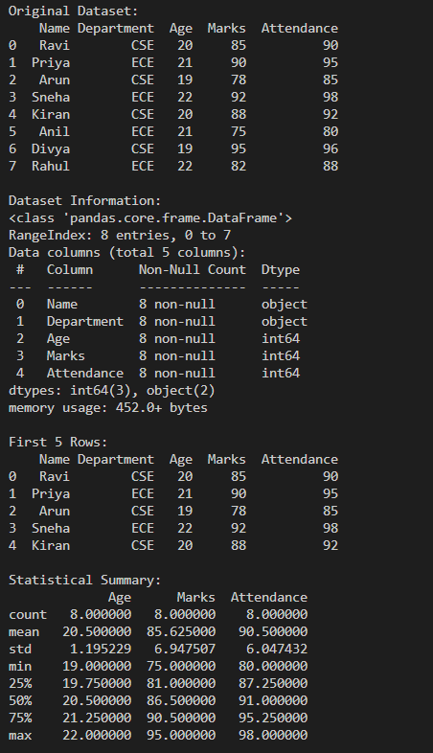
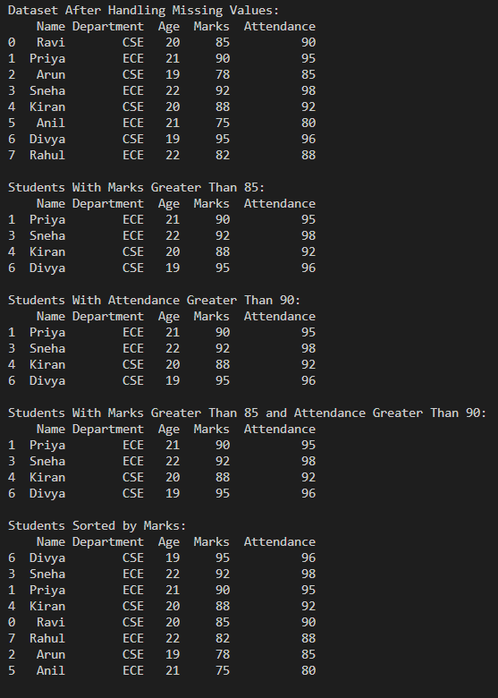

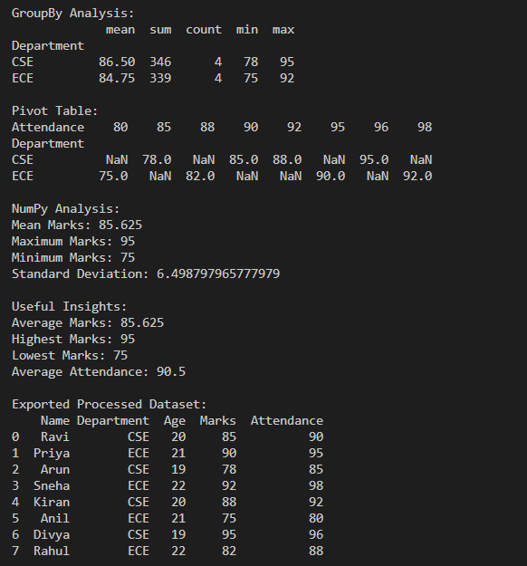

Brief Explanation
This mini project analyzes a Student Performance Dataset using Pandas and NumPy. The dataset is loaded into a DataFrame and inspected using head(), info(), and describe(). Missing values are identified and handled using fillna(). Students can then be selected and filtered based on marks and attendance, while sort_values() sorts students by their marks.
groupby() is used to compare marks across departments, and a pivot table is created to summarize marks based on department and attendance. NumPy is used to calculate statistical values such as mean, minimum, maximum, and standard deviation. Finally, the cleaned dataset is exported to cleaned_student_performance.csv and read again to verify the exported data.

Drive Link for the python files of the tasks:
https://drive.google.com/drive/folders/1QjI5oAj8HhKQ3iKw1aIwLwLsCjDgEGEP?usp=drive_link

