Beyond Data-Only AI: Evaluating Knowledge-Guided Digital Transformation Readiness with Enterprise Innovation Data
Article type: Short Communication | SYNTHETIC RESEARCH DRAFT — NOT FOR JOURNAL SUBMISSION
Rohith Ginjipally
Midwest University
Corresponding author: Rohith Ginjipally | Email: rginjipally@midwest.edu

Abstract
This research-development study asks whether plausible rule-derived organizational features improve digital transformation readiness prediction. Twenty independently seeded synthetic enterprise datasets (2,400 observations each) were generated to compare logistic regression, gradient boosting and a knowledge-feature-augmented logistic model, K-DART. A separate shifted simulation assessed sensitivity to distribution changes. Mean within-distribution AUROC was 0.7685 for K-DART and 0.7689 for logistic regression (paired Wilcoxon p=0.2774). The rule augmentation did not improve discrimination. Two experimental figures and two tables document baseline comparisons, ablation, and calibration. Results establish neither real-world readiness prediction nor validated decision utility; they illustrate the need to validate domain rules and enterprise outcomes independently before claims of knowledge-based advantage.
Keywords: knowledge-based systems; digital transformation; enterprise innovation; data analytics; decision intelligence; AI

1. Introduction
Organizations considering digital transformation face heterogeneous technological, human and financial constraints. Machine-learning readiness predictions are not necessarily actionable: decision makers also need credible constraints and intervention priorities. The research question in this methodological pilot is whether adding rule-derived feature interactions improves predictive performance over conventional statistical and ensemble models. The current rules are hypothetical and should not be mistaken for independently elicited business knowledge. No priority or novelty claim is made without comprehensive prior-art verification.

2. Methods
The benchmark simulates six observed correlated enterprise indicators: infrastructure, workforce skills, innovation investment, leadership, process integration, and financial slack. Outcome labels are stochastically generated from three underlying latent factors with interaction terms. Each of 20 seeds produces a 70/30 stratified split of 2,400 records; each also generates 750 independently simulated shifted-distribution records. This is synthetic methodological testing, not survey-based enterprise validation.
Standardized logistic regression and histogram gradient boosting serve as baselines. K-DART adds four prospective threshold or interaction features representing infrastructure insufficiency, the joint occurrence of infrastructure and leadership, infrastructure-process complementarity, and low workforce skill. All scaling is fit only on training data. The K-DART probability is σ(β₀+βᵀx+γᵀr(x)), where x comprises six observed variables and r(x) denotes four candidate knowledge-feature functions. These functions do not enforce hard constraints.
AUROC, average precision, and Brier score assess predictive discrimination and calibration. A two-sided paired Wilcoxon test compares run-level K-DART and logistic AUROC. Threshold-only and interaction-only ablations isolate rule families. Random seeds and split definitions are implemented in experiment.py.

3. Results
Table 1. Synthetic predictive performance over 20 runs (mean ± between-run SD).
Set | Model | AUROC | Avg. precision | Brier
ID | Logistic | 0.7689 ± 0.0177 | 0.6723 ± 0.0309 | 0.1861 ± 0.0067
ID | GradientBoosting | 0.7374 ± 0.0170 | 0.6345 ± 0.0208 | 0.2024 ± 0.0073
ID | K-DART | 0.7685 ± 0.0182 | 0.6725 ± 0.0303 | 0.1862 ± 0.0068
SHIFT | Logistic | 0.7744 ± 0.0157 | 0.6327 ± 0.0327 | 0.1754 ± 0.0073
SHIFT | GradientBoosting | 0.7394 ± 0.0244 | 0.5836 ± 0.0408 | 0.1915 ± 0.0111
SHIFT | K-DART | 0.7728 ± 0.0156 | 0.6308 ± 0.0329 | 0.1760 ± 0.0073
Table 2. Knowledge-feature ablation (20 independent synthetic runs).
Variant | Mean AUROC | Mean Brier
All rules | 0.7685 | 0.1862
No rule features | 0.7689 | 0.1861
Threshold only | 0.7688 | 0.1861
Interactions only | 0.7684 | 0.1862
Mean synthetic AUROC was 0.7685 for K-DART versus 0.7689 for the logistic baseline. The paired test did not show a significant difference (p=0.2774). The observed performance does not support a predictive advantage from the proposed rules.
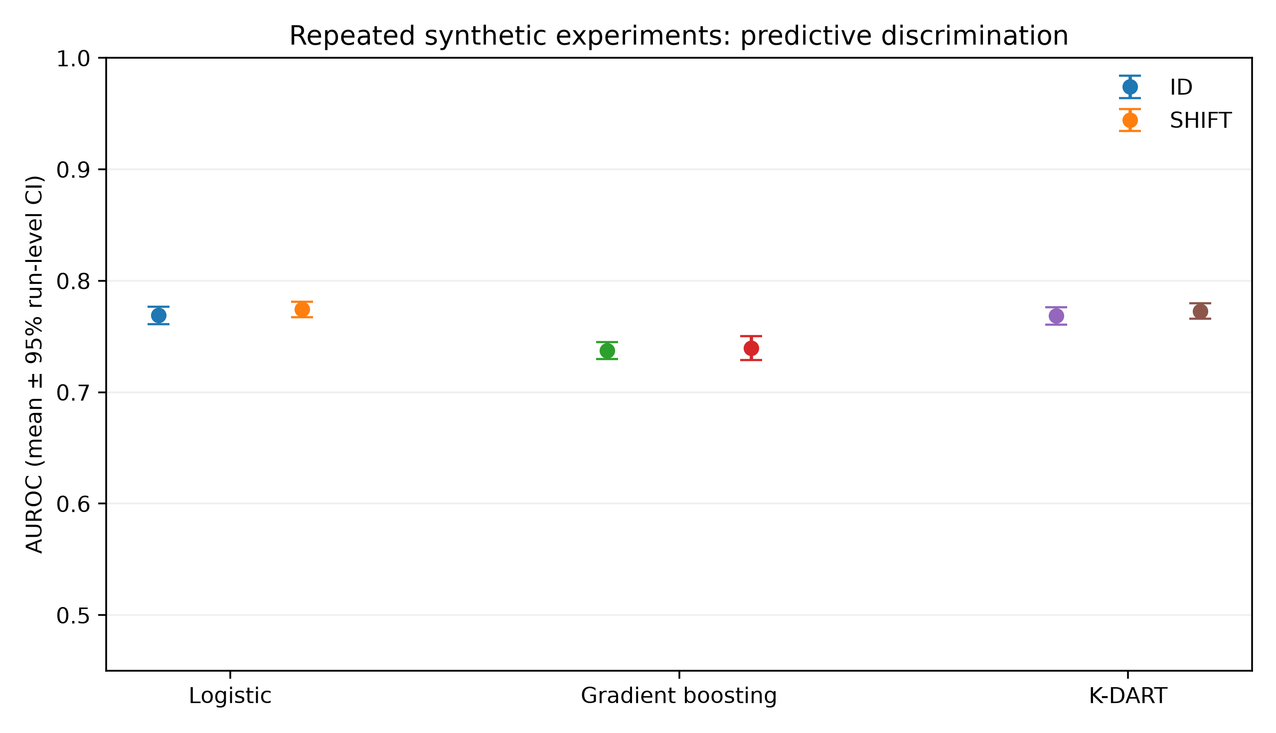
Figure 1. AUROC model comparison with 95% between-run normal-approximation intervals; not confidence bounds for a real population.
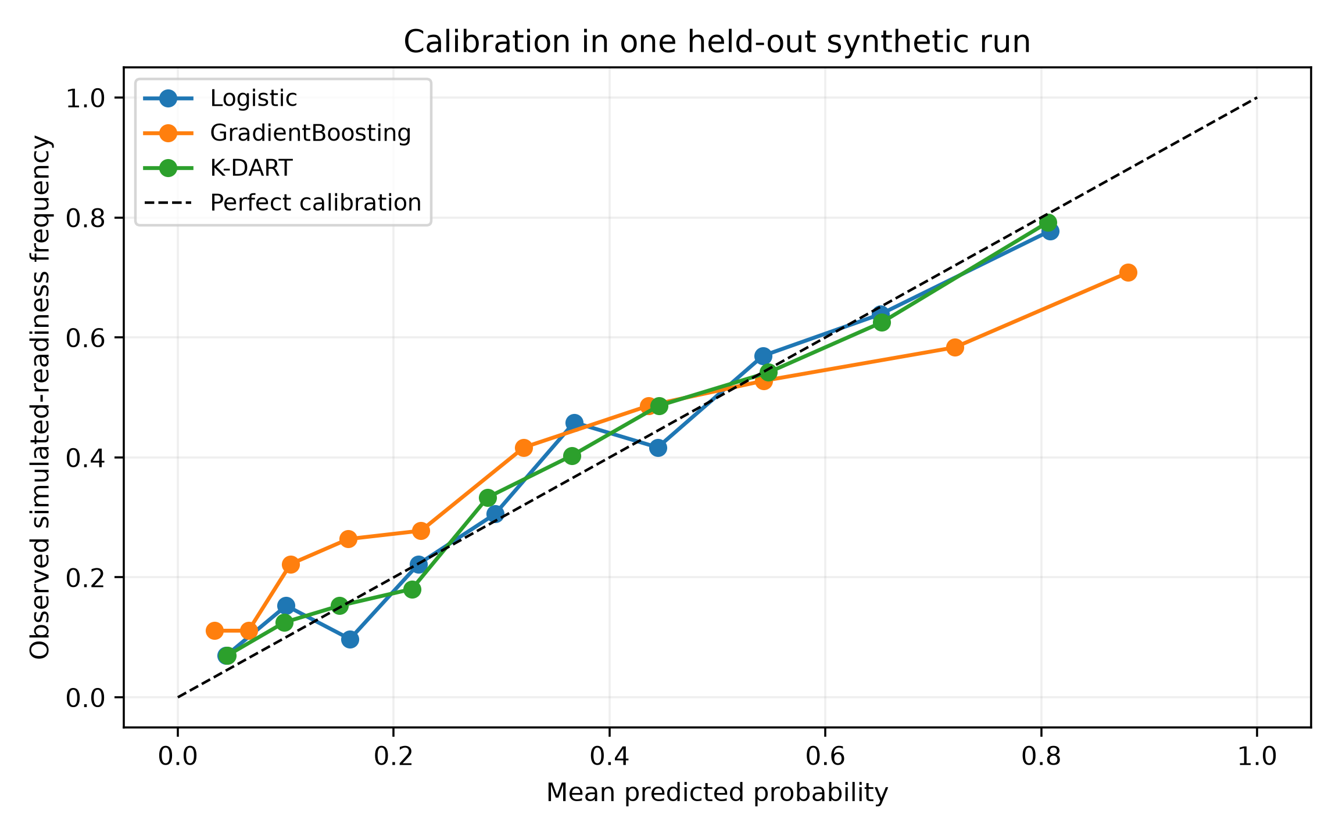
Figure 2. Calibration on one synthetic held-out run; not cross-dataset average calibration.

4. Discussion
These results demonstrate a common risk in knowledge-augmented modeling: plausible engineered rules may not supply incremental information beyond correlated base predictors. A scientifically consequential knowledge-based decision model would require externally elicited constraints and evaluation of decisions, such as the expected cost of selecting unsuitable digital investments. This study does not measure those outcomes. Synthetic shift robustness is not proof of cross-sector generalization.

5. Limitations and conclusion
Labels, enterprise profiles and rule thresholds are simulated. No organizational measurements, expert panel, prospective intervention outcomes, or external validity checks are present. Hence K-DART is not a deployable readiness instrument. Negative results are reported without manufacturing a performance benefit. Future research should acquire approved enterprise data, define an independent readiness target, validate rules with experts, quantify decision utility and compare against stronger knowledge-based baselines.

Data and software availability
Synthetic observations and results are reproducible using experiment.py; source code and generated outputs are hosted in the project repository. Public repository release is not a substitute for depositing an archived research artifact with a persistent identifier where required.

Declarations
Author contributions, funding and competing-interest details require author confirmation. Generative AI assisted manuscript structuring and coding; the author must critically verify all content, references and disclosures before submission.

References
[1] S.M. Lundberg, S.-I. Lee, A unified approach to interpreting model predictions, Advances in Neural Information Processing Systems 30 (2017).
[2] World Bank Group, Enterprise Surveys data, https://www.enterprisesurveys.org/en/data (accessed 23 October 2026).
[3] Eurostat, Community Innovation Survey microdata, https://ec.europa.eu/eurostat/web/microdata/collections-research/community-innovation-survey (accessed 23 October 2026).

