**HR ANALYTICS DASHBOARD**

**USING TABLEAU**

### A Micro Project Report

#### Submitted by

**BOPPANA ROHITH 99220041454**

### B.Tech – Computer Science and Engineering,

### AIML



**Kalasalingam Academy of Research and Education**

**(Deemed to be University) Anand Nagar, Krishnankoil - 626 126**

### March 2024



**SCHOOL OF COMPUTING**

**DEPARTMENT OF COMPUTER SCIENCE AND ENGINEERING**

**BONAFIDE CERTIFICATE**

Bonafide record of the work done by BOPPANA ROHITH - 99220041454 in partial fulfillment of the requirements for the award of the degree of Bachelor of Technology in Specialization of the Computer Science and Engineering, during the Academic Year Even Semester (2023-24)

**Dr. J. Jane Rubel Angelina Dr. P. Anitha**

**Project Guide Faculty Incharge**

**Associate professor Assistant professor**

**Computer Science and Engineering Computer Science and Engineering**

**Kalasalingam Academy of Kalasalingam Academy of**

**Research and Education Research and Education**

**Krishnan kovil - 626126 Krishnan kovil - 626126**

**Mr. M. K. Nagarajan Evaluator**

**Assistant professor**

**Computer Science and Engineering Kalasalingam Academy of Research and Education**

**Krishnan kovil - 626126**

# Abstract

A deep understanding of analytics is essential for making wise decisions in the field of human resources management. With the help of Tableau, this project presents an HR analytics dashboard that provides a thorough overview of important workforce indicators. The dashboard offers real-time insights into workforce dynamics by encapsulating key metrics such as staff numbers, attrition statistics, and attrition rates. It also provides comprehensive analyses, including attrition by department, staff distribution by age group, job satisfaction scores, and attrition trends by gender and educational specialty. This dashboard enables HR professionals to make data-driven decisions, optimize retention strategies, and improve organizational performance by combining data visualization and advanced analytics.

# Contents

1. Introduction 1
   1. Purpose of the HR Analytics Dashboard 1
   2. Scope of the Project 1
      1. Data Collection and Analysis 1
      2. Dashboard Design and Implementation 2
2. Understanding Workforce Dynamics **3**
   1. Employee Count 3
      1. Total Employee Count Analysis 4
   2. Attrition Count and Rate 4
      1. Department-wise Attrition 4
      2. Attrition Rate by Gender for Different Age Groups 5
   3. Active Employees Analysis 6
      1. Employee Engagement and Retention 6
3. Employee Satisfaction and Retention Strategies **7**
   1. Job Satisfaction Rating 7
      1. Employee Survey Analysis 7
      2. Comparison and Benchmarking 9
   2. Education Field-wise Attrition 11
4. Conclusion and Future Work 12
   1. Summary of Findings 12
   2. Recommendations for HR Decision-making 12

CONTENTS CONTENTS

1. References 13
2. Certification 14

**List of Figures**

|  |  |  |  |
| --- | --- | --- | --- |
| 1.1 | HR Analytics Dashboard | . . . . . . . . . . . . . . . . . | 2 |
| 2.1 | Employee Count | . . . . . . . . . . . . . . . . . | 3 |
| 2.2 | Attrition Rate by Gender for different Age Groups | . . . . . . . . . . . . . . . . . | 6 |
| 3.1 | No of Employee by Age Group | . . . . . . . . . . . . . . . . . | 9 |
| 3.2 | Department wise Attrition | . . . . . . . . . . . . . . . . . | 9 |
| 6.1 | Certification details | . . . . . . . . . . . . . . . . . | 14 |

**Chapter 1**

# Introduction

### Purpose of the HR Analytics Dashboard

### Scope of the Project

The HR Analytics Dashboard's objective is to offer useful insights into many facets of the company's workforce. The dashboard uses data analytics to help proactive actions, uncover trends and patterns, optimize HR strategies, and facilitate well-informed decision-making. To put it simply, it's a useful tool that HR professionals may use to comprehend, evaluate, and maximize different facets of the workforce, which ultimately helps the business succeed and last.

#### Data Collection and Analysis

* + - 1. Kaggle, a well-known repository for datasets and data science, was used to obtain data for this project. The dataset selected for investigation contains a wide range of data relevant to the workforce dynamics of the firm.

2. Kaggle provided the dataset, which includes comprehensive information on attrition rates, job roles, satisfaction measures, and employee demographics. This one dataset is the main source for analysis, offering a wealth of factors necessary for thorough workforce assessment and the creation of insights.

3. A comprehensive investigation of workforce trends, patterns, and connections is made possible by the dataset's meticulous selection, which guarantees the availability of pertinent data points essential for a strong analysis.

1.2. Heading 2 Chapter 1. Chapter 1 Title

#### Dashboard Design and Implementation

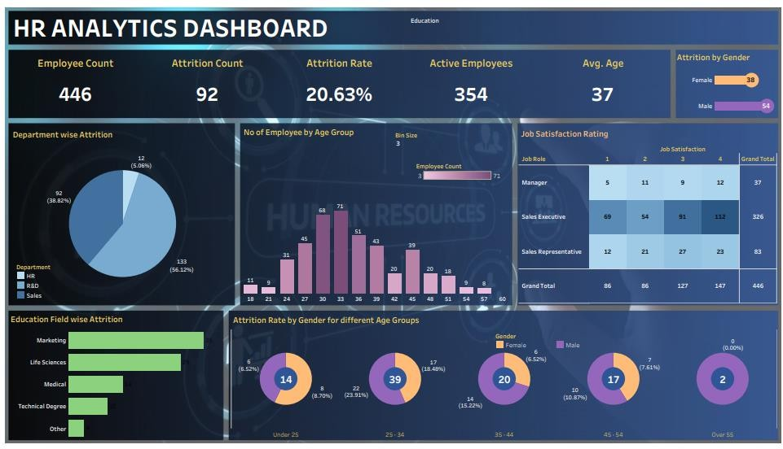

Figure 1.1: HR Analytics Dashboard

Clarity and accessibility were given top priority in the dashboard's design, making it possible for users to quickly navigate between parts and successfully understand the insights that are displayed. The deployment phase also included the integration of user-friendly graphics and interactive components to improve user engagement and enable more in-depth workforce data research.

The HR Analytics Dashboard was created and put into use with the overall goal of giving HR professionals a strong tool for strategic workforce management and data-driven decision-making.

**Chapter 2**

## Understanding Workforce Dynamics

### Employee Count

Understanding the makeup of the workforce inside the company requires a fundamental understanding of personnel count analysis. It offers information about the composition and scope of the workforce and acts as a baseline statistic for a number of HR programs and strategic planning endeavors. Organizations can successfully support their business objectives by identifying trends, anticipating staffing needs, and optimizing resource allocation by analyzing personnel count data over time and across various departments or demographics. Furthermore, comprehension of variations in the number of employees can assist HR practitioners in evaluating the influence of hiring initiatives, retention tactics, and organizational modifications on the general makeup of the workforce.

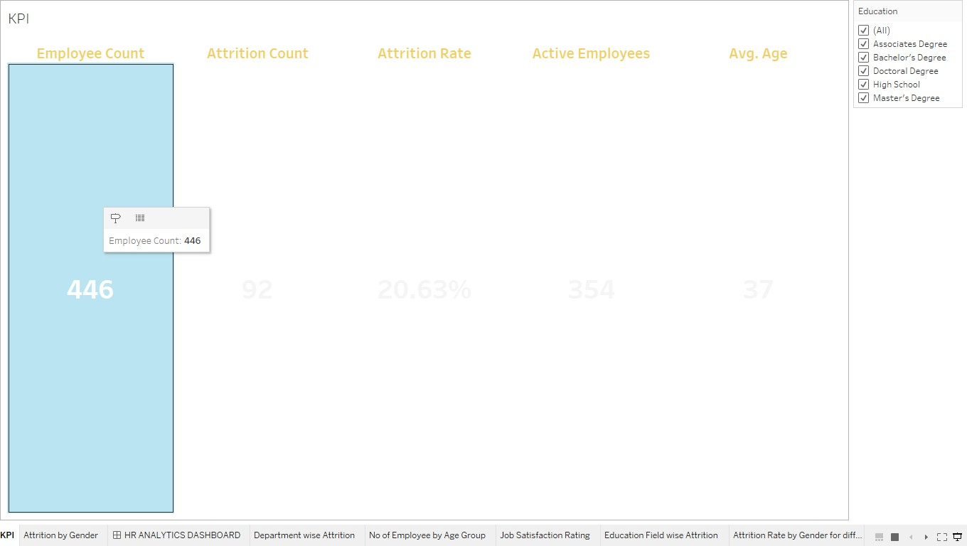

Figure 2.1: Employee Count

2.2. Heading 2 Chapter 2. Chapter 2 Title

#### Total Employee Count Analysis

An important part of workforce management is the examination of the overall staff count, which offers vital information about the organization's human resources. At now, the company employs 446 people, making it a very productive workforce. HR specialists can determine the size and scope of the company by looking at this figure, monitoring changes over time to spot trends that could have an effect on operations. It is critical to comprehend fluctuations in the number of employees since this information influences strategic decisions about hiring, staffing levels, and resource allocation. Furthermore, a comprehensive picture of the workforce can be obtained by combining the analysis of employee count data with other variables like departmental demographics and attrition rates. With this thorough understanding, firms may create focused efforts that promote employee engagement, retention, and overall success.

### Attrition Count and Rate

• There are 92 employees in the organization that have left due to attrition. This figure represents the total number of people who have departed the company in a certain time frame.   
  
• The attrition rate, which is determined to be 20.63%, shows the percentage of workers who have left in comparison to the entire workforce.   
  
• By offering insightful information about workforce dynamics, this attrition count and rate analysis helps HR professionals comprehend and manage employee turnover inside the company.

#### Department-wise Attrition

Significant differences in departure rates exist amongst the organization's departments, according to department-level attrition data.

•The HR division has an attrition rate of 5.06%.

•The attrition rate in the R&D division is noticeably higher at 56.12%.   
On the other hand, the attrition rate in the sales department is significantly lower, at 38.82%.

HR practitioners must have a thorough understanding of department-specific attrition rates in order to pinpoint problem areas and put focused retention initiatives in place to reduce turnover and preserve organizational stability.

#### Attrition Rate by Gender for Different Age Groups

Analyzing gender-specific attrition rates across a range of age groups offers important insights on retention tactics and workforce dynamics.   
  
  
• In the under-25 age range, women have an attrition rate of 8.70%, which is rather higher than that of men (6.52%). This raises the possibility of gender-based variations in the factors influencing younger employees' departure.   
  
• In the age group of 25–34, women attrition is higher at 18.48% than it is for men (23.91%). Different career goals, preferences for work-life balance, or organizational support systems could be the cause of this discrepancy.

• When comparing the 35-44 age range, the attrition rate for females drops to 6.52% while it rises to 15.22% for males. This disparity could be the result of varying priorities or chances for career progression between the sexes within this age bracket.   
  
• Likewise, in the 45–54 age range, women have a lower attrition rate (7.61%) than men (10.87%). Retirement plans, career stability, and job satisfaction are a few possible causes of this disparity.   
  
• HR professionals can identify vulnerable areas and adjust retention efforts by analyzing attrition rates by gender and age group intersection. Organizations can cultivate a workplace culture that is more inclusive and supportive by attending to the specific needs and concerns of various demographic segments. This will ultimately improve employee engagement and company

Chapter 2. Chapter 2 Title 2.3. Heading 3

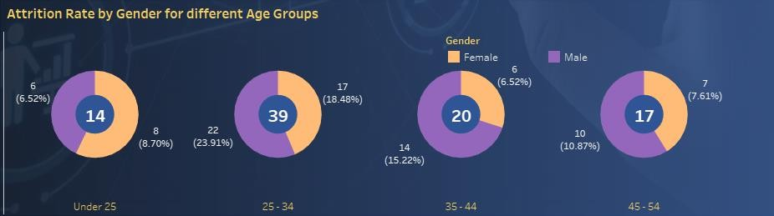

Figure 2.2: Attrition Rate by Gender for different Age Groups

### Active Employees Analysis

Evaluating the success of the company and the stability of the workforce requires careful consideration of its active personnel. Important information on how many workers are now involved in organizational tasks is provided, which boosts output and effectiveness as a whole.  
Strategic workforce planning, which enables firms to efficiently manage human capital resources and match employment levels with business objectives, is based on this thorough study.

#### Employee Engagement and Retention

In order to keep a motivated and dedicated staff, firms must analyze their employee engagement and retention rates. HR specialists may pinpoint areas of strength and possibilities for progress in employee engagement and retention strategies by assessing elements including work satisfaction, company culture, and career development opportunities. Organizations can execute focused initiatives to promote a healthy work environment, raise employee happiness, and lower turnover rates by having a better understanding of the causes of employee engagement and retention.

**Chapter 3**

## Employee Satisfaction and Retention Strategies

### Job Satisfaction Rating

The foundation of an effective organization is employee satisfaction, which affects morale, retention rates, and productivity. Organizations can pinpoint areas for employee experience enhancement and areas for strength by analyzing job satisfaction scores across various jobs.

Manager: 37

Sales Executive: 326

Sales Representative: 83

Organizations can customize retention tactics to match the unique needs and preferences of employees in various roles by having a thorough understanding of job satisfaction ratings. Organizations may lower attrition rates, boost employee engagement, and create a more favorable work environment by concentrating on improving job satisfaction.

#### Employee Survey Analysis

##### Employee Engagement Insights

Analysis of employee surveys dives deeply into employee engagement and offers insightful information on variables affecting morale and output. Organizations can obtain a thorough grasp of employee views, attitudes, and motivations by using survey results.

**Key Findings:**

Sixty-eight percent of workers said they were happy with their current position and duties.   
A need for more possibilities for training and development was expressed by 42% of the workforce. A full 55% of workers emphasized how crucial it is for leaders to communicate openly.   
Comprehending these findings facilitates firms in customizing employee engagement tactics efficiently, cultivating a climate of confidence, cooperation, and ongoing enhancement.

##### Retention Strategy Recommendations

The formulation of retention strategies is also informed by employee survey analysis, which helps firms identify retention difficulties and carry out focused interventions to reduce turnover. Organizations can identify areas of unhappiness and create plans to improve employee loyalty and satisfaction by looking at survey data.

##### Recommendations:

Establish mentorship programs to assist in the professional development of your staff.   
Improve avenues of communication to enable open discussion between staff and management.   
  
Provide attractive benefit and pay packages to encourage staff retention. By putting these retention strategy guidelines into practice, organizations become more resilient, turnover rates decrease, and a climate that promotes long-term success and employee satisfaction is created at work.

Chapter 3. Chapter 3 Title 3.1. Heading 1

#### Comparison and Benchmarking

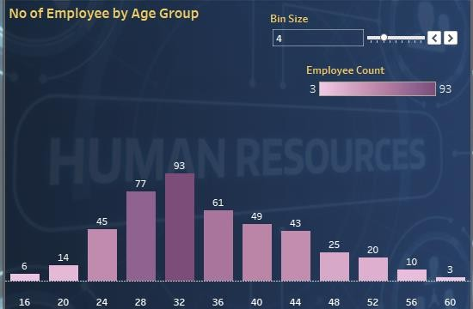

Figure 3.1: No of Employee by Age Group

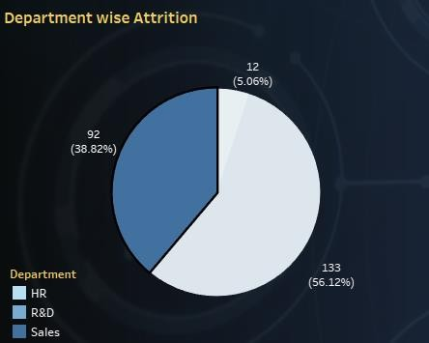

Figure 3.2: Department wise Attrition

**Number of Employees by Age Group:**

Examining the workforce's age distribution gives important information about the workforce's demographic makeup. Organizations can identify trends that may affect personnel management and strategic planning, such as workforce aging or generational shifts, by grouping people into different age brackets. HR professionals can use this data to create training programs, succession planning initiatives, and targeted recruitment strategies that are catered to the unique requirements and preferences of various age groups within the firm. Furthermore, by comprehending how employees are distributed throughout age groups, firms may address possible issues with workforce diversity, succession planning, and knowledge transfer, assuring a sustainable and balanced talent pipeline for expansion and success in the future.

**Department-Wise Attrition:**

Analyzing attrition by department offers important insights into patterns of turnover in various functional areas of the company. HR specialists can spot problem areas and possible risk factors influencing employee departures by looking at attrition rates by department. Organizations can use this study to identify high attrition departments and look into underlying problems including underwhelming leadership, a lack of opportunity for professional advancement, or dissatisfaction with one's position. Equipped with this data, establishments can construct focused retention tactics, such as career development programs, mentorship schemes, and performance management interventions, to reduce staff attrition and improve engagement and contentment. Department-specific attrition research also makes benchmarking efforts easier by enabling businesses to compare turnover rates between departments and industry standards. This helps them identify areas for development and best practices for optimizing workforce management tactics.

3.2. Heading 2 Chapter 3. Chapter 3 Title

### Education Field-wise Attrition

Analysis of education-related attrition provides insightful information about employee departure patterns according to educational background. Organizations can uncover potential relationships between education and attrition rates by classifying employees based on their field of study. This allows for focused interventions and retention initiatives.   
  
**Marketing:** Employees with a marketing background have a noteworthy turnover rate, with 35 attrition counts. This could be due to a number of things, like job mobility within the industry or the high demand for marketing specialists in cutthroat industries.

**biological Sciences:** The attrition rate for workers having a background in the biological sciences is moderate, at 29. Specialized roles with lateral movement and professional growth chances are common in this field, which may increase employee turnover as workers look for new challenges.   
  
**Medical:** With only 14, the attrition rate is comparatively lower for workers with a medical background. Medical careers frequently call for high levels of education and training, which creates a workforce that is more stable and has lower turnover.   
  
**Technical Degree:** Workers possessing a technical degree have a moderate attrition rate of ten. Technical positions typically have lower turnover rates than other areas since they can provide excellent job security and opportunity for skill improvement.

**Other:** With a tally of 4, employees classified in "other" fields have the lowest attrition rate. Employees in this group might have varied educational backgrounds that fall outside of the defined categories, which would lower the attrition rate.   
  
Organizations can enhance retention and performance by customizing recruitment strategies, training programs, and career development initiatives to suit the distinct needs and preferences of employees with varying educational backgrounds by having a thorough understanding of education field-specific attrition patterns.

**Chapter 4**

# Conclusion and Future Work

### Summary of Findings

The main conclusions drawn from the thorough investigation are summarized in the summary of findings. It provides stakeholders with a clear grasp of the implications and suggestions gained from the study by serving as a synthesis of the data and observations gathered during the research process.   
The summary offers a succinct synopsis of the key conclusions, emphasizing noteworthy patterns, trends, and consequences found throughout the investigation. Decision-makers can use it as a useful tool to help them make decisions and take calculated actions based on the research's insights.

### Recommendations for HR Decision-making

Enhancing proactive and strategic human resource management requires integrating data-driven recommendations into HR decision-making processes. Organizations can improve employee engagement, retention, and overall performance by optimizing their HR strategy through the utilization of insights obtained from comprehensive analysis.

**Chapter 5**

# References

* + 1. [Human Resources Dashboards (tableau.com)](https://www.tableau.com/solutions/human-resources-analytics/dashboards)
    2. [Tableau HR Dashboard: Insights at a Glance | by Kalaikc16 | Feb, 2024 | Medium](https://medium.com/%40kalaikc84/tableau-hr-dashboard-insights-at-a-glance-ae8916f1d16d)
    3. [GitHub - ssati19/HR-Analytics-Tableau-Dashboard-: The HR Analytics Dashboard project using](https://github.com/ssati19/HR-Analytics-Tableau-Dashboard-)  [Tableau is designed to provide insights into key metrics and trends related to human resource](https://github.com/ssati19/HR-Analytics-Tableau-Dashboard-)  [management in an organization. The dashboard utilizes visualizations and data analysis](https://github.com/ssati19/HR-Analytics-Tableau-Dashboard-)  [techniques to help HR professionals identify patterns and make data-driven decisions.](https://github.com/ssati19/HR-Analytics-Tableau-Dashboard-)
    4. [(11) HR Analytics Dashboard Using Tableau and SQL Queries - A Complete End-to-End Project](https://www.linkedin.com/pulse/hr-analytics-dashboard-using-tableau-sql-queries-complete-patel-b9zpf/) [Guide [ With Datasets ] | LinkedIn](https://www.linkedin.com/pulse/hr-analytics-dashboard-using-tableau-sql-queries-complete-patel-b9zpf/)
    5. [HR Dashboard: 7 Key Examples and Best Practices | Qlik](https://www.qlik.com/us/dashboard-examples/hr-dashboard)

**Chapter 6**

# Certification

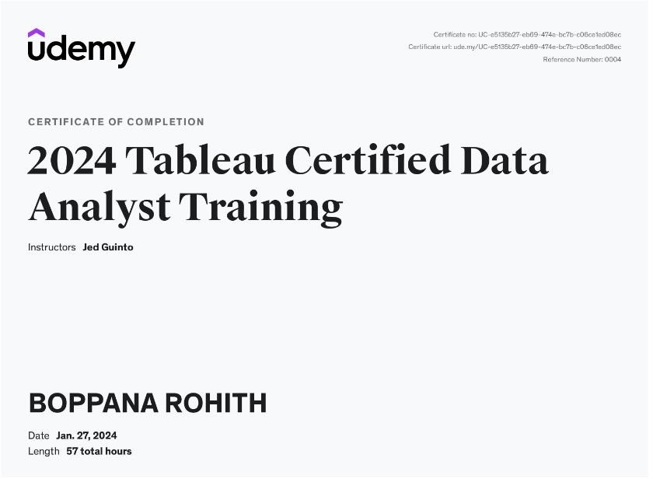

Figure 6.1: Certification details