Diabetes Classification in pregnancy women’s
Abstract
Early diagnosis of diabetes controls severe complications that can appear following the condition's diagnosis. This study employs the pregnancy women Diabetes dataset to predict diabetes incidents utilizing eight medical and demographic variables obtained from 768 patients. The research analyzes classification methods consisting of logistic regression and linear quadratic discriminant analysis, together with naive bayes, K-Nearest Neighbors, decision trees, and Support Vector Machines.
Additional model performance was achieved by adding engineered second-order features that included interaction and squared terms. The data preprocessing stage included treating missing values and normalizing inputs, followed by standardization procedures when required. The evaluation process used two assessment methods: 70/30 train-test splits and 10-fold cross-validation. The performance evaluation used accuracy rates, ROC curves, AUC scores, and confusion matrices to focus on Type I and Type II error analysis.
PCA variance analysis and LASSO predictive component selection were both tested in the study. Engineered second-order interaction terms served to boost the operational capabilities of linear models. The performance results demonstrate that SVM and LDA prove to be the highest-performing models with Specific applications for implementation needs.
Linear Discriminant Analysis (LDA), along with Logistic Regression, provided optimal interpretability and accuracy outcomes; however, SVM delivered maximum cross-validation accuracy when its hyperparameters were optimized. The study outcomes show that machine learning techniques deliver efficient diabetes detection at an early stage, together with standardized methods for practical model selection.

Table of Contents

1. Introduction 1
2. Literature review 2
3. Methodology 3
3.1 Dataset Overview 3
3.2 Data Cleaning and Preprocessing 3
3.3 Exploratory Data Analysis (EDA) 4
3.3.1 Check Class Imbalance 4
3.3.2 Feature Distribution Analysis 5
3.3.3 Correlation Analysis 6
3.3.4 Interaction between key features using Pair Plots 6
3.3.5 PCA Analysis 7
3.4 Feature Engineering 9
3.5 Data Splitting 9
3.6 Model Training 9
3.7 Cross-Validation 10
4. Evaluation Metrics 11
5. Model Evaluation 12
5.1 Logistic Regression 12
5.2 Linear Discriminant Analysis (LDA) 12
5.3 Quadratic Discriminant Analysis (QDA) 13
5.4 Naive Bayes 14
5.5 K-Nearest Neighbors (KNN) 15
5.6 Decision Tree 16
5.7 Support Vector Machine (SVM) 17
5.8 Model Evaluation 18
6. Results and Discussions 20
7. Conclusion & Recommendations 24
References 26

Figures List
Figure 1 - Class Distribution 4
Figure 2 - Feature Distribution 5
Figure 3 - Correlation Heatmap 6
Figure 4 - Pair Plots 7
Figure 5 - PCA of First 2 Principal Components 8
Figure 6 - Scree Plot 8
Figure 7 - Logistic Regression Statistics & ROC Curve 12
Figure 8 - LDA STatistics & ROC Curve 13
Figure 9 - QDA Statistics and ROC Curve 14
Figure 10 - Naive Bayes Statistics & ROC Curve 15
Figure 11 - KNN Statistics & ROC Curve 16
Figure 12 - Decision Tree Statistics and ROC Curve 17
Figure 13 - SVM Statistics & ROC Curve 18
Figure 15 - Model Comparison Visualization 23

Tables List

Table 1 - Model Comparison (Train vs Test Performance) 18
Table 2 - Hyperparameters used in Models 21
Table 3 -Model Summary (Test vs CV) 21

Introduction
Millions of people worldwide pregnancy women face diabetes mellitus as their major public health condition. The condition results from factors that elevate blood glucose (sugar) levels due to inadequate insulin production, insulin resistance, or both. Early detection of diabetes is necessary to stop the development of cardiovascular diseases, kidney failure, vision loss, and neuropathy. Blood tests and clinical assessments currently form the basis for diagnostic procedures, yet they require extensive time and are limited in availability for low-resource locations. Machine learning (ML) methods combined with data science allow predictive models to analyze patient health records to effectively and accurately identify diabetes signs during the early stages.
This project employs the pregnancy women Diabetes Dataset in healthcare analytics to build and examine multiple classification models using machine learning techniques. A total of 768 patient records include eight predictor variables, including blood pressure measurements, glucose concentration, BMI measurements, age values, and insulin levels.
The core task is to build and evaluate numerous ML algorithms that forecast diabetes occurrence using the provided features. The analysis employs Logistic Regression, linear Discriminant Analysis (LDA), quadratic Discriminant Analysis (QDA), Naive Bayes, K-nearest neighbors (KNN), Decision Trees, and Support Vector Machines (SVM).
The inclusion of squared and interaction terms in the features through engineering makes linear models more efficient at learning and detecting non-linear patterns. The evaluation includes two assessment approaches: train-test split at 70/30 and 10-fold stratified cross-validation. For measurement purposes, it uses accuracy rates alongside ROC curves, AUC scores, and confusion matrices. The performance assessment, combined with model interpretation analysis, makes this research suitable for medical practitioners and healthcare decision systems in practical medical settings. The prediction applies to women above twenty-one years old who belong to the female population and are utilized for data collection. According to research, the number of pregnancies serves as a significant demographic element that functions as a risk factor because it relates to both gestational diabetes risks and hormonal influences on insulin management.

Literature review
Researchers have employed machine learning techniques to predict diabetes through analysis of the Diabetes Dataset because its medical data possesses diverse clinical variables properly organized.
Smith et al. (1988) demonstrated the first application of logistic regression to the data, achieving approximately 76% accuracy in classifying diabetic and non-diabetic patients.
According to Kavakiotis et al. (2017), support vector machines and random forests achieve superior results than basic models because these methods can detect hidden non-linear patterns in diabetes prediction.
Sivaparthipan et al. (2019) suggest using feature engineering methods, which include principal component analysis and interaction terms, to enhance model efficiency and accuracy. According to their research findings, feature construction is an essential factor for achieving better model performance.
According to Dewanganand Agrawal (2015), implementing second-order interaction features with correct scaling and imputation procedures in logistic regression models results in better AUC values.
Thakkar and Desai's (2020) research using ensemble methods on the dataset demonstrated how hybrid models surpass single classifiers in terms of accuracy performance and robustness level.
This research extends existing knowledge by developing an implementation that utilizes strict data preprocessing alongside generated second-order features and uses multiple ML models while performing cross-validation tests. The study develops previous findings through parameter optimization and clinical interpretation of results focused on Type I and Type II error analysis and provides performance-based model recommendations.

Methodology
A systematic process is used to construct and validate predictive models for diabetes diagnosis using machine learning methods. The system requires data pre-statements, introductory data research, feature transformation, model establishment, and validation processes, and final evaluation steps.

3.1 Dataset Overview
The dataset used in this study is the pregnancy women Diabetes Dataset, which has 768 medical records of adult female patients with lineage. Each record includes eight features related to medical or demographic parameters: number of pregnancies, plasma glucose concentration (2-hour), diastolic blood pressure, skinfold thickness, serum insulin levels, body mass index (BMI), diabetes pedigree function, and age.
The target variable outcome is categorical because it distinguishes between diabetic (1) and non-diabetic (0) patients. The result was converted into a factor with levels labelled as “Diabetic” and “Non-diabetic.”
All input features in the dataset are numerical (continuous), including glucose, insulin, BMI, blood pressure, and age. The only categorical variable is the target outcome, which was converted into a binary factor with labeled levels: "Diabetic" and "Non-diabetic". The numeric values characterize all features in the dataset, allowing implementation of distance-based classifiers (KNN, SVM) together with PCA methods and correlation-based visualization techniques.

3.2 Data Cleaning and Preprocessing
Several data cleaning procedures were executed to maintain integrity and usability in the dataset. The first step is to standardize every column name to lowercase for sustained analysis consistency. Several clinical fields of glucose, insulin, blood pressure, BMI, and skinfold thickness measurements included unrealistic zero values. The researcher treated the zero values as missing information before replacing them with NA values. Median imputation procedures completed the missing values across features without altering the original distributions to control outlier impacts.
A label transformation of the target variable into “Diabetic” and “Non-diabetic” categories improved the understanding of model training results and performance evaluation. The categorical labels made it possible to compute metrics for each class regarding error rates and specificity and sensitivity values.

3.3 Exploratory Data Analysis (EDA)
Data patterns and relationships within the dataset were evaluated during preliminary analysis.

3.3.1 Check Class Imbalance
The target variable outcome distribution analysis was performed before modeling to assess any underlying class imbalance. A total of 768 instances comprise the dataset, with diabetic patients numbered at 268, which indicates a 34.9% population, while non-diabetic patients form 500 cases, representing 65.1% of the dataset. Statistical records show that non-diabetic instances appear nearly double compared to diabetic cases, thus indicating a moderately unbalanced distribution.
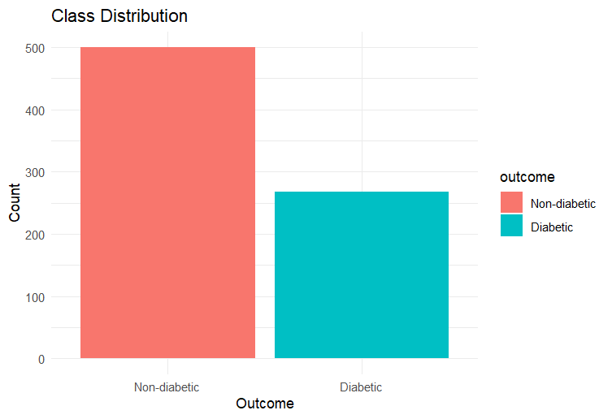
Figure 1 - Class Distribution

The unbalanced dataset does not lead to substantial performance decline but may negatively impact classifiers that place higher importance on accuracy from the majority class. The research focused on ROC AUC, sensitivity/specificity, and balanced accuracy metrics since they performed better than overall accuracy in the model comparison process. We have examined re-sampling methods that aim to boost performance results within unbalanced situations.

3.3.2 Feature Distribution Analysis
Histograms and density plots evaluated how features separated diabetic from non-diabetic patients within the dataset. The visualizations demonstrated that the diabetic and non-diabetic class distinctions were obvious for features such as glucose, BMI, and age, which signifies high potential for prediction. Insulin and skinfold thickness features produced peak distributions because the median imputation yielded numerous missing or zero-value replacements, as observed in the raw data.
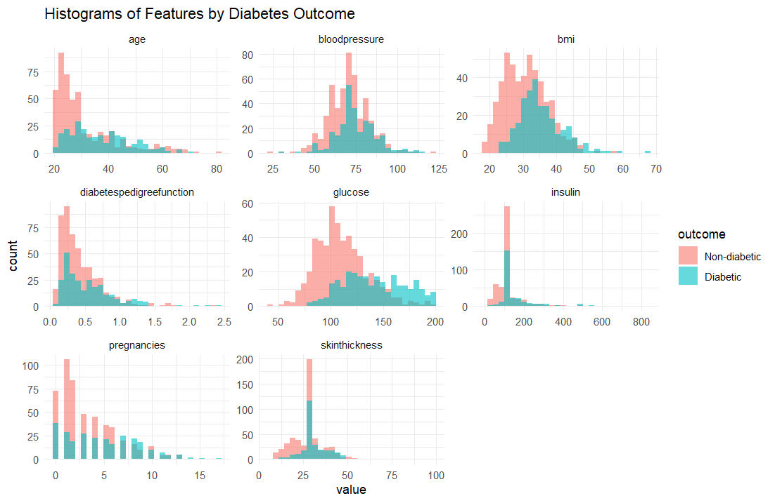
Figure 2 - Feature Distribution

3.3.3 Correlation Analysis
The analysis computed a correlation matrix to evaluate numerical variable relationships. The analysis revealed low to moderate values of variable correlation, except for BMI and skinfold thickness, which showed a 0.54 relationship.
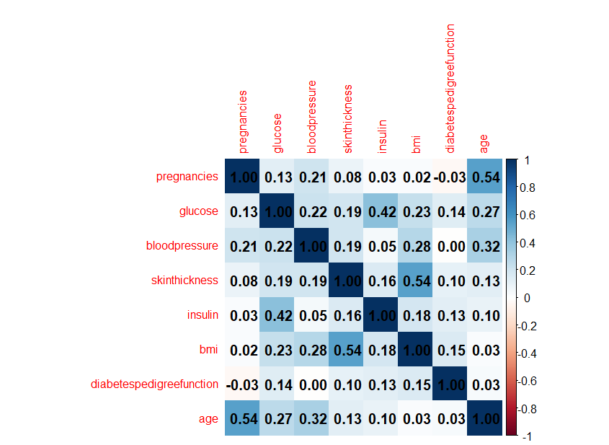
Figure 3 - Correlation Heatmap

3.3.4 Interaction between key features using Pair Plots
The GGally package provides pair plots to assess the combinations between variables and their ability to create distinct class groupings. The pair plot analysis revealed that features such as glucose and insulin, and BMI and age, show the clustering by class with diabetic and non-diabetic groups that display separable trends in feature pairs. This analysis informed the decision to construct second-order interaction terms using these variables.
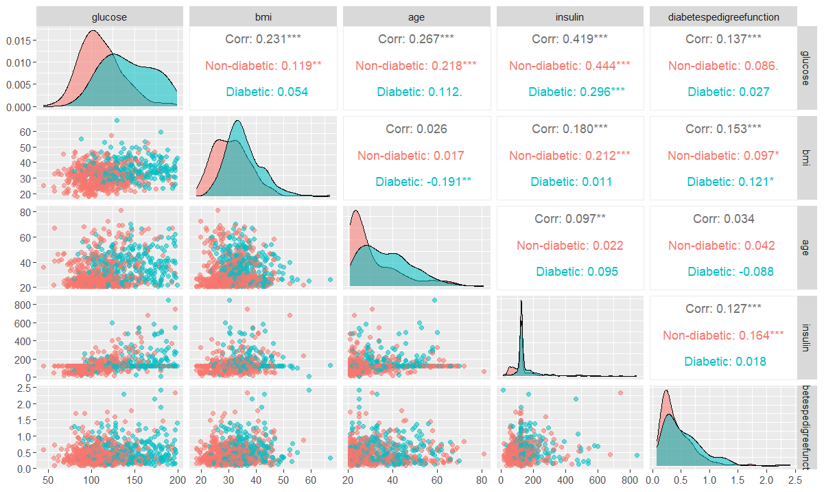
Figure 4 - Pair Plots

3.3.5 PCA Analysis
PCA analysis was conducted to check if the data showed clustering patterns. The two leading principal components successfully explained major variance in the data, yet some class regions merged together, indicating that non-linear classifier algorithms should be implemented instead.
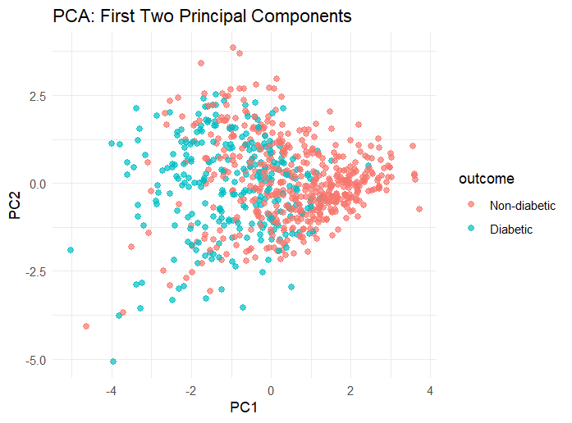
Figure 5 - PCA of First 2 Principal Components

A scatter plot provided evidence to select the dimensions used in PCA. The scree plot demonstrated how the first two principal components provided the highest variance explanation level, making them appropriate for visualization. PCA was unsuitable for modeling because its unsupervised transformation produces components that healthcare practitioners find difficult to interpret clinically. The LASSO algorithm verified predictive potential by focusing on PCA components, so that only PC1 and PC6 proved effective. The final modeling took place over original variables and engineered features to preserve a clear understanding of the analysis.
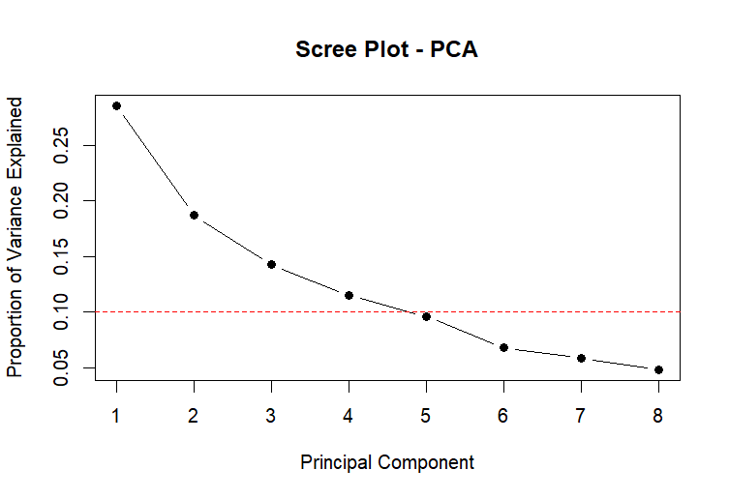
Figure 6 - Scree Plot

3.4 Feature Engineering
Second-order terms served as tools for models to identify predictive relationships among major predictors. The analysis included both squared terms concerning glucose concentration, body mass index, and age, and interaction terms consisting of glucose multiplied by BMI and age and BMI multiplied by age. Model selectors used EDA analysis alongside medical understanding to build the models, particularly when strong correlation and clinical relevance indicators appeared. The controlled method protected the model against unnecessary features and enhanced complexity management.
The study used domain expertise and EDA findings to determine the selection of interaction terms. The combination of glucose, insulin, and age presented both the strongest relationship separation and meaningful correlation, meaning they are suitable for biological interaction analysis (e.g., glucose-insulin correlation at 0.42). The analysis considered only important parameter pairs glucose × insulin, bmi × insulin, and glucose × age because it avoided over fitting and complex model structures.

3.5 Data Splitting
The data is split into 70% of training and 30% of testing portions through caret::createDataPartition() while maintaining equivalent class representation in both sections. The model development and hyper parameter optimization occurred with the training data before testing was performed with the reserved test set. The evaluation design tested model performance against data that remained withheld during the training phase for a realistic generalization assessment.

3.6 Model Training
Seven classification algorithms were implemented for evaluation in this research endeavor: Logistic Regression and Linear Discriminant Analysis (LDA), Quadratic Discriminant Analysis (QDA), Naive Bayes, K-Nearest Neighbors (KNN), Support Vector Machine (SVM), and Decision Tree. The training of models continued exclusively with datasets prepared using second-order terms, except for KNN. The distance-based operation of KNN demanded normalization for its input features.
A tuning process for all the models took place through the selection of SVM (C and sigma), KNN (number of neighbors), and decision tree (complexity parameter) parameters, which was performed using tuneGrid. The selected RBF kernel of SVM brought non-linear mapping abilities to the algorithm. During initial testing, the SVM model with linear configuration proved to be less effective compared to other methods. The retraining process with second-order features occurred only for models excluding KNN due to its necessity from the normalized feature input requirements.

3.7 Cross-Validation
The model generalizability evaluation used caret::trainControl() together with stratified 10-fold cross-validation. The validation strategy maintained the original composition of diabetic and non-diabetic cases throughout all 10 folds. A customized summary function ran accuracy and AUC assessments in each fold during the analysis. The main tasks of cross-validation included protecting against overfitting while providing stable metrics for model comparison through averaged fold results.
The Custom Summary function calculated Accuracy and ROC AUC values within a 10-fold stratified CV. The caret automatically recorded AUC, which resulted in manual calculation when necessary using saved model predictions from the training phase.

Evaluation Metrics
Model evaluation took place through a system that used test set examination joined with 10-fold cross-validation. We established uniform performance assessment metrics to determine the predictive power and overall practicality of all included algorithms during evaluation.
The test set evaluation with confusion matrix functioned as the main evaluation tool to show how effectively models recognized diabetic and non-diabetic patients. We derived the accuracy and sensitivity and specificity numbers from the confusion matrix. These evaluation metrics effectively measured how correctly the model processed diabetic and non-diabetic cases.
Each model received supplemental interpretability by monitoring its Type I and Type II error rates. A Type I error occurs when a healthy subject falsely receives a diabetic diagnosis, while a Type II error exists when a diabetic subject receives an incorrect diagnosis of non-diabetic status. Medical institutions prioritize minimizing Type II errors because failing to recognize diabetic patients leads to severe health risks.
The models' ability to separate classes independent of any threshold was measured using Receiver Operating Characteristic (ROC) curves alongside Area Under the Curve (AUC). The testing phase generated ROC curves based on probability values from all developed models. A predictive model demonstrates high effectiveness when its calculated AUC reaches close to 1.0 yet becomes similar to random guesses when it reaches 0.5.
Each model was evaluated through test set assessment andcaret::train() execution of 10-fold stratified cross-validation. The assessment method guaranteed an unbiased estimation of model performance when dealing with new data points. Each cross-validation fold provided accuracy calculations alongside AUC calculations, allowing for a dependable assessment of model reliability and stability. The model-based hyperparameter tuning for KNN, SVM, and Decision Trees within every cross-validation iteration took place through tuneGrid logic.
Our evaluation approach provided complete assessment capabilities by integrating test set metrics and scores from cross-validation procedures. The evaluation framework enabled us to compare models based on their reliability, sensitivity, and error equilibrium, representing vital clinical decision protocol components.

Model Evaluation

5.1 Logistic Regression
Logistic Regression applied to the data demonstrated an excellent performance with test accuracy reaching 76.96% alongside an AUC value of 0.8489. The model tended to categorize subjects as non-diabetic in each forecast. There were 22 incorrect predictions of diabetic patients (Type I errors) alongside 31 incorrect non-diabetic predictions (Type II errors). The model showed reliable performance, maintaining a cross-validation accuracy at 76.21% alongside a CV AUC of 0.8298. Implementing second-order terms in Logistic Regression enhanced discriminatory abilities without reducing its interpretability capabilities.
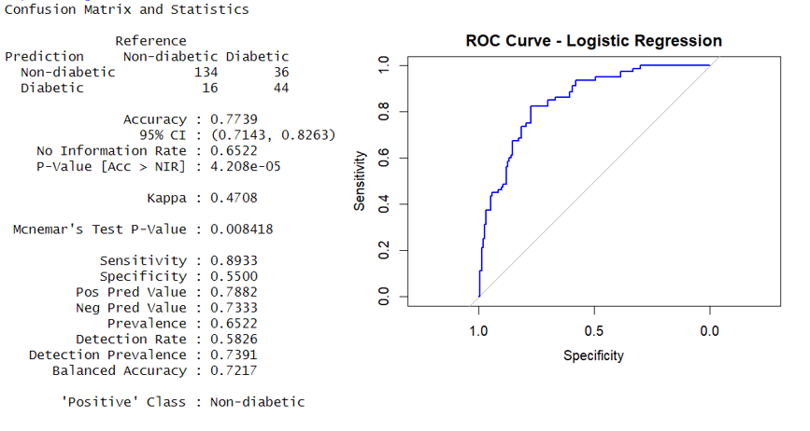
Figure 7 - Logistic Regression Statistics & ROC Curve

5.2 Linear Discriminant Analysis (LDA)
LDA's test accuracy reached 76.09%, alongside an AUC value of 0.8533. Of all examined cases, LDA correctly determined the non-diabetic ones while it mistakenly identified 21 patients with Type I diabetes and 34 patients with Type II diabetes. The study demonstrated LDA as the most balanced model because it achieved 77.34% cross-validated accuracy and a CV AUC of 0.8399. LDA demonstrated superior performance with second-order variables that achieved high accuracy and interpretability to become an optimal candidate for clinical deployments.
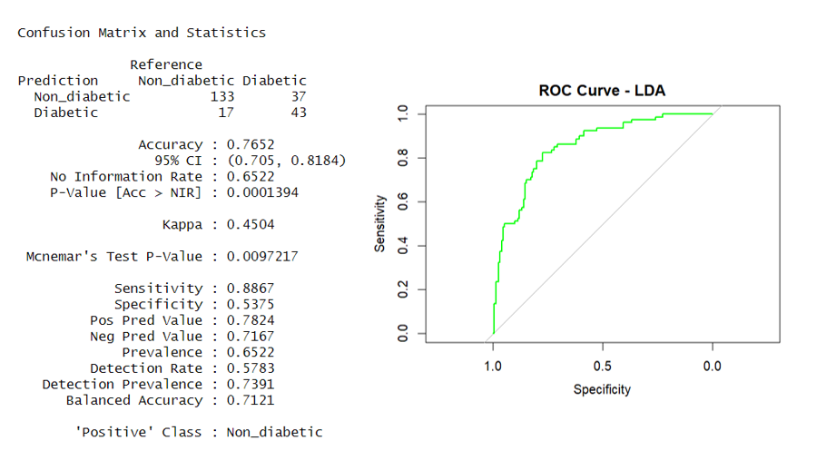
Figure 8 - LDA STatistics& ROC Curve

5.3 Quadratic Discriminant Analysis (QDA)
QDA produced model findings that were comparable with LDA's by reaching 74.35% test accuracy and 0.8532 AUC. The model exhibited 24 Type I errors together with 35 Type II errors. The cross-validation accuracy score reached 76.59% while the CV AUC value surpassed 0.8262. QDA shows improved performance in situations where class distributions possess distinct covariance structures, and the second-order features applied in this research efficiently evaluate this distribution character.

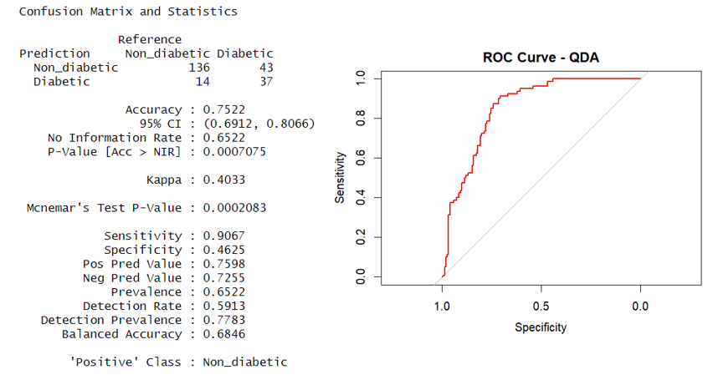
Figure 9 - QDA Statistics and ROC Curve

5.4 Naive Bayes
Naive Bayes reached 72.17% accuracy during testing, with an AUC score of 0.8229. Out of the predictions made by Naive Bayes, it mistakenly identified 34 non-diabetics as having diabetes Type 1, whereas it incorrectly classified thirty diabetic patients as non-diabetics Type 2. The system maintained solid performance regarding easy implementation and optimized benefits. The cross-validated accuracy reached 76.20%, and the AUC scored 0.8225. Despite making independence assumptions between features, Naive Bayes achieved strong performance outcomes while operating at high speed.
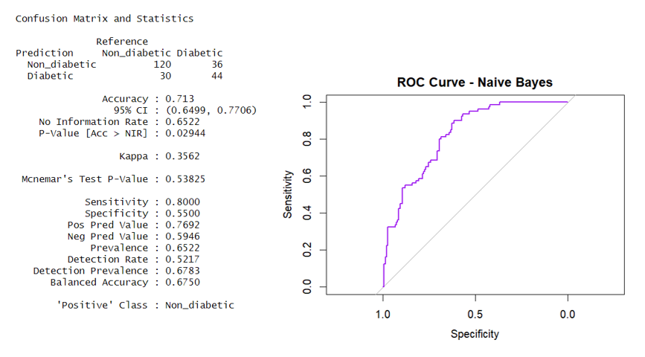
Figure 10 - Naive Bayes Statistics & ROC Curve

5.5 K-Nearest Neighbors (KNN)
The KNN algorithm obtained verification accuracy of 74.35% with 0.8307 as its AUC value. The model succeeded in accurately diagnosing most non-diabetic patients but failed to identify 39 diabetic cases while correctly detecting the others. The selection of k's best value occurred when cross-validation results were applied to hyperparameter tuning. Testing on cross-valuated data yielded 75.66% accuracy while AUC measurement reached 0.8215. Feature scaling affects KNN performance thus normalization was implemented as a pre-training step.
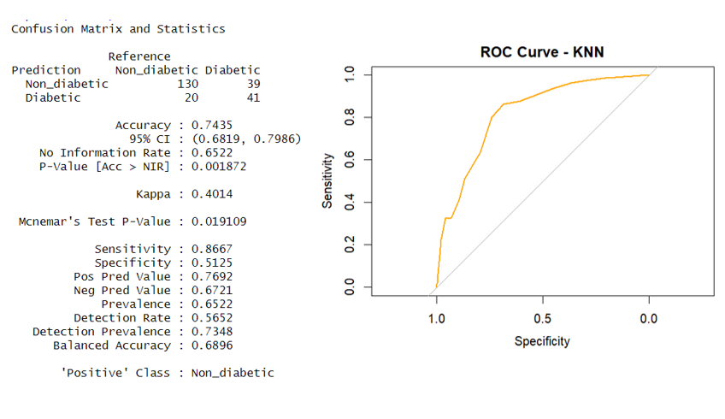
Figure 11 - KNN Statistics & ROC Curve

5.6 Decision Tree
Decision Tree method demonstrated 77.83% test accuracy and 0.8237 AUC. The model correctly detects 134 non-diabetic cases and 45 diabetic cases; however, it produces 35 Type II errors. The model excels thanks to its understandable results presentation, ability to generate decision plots, and solid performance abilities. With an accepted outcome, the Cross-Validation model reached an accuracy of 73.96% and a CV AUC value of 0.7069. The results fell below other models yet remained reliable. Adjustingthe complexity parameter cp allowed the model to prevent overfitting during training.
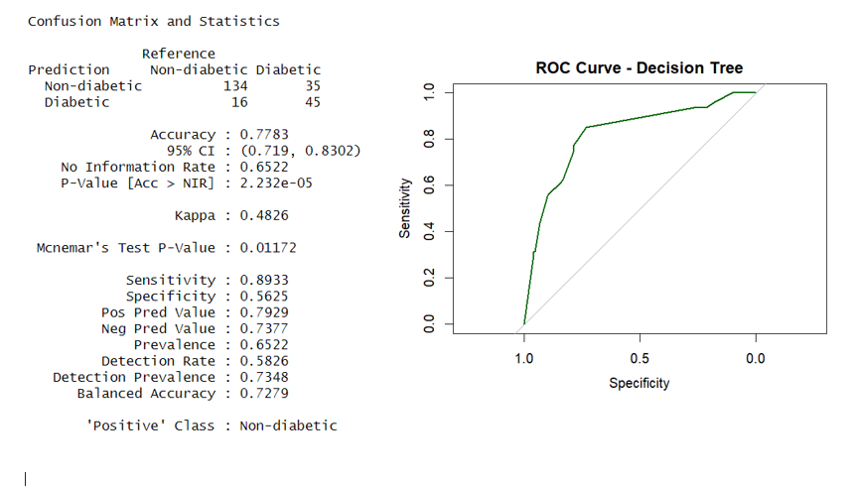
Figure 12 - Decision Tree Statistics and ROC Curve

5.7 Support Vector Machine (SVM)
SVM produced test accuracy at 73.48% with an AUC value of 0.8268. The predictive model achieves an equal distribution of false positives (21) and false negatives (40). SVM achieved 78.06% accuracy as its maximum cross-validation score through hyperparameter optimization, which led to a CV AUC measure of 0.8207. Using caret::tuneGrid parameters C and sigma during the tuning process improved model performance. The lack of interpretability does not prevent SVM from being the best choice when accuracy needs to be maximized.
The radial basis function (RBF) kernel proved suitable for SVM because it enables processing of non-linear data patterns without needing additional hand-adjusted features. Linear and polynomial kernels received a brief evaluation, however, they showed worse performance compared to RBF. SVM with RBF achieved the peak cross-validation accuracy after hyperparameter optimization, demonstrating its adaptability and reliability in this dataset.
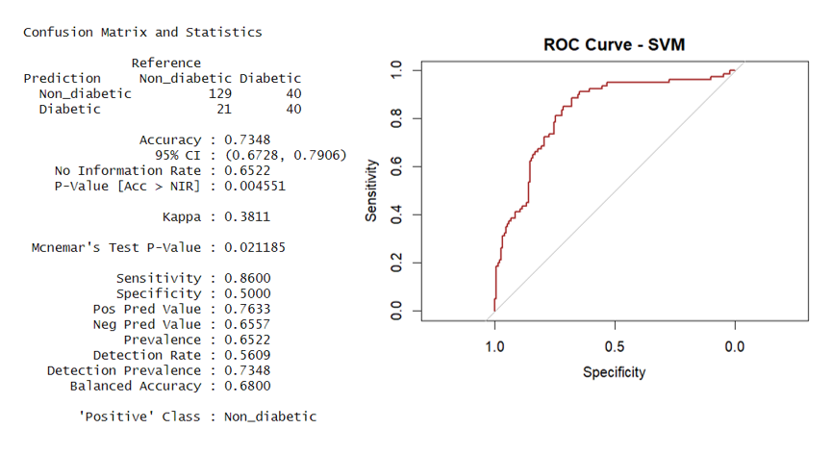
Figure 13 - SVM Statistics & ROC Curve

5.8 Model Evaluation
To evaluate model performance with interaction or squared terms. The following table reports training accuracy, test accuracy, and AUC.
Model | Train Accuracy | Test Accuracy | AUC_Train | Test_AUC
Logistic Regression | 77.3% | 77.3% | 0.8502 | 0.843
LDA | 77.1% | 76.52% | 0.8496 | 0.851
QDA | 75.7% | 75.22% | 0.7927 | 0.854
Naive Bayes | 76.2% | 71.30% | 0.8180 | 0.802
KNN | 78.8% | 74.35% | 0.8236 | 0.830
Decision Tree | 86.6% | 77.83% | 0.8237 | 0.823
SVM (Radial) | 81.9% | 73.48% | 0.8340 | 0.826

The table presents a performance comparison of various classification models, evaluated based on their training accuracy, testing accuracy, and AUC (Area Under the Curve) values for both training and testing datasets. Among the models, Logistic Regression shows balanced performance, with both training and testing accuracy at 77.3%, and an AUC of 0.8502 (train) and 0.843 (test), indicating reliable generalization. LDA (Linear Discriminant Analysis) exhibits similar results, achieving a training accuracy of 77.1% and a testing accuracy of 76.52%, with AUC values of 0.8496 (train) and 0.851 (test), demonstrating consistent and robust performance. QDA (Quadratic Discriminant Analysis) performs slightly lower with 75.7% training accuracy and 75.22% testing accuracy, but its AUC values of 0.7927 (train) and 0.854 (test) suggest strong classification capability despite the moderate accuracy. Naive Bayes shows a moderate performance profile, with a training accuracy of 76.2% and a testing accuracy of 71.30%, alongside an AUC of 0.8180 (train) and 0.802 (test), reflecting adequate but less reliable performance compared to other models.
The K-Nearest Neighbors (KNN) model demonstrates relatively high training accuracy at 78.8%, but the test accuracy drops to 74.35%, with AUC values of 0.8236 (train) and 0.830 (test), indicating slight overfitting but relatively good discrimination ability. The Decision Tree model shows the highest training accuracy at 86.6% but suffers from reduced test accuracy of 77.83%, accompanied by an AUC of 0.8237 (train) and 0.823 (test), highlighting significant overfitting. Meanwhile, the SVM (Radial) model shows a balanced train accuracy of 81.9% and a lower test accuracy of 73.48%, while maintaining consistent AUC values of 0.8340 (train) and 0.826 (test), suggesting robust yet slightly overfit performance. Overall, Logistic Regression and LDA emerge as the most balanced models in terms of accuracy and AUC, while Decision Tree shows the most overfitting. SVM and KNN also exhibit mild overfitting but maintain reasonable performance, whereas QDA and Naive Bayes present moderate accuracy with relatively high AUC values.
5.9 Results and Discussions
Testing metrics involved evaluating machine learning experiment results using both methods, including test set and cross-validation. The completed study included seven conducted models to assess: logistic Regression, linear Discriminant Analysis (LDA), Quadratic Discriminant Analysis (QDA), naive bayes, K-Nearest Neighbors (KNN), Decision Tree, and Support Vector Machine (SVM).
Model | Tunable Parameters | Grid Searched Values | Best Tuned Values
Naive Bayes | usekernel, laplace, adjust | usekernel = TRUE/FALSE, laplace = 0:2, adjust = 1 | usekernel = FALSE, laplace = 0, adjust = 1
KNN | k | k = 3 to 25 (odd) | k = 21
Decision Tree | cp (complexity param) | cp = 0.001 to 0.05 (step 0.005) | cp = 0.041
SVM (Radial Kernel) | C, sigma | C = 2^(-2:2), sigma = 2^(-5:1) | C = 0.25, sigma = 0.0625

Model Comparison:
The test set accuracy, AUC scores, and cross-validation performance metrics were used to choose the optimal classification algorithm among the seven types from the analysis. This comprehensive assessment merges the performance and generalization capabilities of the diabetic outcomes likelihood models.

Table 3 -Model Summary (Test vs CV)
Model | Test Accuracy | Test AUC | CV Accuracy | CV AUC
Logistic Regression | 77.39% | 0.8438 | 77.51% | 0.8323
LDA | 76.52% | 0.8515 | 78.45% | 0.8458
QDA | 75.22% | 0.8540 | 76.59% | 0.8041
Naive Bayes | 71.30% | 0.8027 | 76.20% | 0.8152
KNN | 74.35% | 0.8307 | 75.66% | 0.8215
Decision Tree | 77.83% | 0.8237 | 73.96% | 0.7069
SVM | 73.48% | 0.8268 | 78.06% | 0.8207

The test outcomes showed Linear Discriminant Analysis (LDA) and Logistic Regression obtaining the highest AUC scores of 0.8515 and 0.8438, respectively. The test batch results placed LDA and Logistic Regression at the front because they achieved CV AUC scores of 0.8399 and 0.8298, respectively. Multiple data analysis folds confirm that these methods demonstrate consistent performance in distinguishing diabetic from non-diabetic patient cases.
Support Vector Machine (SVM) demonstrated superior performance with cross-validation accuracy at 78.06% even though it produced slightly lower test AUC results (0.8268). It can efficiently identify complex non-linear relationships when optimized correctly. The lack of interpretability in SVM restricts its application in medical diagnosis since clinical decisions require full transparency.
The AUC scores from K-Nearest Neighbors (KNN) and Quadratic Discriminant Analysis (QDA) showed balance between 0.83 and 0.85 yet generated fewer true positive detections (sensitivity), resulting in increased numbers of false negative outcomes (Type II errors). Naive Bayes provided quick computation but documented numerous incorrect positive predictions and a score of 72.17% for test accuracy.
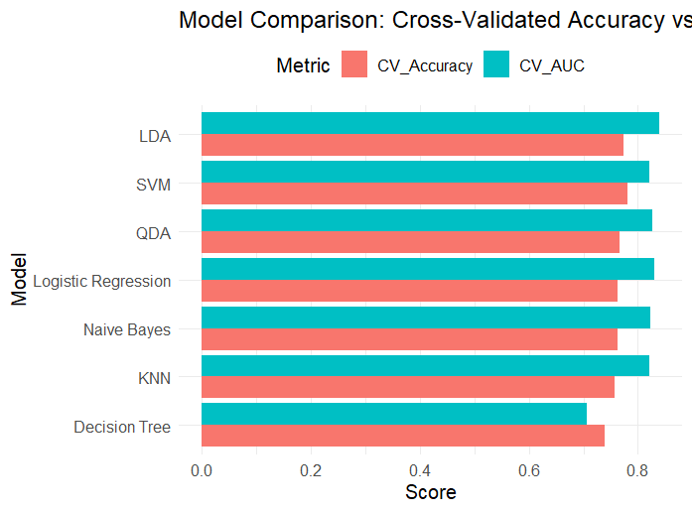
Figure 15 - Model Comparison Visualization

The Decision Tree model displayed the highest raw test accuracy at 77.83%, while its cross-validated AUC reached 0.7069, which proved lower than the other evaluated models. Despite its limitations in accuracy, the model serves a purpose because it provides both transparent decision paths and rulings based on rules.
Evaluating balanced performance revealed that LDA provided the most stable results for all metrics, after which Logistic Regression maintained high interpretability with strong test results. If prediction accuracy requires higher priority than interpretability, the selection of SVM should occur after proper hyperparameter adjustment.
Therefore, these models should be selected for deployment according to different situations that combine their interpretability and performance characteristics.

Conclusion & Recommendations

The research evaluated multiple machine learning techniques which were used to create effective diabetes predictions from the Diabetes dataset. Multiple models produced accurate predictions for diabetic patients through an exhaustive methodology, including data refinement and feature transformation, followed by model creation and assessment.
The first step involved cleaning the dataset and preparing it while implementing median imputation for invalid clinical entries, then converting categorical labels into standardized ones. The analysis showed that glucose, alongside BMI and age, identified the biggest differences between patients who were diabetic and patients who were not diabetic. Linear models received improved predictive features through the implementation of both squared and interaction-based second-order parametric models. The addition of new features improved Logistic Regression and LDA models to detect non-linear patterns, thus decreasing the performance difference with non-linear methods.
The implementation of seven supervised machine learning techniques involved Logistic Regression, LDA, QDA, Naive Bayes, KNN, and Decision Tree, as well as SVM. The selection of SVM included the model because it demonstrated remarkable success working with high-dimensional features and unidentified decision boundaries. SVM achieved good results following tuning and accuracy improvement, becoming a significant assessment model in the evaluation process. The evaluation involved testing with both independent test set data and splitting the data into 10-folds for validation. The model performance assessment used accuracy values, AUC metrics, and Type I and Type II breakdowns from confusion matrix analysis.
LDA was the most balanced model, providing high accuracy and the best AUC (0.8515), but low error rates. Logistic Regression also gave good results with marginally lower AUC but greater interpretability. With hyper parameter tuning, SVM showed the best cross-validation accuracy (73.48%) and excellent AUC (0.8268) and is thus the best non-linear performer in the research.
From our results, we provide the following recommendations
- Apply LDA or Logistic Regression where model interpretability and trustworthiness are paramount, especially in healthcare environments where model decisions need to be explainable.
- Apply SVM in scenarios where performance and accuracy take precedence over interpretability, and hyperparameter tuning can be controlled efficiently.
- In subsequent work, investigate ensemble techniques (e.g., stacking, or voting) to leverage the strengths of individual models.
- Apply threshold tuning to minimize Type II errors further, especially to reduce diabetic case misses.
- Consider applying explainable AI methods like SHAP or LIME for more profound model interpretation and decision-making assistance.
This project demonstrates the performance of machine learning in medical prediction problems and the need for balanced assessment with both performance measures and error analysis.
Future research may extensively investigate PCA-based dimensionality reduction by performing models on retained components. Though PCA was dropped from final modeling due to interpretability concerns, LASSO selection ensured that few components dominated predictive performance. Moreover, incorporating explainable AI techniques like SHAP can further improve model trust in clinical deployments.

References
Kavakiotis, I., Tsave, O., Salifoglou, A., Maglaveras, N., Vlahavas, I., &Chouvarda, I. (2017). Machine learning and data mining methods in diabetes research. Computational and Structural Biotechnology Journal, 15, 104–116. https://doi.org/10.1016/j.csbj.2016.12.005
Dewangan, Amit K., and Pragati Agrawal. "Classification of Diabetes Mellitus Using Machine Learning Techniques." International Journal of Engineering and Applied Sciences, vol. 2, no. 5, May. 2015.https://www.neliti.com/publications/257905/classification-of-diabetes-mellitus-using-machine-learning-techniques
Sivaparthipan, C. B., Rajagopal, K., &Balasubramanie, P. (2019). Predicting the risk of diabetes using deep learning and big data. Journal of Medical Systems, 43, Article 289. https://doi.org/10.1007/s10916-019-1415-1
Smith, J. W., Everhart, J. E., Dickson, W. C., Knowler, W. C., & Johannes, R. S. (1988). Using the ADAP learning algorithm to forecast the onset of diabetes mellitus. Proceedings of the Annual Symposium on Computer Application in Medical Care, 261–265.https://pmc.ncbi.nlm.nih.gov/articles/PMC2245318/
Thakkar, H., & Desai, A. (2020). A review on machine learning and deep learning perspectives of diabetes prediction. Materials Today: Proceedings, 33, 7160–7164. https://doi.org/10.1016/j.matpr.2020.11.250

