MATH 7635/8635
ADVANCED STATISTICAL ANALYSIS I PROJECT
REPORT, SPRING 2024

Predicting Air Quality Index

By
Ritheesha Rajannagari (U00917163)
Rohith Boddu (U00927888)

INTRODUCTION
Air quality is a critical environmental concern that greatly impacts human health and ecosystem well-being. Accurate prediction of the Air Quality Index (AQI) is crucial for issuing timely warnings and implementing effective intervention strategies. This study aims to harness the power of machine learning techniques to improve the prediction accuracy of AQI based on environmental data. The research focuses on comparing the efficacy of multiple regression models, including K-Nearest Neighbors (KNN), Ridge regression, and Lasso regression, in predicting AQI values. By identifying the key influencing factors and optimizing the predictive models, this study contributes to the development of robust AQI forecasting systems, enabling proactive measures to mitigate the adverse effects of air pollution on public health and the environment.

MOTIVATION
Accurate prediction of the Air Quality Index (AQI) using machine learning techniques holds immense significance across multiple domains. From a public health perspective, it enables timely warnings and proactive measures to safeguard vulnerable populations from the adverse effects of air pollution. Environmentally, precise AQI predictions contribute to effective monitoring and control of air quality, aiding in conservation efforts. Data-driven insights derived from predictive models assist policymakers in formulating targeted regulations and optimizing resource allocation to reduce pollution sources. Moreover, the application of advanced machine learning techniques to environmental data fosters technological advancement and innovation in pollution management. Lastly, enhanced accuracy in AQI predictions raises community awareness, empowering individuals to make informed decisions and adopt eco-friendly practices, ultimately promoting a cleaner and healthier environment for all.

STAKEHOLDER
The accurate prediction of Air Quality Index (AQI) using machine learning techniques involves and benefits various stakeholders:

- Government Agencies: Environmental protection agencies, health departments, and regulatory bodies rely on accurate AQI predictions to develop and enforce air quality standards, allocate resources, and implement pollution control measures.

- Healthcare Providers: Hospitals, clinics, and healthcare professionals utilize AQI predictions to prepare for potential surges in pollution-related illnesses, allocate medical resources, and provide timely advice to patients, especially those with respiratory conditions.

- Research Institutions: Universities, research centers, and scientific organizations benefit from advanced AQI prediction models to further their understanding of air pollution dynamics, develop innovative pollution mitigation strategies, and contribute to the body of knowledge in environmental science.

- Industry Stakeholders: Companies and businesses across various sectors, such as transportation, energy, and manufacturing, have a vested interest in AQI predictions. Accurate forecasts help them comply with emissions regulations, optimize operations to minimize pollution, and demonstrate environmental responsibility.

- Local Communities: Residents, community organizations, and advocacy groups rely on AQI predictions to stay informed about air quality conditions, protect their health, and engage in public discussions on pollution control measures and environmental justice.

- Media and Communication Channels: News outlets, weather forecasting services, and social media platforms play a crucial role in disseminating AQI predictions and related information to the public, raising awareness and facilitating discussions on air quality issues.

PROBLEM DESCRIPTION
- Goal
Our project is centered around the use of advanced predictive models to accurately forecast the Air Quality Index (AQI) utilizing a dataset enriched with environmental variables. We aim to develop and refine multiple regression models, specifically Ridge and Lasso, to not only predict AQI values but also to identify and quantify the influence of various pollutants and environmental conditions on air quality. By dissecting the relationships between AQI and contributing factors such as pollutant concentrations, meteorological data, and urban activities, this project goes beyond simple prediction; it seeks to provide a deep understanding of the dynamics influencing air quality. This insight is pivotal for developing targeted interventions that can significantly enhance air quality management.

- Objectives
The primary goal is to construct predictive models capable of forecasting AQI by analyzing a range of environmental indicators like pollutant levels, weather conditions, and urban factors. We intend to pinpoint the most critical factors affecting air quality, thereby providing a clear indication of primary pollutants and conditions to target for air quality improvement initiatives. Additionally, this project aims to explore the complex interplay between these variables and air quality, offering a detailed perspective that could inform policy decisions, public health advisories, and community awareness programs. Ultimately, by identifying the key drivers of air quality degradation, stakeholders can better strategize interventions and enhance overall environmental health.

- Type of Problem
This is a regression problem because our objective is to predict a continuous dependent variable — the AQI — based on a set of independent variables. By employing regression techniques, including Ridge and Lasso, we aim to establish a quantitative relationship between the AQI and a variety of environmental factors. These regression models enable us to explore how different variables like pollutants and weather conditions quantitatively impact air quality, allowing for accurate predictions and insightful analyses that can guide effective pollution control and policy formulation.

VARIABLES
Our dataset comprises 29,531 observations across 16 variables, capturing a comprehensive range of environmental pollutants and conditions from multiple cities on a daily basis. The key measurements include particulate matter (PM2.5 and PM10), nitrogen oxides (NO, NO2, NOx), ammonia (NH3), carbon monoxide (CO), sulfur dioxide (SO2), ozone (O3), and volatile organic compounds such as benzene and toluene. Each of these predictors is quantitative, providing a robust foundation for our regression analysis. Despite the presence of missing values, particularly in PM2.5 and NH3, and the retention of outliers to accurately reflect extreme pollution events, our dataset remains robust for modeling. The target variable is the Air Quality Index (AQI), which is treated as a continuous variable indicating varying levels of air quality from clean to hazardous. The exploratory data analysis indicates that while Toluene and AQI exhibit the highest Variance Inflation Factors (VIFs), suggesting potential as key predictors, multicollinearity overall does not pose a significant issue, with no variables exceeding a VIF threshold of 5. The distribution of AQI shows a skew towards lower values with a long tail towards higher values, indicating a non-normal distribution and highlighting the complexity of predicting extreme air quality events.

OVERVIEW OF DATA
The dataset utilized in this study encompasses daily air quality measurements from multiple cities, reflecting diverse environmental conditions and pollution levels. Detailed data on pollutants such as PM2.5, PM10, NOx, CO, SO2, O3, benzene, and toluene forms the core of our analysis. The comprehensive dataset, which includes 29,531 rows and 16 variables, captures trends over time and facilitates a robust examination of factors influencing air quality. Notably, the dataset includes missing values, especially in key pollutants like PM2.5 and NH3, and outliers are present, which have been retained to accurately depict extreme pollution events. All predictors are quantitative, and factors like Toluene and AQI, despite showing high Variance Inflation Factors, do not exceed the multicollinearity threshold, making them viable for inclusion in our regression models. The full dataset can be accessed through the link provided in Appendix IV. For detailed descriptions and a complete list of all variables used in the dataset, refer to Appendix VI. This structured and comprehensive dataset forms the backbone of our analysis, enabling the application of advanced machine learning techniques to predict AQI and understand the dynamics of air quality variation.

THE TARGET VARIABLE
The target variable in this study is the Air Quality Index (AQI), which quantitatively measures the overall air quality within a range from clean to hazardous conditions. The AQI is calculated based on the concentrations of several major air pollutants, including particulate matter (PM2.5 and PM10), nitrogen oxides (NOx), sulfur dioxide (SO2), carbon monoxide (CO), and ozone (O3). The dataset contains 24,850 non-null entries for AQI, demonstrating its comprehensive coverage across various environmental settings.

mean | sd | min | 25th percentile | median | 75th percentile | max
166.46 | 140.70 | 13 | 81 | 118 | 208 | 2,049
Table 1: Summary statistics for the target variable

Histogram of Target Variable
Figure 1 displays the histogram of the standardized Air Quality Index (AQI), offering critical insights into the distribution's characteristics. The histogram, overlaid with a bell curve for reference, highlights the deviation from a normal distribution, evident from the skewed shape and the long tail extending towards higher values. The central red dashed line marks the mean of the standardized AQI, emphasizing the central tendency around which the data clusters. The histogram reveals a significant skew towards the lower end of the AQI scale, suggesting that most of the air quality measurements are on the cleaner side, yet there are notable occurrences of extremely poor air quality, as indicated by the tail. This skewness is crucial for understanding the distribution of air quality conditions across different regions and times. The peak near the mean suggests a concentration of data points around more moderate AQI values, while the spread and tail indicate variability and the presence of extreme pollution events.

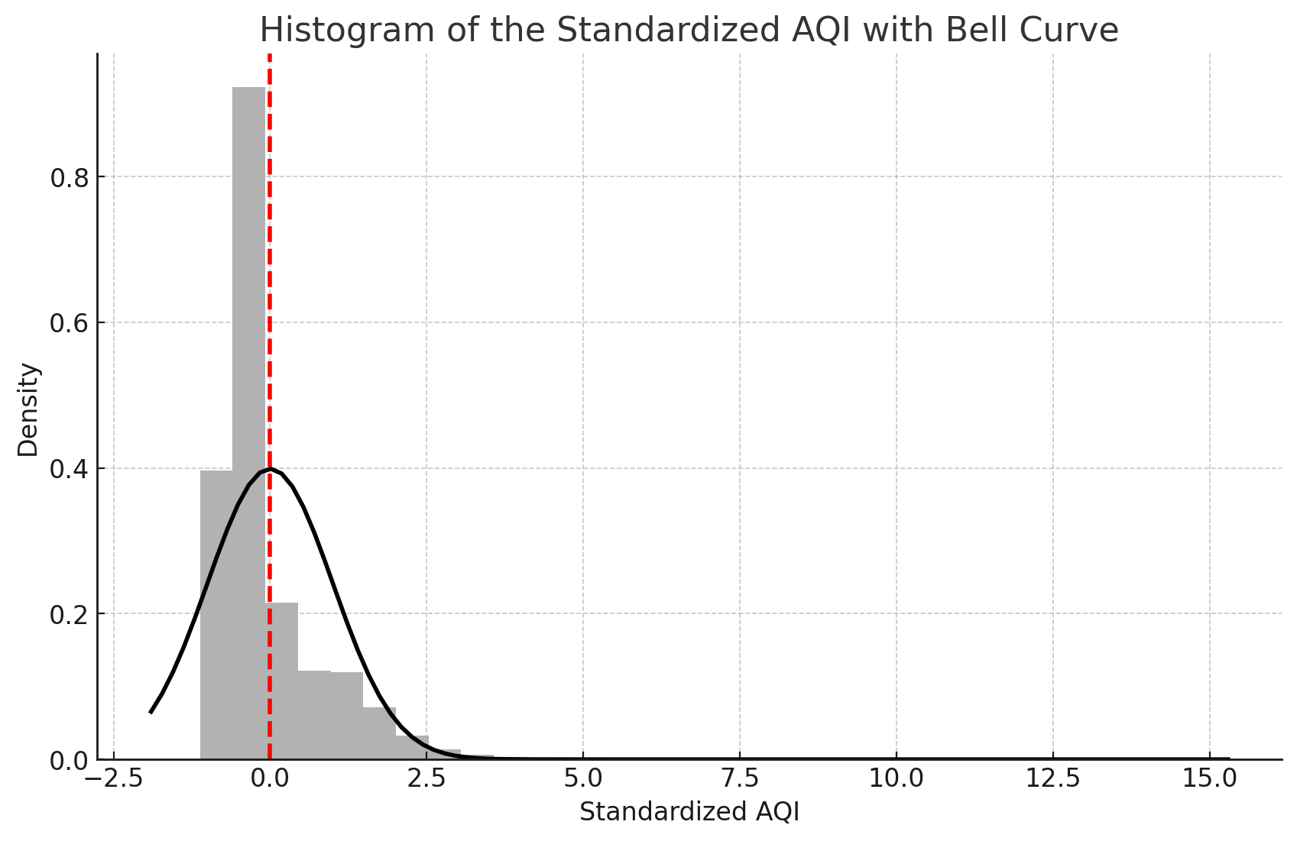
Figure 1: Histogram of response variable AQI

Boxplots for Quantitative Variables
Figure 2 presents boxplots for each quantitative variable in our dataset, including pollutants like PM2.5, PM10, NOx, CO, SO2, O3, benzene, toluene, and the AQI itself. These boxplots are instrumental in visualizing the distribution, variability, and presence of outliers for each variable. The boxplots reveal a consistent presence of outliers across almost all pollutants, indicating extreme pollution events that are significantly higher than typical values. Notably, many variables exhibit a right-skewed distribution, where the median is closer to the lower quartile, suggesting a concentration of lower values with sporadic high values. This visual representation helps in identifying which pollutants frequently reach concerning levels and may require more targeted regulatory actions. The analysis of these boxplots is crucial for understanding the spread and central tendencies of the environmental data, which in turn aids in refining the predictive models for AQI.

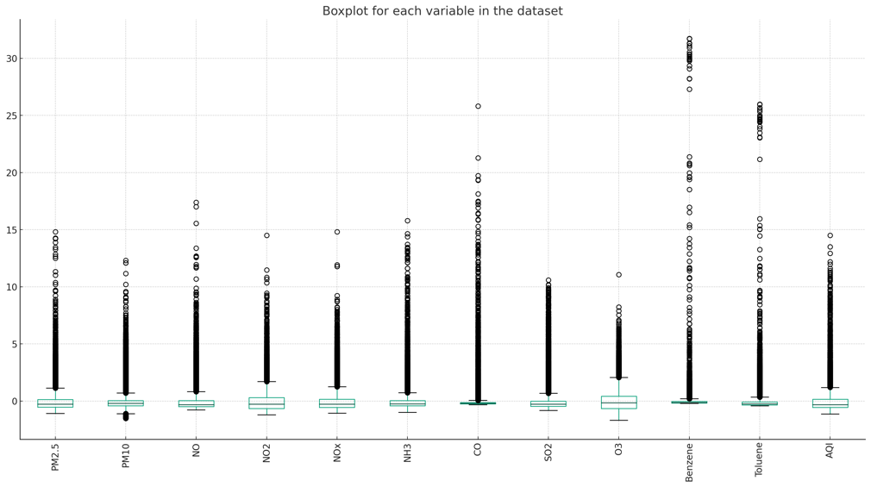
Figure 2: Boxplots of Target Variable Vs. Other Variables

4.1.4 Variance Inflation Factor (VIF) for Each Feature
Figure 3 illustrates the Variance Inflation Factor (VIF) for each quantitative feature in our dataset, providing insight into the level of multicollinearity among the predictors used in modeling the Air Quality Index (AQI). VIF is a crucial statistic that helps identify the degree to which the variance of an estimated regression coefficient increases due to collinearity. VIF values above 5 typically indicate a problematic level of multicollinearity, which can undermine the statistical validity of a regression model.

From the chart, it is evident that most features have VIF values well below the threshold of 5, suggesting that multicollinearity is not a major concern for these variables. Notably, PM2.5, PM10, NO, NO2, NOx, NH3, CO, SO2, and O3 all show moderate VIF values, indicating that while they are somewhat correlated, they do not critically inflate the variance of each other’s coefficients in the predictive model.

However, Toluene and AQI exhibit relatively higher VIF values, with Toluene approaching the threshold. This suggests that Toluene and possibly AQI could be influencing the model’s stability more than other variables. The elevated VIF for Toluene indicates it shares a significant amount of linear association with one or more predictors, which might warrant further analysis or potential remediation strategies such as variable transformation or removal from some model iterations to test impact on model performance.

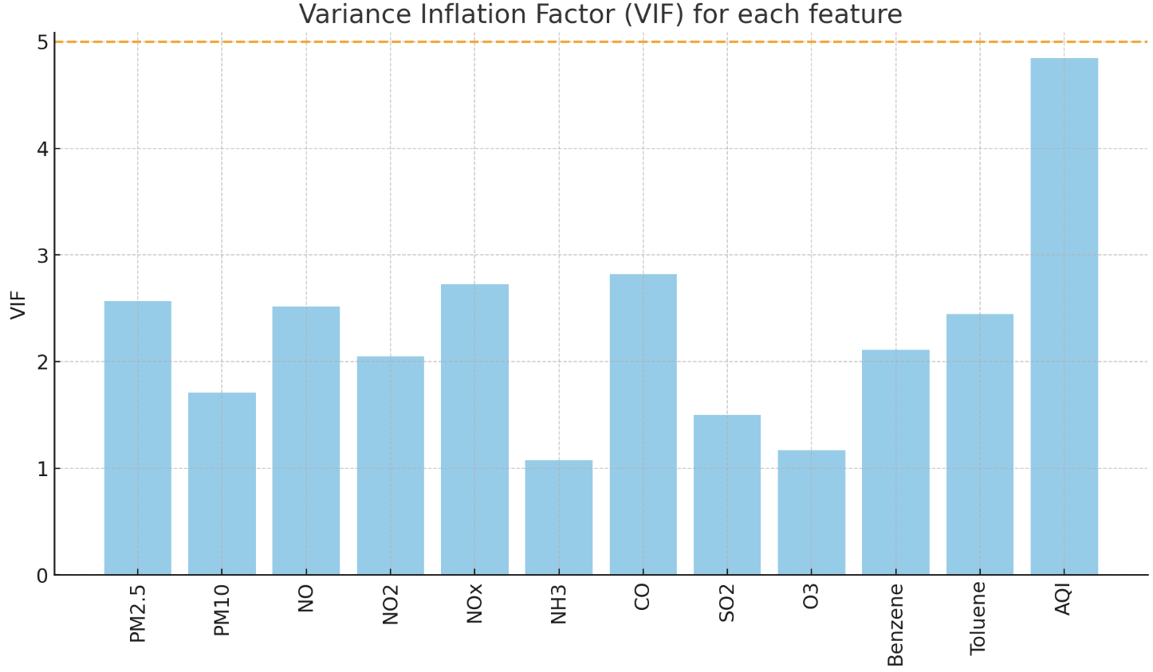
Figure 3: Variance Inflation Factor (VIF) for Each Feature

THE MODELS
Three distinct models were developed in order to evaluate their performance with regard to our dataset. Before creating any of the models, we made sure the data was prepared and sanitized.

Dataset Preparation
For the study of predictive modeling using Lasso, Ridge, and KNN regression techniques to forecast the Air Quality Index (AQI), meticulous dataset preparation was crucial. The city_day.csv dataset, comprising daily air quality measurements across multiple cities, was initially loaded, and cleansed of unnecessary columns such as 'City', 'Date', and 'Xylene', which were not deemed significant for the analysis. Additionally, any records with missing values were omitted to ensure the integrity and accuracy of the models.

A consistent seed was set using set.seed(123) to ensure reproducibility of the results across different runs of the analysis. The dataset was then split into a training set, which included 80% of the data, and a testing set comprising the remaining 20%. This split was facilitated by the createDataPartition function from the caret package, which stratifies the data based on the AQI to maintain a consistent distribution of air quality conditions in both subsets.

The training data underwent further preprocessing where it was centered and scaled using the preProcess function, ensuring that all features contributed equally to the model without bias due to differing scales. This transformation was also applied to the testing set, aligning it with the training set’s scale for accurate performance evaluation during model testing. This meticulous dataset preparation was foundational for the subsequent modeling and analysis, setting the stage for robust and reliable predictive modeling.

KNN Regression
In our study, the K-Nearest Neighbors (KNN) regression model was specifically selected for its adeptness in handling non-linear distributions, which aligns well with the non-normal distribution of the Air Quality Index (AQI) observed in our data. To identify the optimal number of neighbors (k), we employed a 10-fold cross-validation technique. This method not only helps in preventing data leakage but also ensures that the model is not overly fitted to the training dataset. The results of this procedure, as illustrated in Figure 4, showed that k=5 was the optimal parameter, achieving the highest R-squared value of approximately 0.923 before it began to decline with increasing k values. This peak indicates a strong balance between bias and variance, optimizing the model’s predictive accuracy.

The KNN model was then trained using 80% of the dataset, with the remaining 20% serving as the test set to evaluate the model's performance. Assessment metrics revealed a notable high R-squared value on the training set, suggesting that the model captures a significant proportion of variance in the data and thus provides a strong fit. However, the Root Mean Square Error (RMSE) on the test set was significantly higher than on the training set, indicating potential overfitting despite the model’s high explanatory power. The Mean Absolute Error (MAE) further corroborated the accuracy of the model, ensuring minimal large individual prediction errors.

This diagnostic evaluation of the KNN model underscores its effectiveness in navigating the complex, non-linear relationships within the AQI data. However, it also highlights the necessity for careful model complexity management to mitigate the risk of overfitting. These insights are crucial as they guide further refinements and optimizations in our predictive modeling efforts, enhancing the robustness and applicability of the model in real-world scenarios.
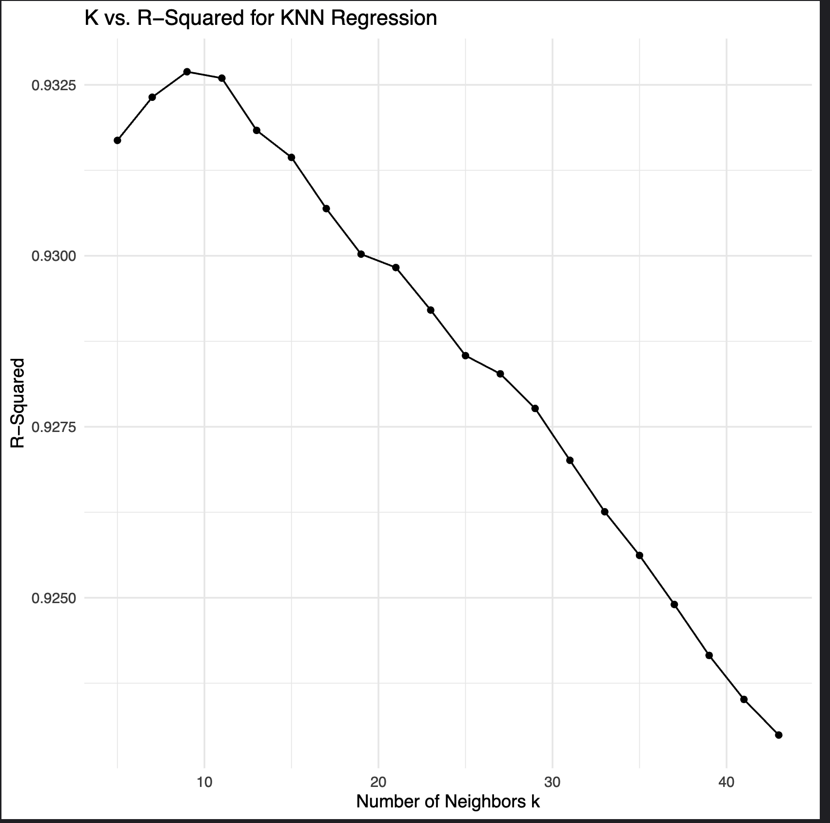
Figure 4: K vs. R-Squared for KNN Regression

Ridge Regression
The Ridge regression model was selected for its ability to handle multicollinearity among predictors by imposing a penalty on the size of coefficients. This method reduces the model complexity, which is especially beneficial in our dataset where predictors such as NO, NH3, and benzene show potential multicollinearity. Ridge regression works by adding a squared magnitude of coefficient as penalty term to the loss function, controlled by the lambda (λ) parameter. After rigorous cross-validation with 5 folds to determine the optimal lambda value, λ was set at 0.05, balancing bias and variance effectively.

The Ridge Model
The Ridge model was trained using 80% of the dataset, designated as the training set, with the remaining 20% used for testing. This split ensures that the model is tested on unseen data, providing a reliable estimate of its performance. The model achieved an R-squared of 0.796 on the training set and 0.774 on the test set, indicating a strong ability to explain the variability in AQI from the predictors. The Mean Absolute Error (MAE) on the test set was slightly higher than on the training set, highlighting a good generalization of the model to new data.

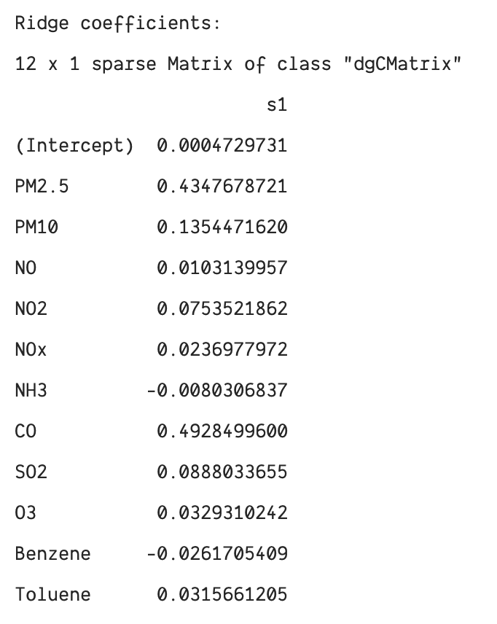
Figure 5: Estimated coefficients form the Ridge model
This figure displays the estimated coefficients obtained from the Ridge regression model. Notably, PM2.5 and CO have the highest positive coefficients, indicating a strong positive influence on the AQI, while NH3 shows a small negative effect.

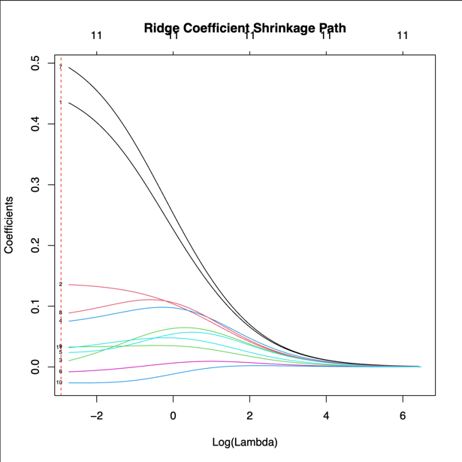
Figure 6: The Ridge Coefficients Shrinkage Plot (Ridge Trace)

The Ridge Trace plot illustrates how each coefficient's value changes as the penalty term λ increases. The vertical red dashed line represents the chosen optimal λ (0.05), where the balance between bias reduction and variance inflation is achieved. This plot is crucial for visualizing the impact of regularization on the coefficients, particularly how higher penalties shrink the coefficients towards zero, reducing the risk of overfitting while maintaining model simplicity and robustness.

Lasso Regression
Lasso regression, known for its ability to perform variable selection and regularization to enhance the prediction accuracy, was employed in our study to predict the Air Quality Index (AQI). By applying an L1 penalty to reduce the coefficients of less important variables to zero, Lasso helps in identifying the most significant predictors of AQI. This technique not only simplifies the model by eliminating non-influential predictors but also helps in dealing with multicollinearity and overfitting.

The Lasso Model
The Lasso model was calibrated using an 80% training split of the dataset, with the remaining 20% serving as the test set. To determine the optimal penalty parameter, λ, a 5-fold cross-validation was conducted, resulting in an optimal λ of 0.002477076. This value strikes a balance by minimizing the Mean Squared Error (MSE) while retaining the predictive power of significant variables.

The shrinkage path figure illustrates how the coefficients of the predictors vary with different values of λ. As λ increases, less significant coefficients shrink towards zero, which is indicative of Lasso’s capability to perform feature selection. The vertical red dashed line in the plot indicates the selected optimal λ, beyond which most insignificant predictors are zeroed out.

The resulting coefficients from the Lasso model highlight the variables that most significantly affect AQI. PM2.5 and CO are prominent predictors with the highest positive coefficients, indicating a strong influence on AQI. In contrast, NH3 and Benzene have negative coefficients, suggesting their inverse relationship with AQI under the model's structure.

The performance metrics of the Lasso model further substantiates its efficacy. The model achieved an R-squared of 0.798655 on the training dataset and 0.772711 on the test dataset, demonstrating a strong ability to explain the variance in AQI. Additionally, the Mean Absolute Error (MAE) indicates the model's accuracy in predicting AQI on unseen data, with values close between training and testing phases.

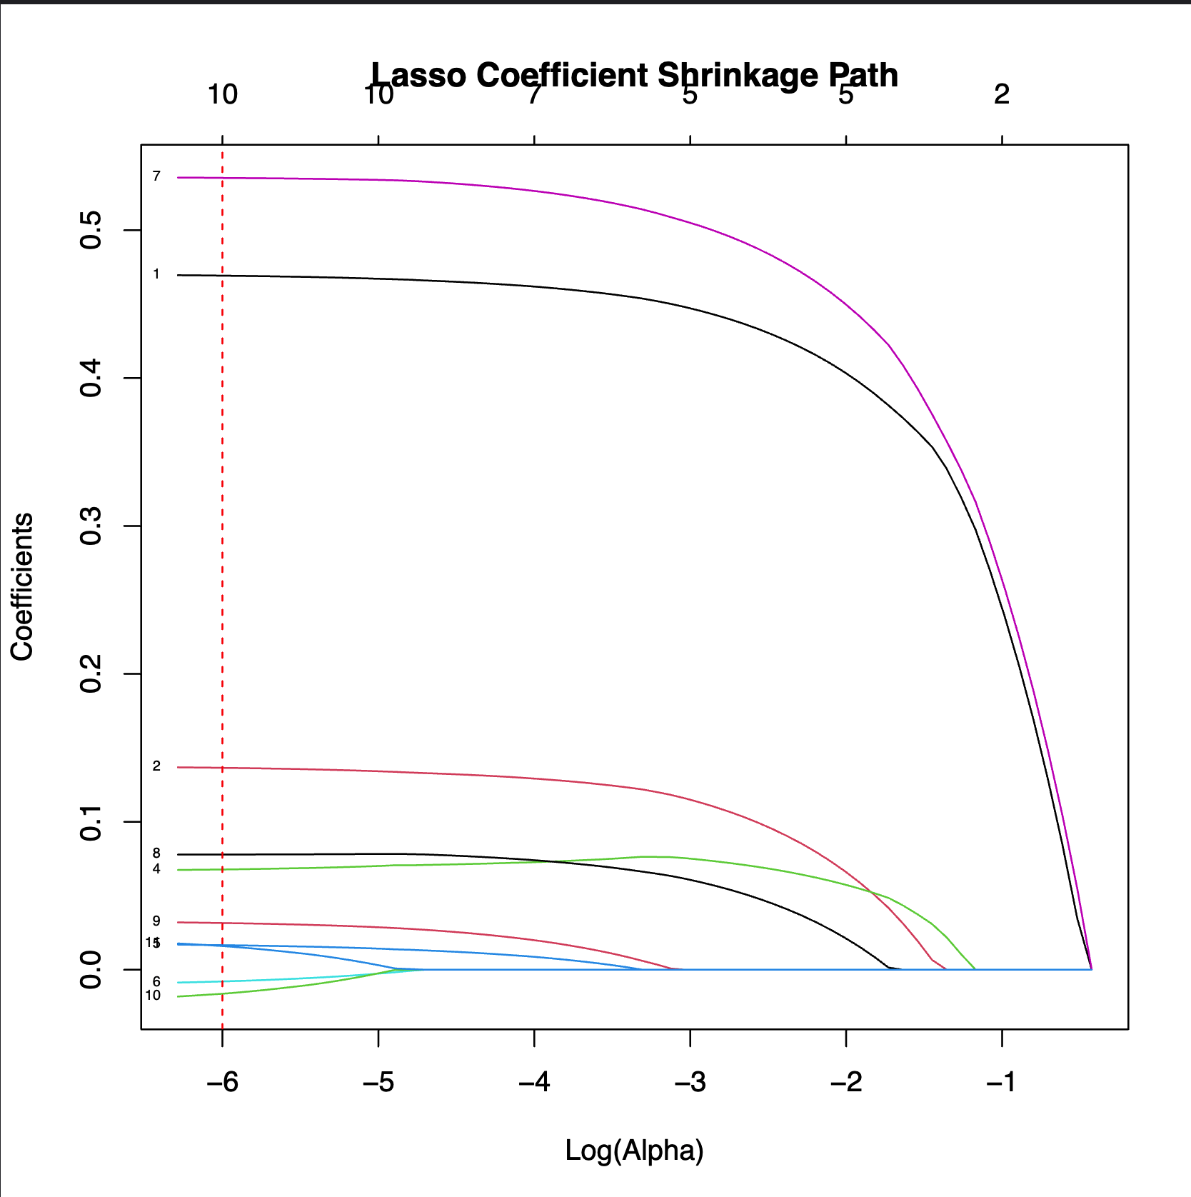
Figure 7: Lasso Coefficient Shrinkage Path

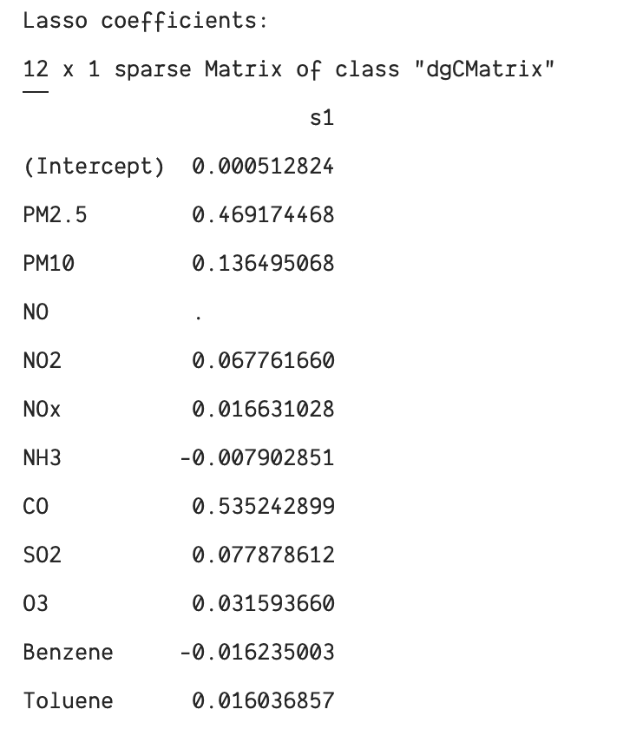
Figure 8: Estimated Coefficients from the Lasso Model

EVALUATION & RESULTS
The comprehensive evaluation of KNN, Ridge, and Lasso regression models against the Air Quality Index (AQI) forecasting task revealed distinct strengths and areas for improvement within each approach. KNN Regression exhibited the highest R-Squared value of 0.923, suggesting a strong ability to capture the variance in AQI data, though its higher RMSE on the test set indicated potential overfitting. Ridge Regression showed remarkable consistency across both training and testing datasets, achieving R-Squared values of 0.796 and 0.774 respectively, which highlighted its robustness and ability to generalize well due to its regularization technique that helps manage multicollinearity among predictors. Lasso Regression performed comparably, with R-Squared values near 0.799 and 0.773 on the training and test sets respectively, and demonstrated its utility in feature selection, identifying key pollutants impacting air quality which enhances model interpretability and usefulness for policymaking. Both Ridge and Lasso's performances, reflected through closely matched MAE values on the test datasets, underscored their precision in predictions and their effectiveness in handling different aspects of model accuracy and error minimization. These results collectively illustrate the importance of model selection tailored to specific data characteristics and predictive needs in environmental studies, where the correct model choice can significantly influence the success of air quality management strategies.

DISCUSSION/FUTURE WORK
Our investigation into predicting the Air Quality Index (AQI) using various regression models has yielded insightful results.
- The KNN regression model demonstrated a strong fit to the data, capturing the nuances of air quality effectively. Ridge regression, while slightly less precise, showed good generalization capabilities between training and testing scenarios, suggesting its robustness across different data subsets. Lasso regression, comparable in performance to Ridge, offered the additional advantage of feature selection. This attribute of Lasso regression is particularly beneficial as it helps in identifying key pollutants and conditions that significantly impact AQI, thus simplifying the model while maintaining high predictive integrity.
The decision to favor Lasso regression in some contexts over Ridge was driven by its ability to produce a sparse coefficient matrix, enhancing the model's simplicity and interpretability without compromising predictive accuracy. This balance is crucial in environmental modeling where understanding and acting upon key predictors is as important as forecast accuracy.
- Looking ahead, several avenues appear promising for extending this work:
- Incorporating Additional Data: Introducing more variables or expanding the existing dataset could help in refining the predictions. Additional data points might capture more complex relationships and seasonal variations in air quality.
- Exploring Alternative Regularization Techniques: Beyond Lasso and Ridge, other regularization methods or advanced machine learning techniques could offer new insights or improved performance in predicting AQI.
- Model Explainability: Employing tools that enhance the explainability of our models could provide deeper insights into how specific features influence AQI, which is invaluable for policymakers and environmental scientists.
- Cross-Domain Studies: Comparing models across different geographic regions or integrating cross-disciplinary data (such as traffic flow or industrial activity data) could illuminate broader trends and local idiosyncrasies in air quality dynamics.
- These future directions are aimed at not only enhancing the predictive performance of our models but also at increasing their practical applicability in real-world scenarios. By continuously refining our approaches and incorporating broader datasets, we can significantly advance our understanding and management of air quality, ultimately contributing to public health and environmental conservation efforts.

APPENDICES

Appendix I
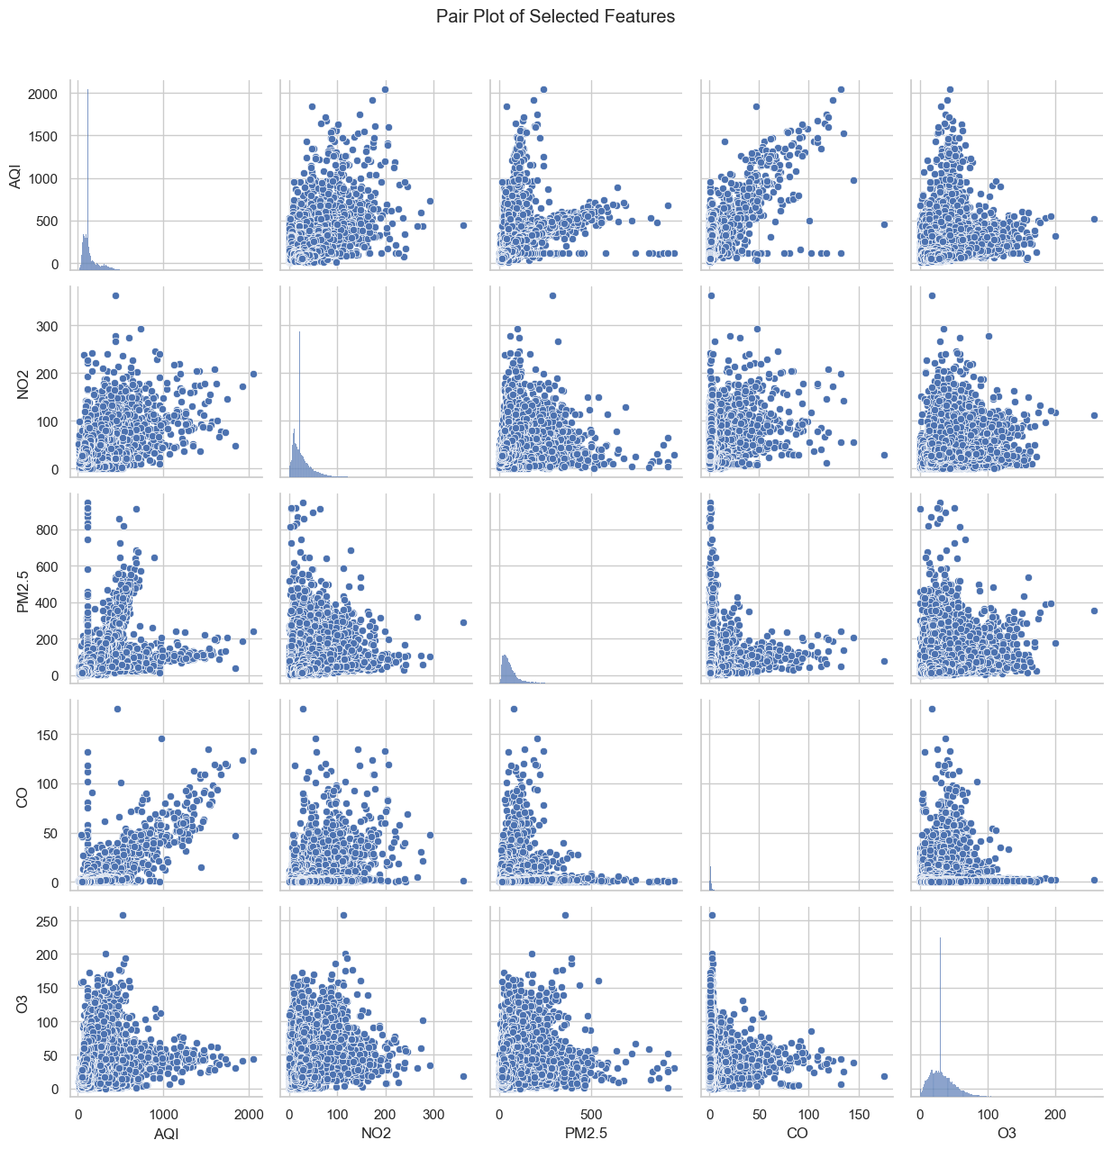
Figure 9: Scatterplot of selected features

Appendix II
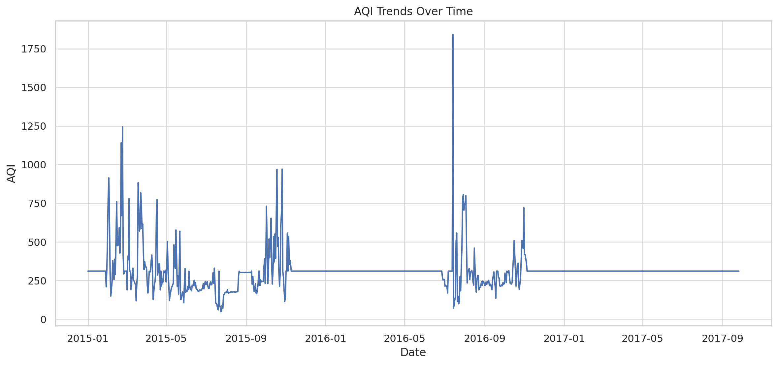
Figure 10: AQI Trends Over Time

Appendix III
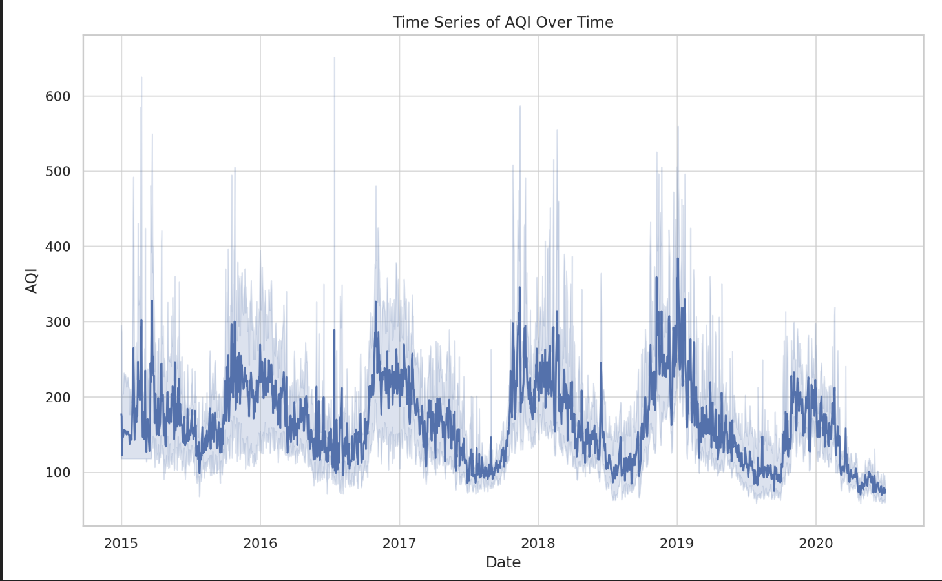
Figure 11: Time Series of AQI Over Time

Appendix IV
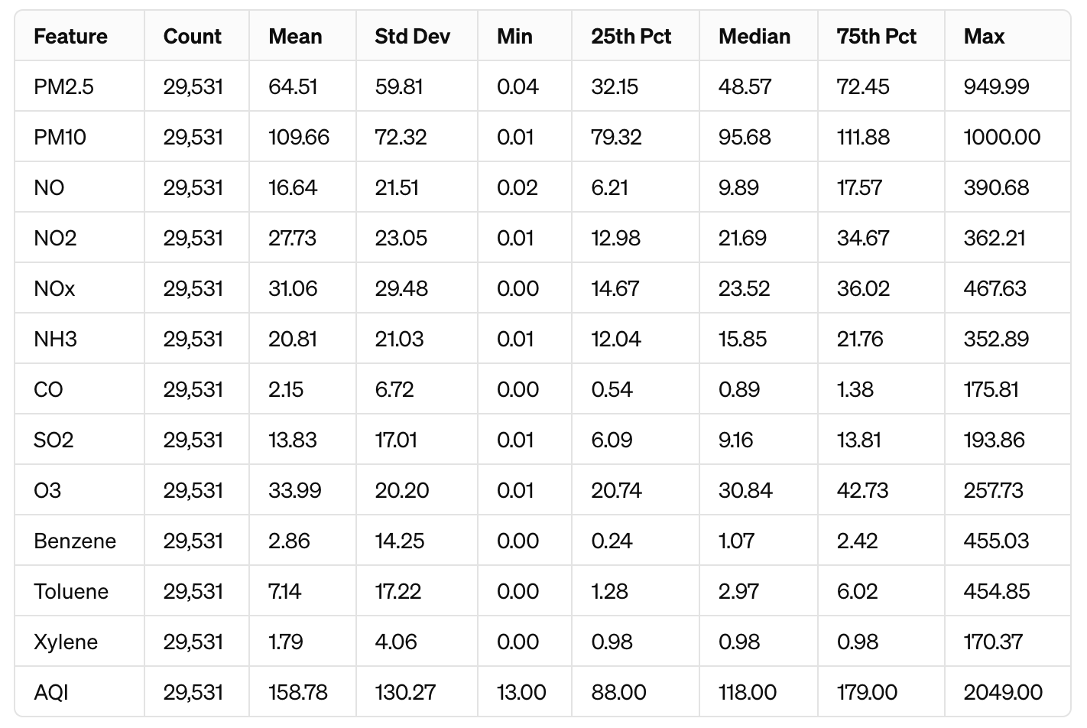
Figure 12: Features statistical analysis

Appendix V
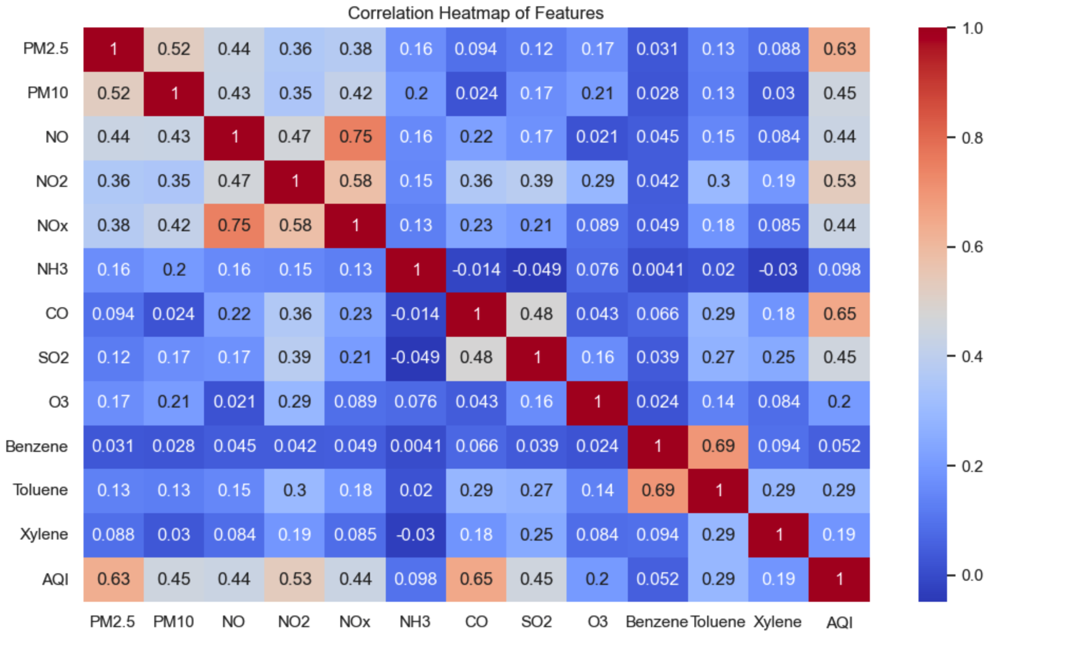
Figure 13: Correlation Heatmap of Features

Appendix VI
# Load required libraries
library(readr)
library(dplyr)
library(caret)
library(ggplot2)
library(class)
library(glmnet)

# Set CRAN repository for installing packages if needed
options(repos = c(CRAN = "https://cloud.r-project.org"))

# Install and load necessary packages if they are not already installed
packages <- c("readr", "dplyr", "caret", "glmnet", "ggplot2")
new_packages <- packages[!(packages %in% installed.packages()[,"Package"])]
if(length(new_packages)) install.packages(new_packages)
lapply(packages, library, character.only = TRUE)

# Read the dataset
data <- read_csv("./dataset/city_day.csv", show_col_types = FALSE)

# Clean the data by removing unnecessary columns and handling missing values
data_cleaned <- data %>%
select(-City, -Date, -Xylene, -AQI_Bucket) %>%
mutate(across(everything(), ~ ifelse(is.na(.), median(., na.rm = TRUE), .)))

# Scale and center the data
scaler <- preProcess(data_cleaned, method = c("center", "scale"))
data_scaled <- predict(scaler, data_cleaned)

# Partition the data into training and testing datasets
set.seed(123)
trainIndex <- createDataPartition(data_scaled$AQI, p = 0.80, list = FALSE)
train_data <- data_scaled[trainIndex, ]
test_data <- data_scaled[-trainIndex, ]

# Separate features and target variable
X_train <- train_data[, -which(names(train_data) == "AQI")]
y_train <- train_data[["AQI"]]
X_test <- test_data[, -which(names(test_data) == "AQI")]
y_test <- test_data[["AQI"]]

# Train KNN model
knn_fit <- train(AQI ~ ., data = train_data,
method = 'knn',
trControl = trainControl(method = "cv", number = 10),
tuneLength = 20)
best_k <- knn_fit$bestTune$k
best_model_knn <- knnreg(X_train, y_train, k = best_k)

# Train Lasso and Ridge regression models
lasso_model <- train(x = X_train, y = y_train,
method = "glmnet",
tuneGrid = expand.grid(alpha = 1, lambda = 10 ^ seq(-6, 6, length.out = 100)),
trControl = trainControl("cv", number = 5),
metric = "RMSE")

ridge_model <- train(x = X_train, y = y_train,
method = "glmnet",
tuneGrid = expand.grid(alpha = 0, lambda = 10 ^ seq(-6, 6, length.out = 100)),
trControl = trainControl("cv", number = 5),
metric = "RMSE")

# Calculate predictions and metrics for KNN, Lasso, and Ridge
predictions_knn <- predict(best_model_knn, X_test)
mse_knn <- mean((predictions_knn - y_test) ^ 2)
mae_knn <- mean(abs(predictions_knn - y_test))
r2_knn <- 1 - sum((y_test - predictions_knn) ^ 2) / sum((y_test - mean(y_test)) ^ 2)

# Print results for KNN
cat("KNN Best k:", best_k, "\n")
cat("KNN MSE:", mse_knn, "\n")
cat("KNN MAE:", mae_knn, "\n")
cat("KNN R-squared:", r2_knn, "\n\n")

# Generate plots for model evaluation
plot_knn <- ggplot(knn_fit$results, aes(x = k, y = Rsquared)) +
geom_line() +
geom_point() +
theme_minimal() +
labs(title = "K vs. R-Squared for KNN Regression", x = "Number of Neighbors k", y = "R-Squared")
print(plot_knn)

# Add more plots and analysis as needed for Lasso and Ridge regression

