Fake Product Detection System Based on Blockchain
Benakappa S M¹, Rishabh Jayaram², Rishika², Rohith B S², Sanketh S T²
¹Associate Professor, Department of Computer Science and Engineering, JNNCE, Shivamogga, Karnataka, India
²UG Students, Department of Computer Science and Engineering, JNNCE, Shivamogga, Karnataka, India

----------------------------------------------------------------------------------------------------------------------------------------------
Abstract - The rapid growth of counterfeit products has become a serious concern worldwide, affecting consumer trust, brand reputation, and supply chain transparency. To tackle this issue, this paper proposes a blockchain-based fake product detection system that verifies product authenticity and prevents duplication. The system uses the decentralized and tamper-resistant features of blockchain to securely store product information across the supply chain. Each product is assigned a unique digital identity linked to a QR code, which allows consumers or stakeholders to verify authenticity by scanning the code. The system cross-checks the scanned data with blockchain records to identify genuine or counterfeit products. Since blockchain records cannot be altered without consensus, the solution effectively prevents data manipulation. The results demonstrate that the proposed system offers a secure, transparent, and reliable method for product authentication, making it suitable for real-world applications in retail, manufacturing, and supply chain management.
Key Words: Blockchain, Fake Product Detection, Product Authentication, Anti-Counterfeiting, Supply Chain Security.

1.INTRODUCTION
The expansion of counterfeit products has emerged to be a significant issue in all markets in the world, involving manufacturers, retailers, and even the consumer. False products not only cause losses to the brand economically, but also cause a lack of customer confidence, and in some instances cause severe safety hazards. In the new supply chains characterized by various stakeholders and places, tracking products and their authenticity have been a challenge to be dealt with through the old means. Barcodes, labels, and central databases are easily duplicated and altered, and therefore cannot be used to verify the products in a long-term basis.
The blockchain technology provides a new and efficient approach to the described challenges by offering a secure and transparent means of data storage and sharing. In contrast to traditional systems, blockchain is decentralized with records being distributed in the network and is unable to be changed without the consent of the group. This is what makes blockchain very resilient to tampering and fraud and is important in applications where trust and integrity of data is needed.
The proposed system is a blockchain-based fake product detection system, which can aid in confirming the authenticity of a product in the supply chain in the context of this project. Upon manufacturing, every product is given a distinct digital identity that is safely stored in the blockchain. This identity is associated with QR code located on the product package. Upon scanning the code, the system replies by accessing the information that is stored in the blockchain and determine whether the product is authentic or not.

2. RELATED WORK
The rise of counterfeit products has pushed researchers to look for better ways to verify product authenticity and protect supply chains. Early studies showed that blockchain can be used to store product information in a secure and unchangeable manner, especially when combined with QR codes or barcodes for easy verification by consumers [1]. These systems improved transparency and reduced reliance on centralized databases, but they often required high setup costs and technical expertise, which limited their practical adoption [2].
To address these challenges, later research focused on decentralized applications built on Ethereum that use smart contracts to automate product registration and ownership tracking [3]. Some solutions strengthened QR-code security by introducing cryptographic hashing or single-use verification methods to prevent duplication [4]. Other works adopted permissioned blockchain platforms such as Hyperledger Fabric to enhance privacy and enterprise control, though issues related to system complexity and user acceptance still remained [5], [6].
More recent studies applied blockchain-based authentication systems in areas such as pharmaceuticals and fashion, where counterfeit risks are high. These implementations reported improved consumer trust and better traceability across supply chains [7]. Research on user behavior also indicated that simplicity and trust play a major role in adoption [8]. Overall, existing work confirms the potential of blockchain-based product authentication while highlighting the need for a simple, scalable, and cost-effective solution, which forms the basis of the proposed system [9].

3. PROBLEM STATEMENT AND OBJECTIVES
3.1. Problem Statement
Fashion piracy is growing at a global scale and has become a critical issue of concern about the quality of the products, brand image, and national economies. Not only do fake products lead to loss of money by the manufacturers, but also create safety hazards to users. With the increased complexity of global supply chains, it is more difficult to know the authentic products and track the route that they have gone, enabling the penetration of counterfeit goods onto the market.
There are limitations in the technology of product authentication and tracking that is already in place like QR code, barcode, RFID systems. They are easy to duplicate or manipulate and are often based on central databases, and participants in the supply chain do not have transparency. These shortcomings make it hard to have a high degree of reliability in checking the authenticity of products or detecting fraud in real-time.
To overcome these challenges, there is great need to have a safe, open, and invulnerable system that guarantees product authentication and tracking to the manufacturer to the final customer. With blockchain technology, the supply chain can be trusted and its integrity ensured since the data that is entered in the system cannot be altered once it is entered.
Through the application of the decentralized model of identifying the anti-counterfeit products based on blockchain, all parties involved in the supply chain such as manufacturers, distributors, retailers and consumers can confirm the authenticity of products at each step. This strategy goes a long way in curbing the distribution of fake products, transparency and consumer confidence as they are sure the products are original and can be traced throughout the lifecycle.

3.2. Objectives
The primary objectives of this project are:
- To design and develop a blockchain-based system to validate the products and avert counterfeiting.
- Introduce QR codes and smart contracts to provide visibility and ensure the impossibility of their manipulation by products in the supply chain.
- To enable consumers to check the authenticity of products by scanning QR codes which are connected to the immutable blockchain records.
- To make supply chains more transparent and trustful to its stakeholders through a safe platform of product genuineness.

4. PROPOSED SYSTEM
The proposed system offers a simple and reliable way to detect fake products using blockchain technology. In this system, every product is given a unique digital identity at the time of manufacturing, which includes details such as product ID, batch number, manufacturing date, and ownership information. This data is securely stored on the blockchain, making it difficult to alter or manipulate. A QR code linked to the blockchain record is then attached to the product. As the product moves through the supply chain, authorized sellers update ownership details on the blockchain, ensuring a transparent transaction history. When a consumer scans the QR code using a mobile or web application, the system instantly retrieves the stored blockchain information and checks whether the product is genuine. If the details match, the product is confirmed as original; otherwise, it is identified as counterfeit. By using the decentralized and tamper-resistant nature of blockchain, the system improves trust, traceability, and security, offering a practical solution for real-world product authentication.
4.1. System Architecture
The system architecture is defined by 4 main components, namely that of User Interface Layer, Application Layer, Blockchain Layer and Verification Layer. These are the elements that are combined to protect the registration of products, the ability to monitor ownership, and authenticity at real-time.

User Interface Layer
The layer offers web-based interfaces between manufacturers, sellers and consumers. Manufacturers create a registration of products and produce QR codes, sellers control transfer and sale of products, and buyers confirm the authenticity of the product through the scanning of QR codes in a mobile or web-based application. The interface is user friendly and accessing it is secure depending on user roles.

Application Layer
The application layer is a layer that connects the user interface to the blockchain network. It interprets user requests, authenticates inputs and interacts with blockchain smart contracts via blockchain APIs. This is the layer that processes the creation of QR-codes, authentication of users, validation of transactions, and communication with the off-chain storage of individual non-critical data like user profiles.

Smart Contracts layer (Blockchain Layer).
The main component of the suggested system is the blockchain layer. Smart contracts are deployed to store product information like product ID, batch number, manufacturing date and ownership history in an unalterable way. After the data is stored, it cannot be changed unless there is network consensus thus tamper proof storage. Every transaction, such as product registration, and ownership transfer, is permanently recorded on the blockchain, and it is traceable.

Verification Layer
The authentication layer is in charge of real time product authentication. Upon the QR code scan, the system retrieves the blockchain record corresponding to the QR and matches it with the scanned information. When the information is identical, then the product is confirmed as authentic; otherwise, the product is detected as a fake. The layer provides rapid, efficient and transparent authentication to end users.
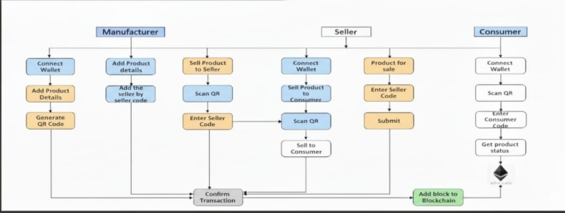
Fig. 1. Architecture of the proposed Blockchain-based product authentication using QR codes.

4.2. Methodology
The proposed system adheres to a systematic and sequential approach towards a sure protection of product authentication and successful identification of fake products. It starts when the manufacturing stage is reached where each genuine product is registered within the system through creation of a unique product ID with the necessary details like batch number, manufacturing date and also the ownership information. These facts are transformed into a cryptographic hash and recorded on the blockchain with the help of smart contracts and are immutable as well as data-integrity guaranteed.
After the data of the product is successfully stored on the blockchain, a QR code correlated with the blockchain operation is created and attached to the actual product. In the distribution stage, the authorized sellers check the product and update the ownership records in the blockchain when a product is transferred or sold. This is a step-by-step update system that keeps a history of transactions throughout the supply chain that is not tampered with.
During the last phase, product authenticity is checked by the consumer, scanning the QR code with either a web or mobile application. The system recalls the related blockchain record and remotely compares it with the scanned records. In case of the information being similar the product is verified to be a genuine one otherwise it becomes a counterfeit. The approach is a safe way of authentication, reduced manual control, and enhanced confidence among all parties.

  - Workflow of the Proposed System
The proposed blockchain-based originality detection system of products has its workflow that describes the overall workflow of verifying products in manufacturing to consumption. The working process begins with the user input that is, the Web-based interface where manufacturers sign-in to add new product to the system by providing product specifications. On submission, the system will create a blockchain transaction with the help of smart contracts and will produce a QR code associated with the immutable product record.
Under the second step, sellers can gain access to the system to validate registered products and provide updated ownership information in the case of transferring products and/or selling them. The blockchain is transparent and traceable with every transaction registered as a new block. This is followed by the step in the workflow of the consumer verification, during which, the user scans the QR code on the product. The system creates a blockchain record and authenticates the product information in real-time.
Lastly, the system shows the consumer the result of the verification, whether the product is original or fake. Any inconsistency or recurrence scanning can be indicated to be inquired on further.
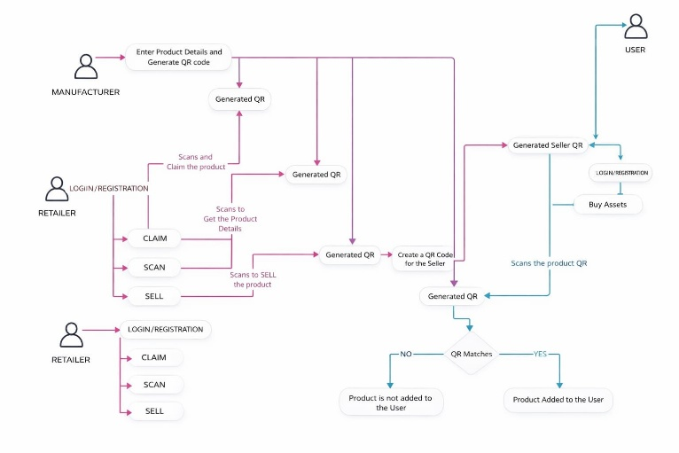

Fig. 2. Workflow of the proposed QR-code–driven product tracking and verification workflow.
- IMPLEMENTATION AND RESULTS
The new product is a system that uses blockchain to check if something is real. This system was made with contracts that are on a blockchain network and a website that people can use. Companies put their products on the system by saving the details on the blockchain and making a code called a QR code that is linked to that product. When someone sells a product, they update who owns it now. People who buy something can check if it is real by scanning the QR code. We tried this system with products and it worked very well. The system was able to check everything in time and the records could not be changed. The blockchain-based product originality detection system is very good, at doing what it is supposed to do. Genuine products were successfully identified, while attempts to verify unregistered or altered products were flagged as counterfeit. The implementation demonstrated improved transparency, reliable traceability, and effective prevention of data manipulation, confirming the system’s practicality for real-world supply chain applications.

5.1. Implementation Details
The new product is a system that uses blockchain to check if something is real. This system is made with blockchain technology, smart contracts, special codes that can be read with a phone and a website that people can use. The system is built on a blockchain platform like Ethereum. On this platform smart contracts are. Used to keep track of who owns a product, who it is sold to and if it is real. The blockchain-based product originality detection system is a part of this. The system uses blockchain technology and smart contracts to make sure everything is safe and honest. The blockchain-based product originality detection system is very important, for checking if products are real. Each product that a manufacturer registers gets its special digital identity. This digital identity has lots of details about the product like the product ID, the batch number it was made in the date it was made and who currently owns it. The manufacturer puts all these details together. Then uses cryptography to hash them. They store the details on the blockchain. This way the details, about the product cannot be. Nobody can tamper with them. The blockchain keeps the details about each product safe.
The company makes a QR code for every product that is registered. This QR code is connected to the blockchain transaction hash for that product. The QR code is like a name tag, for the product.
The system has a part that people can use on the web. This part is made so that different people can use it like the people who make the products the people who sell the products and the people who buy the products. Manufacturers can add products and make QR codes, for them. Sellers can check if the products are real and update who owns them when they are being sent out or sold. Consumers can scan the QR code to see if the product is authentic.
The website uses tools called Web3 libraries to talk to the blockchain. These tools help keep things safe when the website is talking to the contracts that are already set up.
The system works well because it uses simple data structures and good security measures. This helps to keep things running quickly and prevents delays. When you scan a QR code the system checks the details of the product against the information stored on the blockchain. It does this in time to make sure everything matches up. If something does not match the system will flag the product as fake away. The system also keeps a record of every transaction, for each product. This means that people who are allowed to see this information can track where a product has been and what has happened to it. The system is transparent. It is easy to see what is going on with each product. The blockchain record is really important for the system to work properly. Overall, the implementation demonstrates a secure, scalable, and practical solution for real-world counterfeit detection by leveraging the decentralized and tamper-resistant nature of blockchain technology.

5.2. Experimental Setup
The setup for the blockchain-based product originality detection system was made to see how well it works how accurate it is. If it is reliable when it is used in real life.
The system was put in a place where we can control what happens and we used a test blockchain network to pretend that it is being used in the real world with companies and people buying and selling things.
We used computer programs called smart contracts on the blockchain to keep track of products, who owns them and to make sure they are real.
There was also a website that people could use and it only let them do things based on who they're, like if they are the person making the product the person selling it or the person buying it.
The experiments were conducted by registering multiple products with unique identifiers and generating corresponding QR codes linked to blockchain transaction hashes. These QR codes were attached to simulated product instances and scanned at different stages of the supply chain. Authorized sellers updated ownership details through blockchain transactions, while consumers verified products by scanning the QR codes using a mobile or web interface. Both genuine and counterfeit scenarios were tested by attempting to scan unregistered, duplicated, or altered QR codes.

  - Results and Performance Analysis
The qualitative assessment of the new blockchain, based system for verifying the originality of a product concentrates on features like user, friendliness, openness, safety, and general user experience. It was found to be very user, friendly for all involved parties during the system trial. Manufacturers easily registered products and created QR codes, sellers smoothly updated ownership details, and consumers effortlessly checked product authenticity by a mere QR code scanning. The confirmation outcomes were visually accessible, thus enabling users to readily grasp if a product was authentic
    - Qualitative Results
The qualitative evaluation of the proposed blockchain-based product originality detection system highlights how intuitive, transparent, and trustworthy the system feels in real-world use. During testing, all stakeholders found the platform easy to interact with and quick to understand. Manufacturers could register products and generate QR codes with minimal effort, sellers were able to update ownership and transaction details smoothly, and consumers verified product authenticity simply by scanning a QR code using their smartphones. The verification outcome was displayed in a clear and user-friendly manner, making it easy even for non-technical users to identify whether a product was genuine or counterfeit.
Figure 3 that depicts the Product Verification module in which customers are able to instantly check the validity of the products prior to purchase. The interface also has a scanning option using QR, which automatically retrieves the product information including serial number, consumer code, and seller information. Once the user scans the QR code or uploads an image, the system will retrieve on-chain records of the blockchain ledger and show the verification status of the product. Other supporting features that are displayed on the dashboard include purchase history, seller identification, safety guidelines and scan statistics including pass rate, number of escalation and average scan time. After a validation, the system will confirm the validity of the product and display the relevant blockchain address, which is a guarantee of transparency, tamper-proof validation, and end-to-end traceability to consumers.
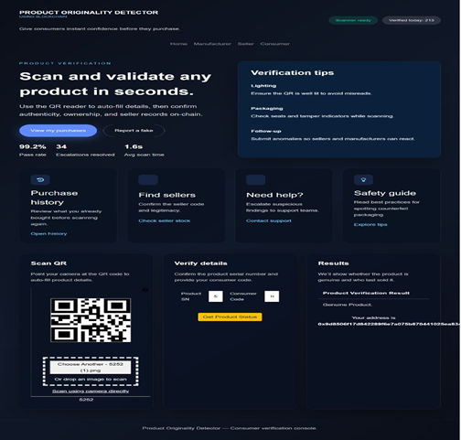
Fig. 3. Final Outlook of Blockchain-Based Authenticity Detection GUI
    - Snapshots
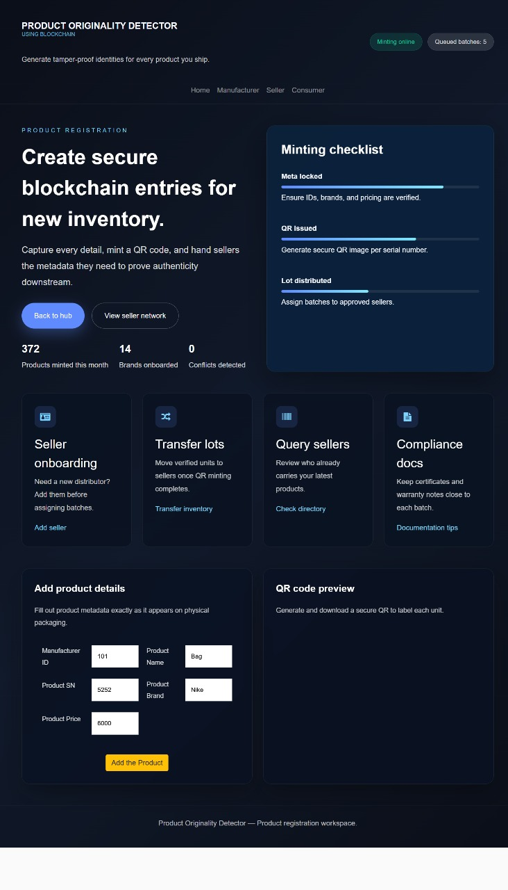
Fig. 4. Output of Product Verification Button for Blockchain Minting and QR Generation
The figure 4 shows the overall workflow of the Product Originality Detection System using Blockchain technology. The process starts with product registration. Manufacturers upload product details like product ID, description, and manufacturing information into the system. Next, these details are converted into a unique hash value and securely stored as a block in the blockchain network. This ensures that the data cannot be changed or tampered with. A QR code is generated and attached to the product, linking it to the corresponding blockchain record. When a consumer or authority scans the QR code, the system retrieves the stored blockchain data and compares it with the scanned product information. If the data matches, the product is confirmed as genuine; if not, it is marked as counterfeit. This figure shows how blockchain provides transparency, traceability, and security in detecting fake products throughout the supply chain.
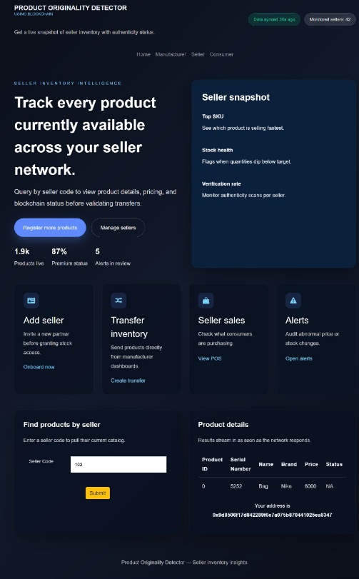
Fig. 5. Seller Inventory and Product Authenticity Dashboard
The figure 5 shows the seller dashboard of the blockchain-based Product Originality Detector, designed to give a clear and simple view of inventory and product authenticity. Through this interface, sellers and manufacturers can easily track all available products, check their verification status, and monitor stock health in real time. Features such as alerts, sales insights, and verification rates help users quickly identify unusual activity or low stock levels. By entering a seller code, detailed product information including brand, price, and authenticity status is displayed instantly. Overall, the dashboard makes inventory management more transparent and reliable while helping stakeholders confidently handle only genuine products across the supply chain. This figure shows how blockchain provides transparency, traceability, and security in detecting fake products throughout the supply chain.
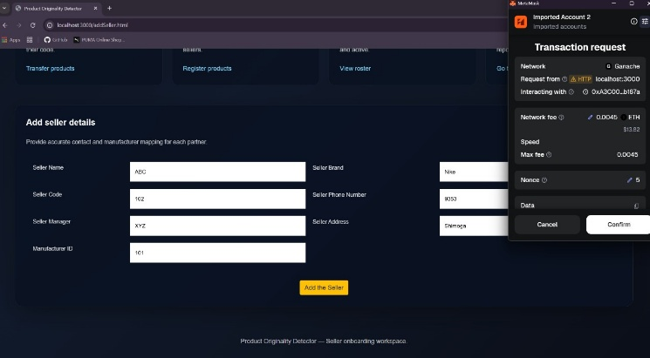
Fig. 6. Seller onboarding interface with blockchain transaction confirmation via MetaMask
In figure 6 value is the transaction confirmation window which is presented in the case of the seller onboarding process when the seller-related information is added to the blockchain. Once the user would fill in the name of the seller, his/her code, brand, phone number, manager, address, and manufacturer ID, the system would initiate a MetaMask transaction request which would safely write this data to the decentralized ledger. Before being executed, the confirmation panel displays information about the interacting contract address, type of network, gas fee, and nonce of the transaction. This system ensures that only the referenced entries of sellers are added to the authenticity graph by necessitating explicit approval by MetaMask which ensures that only the verified sellers are included in the system. This guarantees trusted onboarding that is not tampered with in the whole supply network.
    - Performance Analysis
The efficiency of the suggested blockchain, based product originality detection system was assessed based on main aspects such as confirmation accuracy, reaction time, system stability, and scalability. In the trial phase, the system was distinguished by its accuracy in identifying the original products and thus it has been successful. As a result of the blockchain registration, the products have always been confirmed to be authentic, while the replication, alteration, or non, registration of QR codes have been pointed out as counterfeit, which shows that the authentication process is reliable.
Response time was a factor in the experiment that involved the measuring of time which is taken for retrieving records after a QR code scan on the blockchain. The system was able to provide verification almost in real, time thereby the delay between the scanning and authentication process was very minimal, thus it can be termed as a device for use in retail and consumer, facing environments. The adoption of lightweight data handling and the optimized smart contract interactions were the main contributors to the reduction of computational overhead and transaction latency.
    - Impact of System Optimizations
System optimization was a major factor in enhancing the overall performance and dependability of the innovative blockchain, based product originality detection system.
By refining smart contract logic and cutting down on unnecessary blockchain transactions, the system was able to achieve quicker verification times as well as lower computational overhead.
Storage requirements were greatly reduced through the use of lightweight data structures and efficient hashing techniques without compromising data integrity.
All these optimizations allowed for seamless communication between the frontend application and the blockchain network, thus enabling faster response to the QR
    - Discussion
The experimental results show that the proposed T2V Studio system achieves a balance between visual quality, movement consistency, and computing efficiency. While the system is limited to short video lengths and relies entirely on pretrained models, it effectively serves its purpose as an accessible and user-friendly framework for Text-to-Video generation. The results indicate that motion-aware diffusion techniques like AnimateDiff significantly improve temporal coherence, making the system suitable for fast content creation and prototyping applications.

- APPLICATIONS
- Pharmaceutical Industry – Verifies the authenticity of medicines and prevents the distribution of counterfeit drugs.
- Luxury Goods and Fashion – Ensures originality of branded products such as watches, bags, and apparel.
- Electronics Supply Chain – Tracks genuine electronic components and devices to avoid fake or refurbished products.
- Food and Agriculture Sector – Confirms product origin and traceability of food items from producers to consumers.
- Automobile and Spare Parts Industry – Detects counterfeit spare parts and maintains transparency in the supply chain.

- CONCLUSION
This project demonstrates the practical feasibility of using blockchain technology to verify product authenticity through a secure, transparent, and tamper-proof supply chain framework. By enabling immutable record-keeping from manufacturers to end consumers, the system effectively addresses key challenges associated with counterfeit products. The decentralized nature of blockchain ensures trust among all participants without relying on a single centralized authority.

- FUTURE SCOPE
In the future, the system can be further enhanced by integrating IoT sensors to monitor product conditions such as temperature, humidity, and handling in real time. This would be especially beneficial for sensitive goods like pharmaceuticals, food items, and electronics, ensuring not only authenticity but also quality throughout the supply chain.
Scalability can be improved by adopting more efficient consensus algorithms and advanced blockchain architectures, allowing the system to handle a larger number of transactions with reduced latency and cost. This would make the solution more suitable for large-scale commercial deployment across global supply chains.
Additionally, developing a dedicated mobile application would improve accessibility and ease of use for a wider range of users. With mobile support, consumers could instantly verify products using their smartphones, and sellers could update records on the go, further increasing adoption and effectiveness of the system.

- REFERENCE
[1] | Jayaprasanna, M. C., Soundharya, V. A., Suhana, M., & Sujatha, S. (2021, February). A block chain-based management system for detecting counterfeit product in supply chain. In 2021 Third international conference on intelligent communication technologies and virtual mobile networks (ICICV) (pp. 253-257). IEEE.
[2] | Geetha, R., Jayakumar, D., Prabakaran, P., Nivedha, S., Sindhu, M., & Thivyarathi, R. C. (2024, May). An Experimental Evaluation of an Effective QR Code Based Duplicate Product Detection Using Blockchain Technology. In 2024 International Conference on Intelligent Systems for Cybersecurity (ISCS) (pp. 1-7). IEEE.
[3] | Pragadeesh, M., Vignesh, B. K., Ashraf, S. M., & Kumar, R. D. (2024, February). Anti Counterfeiting Solution For Product Authentication Using Blockchain. In 2024 Second International Conference on Emerging Trends in Information Technology and Engineering (ICETITE) (pp. 1-4). IEEE.
[4] | Dhore, M. L., Loya, R., Sasne, R., Rokade, T., & Chandak, R. (2024, August). Anti-Counterfeit Product Identification System: A Paradigm Shift in Supply Chain Integrity. In 2024 8th International Conference on Computing, Communication, Control and Automation (ICCUBEA) (pp. 1-6). IEEE.
[5] | Singhal, I., Bisht, H. S., & Sharma, Y. (2021). Anti-counterfeit product system using blockchain technology. Int. J. Res. Appl. Sci. Eng. Technol, 9(12), 291-295.
[6] | Shankar, B. P., Rajkumar, N., Viji, C., Kumar, K. D., Saravanakumar, S., & Mohanraj, A. (2024, September). Approach to Identifying Counterfeit Products with QR Codes and Computational Algorithms. In 2024 5th International Conference on Smart Electronics and Communication (ICOSEC) (pp. 1203-1209). IEEE.
[7] | Prathipa, S., Harish, K., & Thashanmouli, N. (2022, November). Counterfeit product detection in supply chain management with blockchain. In 2022 1st International Conference on Computational Science and Technology (ICCST) (pp. 841-844). IEEE.
[8] | Mane, V., Patil, R., Pawar, S., & Pujari, N. (2024, August). Detection of Counterfeit Products with QR Codes using Blockchain Technology. In 2024 7th International Conference on Circuit Power and Computing Technologies (ICCPCT) (Vol. 1, pp. 545-550). IEEE.
[9] | Keerthy, G., Rohith, N., Bg, H., Nayak, A. D., & Srinivas, D. B. (2023, July). Enhancing product authentication and counterfeit detection using qr codes and blockchain technology. In 2023 2nd International Conference on Edge Computing and Applications (ICECAA) (pp. 262-267). IEEE.

