Week 9: Pipeline Creation using script
- Evaluation of Jenkins pipeline.
- WORKING ON BUILD TRIGGERS FOR LAST JENKINS PIPILINE
- Hands-on practice on creation of scripted Jenkins pipeline.
- Take the screenshots for above task

Procedure
General :
Description :- provide the description of the project
Build triggers: here we can provide with build triggers of you choice
Advance project option:
Definition:
Choose pipeline script

Here code for pipeline -script

Copy the code there
-------------------------------------------------------------------------------------------------------------------------
pipeline {
agent any
tools{
maven 'MAVEN-HOME'
}
stages {
stage('git repo & clean') {
steps {
//bat "rmdir /s /q mavenjava"
bat "git clone provide your github link"
bat "mvn clean -f mavenjava"
}
}
stage('install') {
steps {
bat "mvn install -f mavenjava"#project name#
}
}
stage('test') {
steps {
bat "mvn test -f mavenjava"
}
}
stage('package') {
steps {
bat "mvn package -f mavenjava"
}
}
}
}

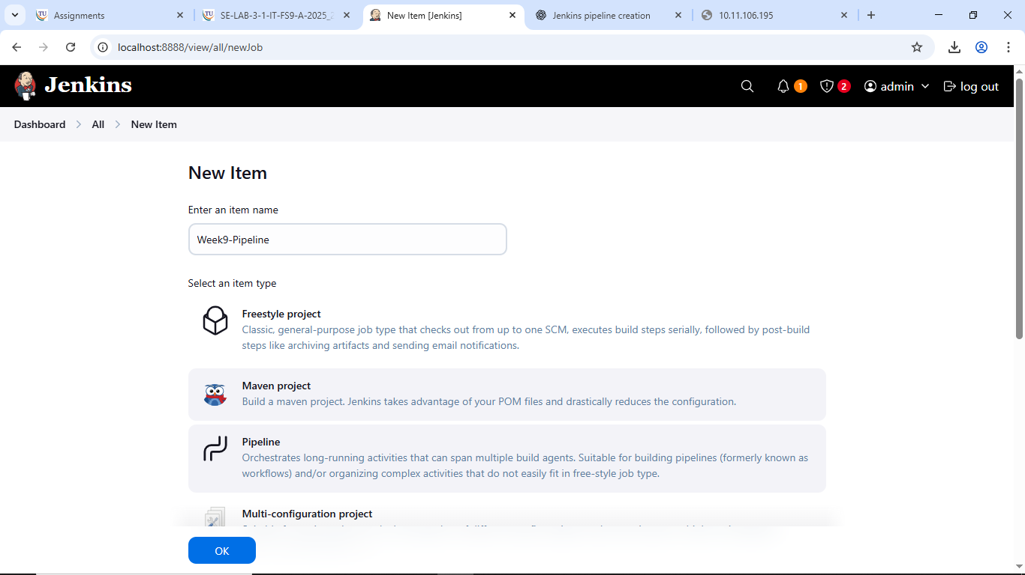

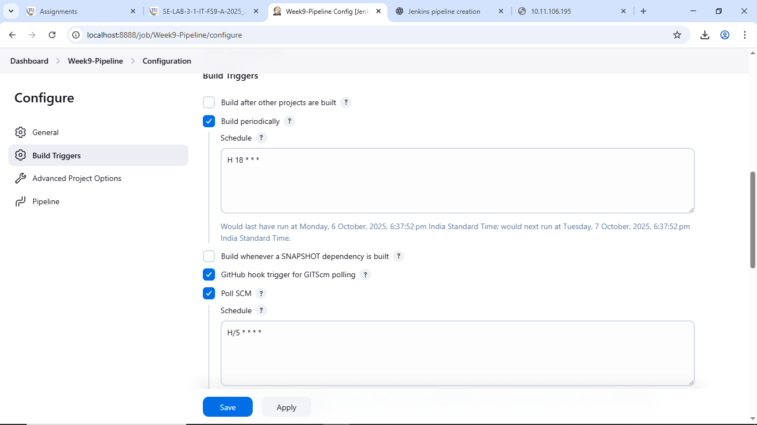
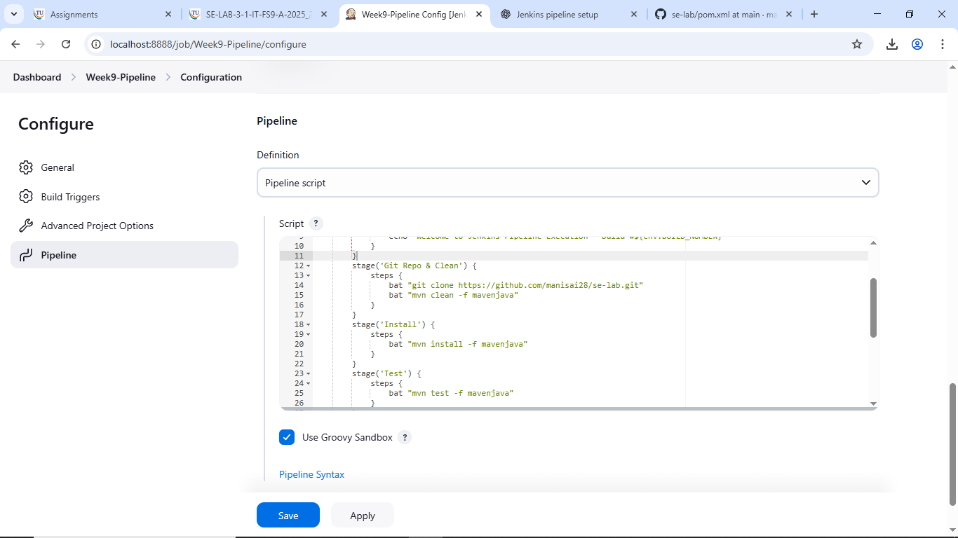

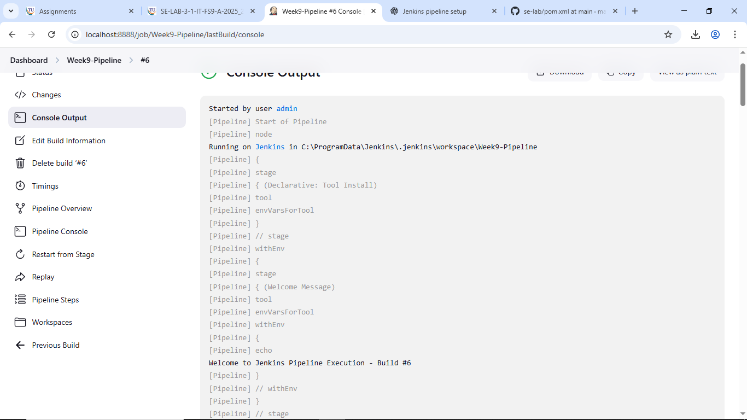

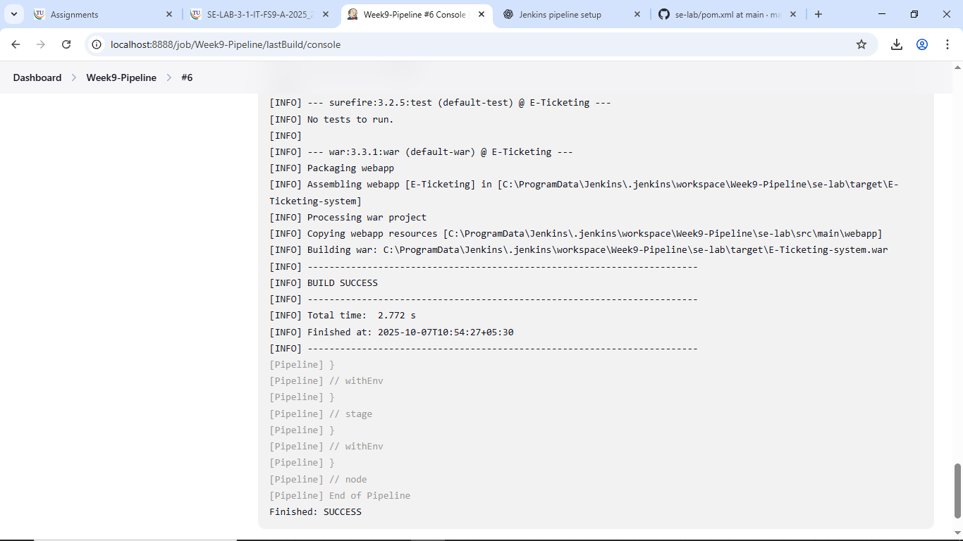
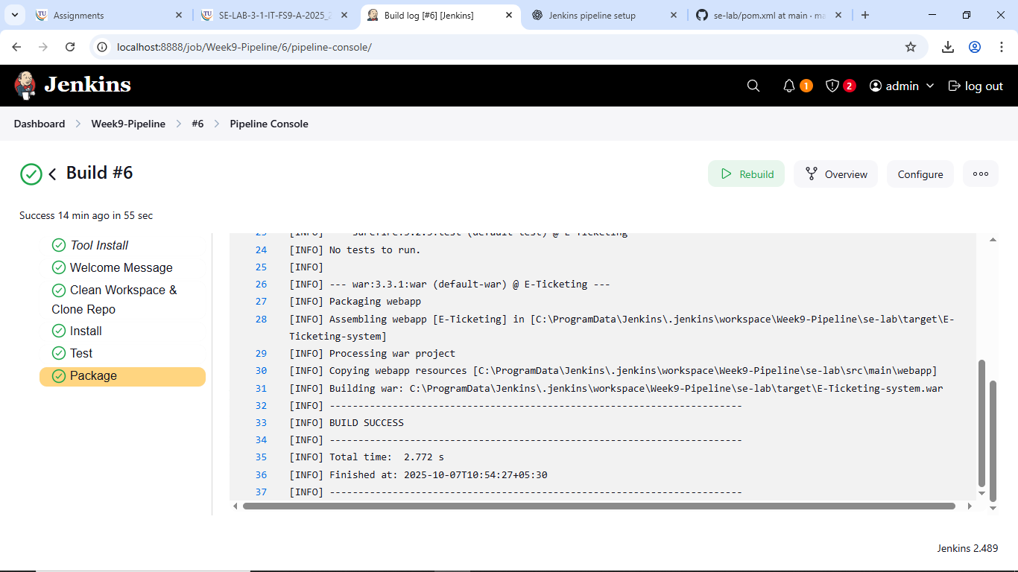
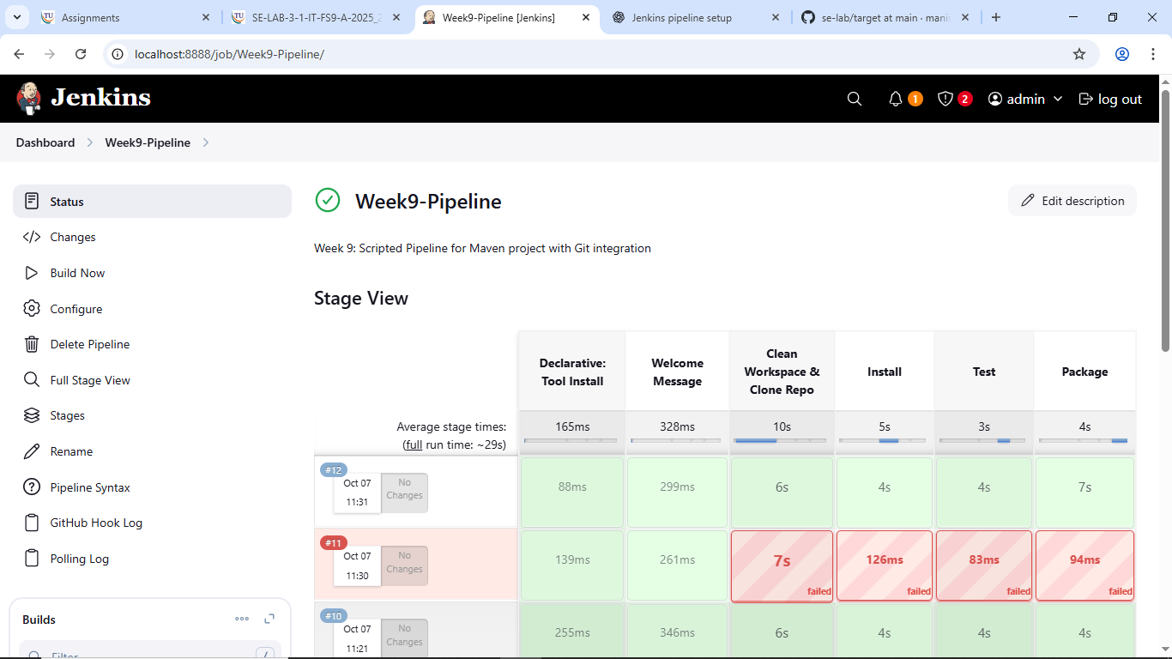
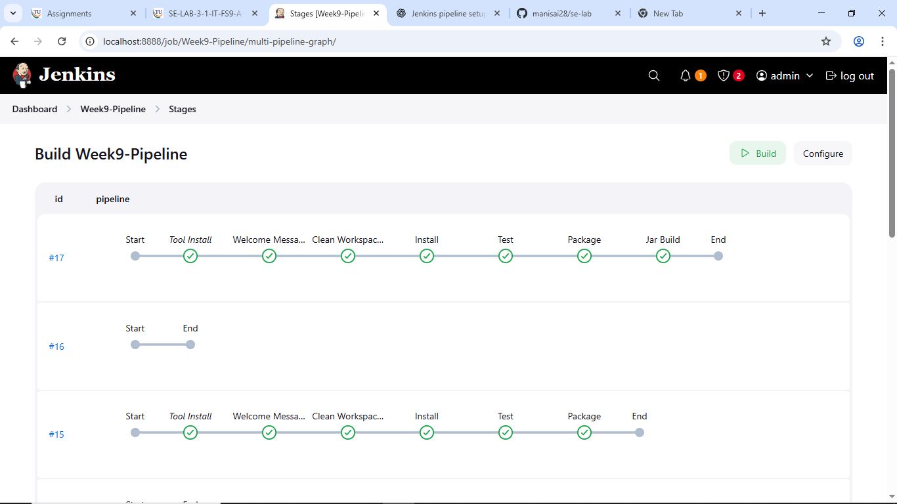
Apply and save
SBQ’s:
- Your manager asks you to clean the workspace before building — which stage in this pipeline takes care of it?
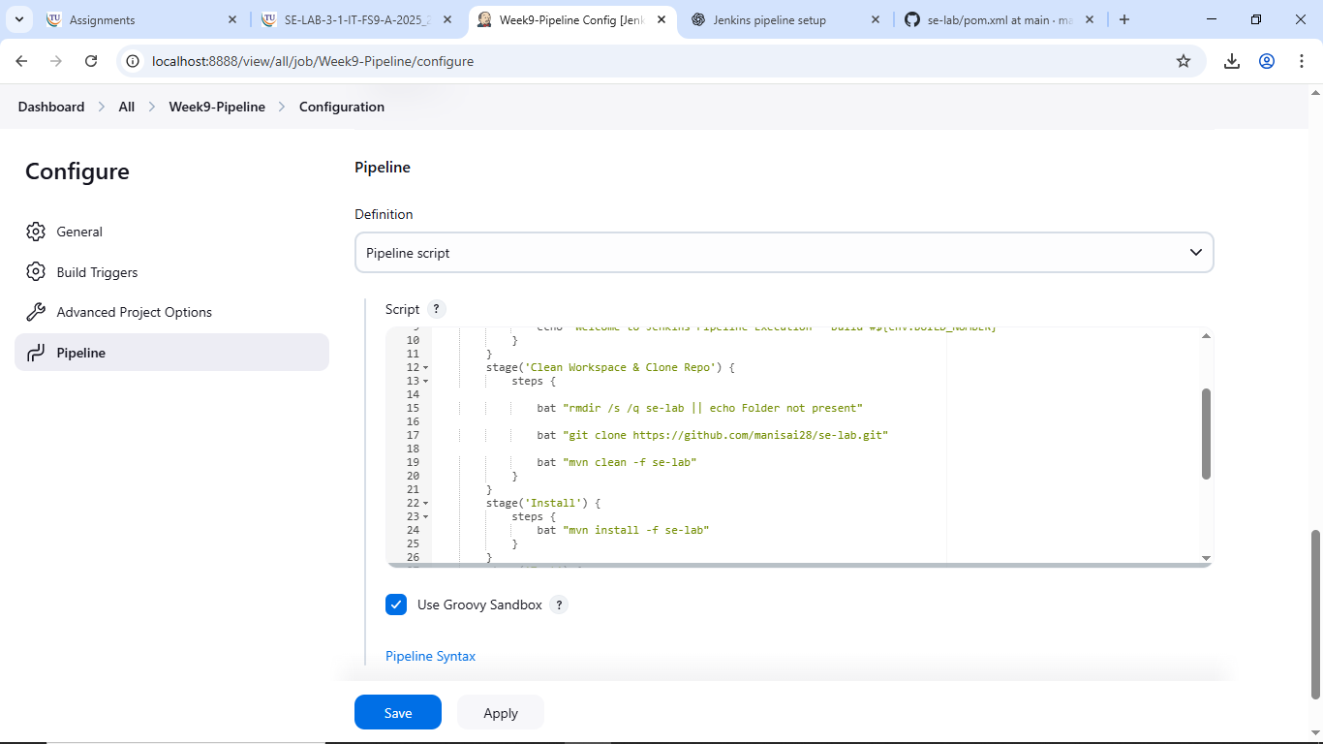

- The GitHub repository link is missing in the script — where exactly do you provide it?
- If Maven is not configured globally in Jenkins, which section of the pipeline will fail first?
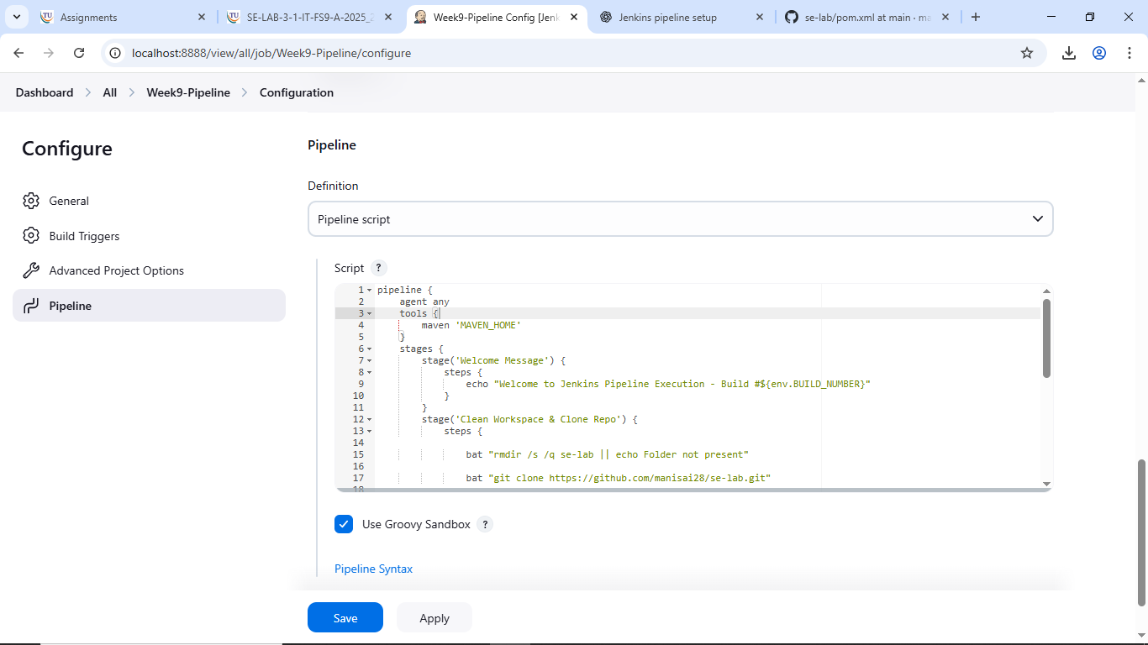
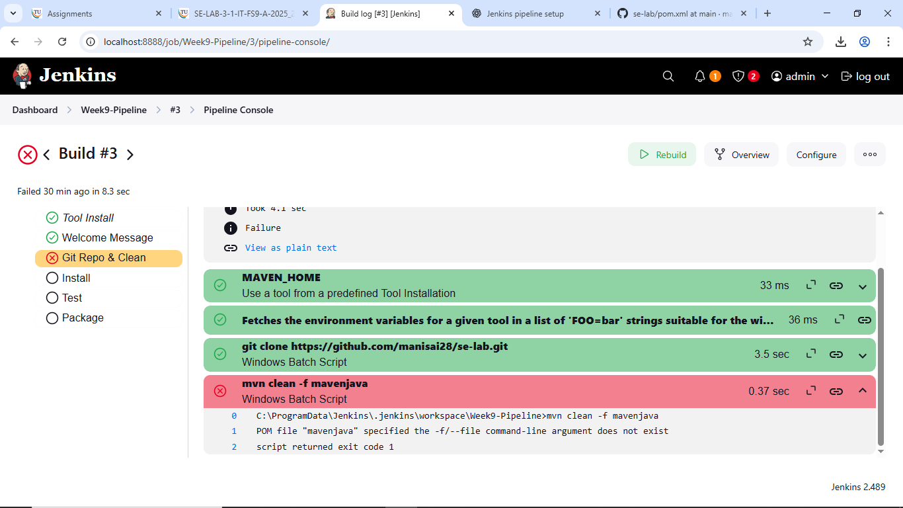
- A teammate complains the pipeline is not creating .war files — which stage is responsible?
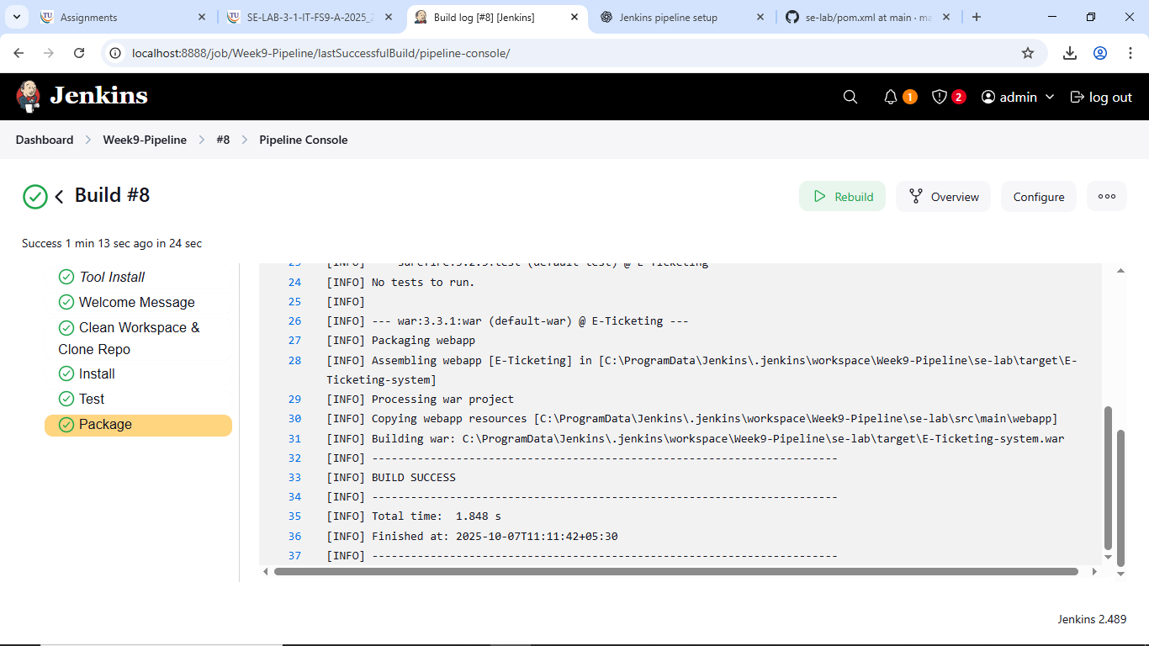
- Your test cases failed, but the pipeline still continued — how will Jenkins behave in the test stage?
- Instead of running nightly builds, you want this pipeline to trigger only when GitHub changes occur — where will you configure it?
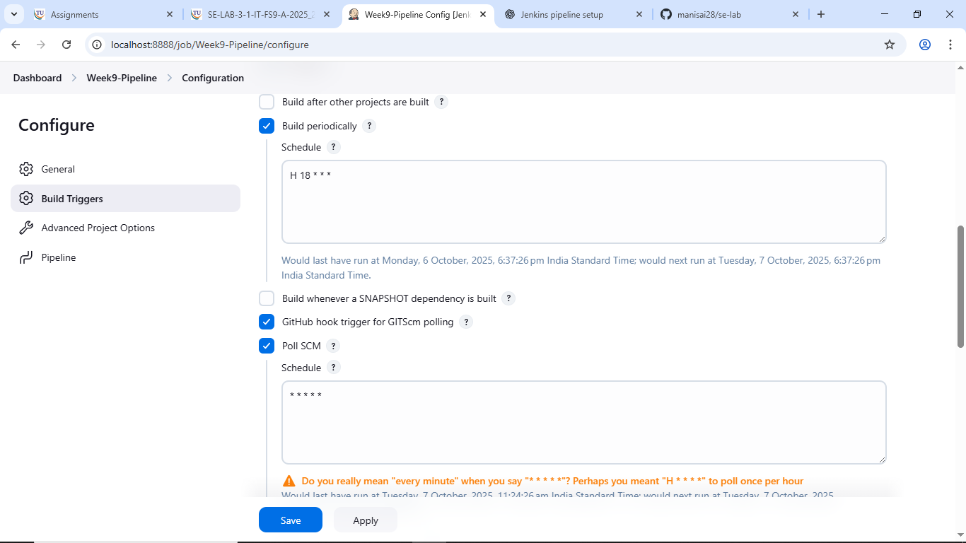
- If you replace mvn clean with mvn compile, what difference will it make to the project build?
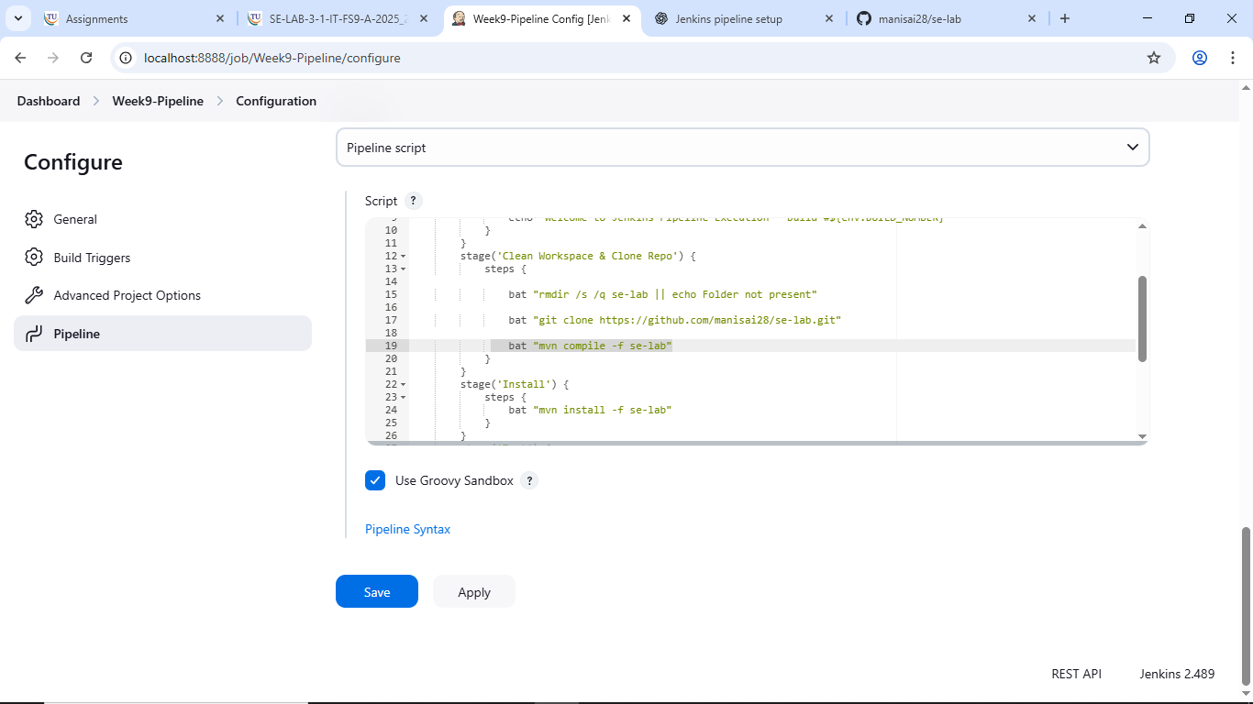
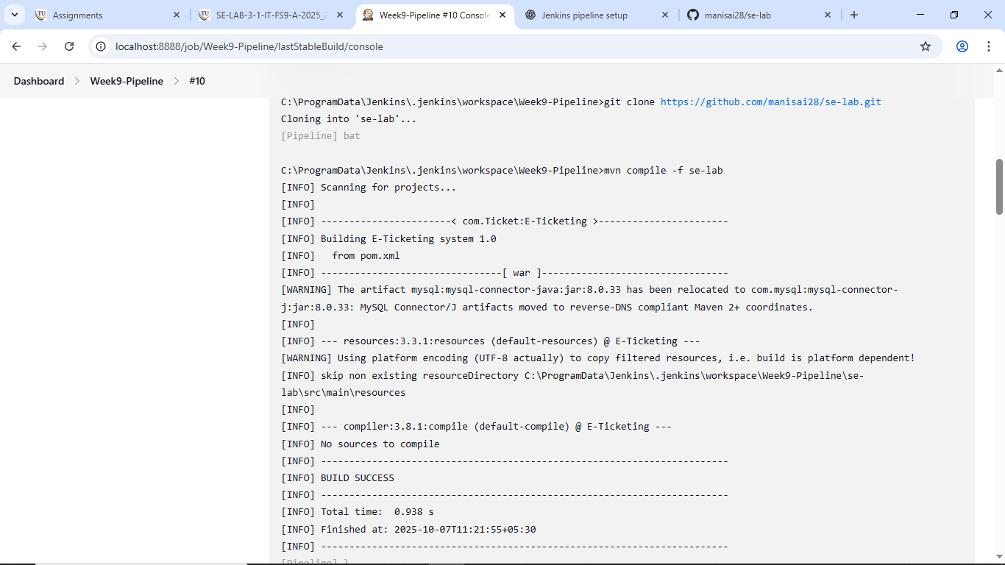

- The project folder name is not mavenjava but studentapp — which parts of the script must you edit?
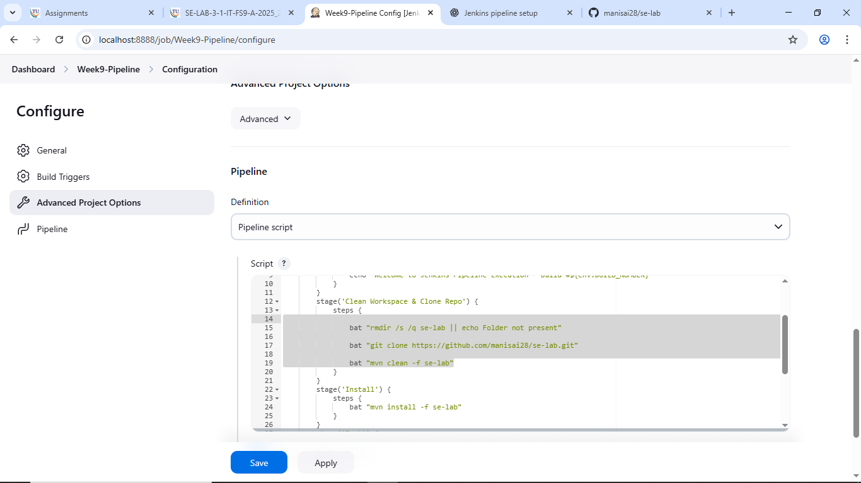
- If the install stage fails, will the test and package stages still run in this pipeline?
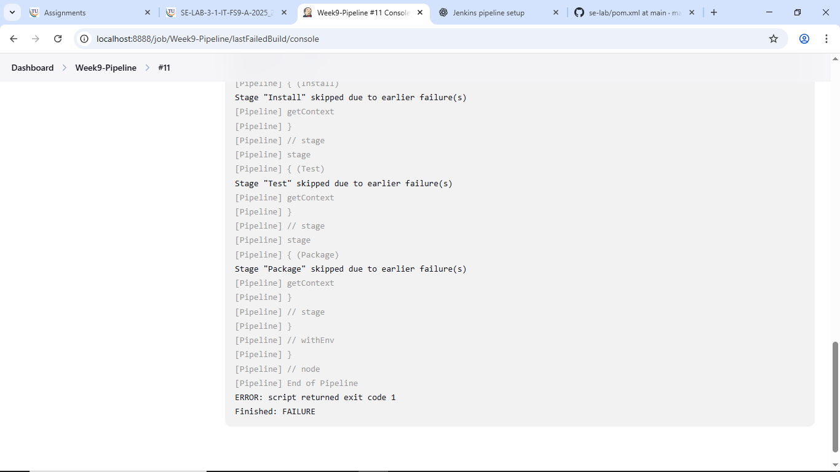
- A student asks where to add deployment steps to Tomcat after packaging — which is the best place in this script?
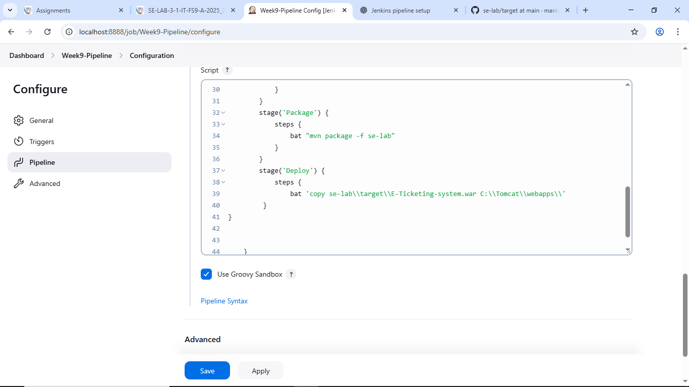
- Why is tools { maven 'MAVEN-HOME' } used in this pipeline?
- If GitHub credentials are private, how can you secure them in the git repo & clean stage?
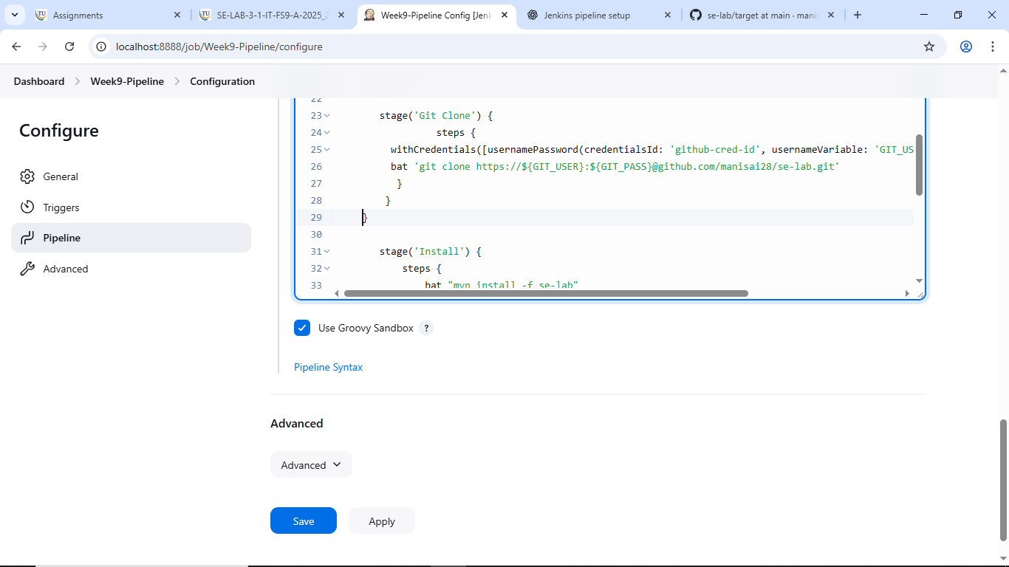
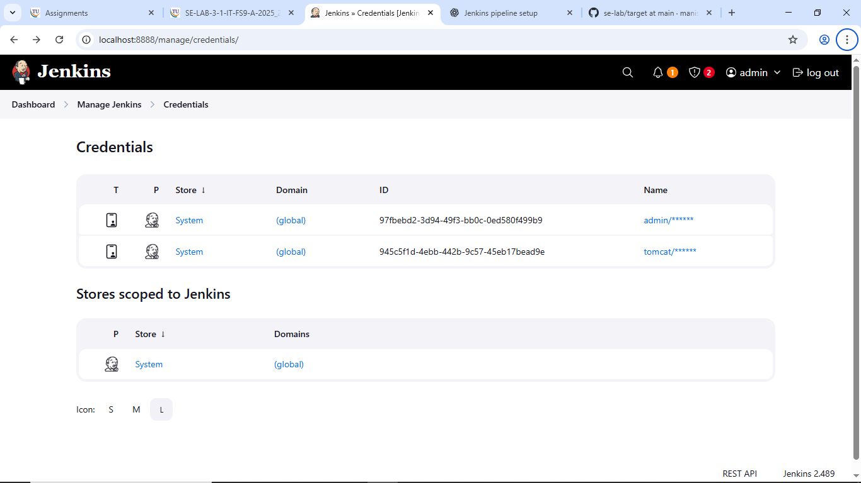

- Which Jenkins plugin is needed to recognize the pipeline { ... } structure in this script?
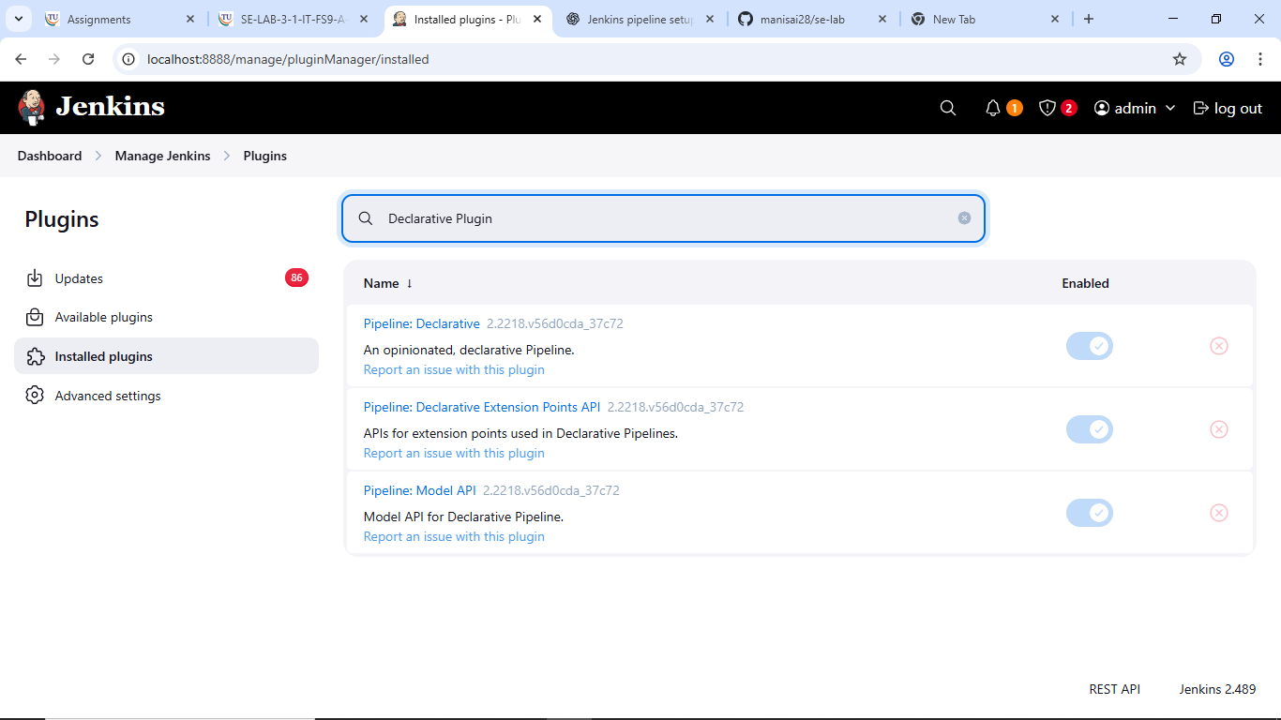
- In Windows, the script uses bat commands — what change would you make if Jenkins runs on Linux?
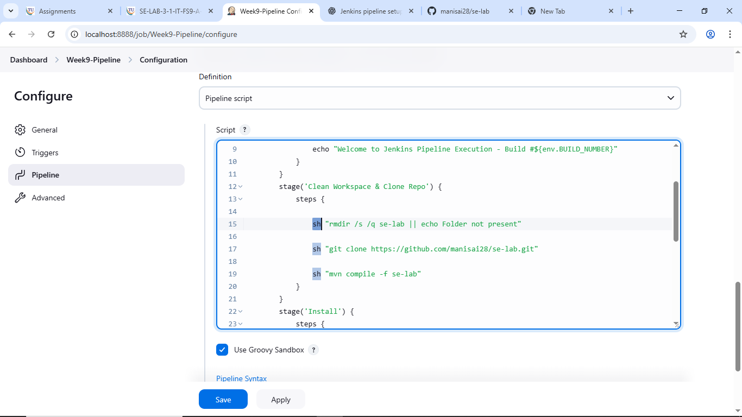
- How will you modify the pipeline to stop execution if the GitHub clone command fails?
Your project lead asks you to print a welcome message in Jenkins to confirm the pipeline is working — how would you script it?
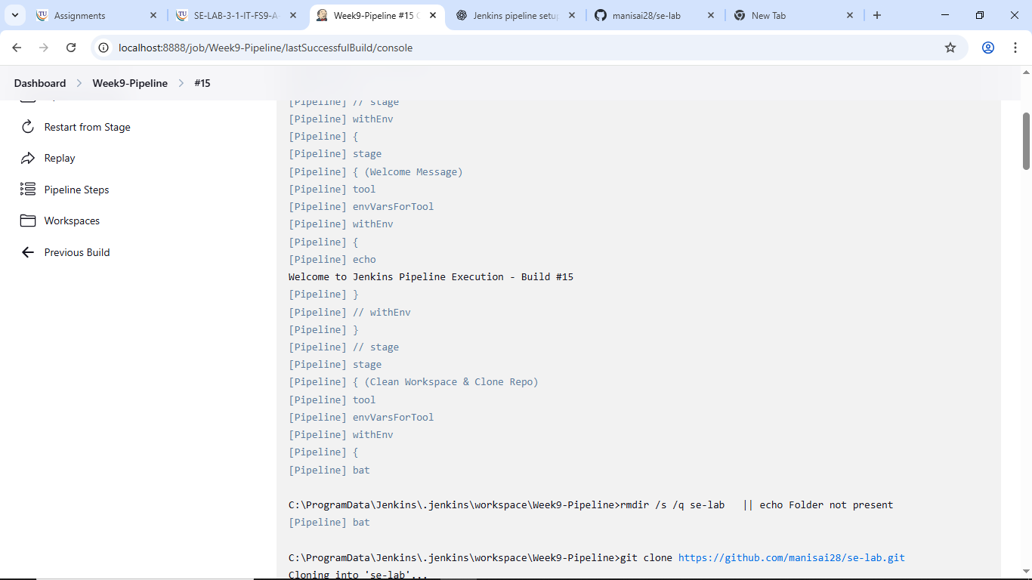

- A teammate forgot to pull the latest GitHub code before building; how can you fix this in your pipeline?
- Your Java file Hello.java must be compiled every time code is committed — how will you add this step?

- Tests should stop the pipeline if they fail — where will you put the mvn test command?
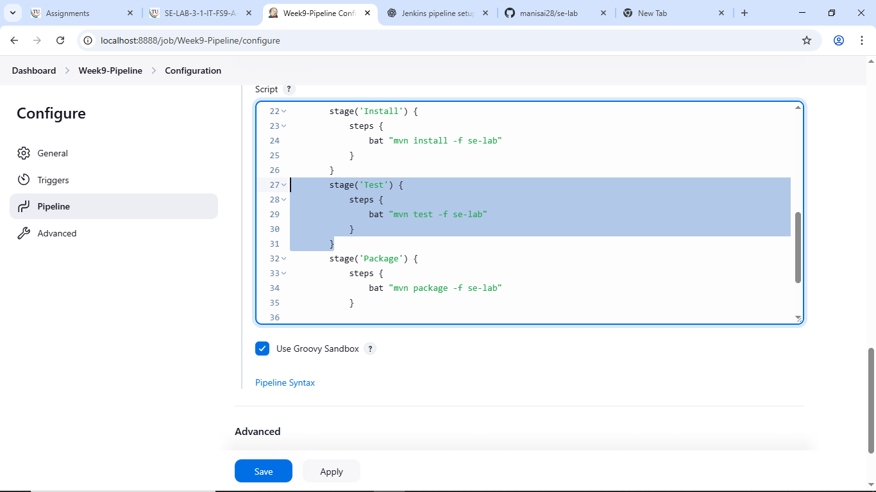
- Every evening at 6 PM your pipeline should run automatically — how can you set this in Jenkins?
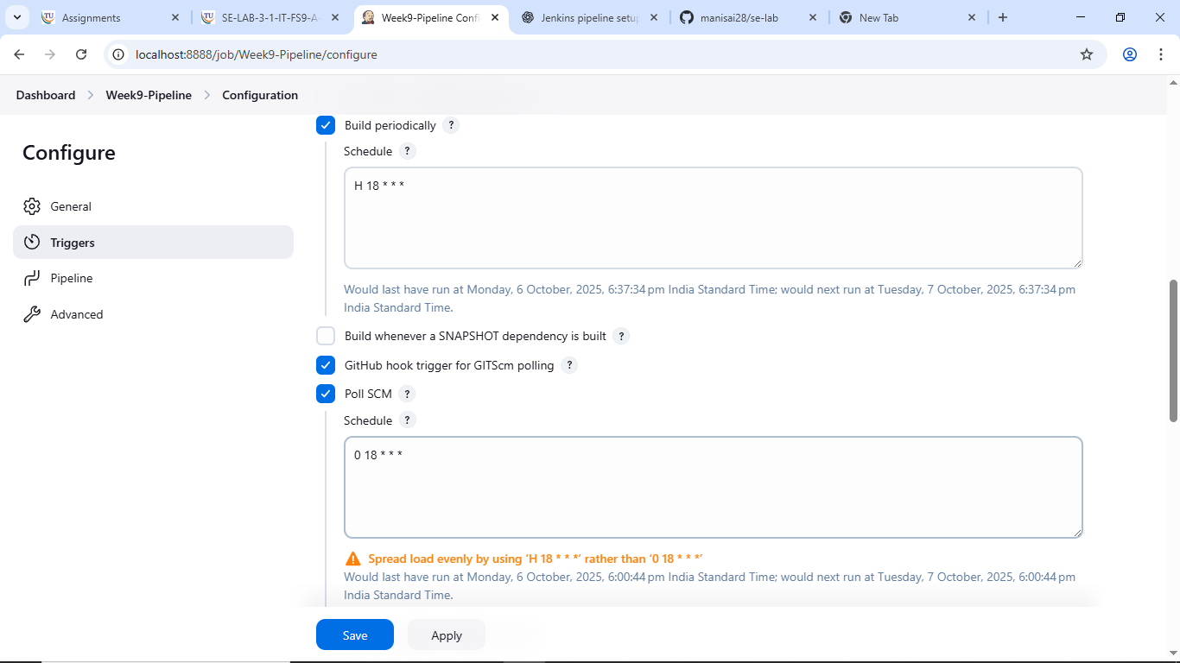
- You only want to package the project if compilation succeeds — how would you connect the stages?
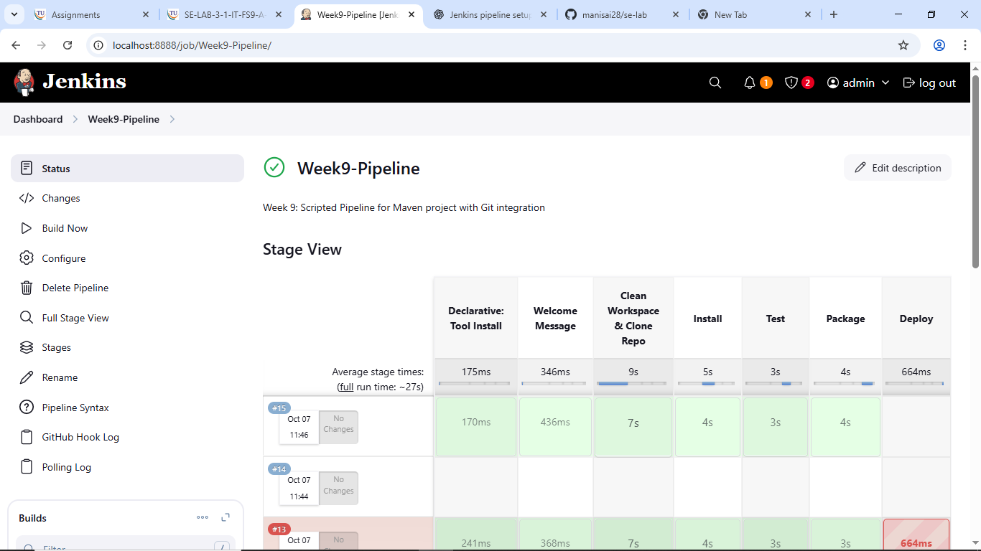
- Your professor wants a .jar file generated for submission — what pipeline stage will you add?
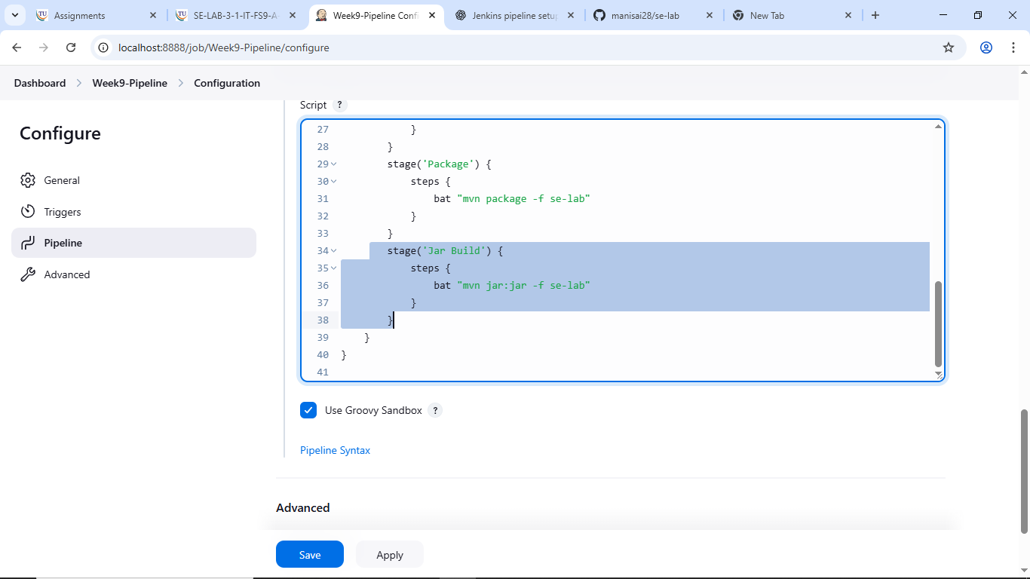
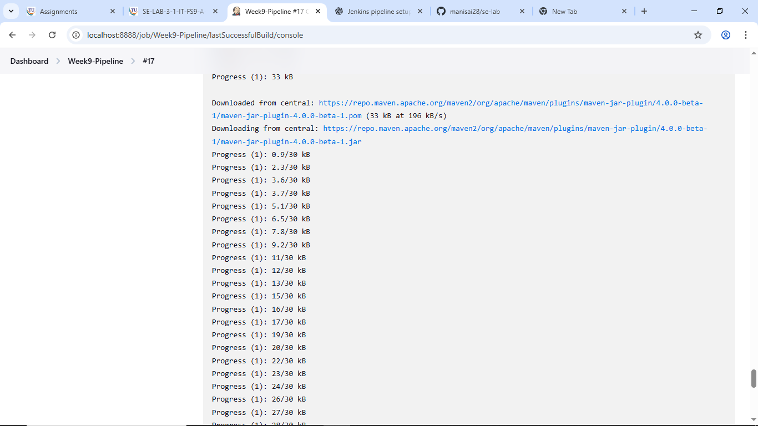
- A Git clone step is failing due to wrong credentials — how would you secure and use them in your script?
- A teammate wants to see the build number inside console logs — how do you print it in the pipeline?

