LAB ACTION PLAN FOR WEEK 10

Working with minikube and Nagios
Hands-on practice of creating, running and scaling pods in minikube.
Running Nginx server on specified port number by explaining the Nginx monitoring tool
Running Nagios server and Understanding the Monitoring tool using Docker.
AWS-free Trier account Creation steps
Upload the screenshots for the tasks
Kubernetes:
Kubernetes is a tool that automates how we run and manage applications inside the container.
Dockers will only run containers, if in any case the container fails/stopped/killed, the docker will not help us, here is where Kubernetes plays an important role, Kubernetes cluster will be responsible in creating a new container and managing various containers.
POD: In Kubernetes, a Pod is the smallest deployable unit that you can create and manage.
Minikube:
Minikube creates a VM on your local machine and deploys a simple Kubernetes cluster with one node. It's a lightweight implementation.Minikube is a version of Kubernetes.
Nagios:
Nagios is an open-source IT infrastructure monitoring tool. It monitors
Serrvers
Network devices
Applications and services
It alerts admnistrators when issues occur and notifies when they are resolved.

Step 1: Install Prerequisites
Before installing Minikube, ensure the following are installed:
Virtualization Support:
Verify virtualization is enabled:
Hypervisor:
Minikube supports multiple hypervisors (e.g., Hyper-V, VirtualBox, or Docker as a driver).
Install one of the following:
Hyper-V (pre-installed on Windows 10/11 Pro or Enterprise).
Docker Desktop (if you want to use Docker as the driver).

Step 2: Download Minikube
Open a PowerShell or Command Prompt with administrator privileges.
Download the latest Minikube executable using this command:
curl -LO https://storage.googleapis.com/minikube/releases/latest/minikube-installer.exe
Install Minikube by running the installer:
.\minikube-installer.exe

Step 3: Add Minikube to PATH
If Minikube is not automatically added to your PATH during installation:
Open System Properties → Environment Variables.
Add the directory where Minikube is installed (e.g., C:\Program Files\Minikube) to your PATH variable.

Step 4: Start Minikube
Open a terminal (PowerShell or CMD). Do the following commands
Start Minikube with a specified driver (e.g., Hyper-V, Docker, or VirtualBox). For example:
Hyper-V:
minikube start --driver=hyperv
Docker:
minikube start --driver=docker
Verify Minikube is running:
minikube status

Step 5: Interact with Minikube

kubectl is a command-line tool used in Kubernetes to interact with and manage Kubernetes clusters.
Once Minikube is running:
Use kubectl to interact with the cluster.
Install kubectl if not already installed:
minikube kubectl -- get pods -A
Or download it separately from the official Kubernetes site.
Open the Minikube dashboard (optional):
minikube dashboard

Optional: Check Your Installation
Run the following to verify the installation:
Minikube version
kubectl version --client

Troubleshooting
If Minikube fails to start:
Ensure your hypervisor (Hyper-V/Docker/VirtualBox) is installed and running.
Check the Minikube logs:
minikube logs
Updating Minikube:
minikube update-check
minikube update
Minikube Automation Steps
Step 1: Start Minikube Cluster
Open your terminal and run the command:
minikube start
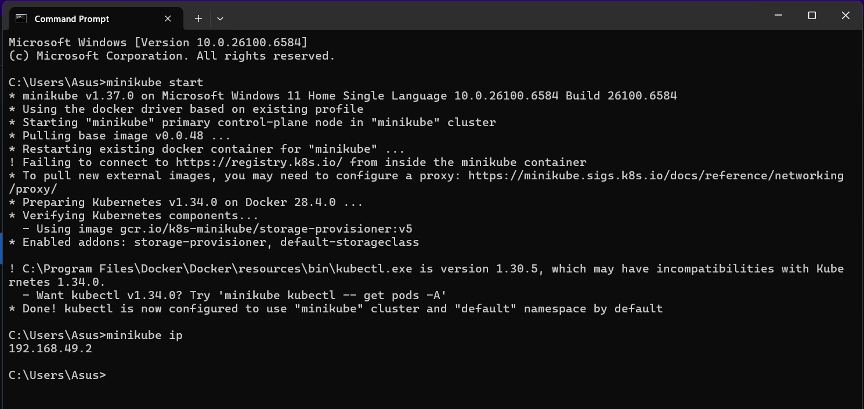
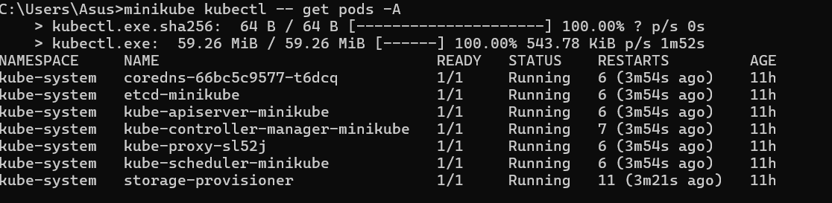
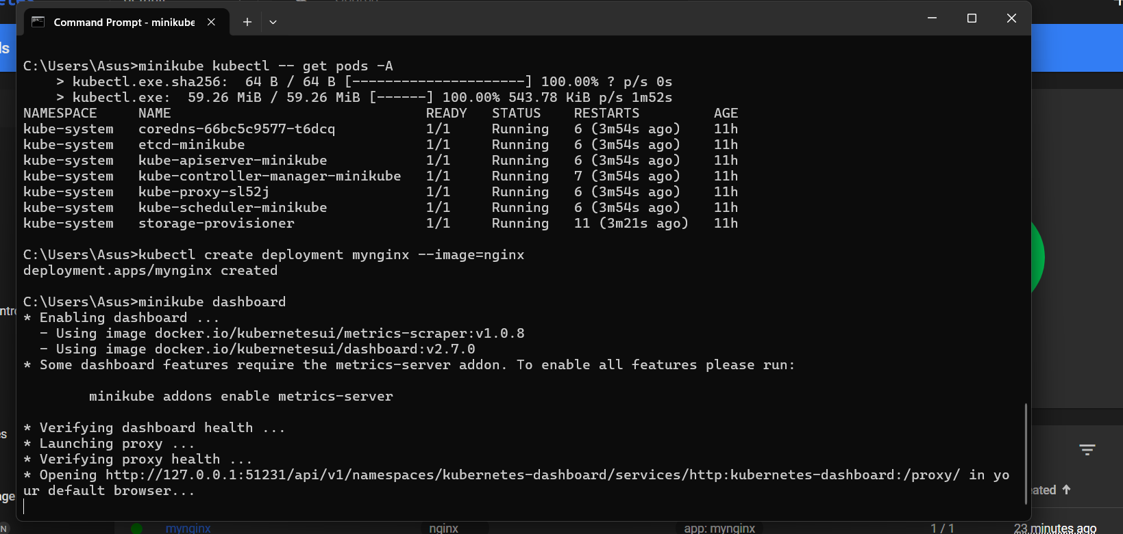
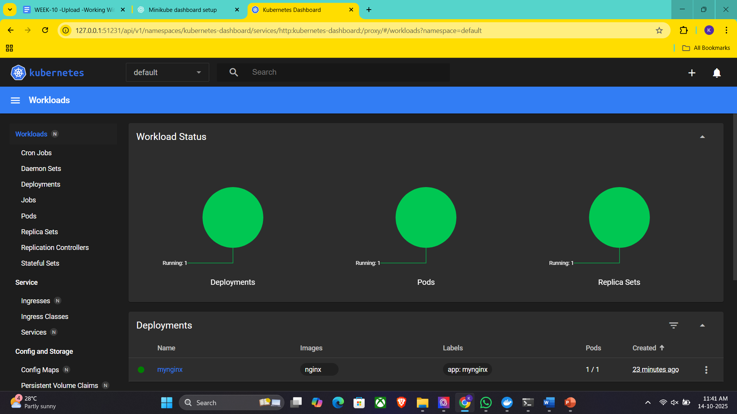
Step 2: Create and Manage Deployment
Create an application in Kubernetes:
Command:
kubectl create deployment mynginx --image=nginx

if already created then
kubectl set image deployment/myngnix nginx=nginx:latest
Verify the deployment using: Kubernetes responds by showing you a list that includes the names of your deployment groups
kubectl get deployments
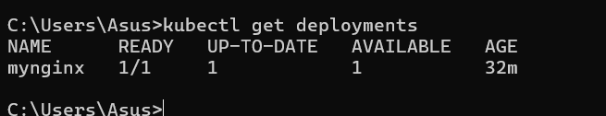
Ensure mynginx appears in the output.
Check the following commands:
kubectl get pods
kubectl describe pods
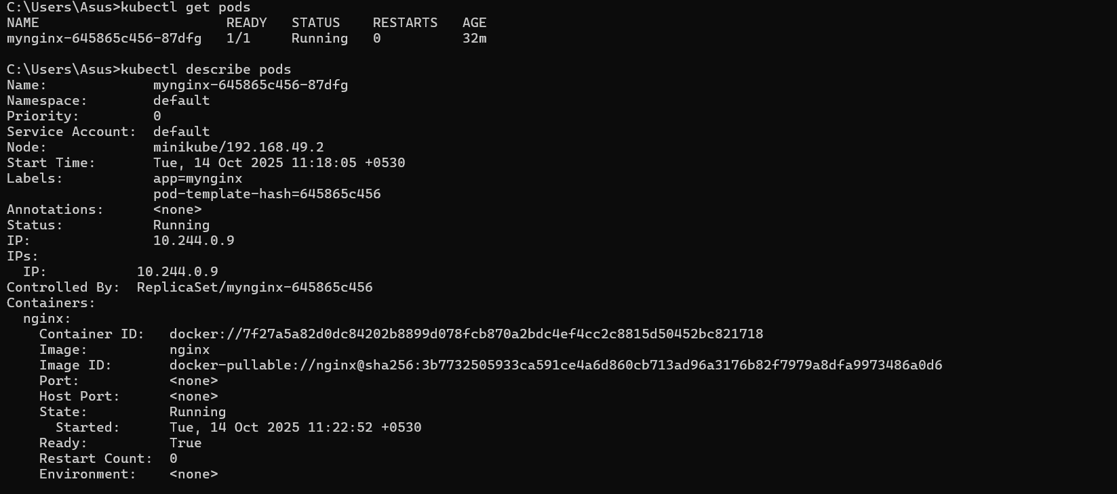
Expose Deployment as a Service:
Command:
kubectl expose deployment mynginx --type=NodePort --port=80 --target-port=80

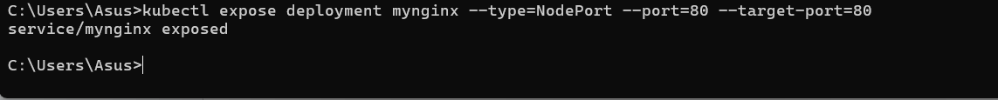
Step 3: Scale the Deployment
Command:Scales the Nginx deployment to 4 replicas (pods).
kubectl scale deployment mynginx --replicas=4
kubectl get service myngnix
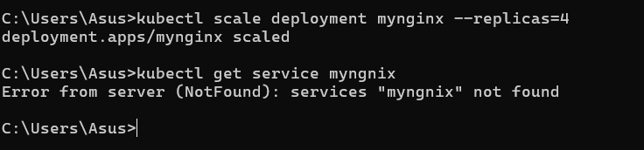
Step 4: Access the Nginx App
Using Port Forwarding:
Command:
kubectl port-forward svc/mynginx 8081:80

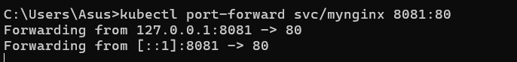
Access the app via http://localhost:8081.
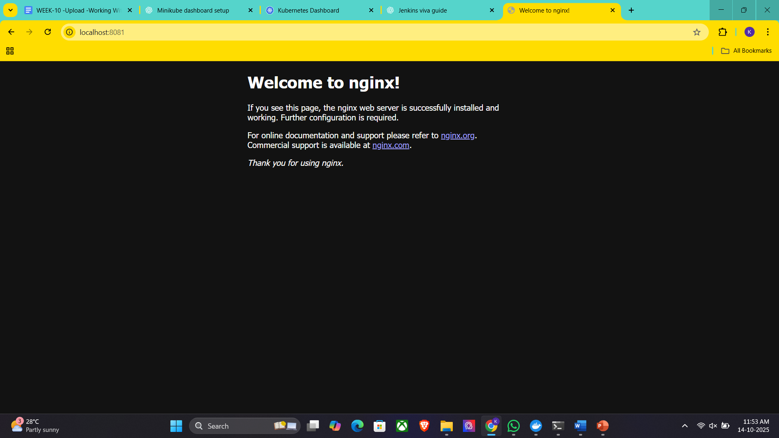
If Error, use this option, Using Minikube Tunnel:
Start the tunnel:
minikube tunnel
Retrieve the service URL:
minikube service mynginx --url
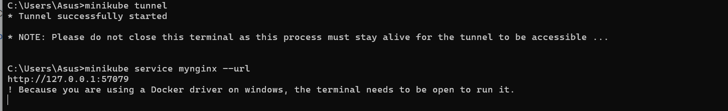
Open the provided URL in your browser.
Open the kubernets dashboard
Open the minikube dashboard
Minikube dashboard
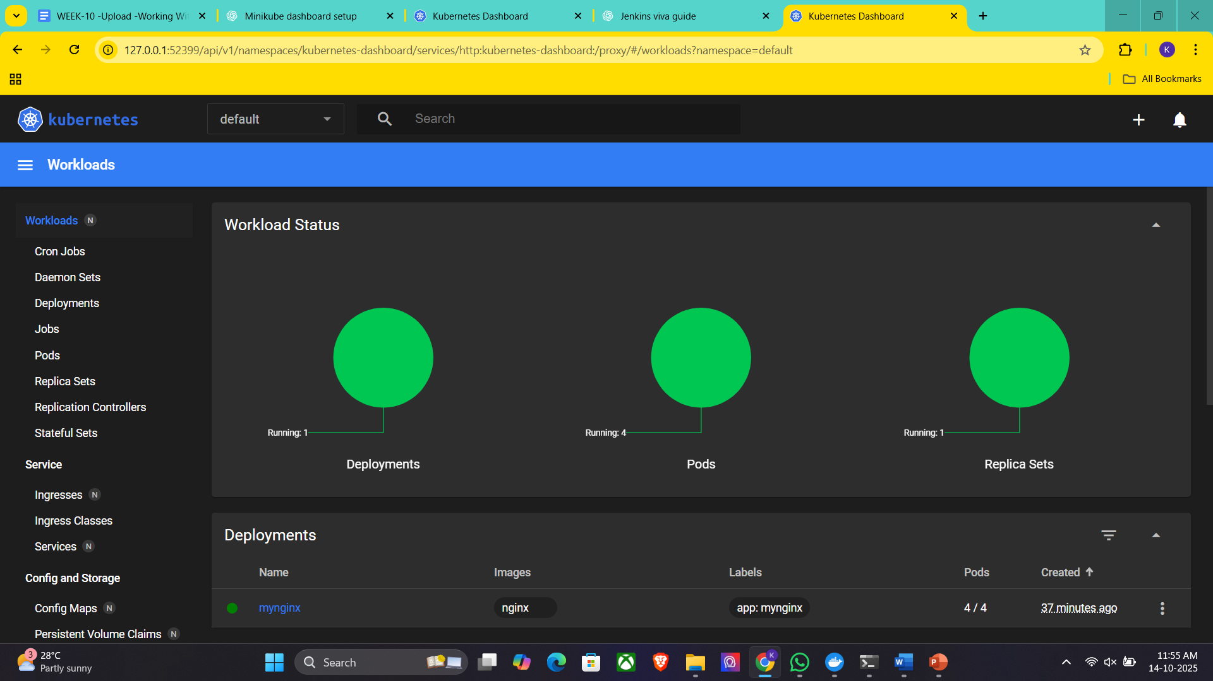
Step 5: Stop and Clean Up
Stop Nginx Deployment:
Commands:
kubectl delete deployment mynginx
kubectl delete service mynginx
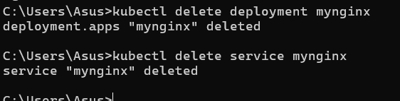
Stop Minikube (Optional):
Command:
minikube stop
Delete Minikube Cluster (Optional):
Command:minikube delete
Nagios Automation Steps
Step 1: Pull the Nagios Docker Image
Open a terminal and run:
docker pull jasonrivers/nagios:latest
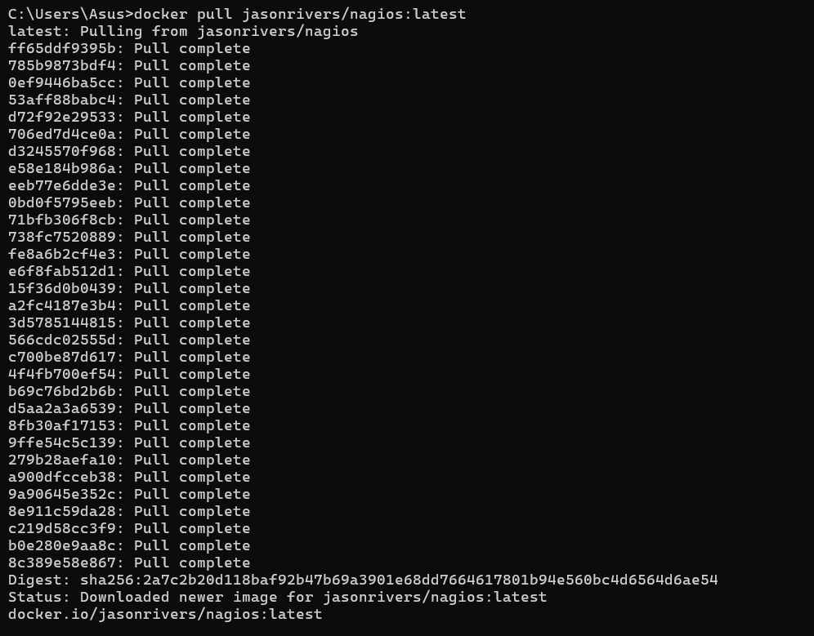
Step 2: Run Nagios
Command:
docker run --name nagiosdemo -p 8888:80 jasonrivers/nagios:latest

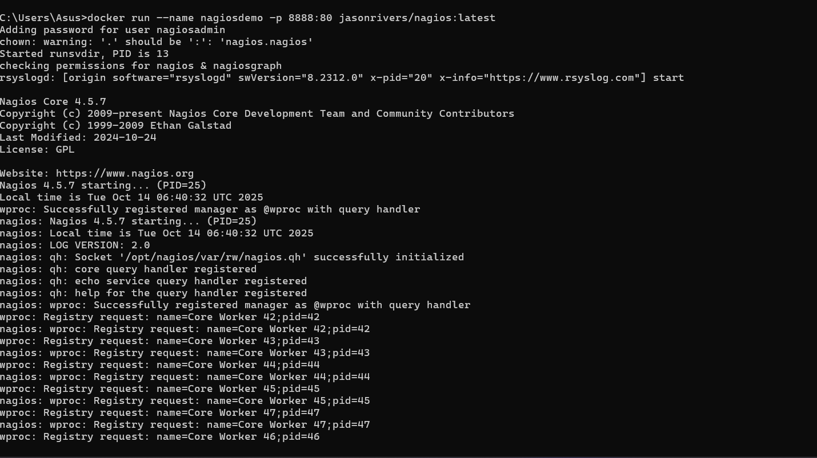
Step 3: Access Nagios Dashboard
Open your browser and navigate to:
http://localhost:8888
Login Credentials:
Username: nagiosadmin
Password: nagios
Once logged in, explore:
Hosts: View systems being monitored.
Services: Check tasks being monitored (e.g., CPU usage).
Alerts: Access recent notifications.
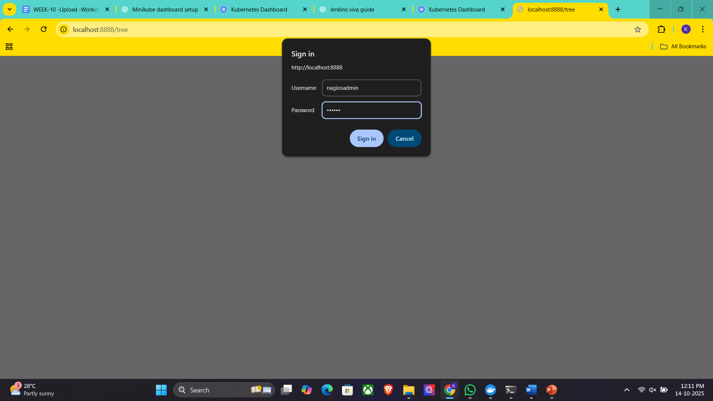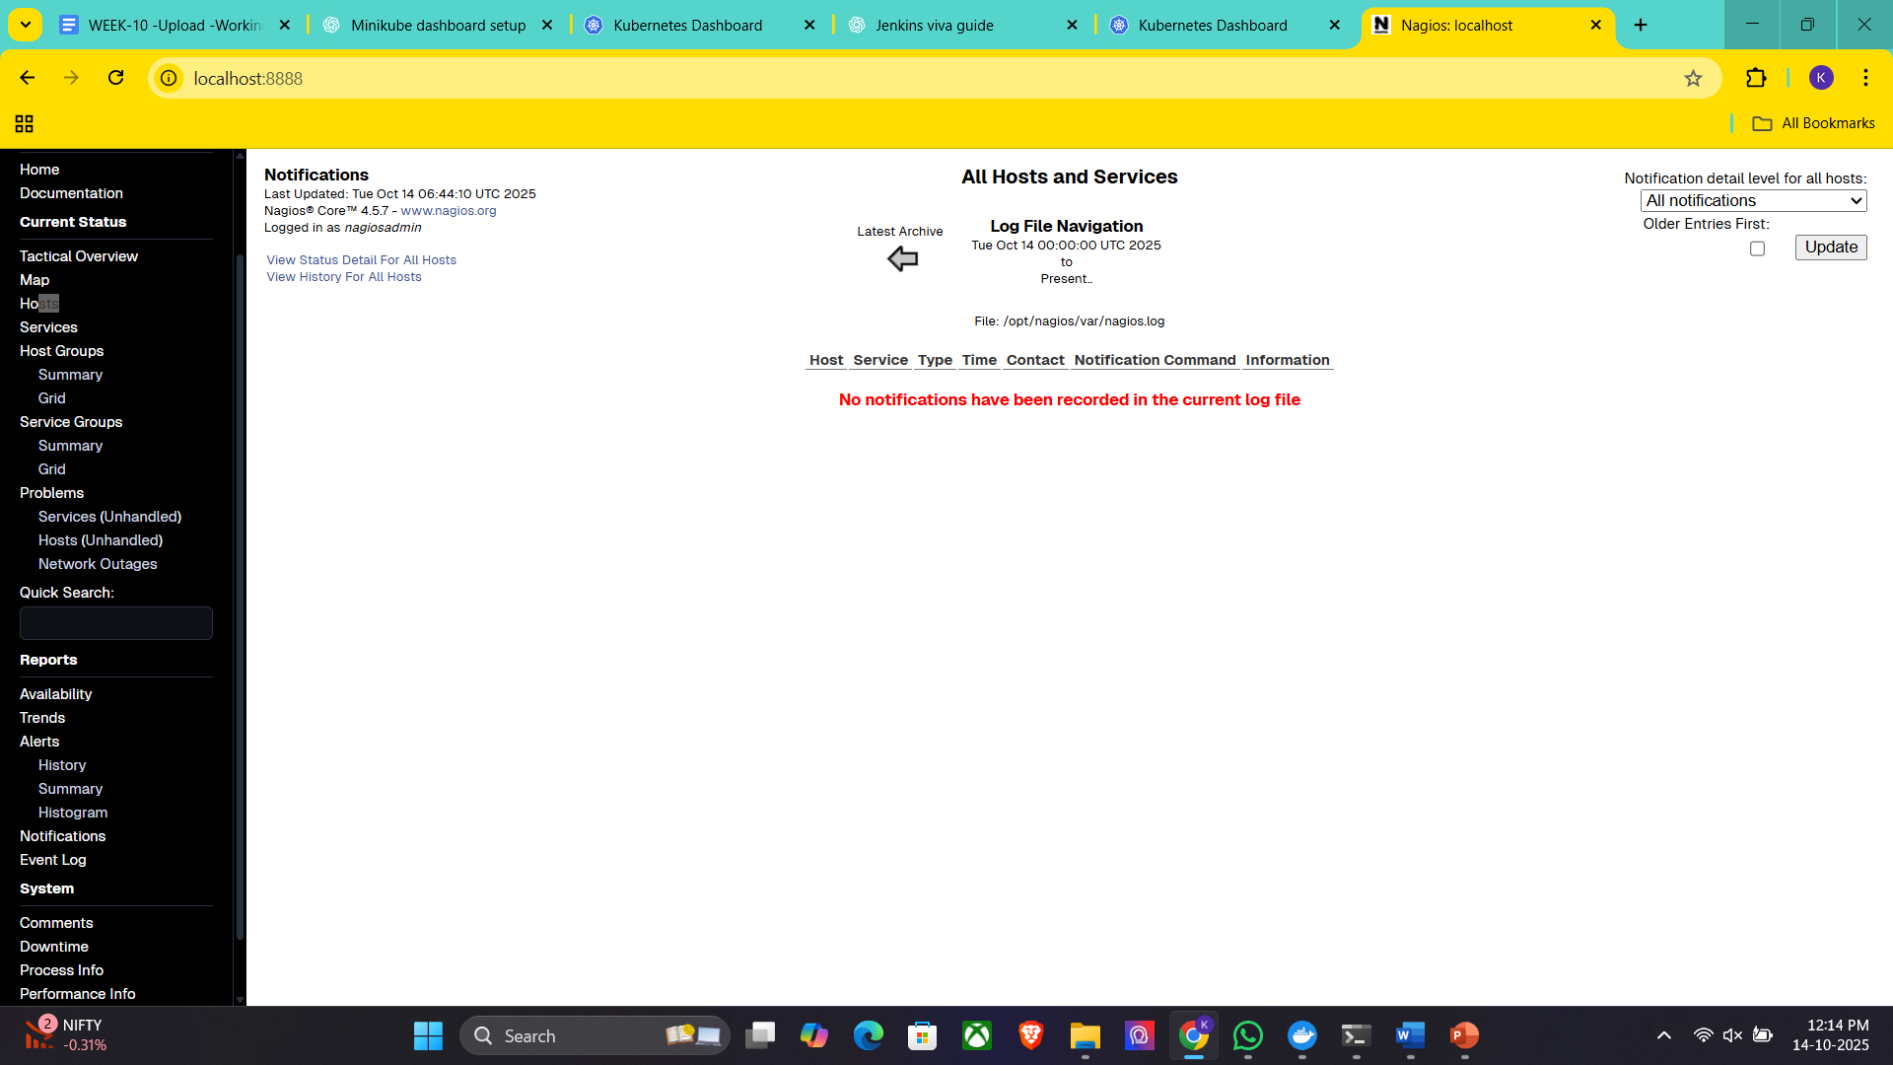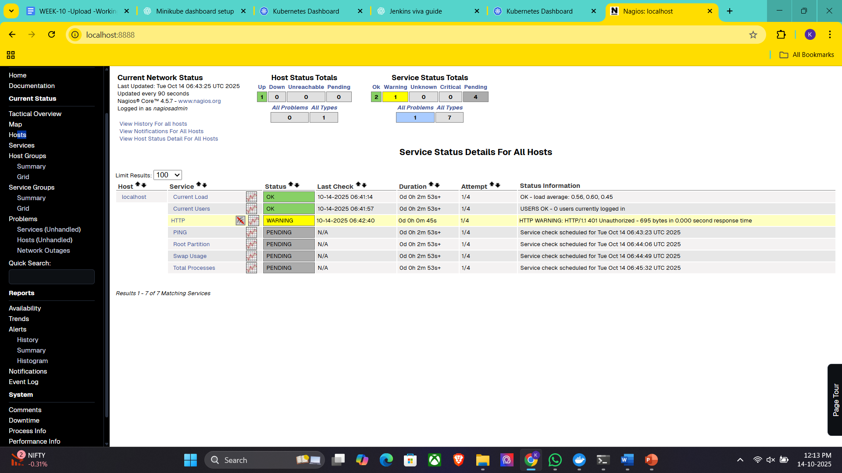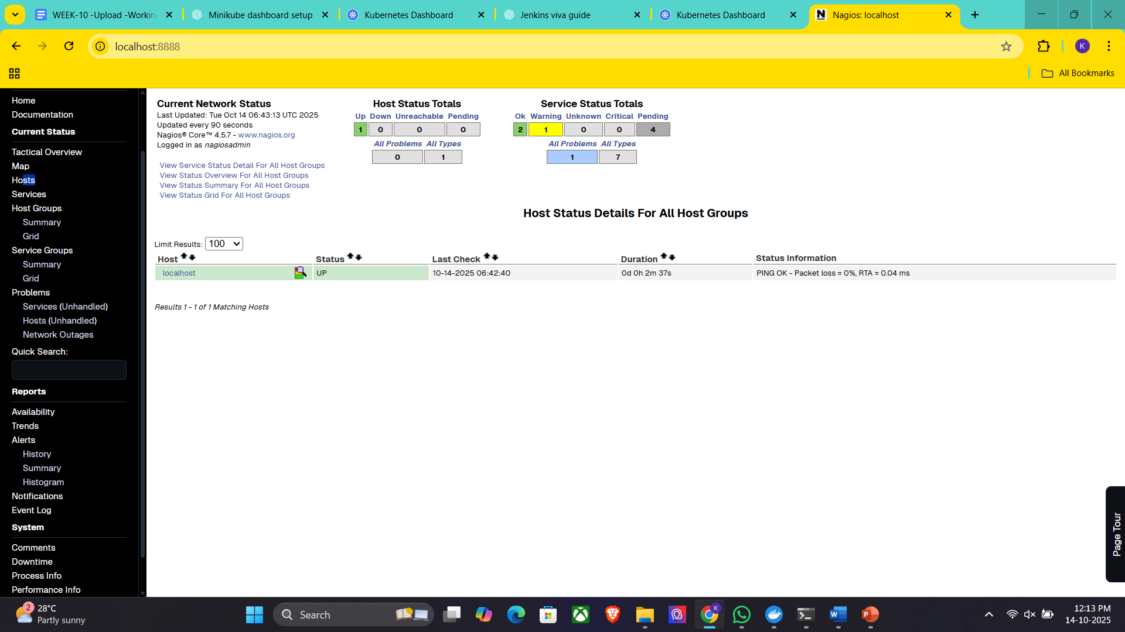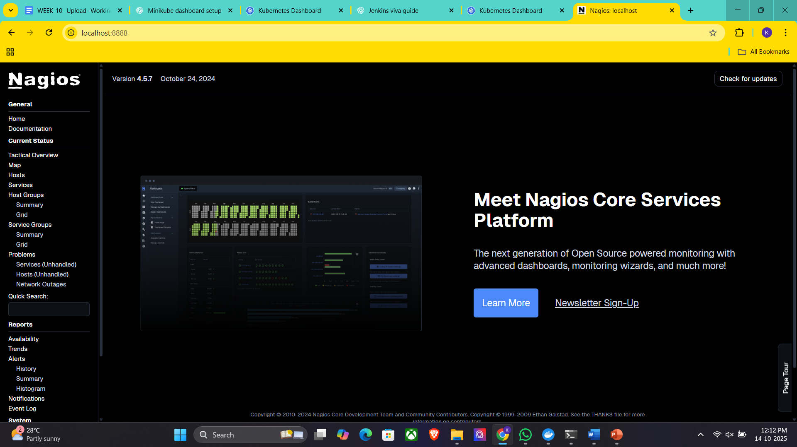
Step 4: Monitoring Host Details
Navigate to the Host Information Page:
Select a host from the Hosts menu.
Key Details:
Host Status: Indicates if the system is UP or DOWN.
Metrics: View CPU usage, memory status, and network activity.
Actions: Reschedule checks, disable notifications, or schedule downtime.
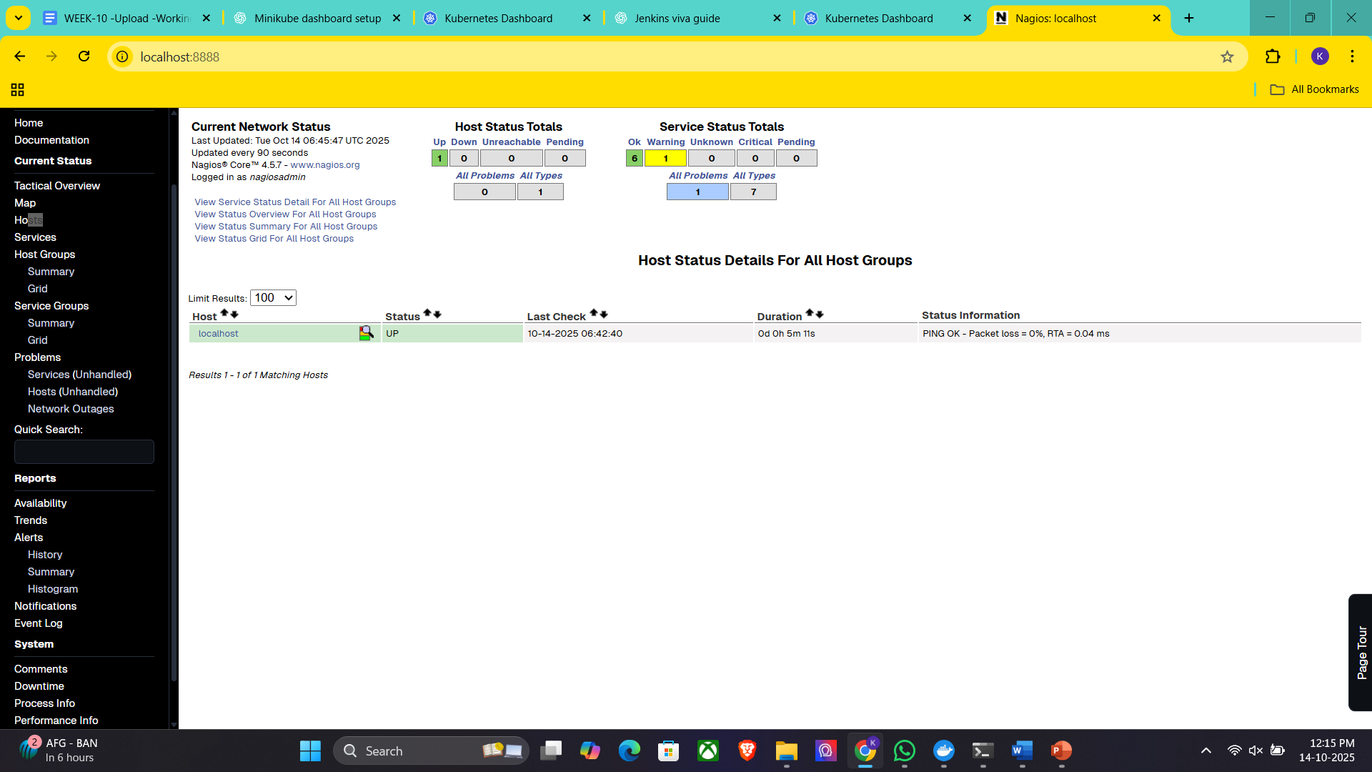
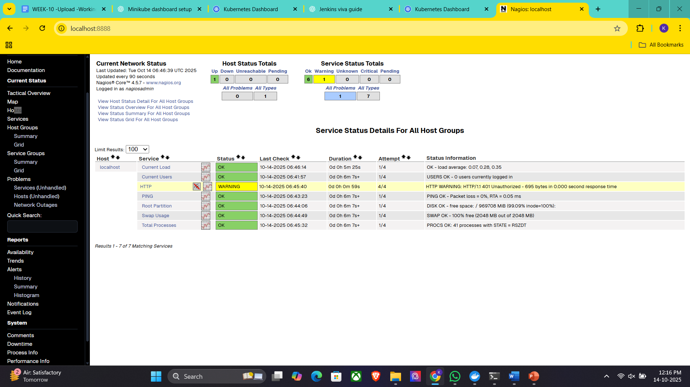
Step 5: Stop and Remove Nagios
Stop the Container:
Command:
docker stop nagiosdemo
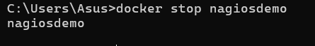
Delete the Container:
Command:
docker rm nagiosdemo
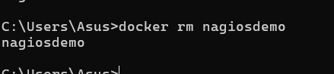
Remove the Image (Optional):
List images:
docker images
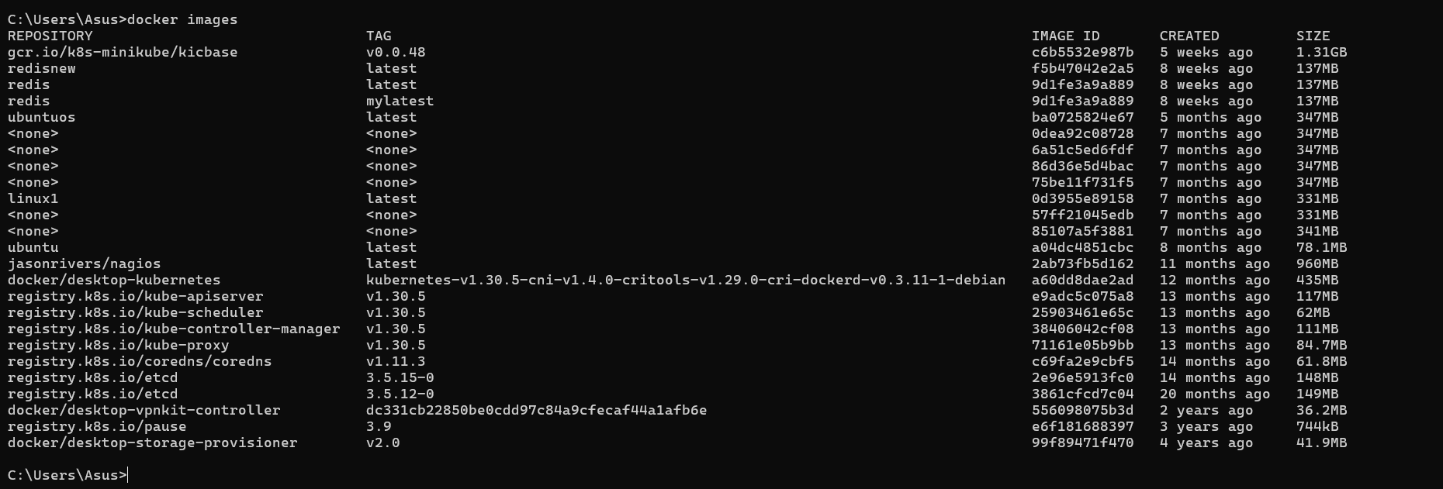
Delete the Nagios image:
docker rmijasonrivers/nagios:latest

Observe the docker containers in DockerHub, we can see the latest Nagios Installed running on port:8888
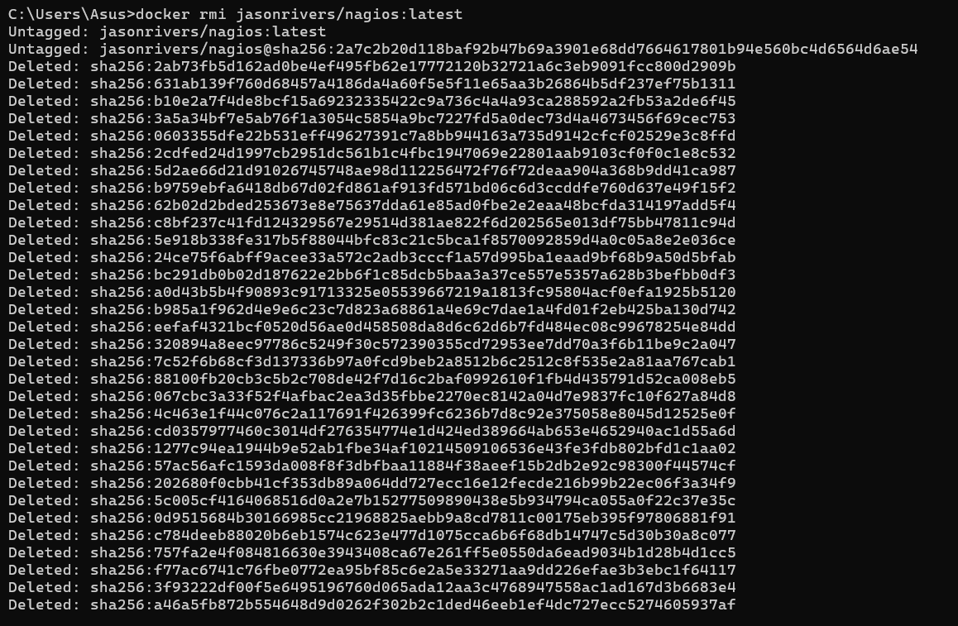

-------------------------------------------------------------------------------------------------------------------------------
Steps for AWS-free trier account creation
open https://aws.amazon.com
click on create AWS account
Provide email id and name details for AWS account creation then a screen will appear as below
Enter verification code received in your mail
Provide your contact details and agree Terms and conditions, then click on create
Provide billing details, click on verify and continue
Amazon chagres 2 rs and it will be credit back into your account once verification is over
Once payment success a screen appear as below, provide your working contact number after selecting country, and click on send SMS after entering the details
Provide verification code received in your mobile
Now select basic plan and click on complete sign up
Now a screen appear as follows then click on AWS management console
You will navigating to the aws page ..where you need to Select role as Academic/Researcher and interest as DevOps and click on submit
Sign into AWS console as Root user
A console screen appears aws will appear

SBQ’s

1.Your Pod keeps restarting repeatedly. What will you do?
Ans : Check pod logs → kubectl logs <pod-name>
App might crash or config is wrong. Fix and restart.
2.A Kubernetes pod is stuck in a "Pending" state. What could be the possible reasons, and how would you troubleshoot it?
Ans:Not enough space or wrong settings.
Check with kubectl describe pod <pod-name>.
3.How would you debug a failed deployment in Kubernetes?
Ans:See what went wrong → kubectl describe deployment <name>
Check pod logs and fix the error.
4.You have a Kubernetes Deployment with multiple replicas, and some pods are failing health checks. How would you identify the root cause and fix it?
Check logs and probes.Maybe wrong port or not enough startup time.
5.How do you roll back a faulty deployment?
Ans: Run → kubectl rollout undo deployment/<name>
6.How do you debug a running Pod?
Ans:Logs → kubectl logs <pod-name>
Go inside → kubectl exec -it <pod-name> -- /bin/bash
7.You need to expose a local service externally.How to do?
Ans:Run → kubectl expose deployment <name> --type=NodePort --port=80
8.How to Start and stop Nagios
Ans:Start → sudo systemctl start nagios ,Stop → sudo systemctl stop nagios
9.You installed Nagios but the web interface shows “Unable to connect to Nagios process”.how to resolve this?
Ans: Check → sudo systemctl status nagios
Then start it again.
10.You added a new host in Nagios, but it’s not appearing on the web interface.how to check?
Ans: Check config →sudo /usr/local/nagios/bin/nagios -v /usr/local/nagios/etc/nagios.cfg
Restart Nagios.
11.How can you check whether Nagios is running properly?
Ans: sudo systemctl status nagios
12.How do you view Nagios logs in real-time
Ans:sudo systemctl status nagios
13.What are the advantages of using Nagios?
Ans:· Sends alerts
· Free and open source
· Easy to use

Conclusion: In this week we learnt how to deploy pods in minikube and how to monitor our local system using Nagios tool and will know how to create the aws free trier account.

