Gopisetty Rohith

**Exercise 1: Control Structures**

**Scenario 1:** The bank wants to apply a discount to loan interest rates for customers above 60 years old.

**Question:** Write a PL/SQL block that loops through all customers, checks their age, and if they are above 60, apply a 1% discount to their current loan interest rates.

PL/SQL:

begin

for record in (

select l.LoanID, c.Name, c.DOB, l.InterestRate

from Loans l

join Customers c on l.CustomerID = c.CustomerID

where trunc(months_between(sysdate, c.DOB)/12)>60)

loop

update Loans

set InterestRate = InterestRate - 1

where LoanID = record.LoanID;

dbms_output.put_line('Loan ID'||record.LoanID||','||'Customer'||record.Name||','||'New Update Interest'|| (record.InterestRate - 1)||','||'Customer Age'||trunc(months_between(sysdate, record.DOB)/12)

);

end loop;

end;

/

Output:

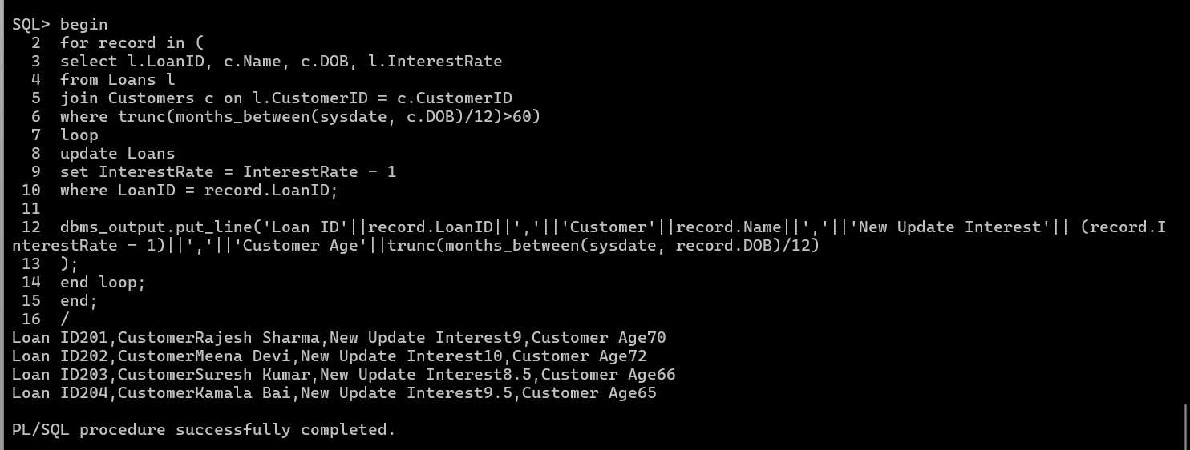

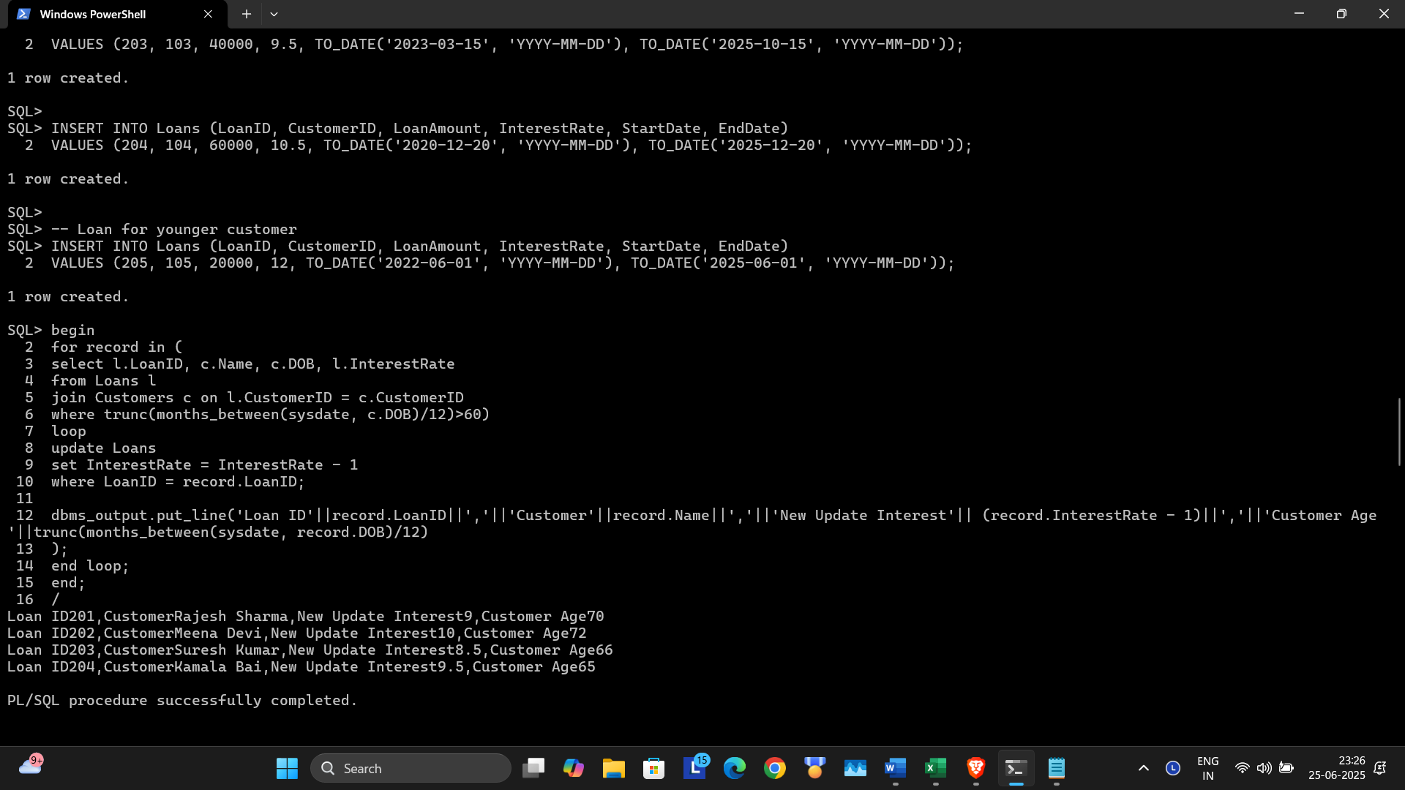

**Scenario 2:** A customer can be promoted to VIP status based on their balance.

**Question:** Write a PL/SQL block that iterates through all customers and sets a flag IsVIP to TRUE for those with a balance over $10,000.

PL/SQL

begin

for record in (

select CustomerID, Name, Balance from Customers

where

Balance > 10000

)

loop

update customers

set IsVIP = 'TRUE'

where CustomerID = record.CustomerID;

dbms_output.put_line('Customer ID: '||record.CustomerID||','||'Name : '||record.Name||','||'Balance : '||record.Balance|| ' -> Marked as VIP');

end loop;

end;

/

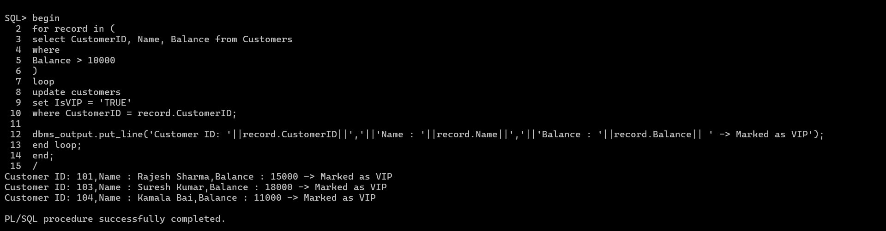

**Scenario 3:** The bank wants to send reminders to customers whose loans are due within the next 30 days.

**Question:** Write a PL/SQL block that fetches all loans due in the next 30 days and prints a reminder message for each customer.

PL/SQL

begin

for record in (

select c.Name, l.LoanID,l.EndDate

from Loans l

join Customers c on l.CustomerID = c.CustomerID

where

l.EndDate between sysdate and sysdate + 30

)

loop

dbms_output.put_line('LoanID '||record.LoanID||

'for '||record.Name||'is due on '||to_char(record.EndDate,'DD-MON-YYYY'));

end loop;

end;

/

