**Exercise 3: Stored Procedures**

**Scenario 1:** The bank needs to process monthly interest for all savings accounts.

**Question:** Write a stored procedure **ProcessMonthlyInterest** that calculates and updates the balance of all savings accounts by applying an interest rate of 1% to the current balance.

PL/SQL

SQL> create or replace procedure ProcessMonthlyInterest as

2 begin

3 update Accounts

4 set Balance = Balance + (Balance * 0.01),

5 LastModified = sysdate

6 where AccountType = 'SAVINGS';

7 end;

8 /

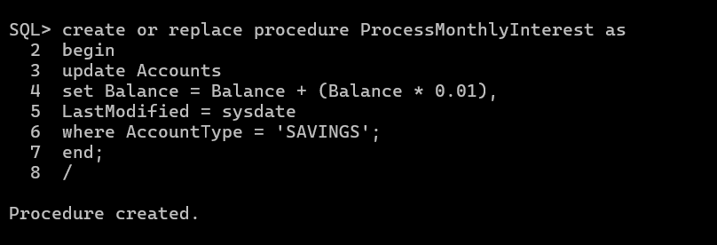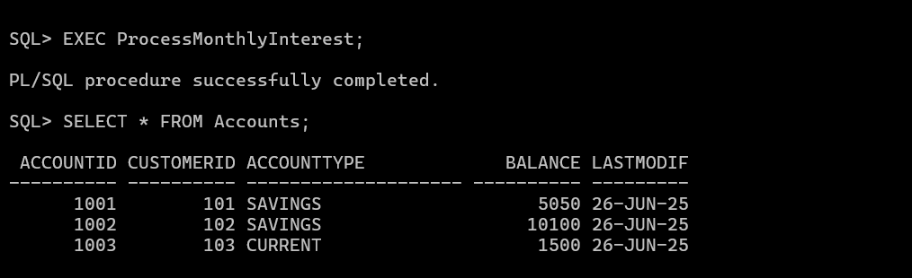

**Scenario 2:** The bank wants to implement a bonus scheme for employees based on their performance.

**Question:** Write a stored procedure **UpdateEmployeeBonus** that updates the salary of employees in a given department by adding a bonus percentage passed as a parameter.

SQL> create or replace procedure UpdateEmployeeBonus(

2 p_Department in varchar2,

3 p_BonusPercent in number)

4 as

5 begin

6 update Employees

7 set Salary = Salary + (Salary * p_BonusPercent / 100)

8 where Department = p_Department;

9 end;

10 /

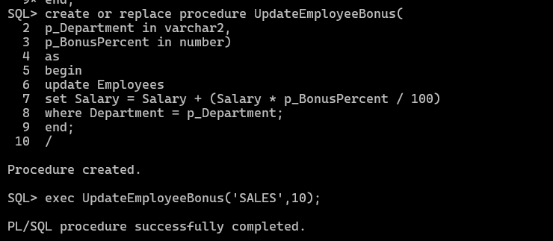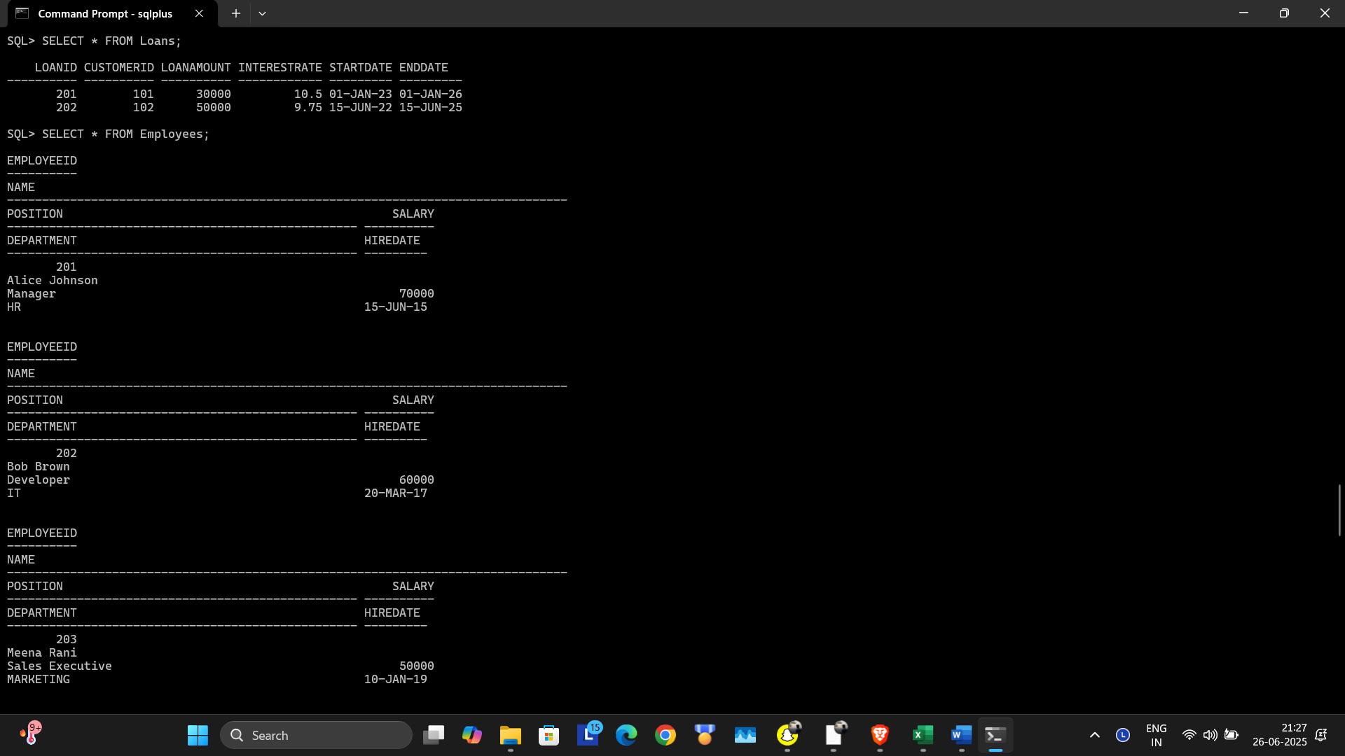

**Scenario 3:** Customers should be able to transfer funds between their accounts.

**Question:** Write a stored procedure **TransferFunds** that transfers a specified amount from one account to another, checking that the source account has sufficient balance before making the transfer.

PL/SQL:

SQL> create or replace procedure TransferFunds(

2 p_FromAccountID in number,

3 p_ToAccountID in number,

4 p_Amount in number)

5 as

6 v_FromBalance number;

7

8 begin

9 select Balance into v_FromBalance

10 from Accounts

11 where AccountID = p_FromAccountID

12 for update;

13

14 if v_FromBalance < p_Amount then

15 RAISE_APPLICATION_ERROR(-20001,'Insufficient funds in source account.');

16 end if;

17

18 update Accounts

19 set Balance = Balance - p_Amount,

20 LastModified = sysdate

21 where AccountID = p_FromAccountID;

22

23 update Accounts

24 set Balance = Balance + p_Amount,

25 LastModified = sysdate

26 where AccountID = p_toAccountID;

27

28 insert into Transactions(TransactionID, AccountID, TransactionDate, Amount,TransactionType)

29 values (TRANSACTIONS_SEQ.NEXTVAL, p_FromAccountID, sysdate, p_Amount, 'DEBIT');

30

31 insert into Transactions(TransactionID, AccountID, TransactionDate, Amount,TransactionType)

32 values (TRANSACTIONS_SEQ.NEXTVAL, p_ToAccountID, sysdate, p_Amount, 'CREDIT');

33 END;

34 /

