**Mockito Hands-On Exercises**

**Exercise 1: Mocking and Stubbing**

Code:

package com.cognizant.mockito;

public interface ExternalApi {

String getData();

}

package com.cognizant.mockito;

public class MyService {

private ExternalApi api;

public MyService(ExternalApi api) {

this.api = api;

}

public String fetchData() {

return api.getData();

}

}

package com.cognizant.mockito;

import org.junit.Test;

import org.mockito.Mockito;

import static org.junit.Assert.*;

import static org.mockito.Mockito.when;

public class MyServiceTest {

@Test

public void testExternalApi() {

ExternalApi mockApi = Mockito.mock(ExternalApi.class);

when(mockApi.getData()).thenReturn("Mock Data");

MyService service = new MyService(mockApi);

String result = service.fetchData();

assertEquals("Mock Data", result);

}

}

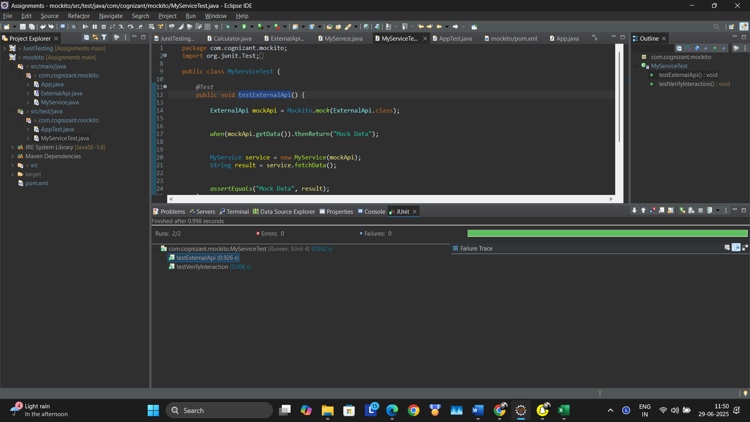

**Exercise 2: Verifying Interactions**

**Code:**

**package com.cognizant.mockito;**

**import org.junit.Test;**

**import org.mockito.Mockito;**

**import static org.junit.Assert.*;**

**import static org.mockito.Mockito.verify;**

**import static org.mockito.Mockito.when;**

**public class MyServiceTest {**

**@Test**

**public void testExternalApi() {**

**ExternalApi mockApi = Mockito.mock(ExternalApi.class);**

**when(mockApi.getData()).thenReturn("Mock Data");**

**MyService service = new MyService(mockApi);**

**String result = service.fetchData();**

**assertEquals("Mock Data", result);**

**}**

**@Test**

**public void testVerifyInteraction() {**

**ExternalApi mockApi = Mockito.mock(ExternalApi.class);**

**MyService service = new MyService(mockApi);**

**service.fetchData();**

**verify(mockApi).getData();**

**}**

**}**

