**WEEK 4:**

**Spring REST using Spring Boot 3**

1. **Create a Spring Web Project using Maven**

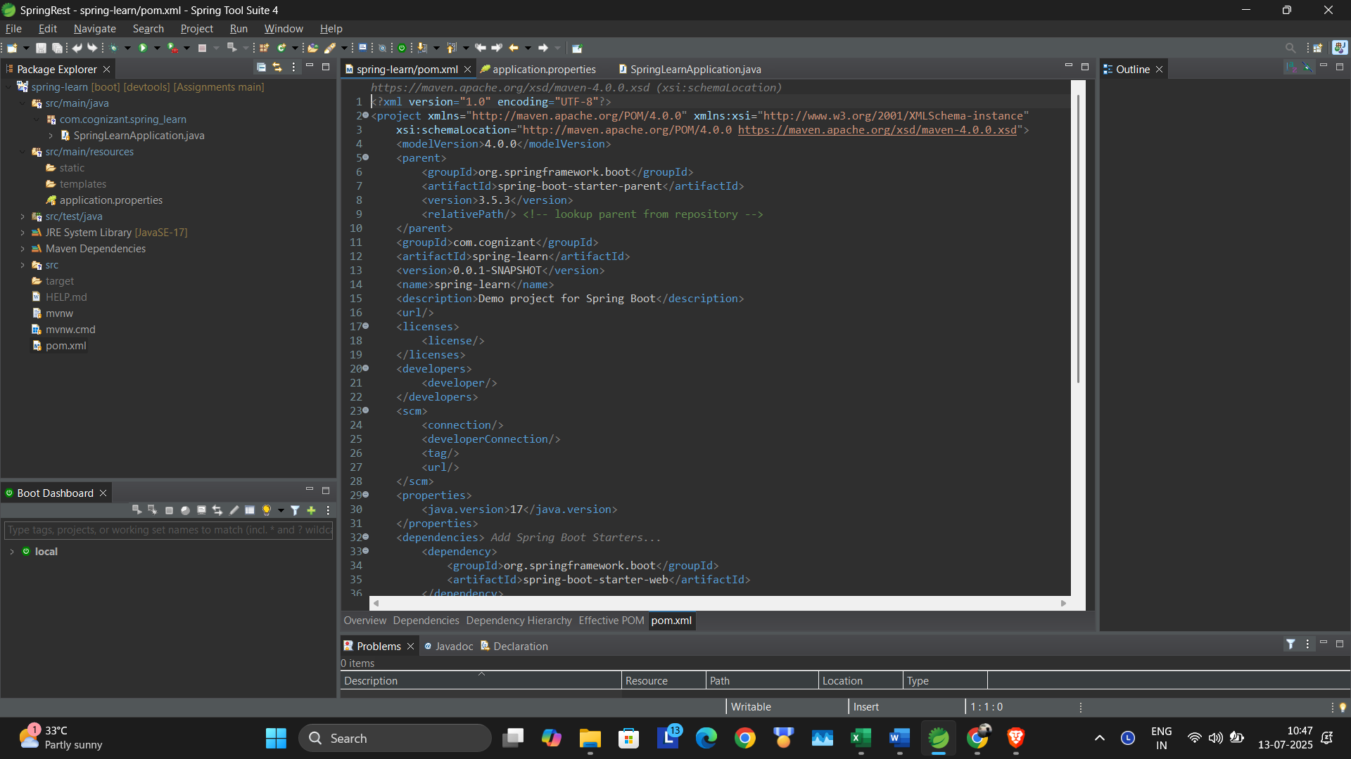

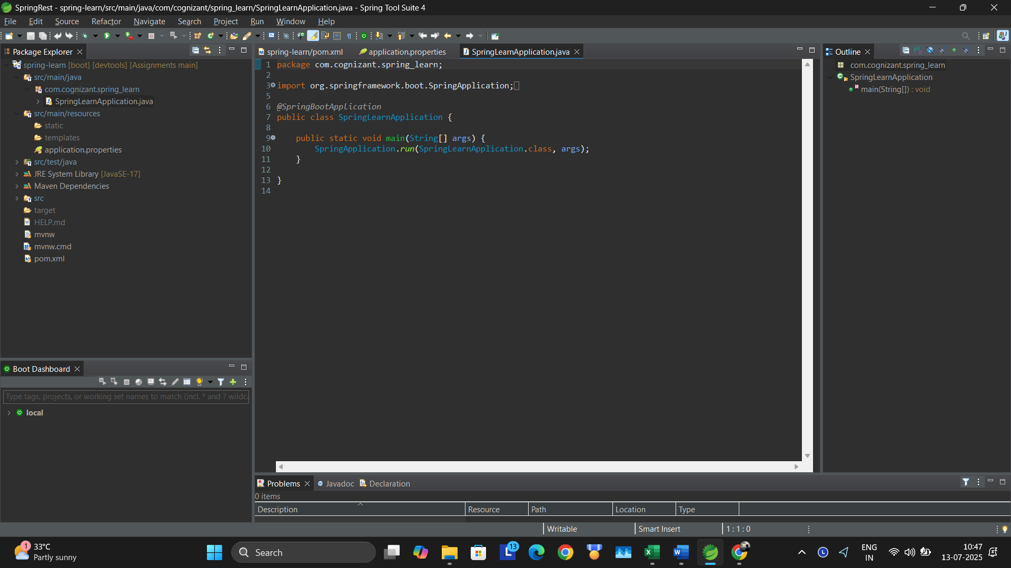

**Hands on 2**

**Spring Core – Load SimpleDateFormat from Spring Configuration XML**

Code:

package com.cognizant.spring_learn;

import java.text.ParseException;

import java.text.SimpleDateFormat;

import java.util.Date;

import org.springframework.boot.SpringApplication;

import org.springframework.boot.autoconfigure.SpringBootApplication;

import org.springframework.context.ApplicationContext;

import org.springframework.context.support.ClassPathXmlApplicationContext;

*@SpringBootApplication*

public class SpringLearnApplication {

public static void main(String[] args) {

SpringApplication.*run*(SpringLearnApplication.class, args);

*displayDate*();

}

public static void displayDate() {

ApplicationContext context = new ClassPathXmlApplicationContext("date-format.xml");

SimpleDateFormat format = context.getBean("dateFormat", SimpleDateFormat.class);

try {

Date parsedDate = format.parse("13/07/2025");

System.***out***.println("Parsed Date: " + parsedDate);

} catch (ParseException e) {

System.***out***.println("Failed to parse date: " + e.getMessage());

}

}

}

<?xml version="1.0" encoding="UTF-8"?>

<beans xmlns="http://www.springframework.org/schema/beans"

xmlns:xsi="http://www.w3.org/2001/XMLSchema-instance"

xsi:schemaLocation="http://www.springframework.org/schema/beans

https://www.springframework.org/schema/beans/spring-beans.xsd">

<bean id="dateFormat" class="java.text.SimpleDateFormat">

<constructor-arg value="dd/MM/yyyy" />

</bean>

</beans>

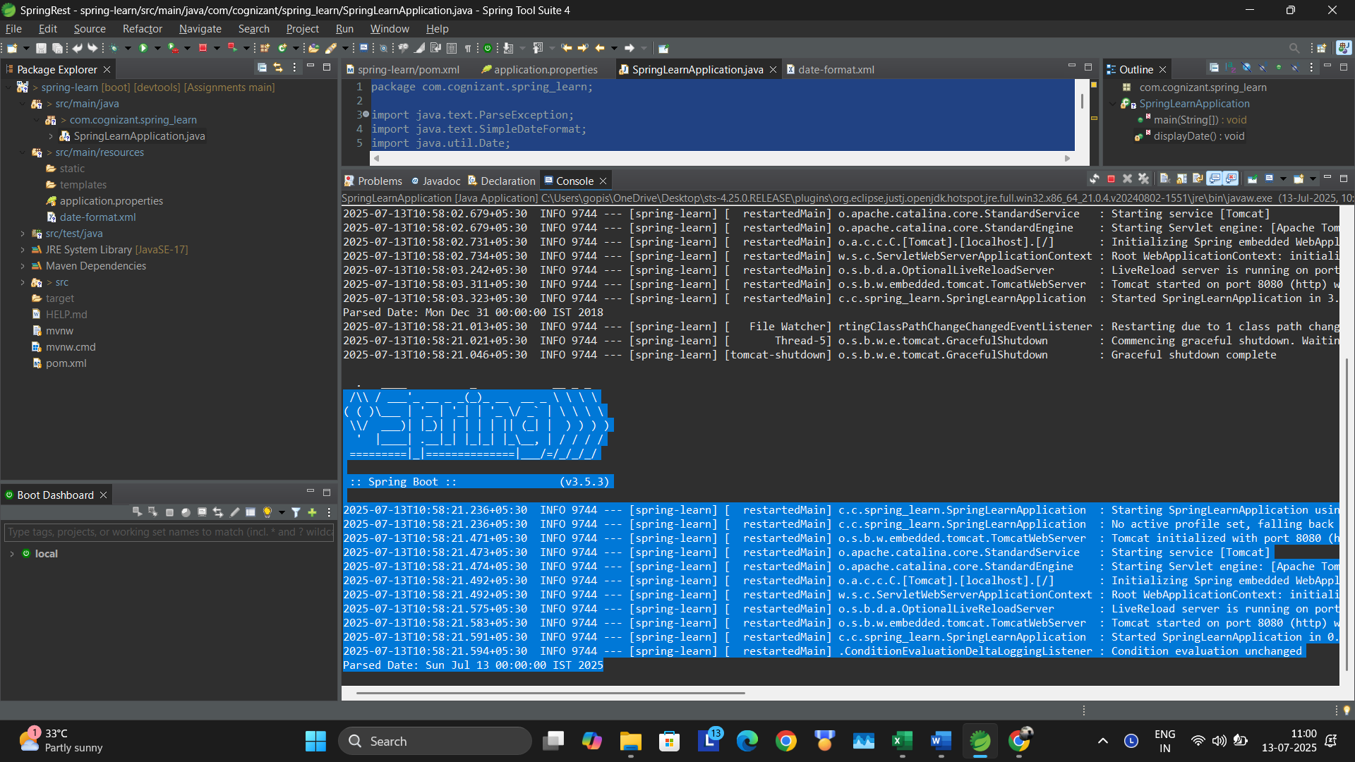

**Hands on 3**

**Spring Core - Incorporate Logging**

spring.application.name=spring-learn

logging.level.org.springframework=info

logging.level.com.cognizant.springlearn=debug

logging.pattern.console=%d{yyMMdd}|%d{HH:mm:ss.SSS}|%-20.20thread|%5p|%-25.25logger{25}|%25M|%m%n

server.port = 8080

public static void displayDate() {

***LOGGER***.info("START");

ApplicationContext context = new ClassPathXmlApplicationContext("date-format.xml");

SimpleDateFormat format = context.getBean("dateFormat", SimpleDateFormat.class);

try {

Date date = format.parse("13/07/2025");

System.***out***.println("Parsed Date: " + date);

} catch (ParseException e) {

System.***out***.println("Failed to parse date: " + e.getMessage());

}

***LOGGER***.info("END");

}

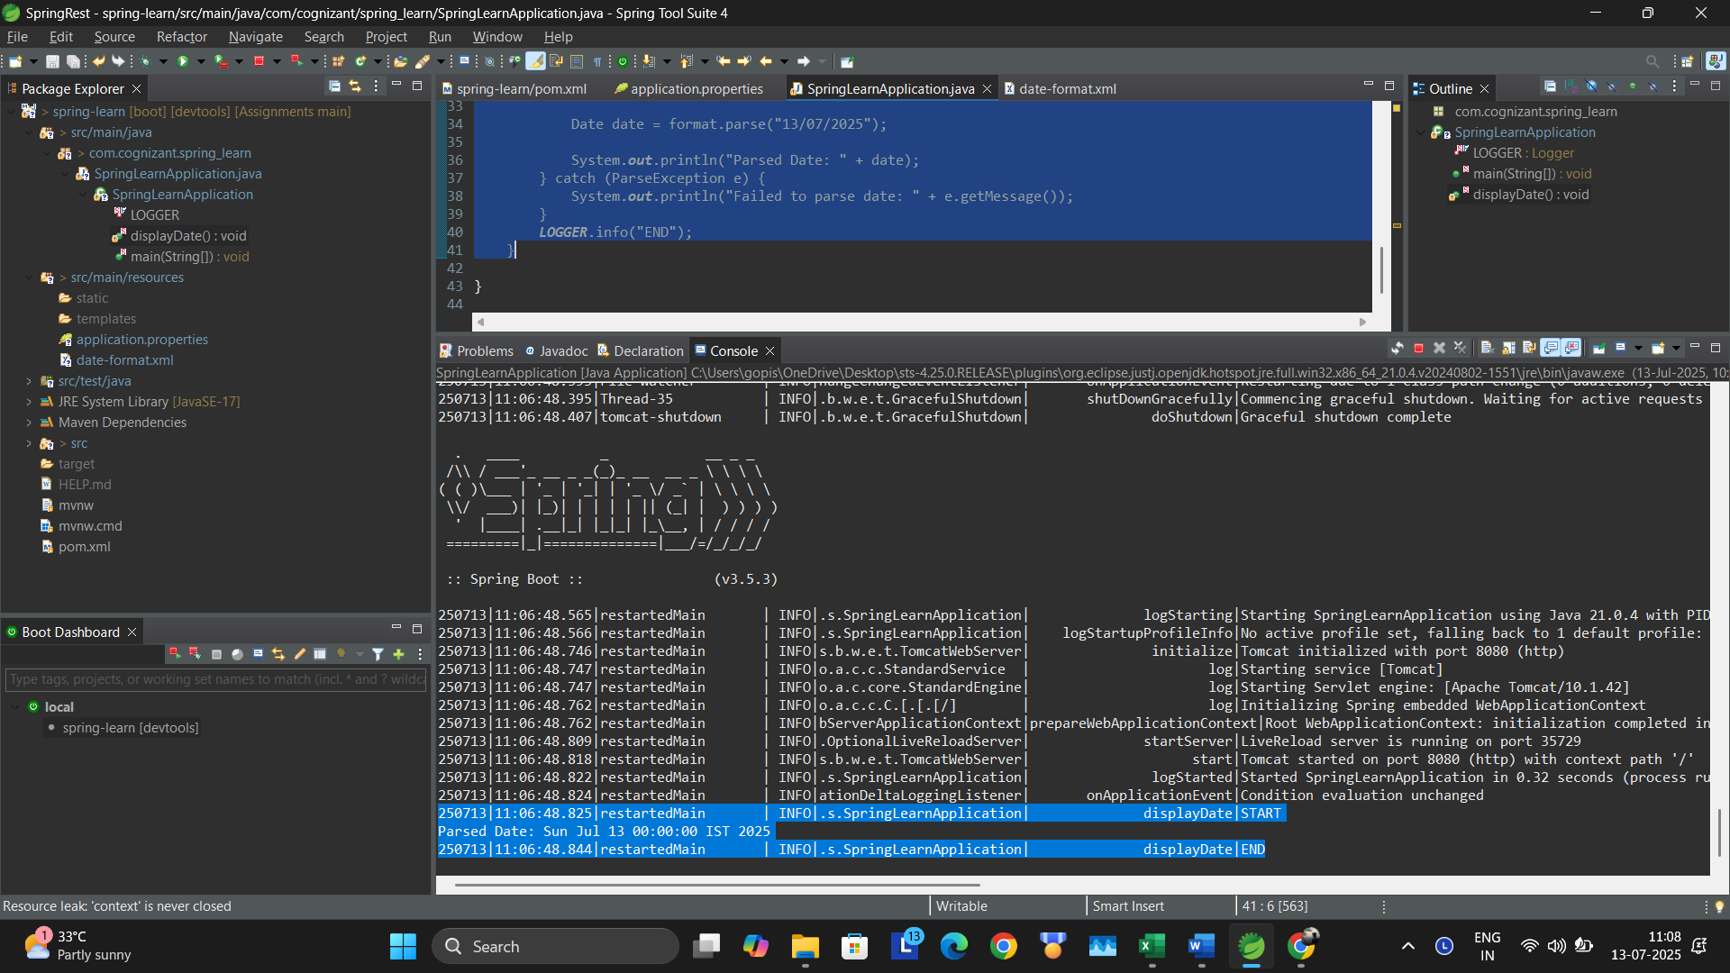

**Hands on 4**

**Spring Core – Load Country from Spring Configuration XML**

Country.java

package com.cognizant.spring_learn;

import org.slf4j.Logger;

import org.slf4j.LoggerFactory;

public class Country {

private static final Logger LOGGER = LoggerFactory.getLogger(Country.class);

private String code;

private String name;

public Country() {

LOGGER.debug("Inside Country Constructor.");

}

public String getCode() {

LOGGER.debug("Inside getCode()");

return code;

}

public void setCode(String code) {

LOGGER.debug("Inside setCode()");

this.code = code;

}

public String getName() {

LOGGER.debug("Inside getName()");

return name;

}

public void setName(String name) {

LOGGER.debug("Inside setName()");

this.name = name;

}

@Override

public String toString() {

return "Country [code=" + code + ", name=" + name + "]";

}

}

Country.xml:

<?xml version="1.0" encoding="UTF-8"?>

<beans xmlns="http://www.springframework.org/schema/beans"

xmlns:xsi="http://www.w3.org/2001/XMLSchema-instance"

xsi:schemaLocation="http://www.springframework.org/schema/beans

https://www.springframework.org/schema/beans/spring-beans.xsd">

<bean id="country" class="com.cognizant.spring_learn.Country">

<property name="code" value="IN" />

<property name="name" value="India" />

</bean>

</beans>

Output:

