**Hello World RESTful Web Service**

package com.cognizant.spring_learn.controller;

import org.springframework.web.bind.annotation.RestController;

*@RestController*("/hello")

public class HelloController {

public String sayHello() {

return "Hello World!!";

}

}

Output:

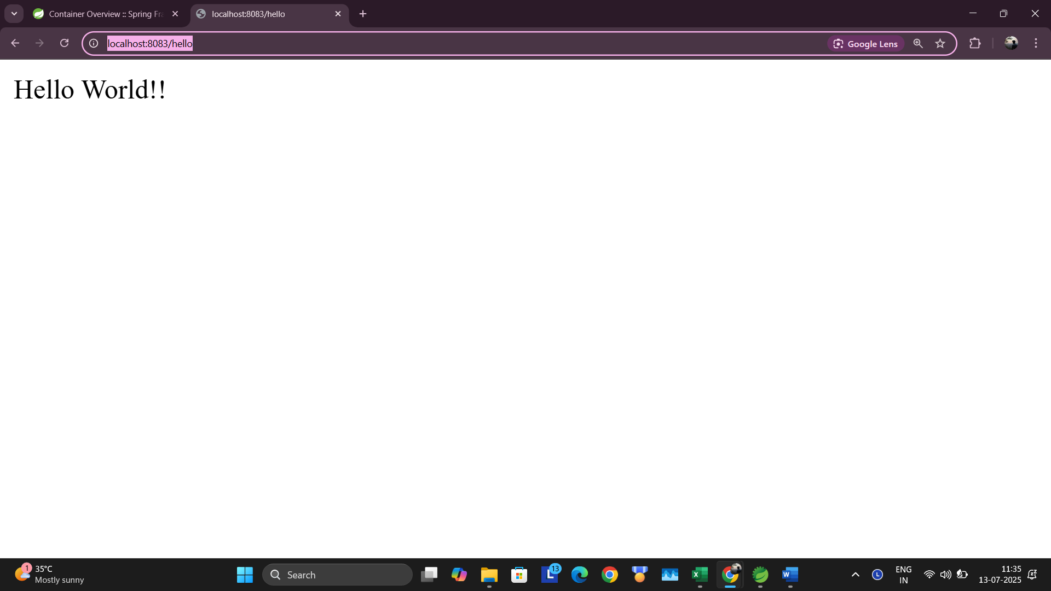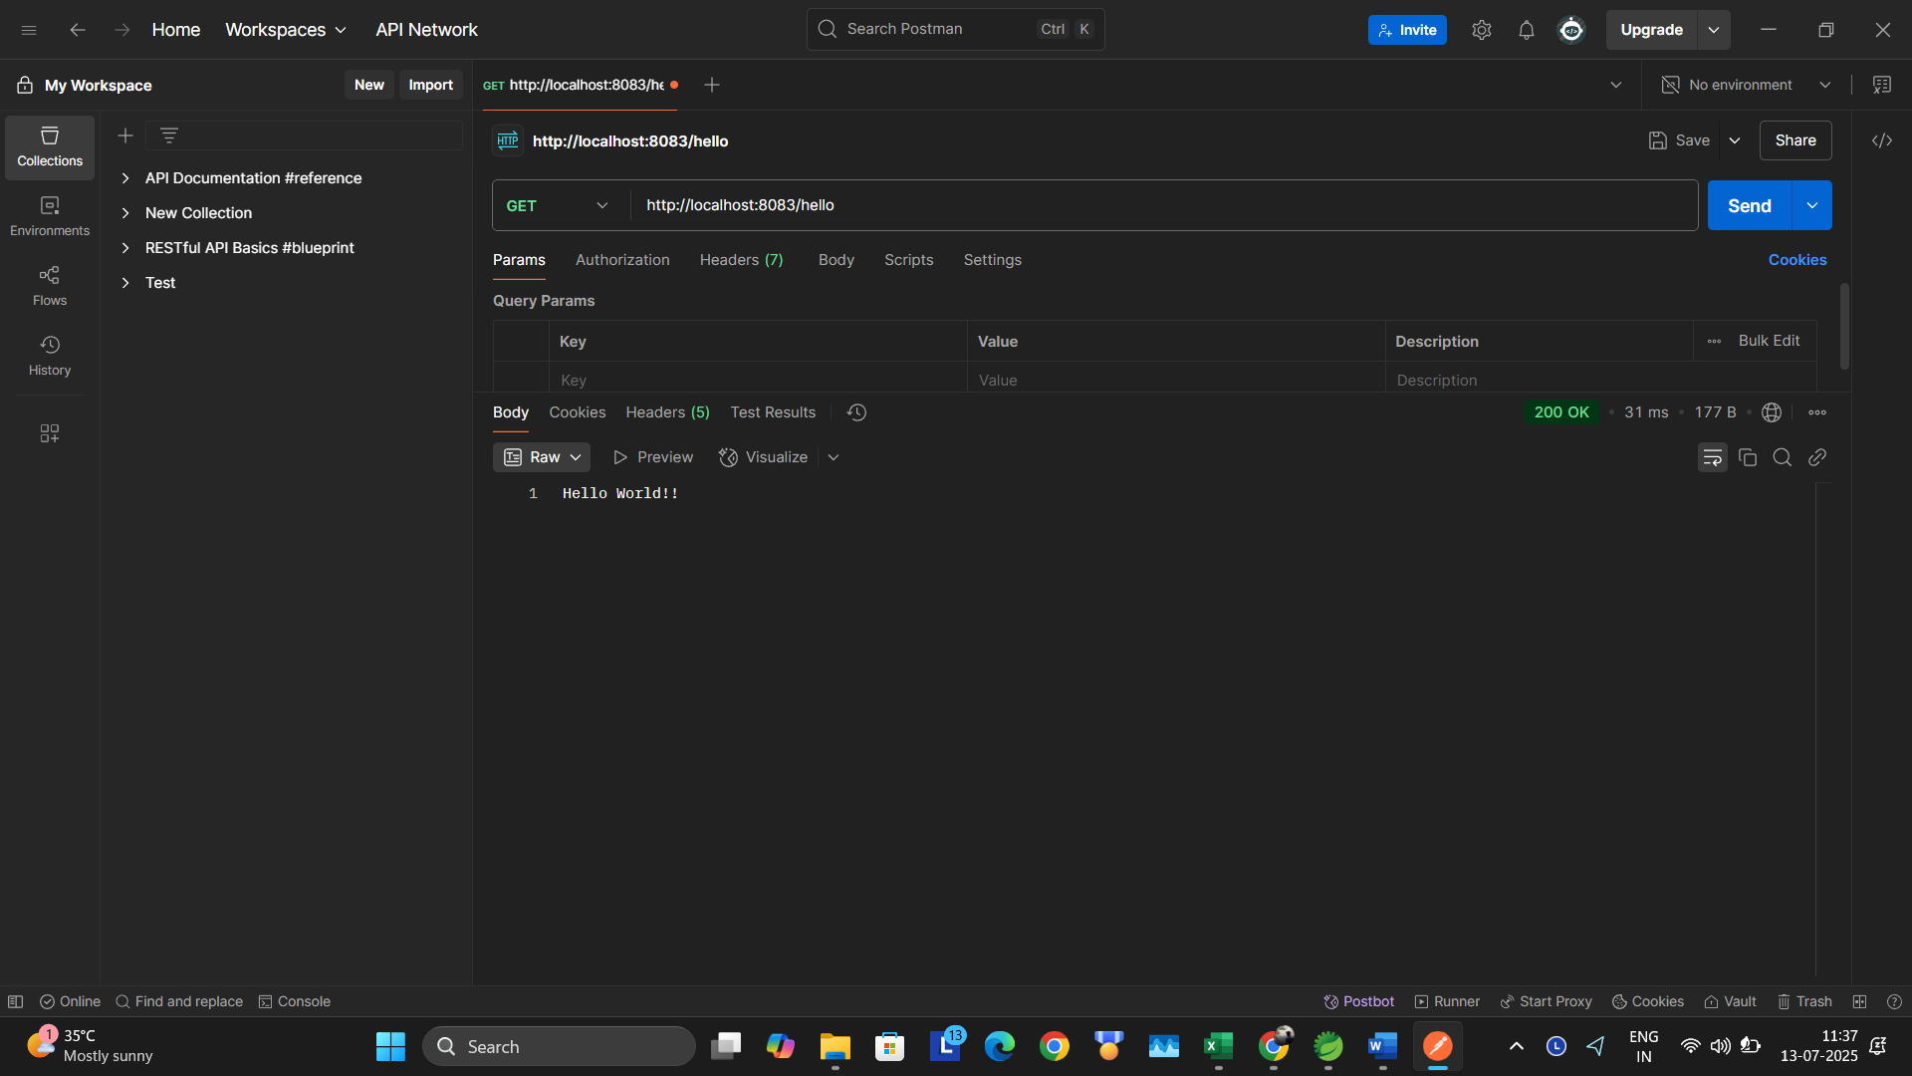

**REST - Country Web Service**

package com.cognizant.spring_learn.controller;

import com.cognizant.spring_learn.Country;

import org.springframework.context.ApplicationContext;

import org.springframework.context.support.ClassPathXmlApplicationContext;

import org.springframework.web.bind.annotation.RequestMapping;

import org.springframework.web.bind.annotation.RestController;

*@RestController*

public class CountryController {

*@RequestMapping*("/country")

public Country getCountryIndia() {

ApplicationContext context = new ClassPathXmlApplicationContext("country.xml");

Country country = context.getBean("in", Country.class);

return country;

}

}

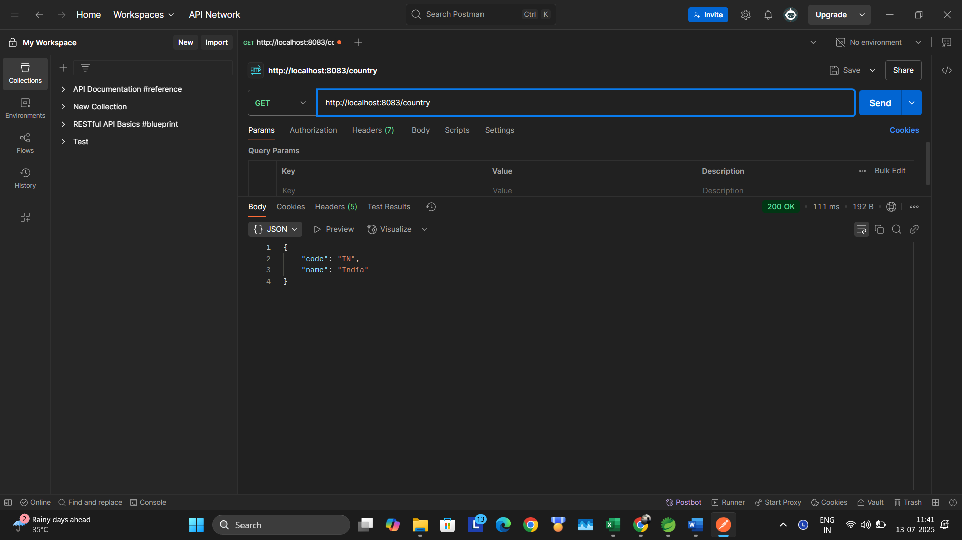

**REST - Get all countries**

*@GetMapping*("/countries")

public List<Country> getAllCountries() {

ApplicationContext context = new ClassPathXmlApplicationContext("country.xml");

return (List<Country>) context.getBean("countryList");

}

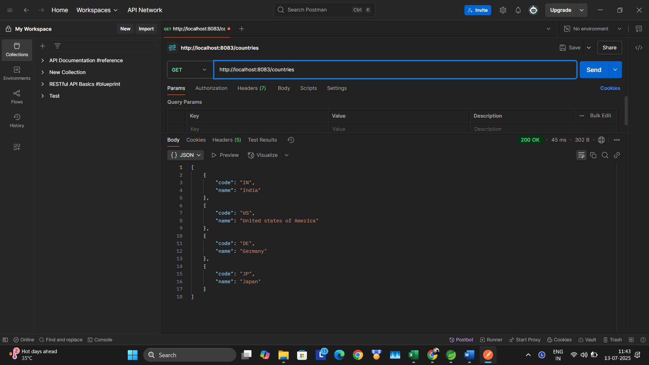

**REST - Get country based on country code**

*@GetMapping*("/countries/{code}")

public Country getCountry(*@PathVariable* String code) {

return countryService.getCountry(code);

}

package com.cognizant.spring_learn.service;

import com.cognizant.spring_learn.Country;

import org.springframework.context.ApplicationContext;

import org.springframework.context.support.ClassPathXmlApplicationContext;

import org.springframework.stereotype.Service;

import java.util.List;

*@Service*

public class CountryService {

public Country getCountry(String code) {

ApplicationContext context = new ClassPathXmlApplicationContext("country.xml");

List<Country> countryList = (List<Country>) context.getBean("countryList");

for (Country country : countryList) {

if (country.getCode().equalsIgnoreCase(code)) {

return country;

}

}

return null;

}

}

