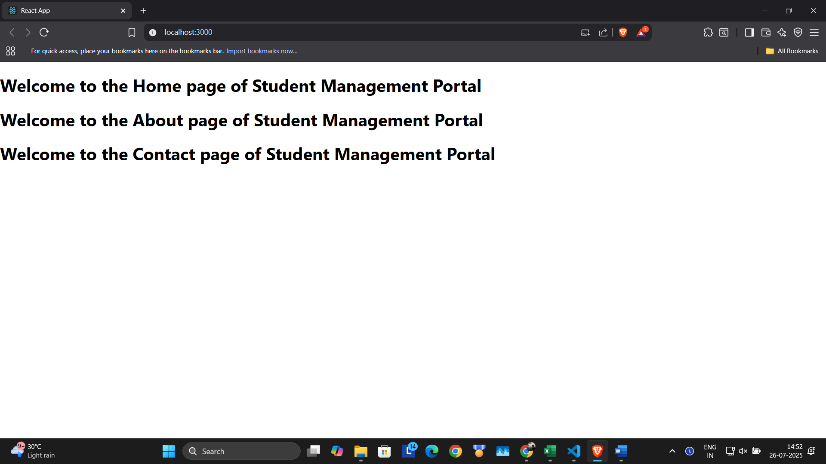

import logo from './logo.svg';

import Home from './Components/Home';

import About from './Components/About';

import Contact from './Components/Contact';

function App() {

  return (

    <div className='container'>

      <Home/>

      <About/>

      <Contact/>

    </div>

  );

}

export default App;

import React, { Component } from "react";

 export default class Home extends Component{

    render(){

        return (

            <div>

                <h1>Welcome to the Home page of Student Management Portal</h1>

            </div>

        );

    }

}

import React, { Component } from "react";

 export default class Contact extends Component{

    render(){

        return (

        <div>

            <h1>Welcome to the Contact page of Student Management Portal</h1>

        </div>

        );

    }

}

import React, { Component } from "react";

 export default class About extends Component{

    render(){

        return (

        <div>

            <h1>Welcome to the About page of Student Management Portal</h1>

        </div>

        );

    }

}